# Prediction Results for Return Time Difference

This document contains the analysis of the prediction results for time difference between pickup and return of chessies. The model used for the prediction is the sliding window XGBoost (parameters used are specified in the following section).

## General Analysis Parameters and Information

Number of files in analysis 251

Dates range: 2025-02-16 - 2025-11-02

Columns not used: 7

CHS ID

CTR Trip Id

CHS Return Dt

CHS Return LOC

CHS Pickup Date

CTR pick Dt

CTR Return Dt

Model used: Sliding window XGBoost (Regressor)

Window size: 1000

Window step size: 100

Error THR: 20

Test portion: 0.2

## Files Detailed Analysis

### Results for Latest_Test_2025-09-28.csv

Lines used: 7973 out of 14264 (55%)

Data sorted by: CHS Pickup Date

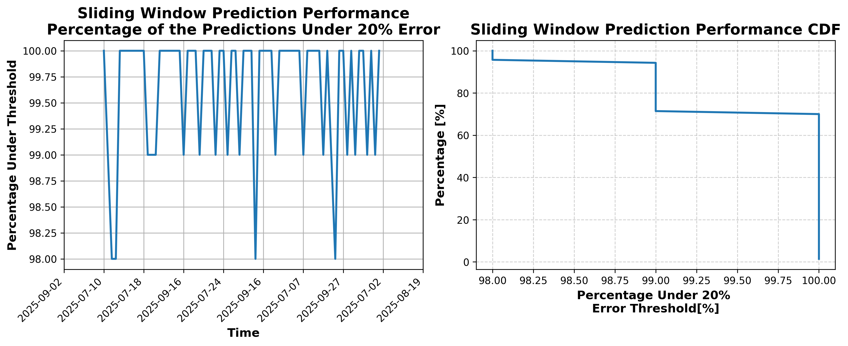

### Results for Latest_Test_2025-07-05.csv

Lines used: 9313 out of 14226 (65%)

Data sorted by: CHS Pickup Date

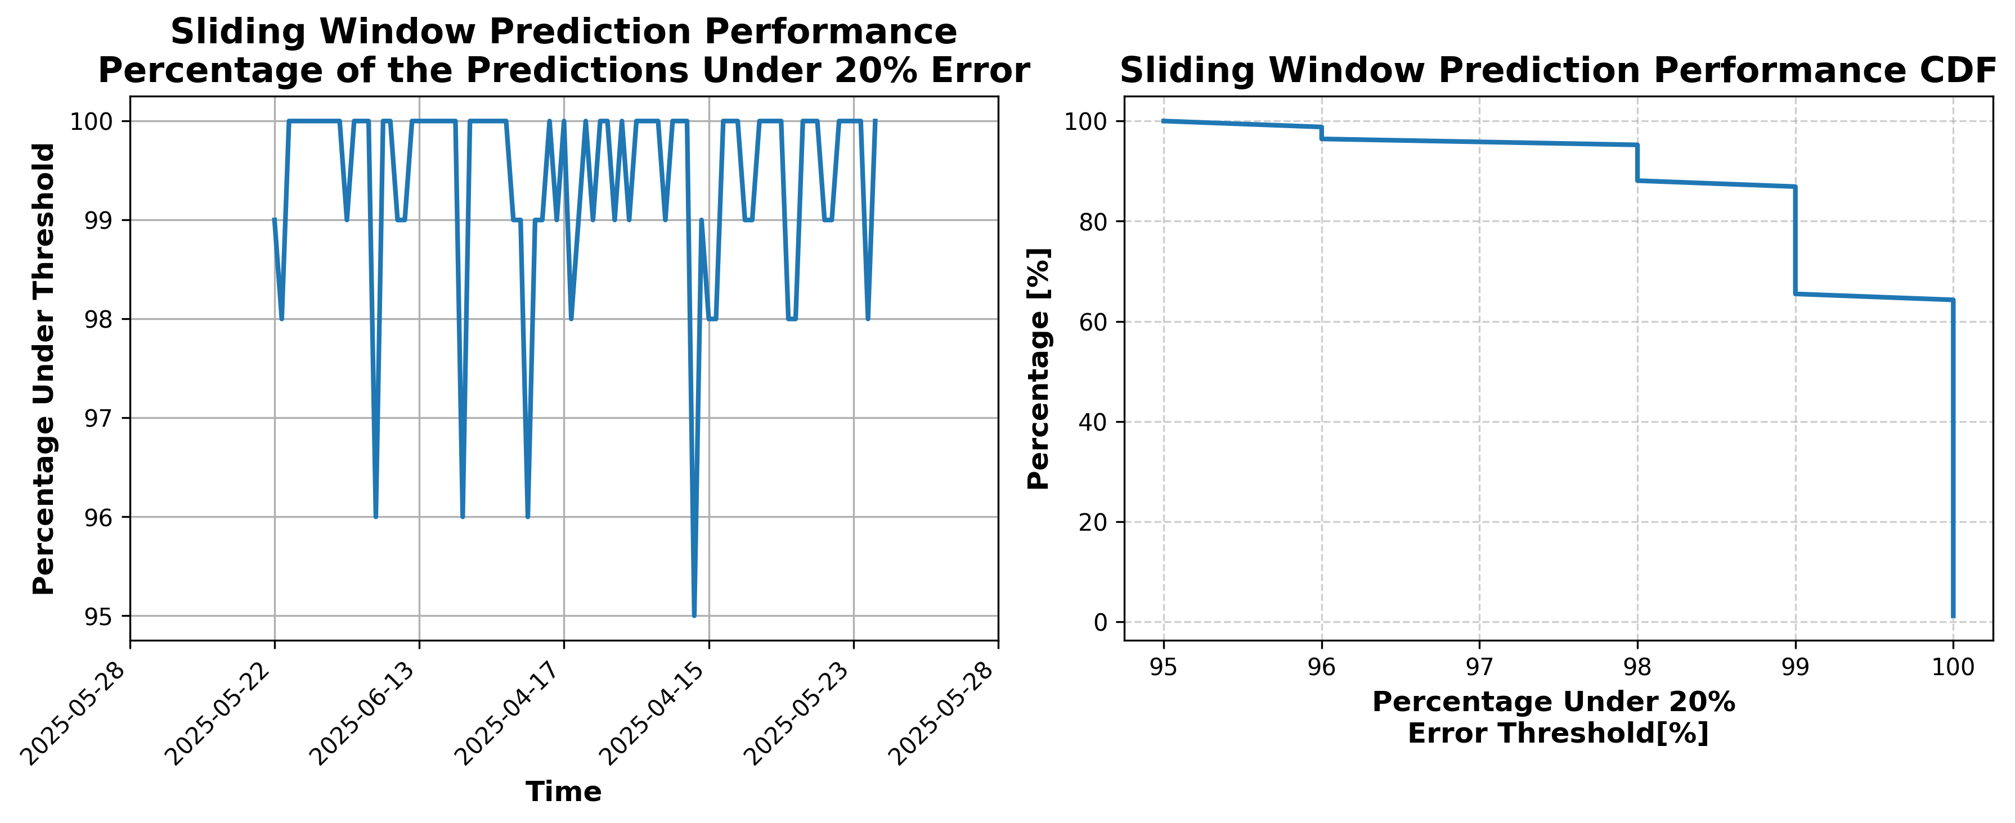

### Results for Latest_Test_2025-07-11.csv

Lines used: 9006 out of 14241 (63%)

Data sorted by: CHS Pickup Date

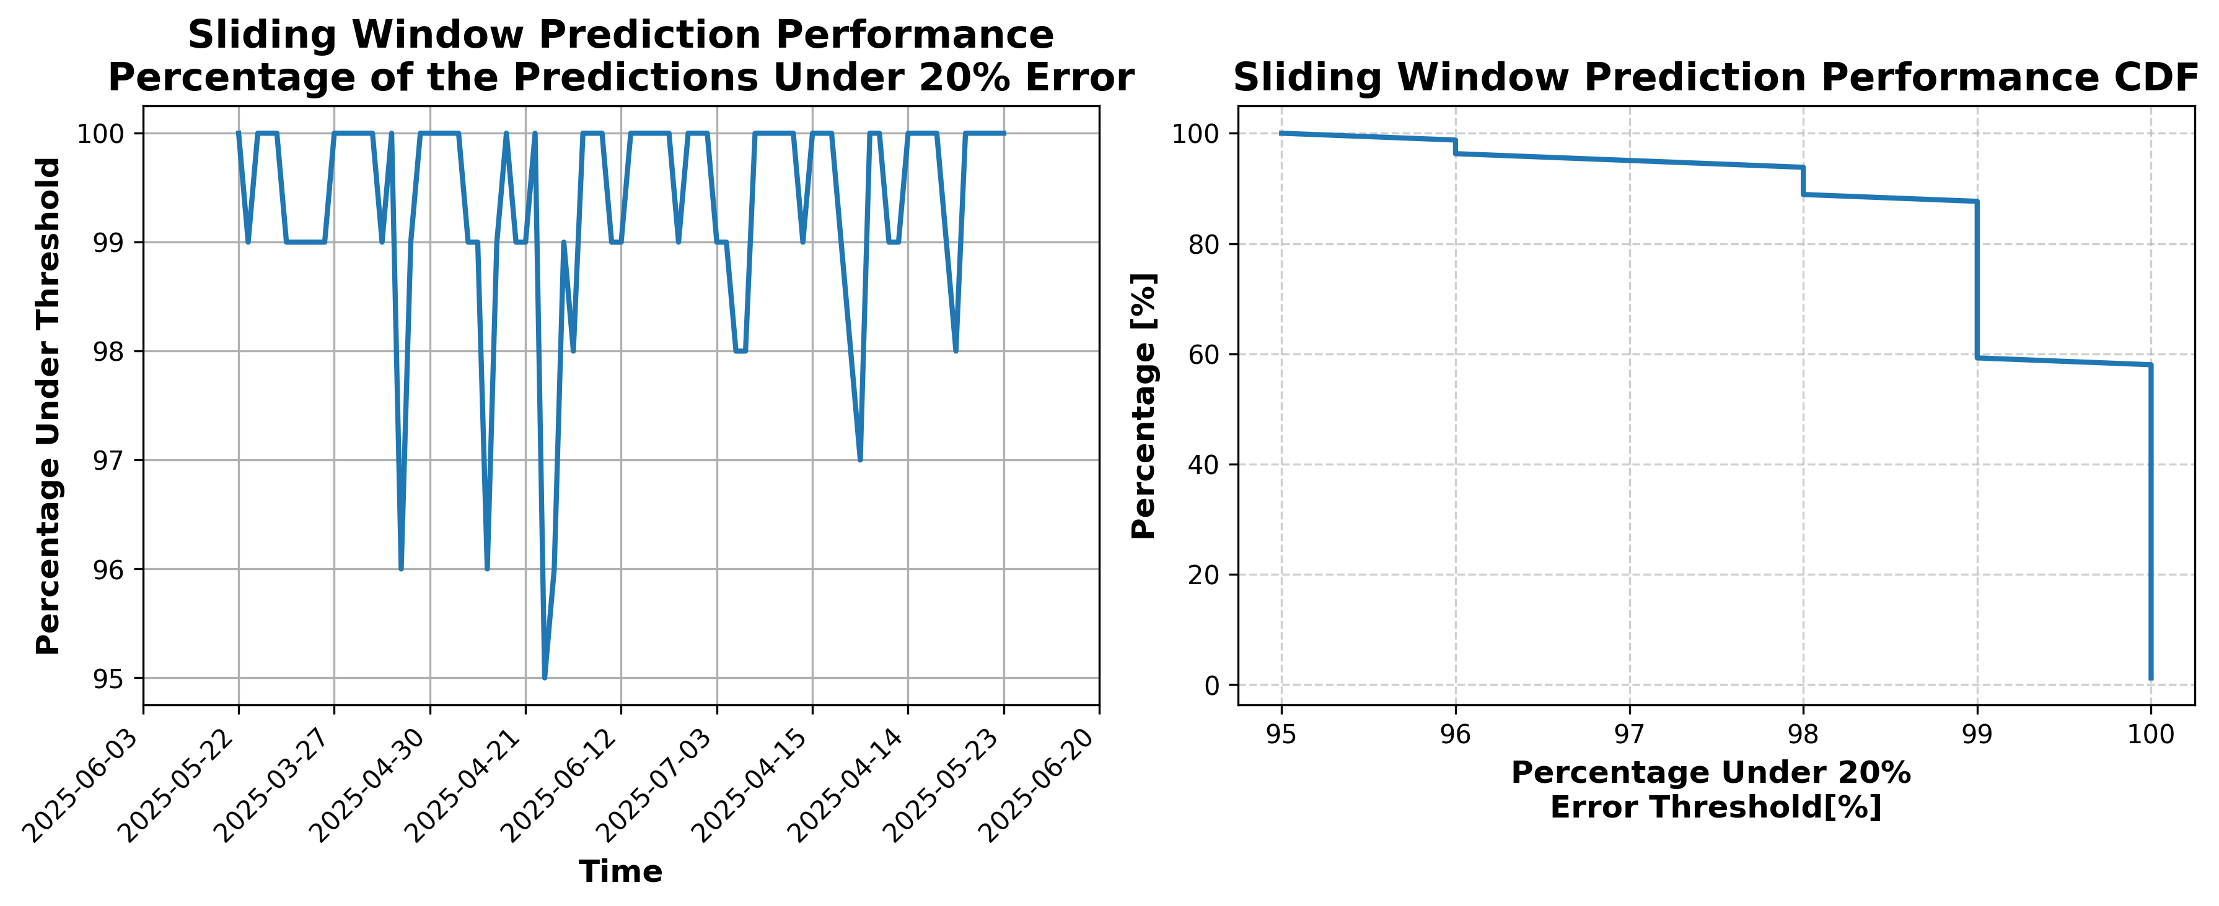

### Results for Latest_Test_2025-09-14.csv

Lines used: 8428 out of 14343 (58%)

Data sorted by: CHS Pickup Date

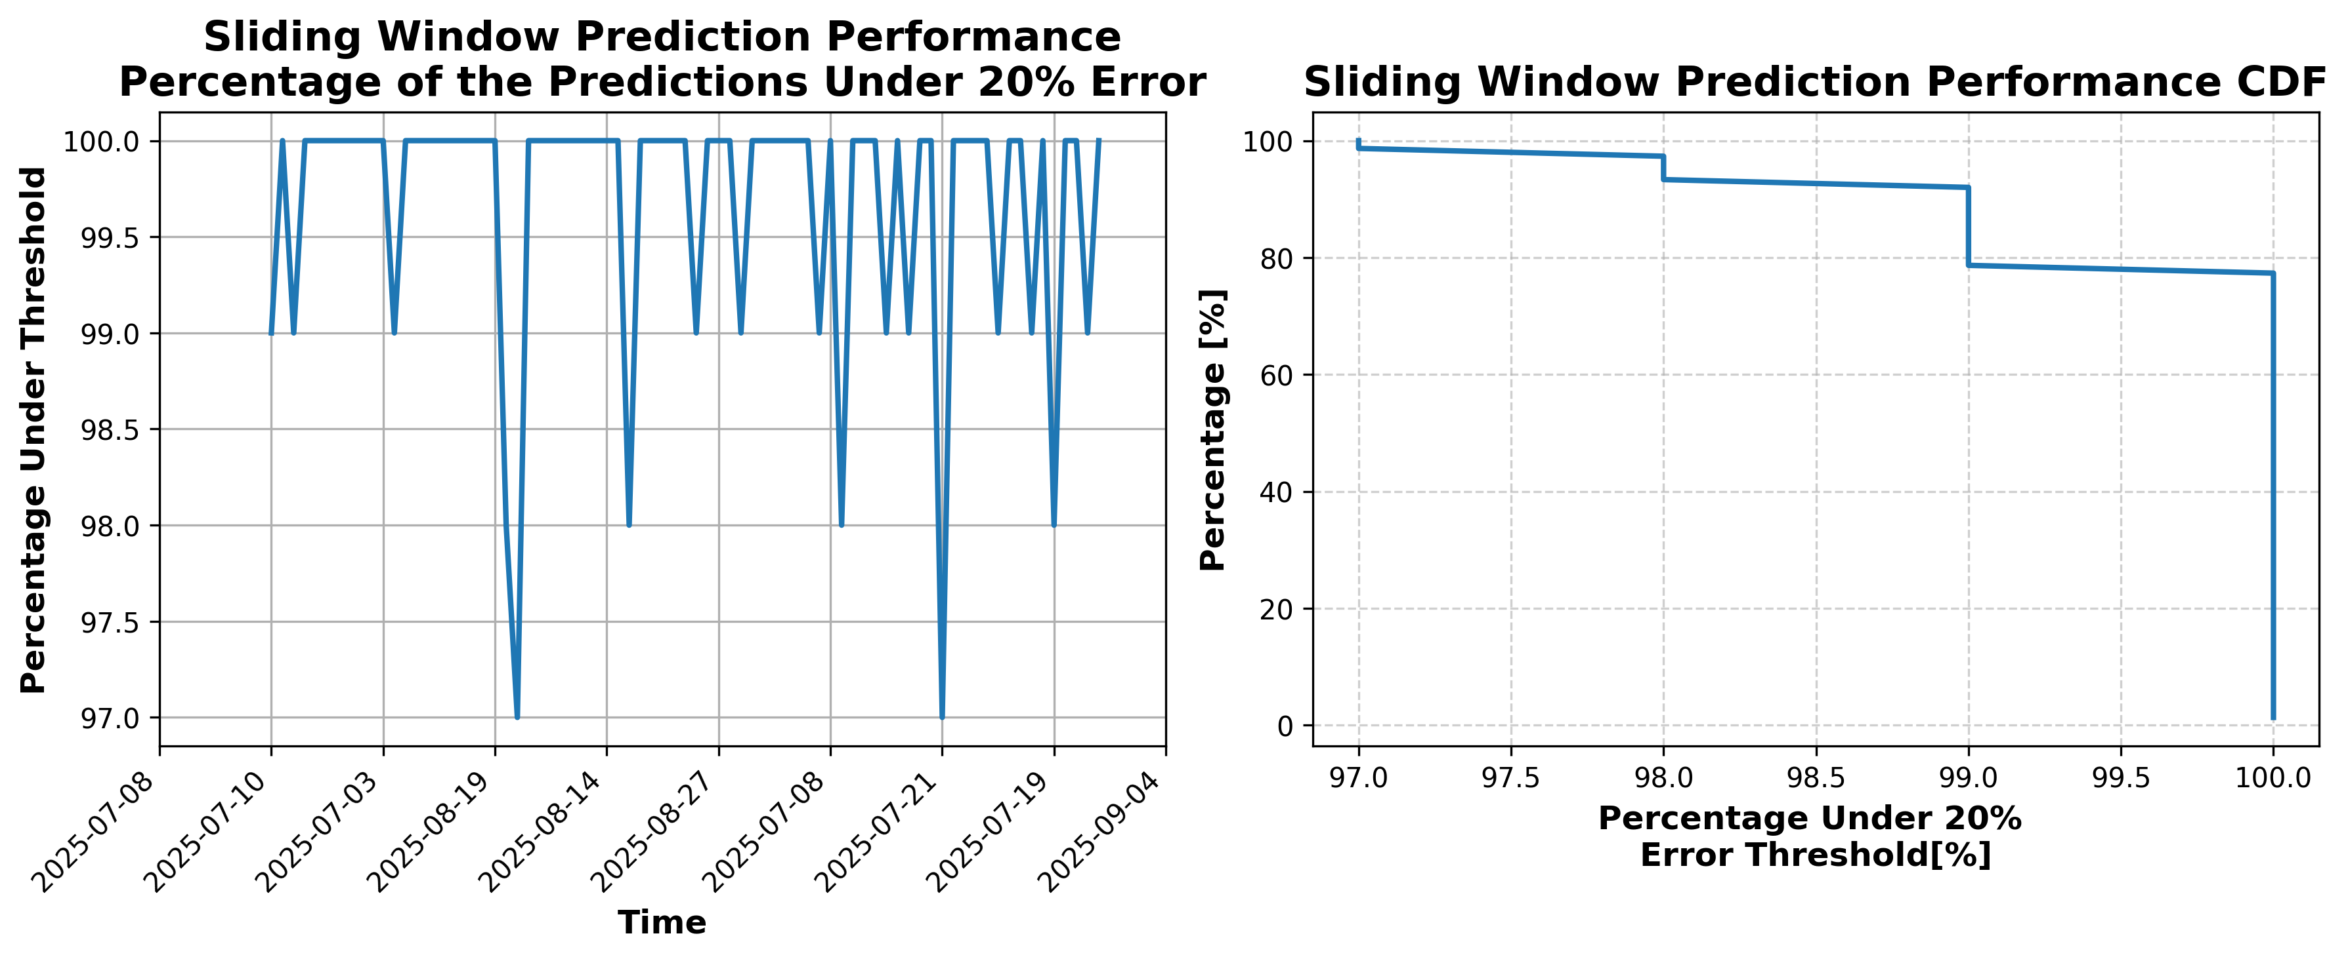

### Results for Latest_Test_2025-10-09.csv

Lines used: 7600 out of 13843 (54%)

Data sorted by: CHS Pickup Date

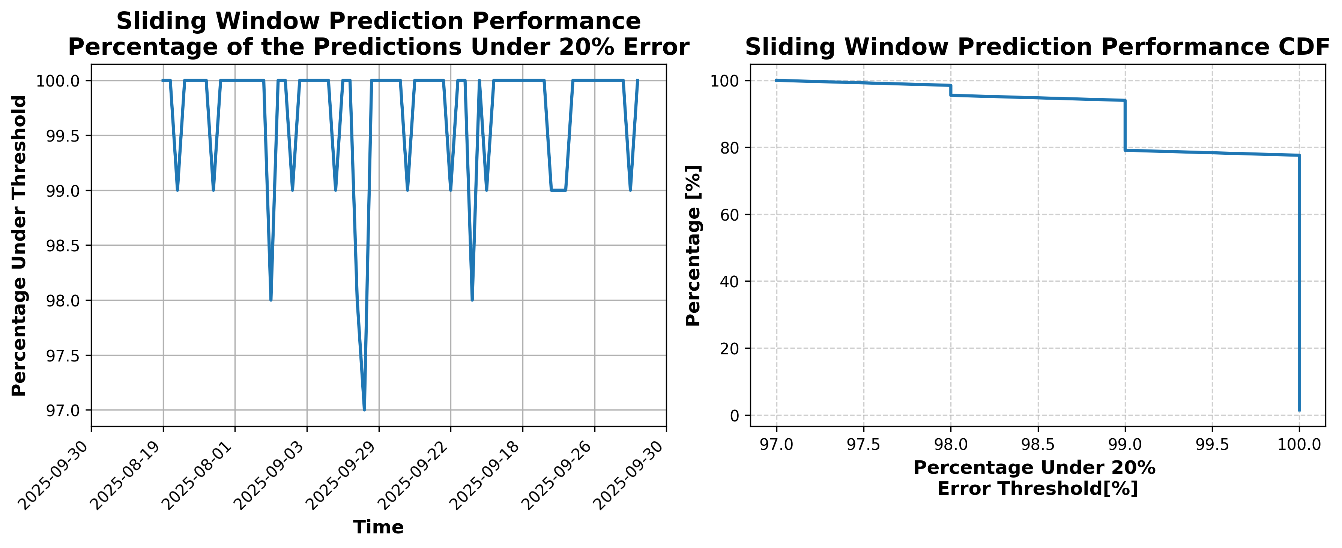

### Results for Latest_Test_2025-10-21.csv

Lines used: 7362 out of 13678 (53%)

Data sorted by: CHS Pickup Date

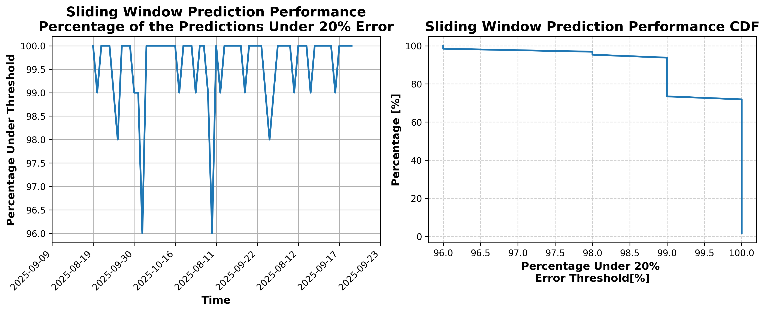

### Results for Latest_Test_2025-05-14.csv

Lines used: 8957 out of 14648 (61%)

Data sorted by: CHS Pickup Date

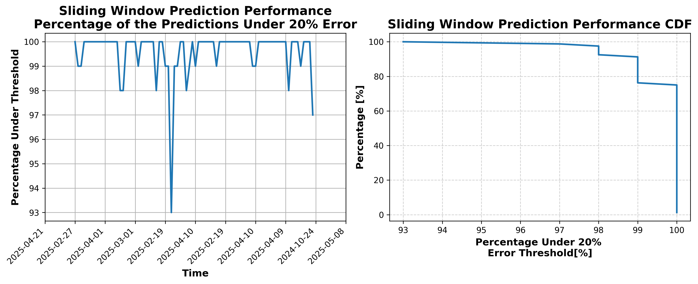

### Results for Latest_Test_2025-05-28.csv

Lines used: 9392 out of 14516 (64%)

Data sorted by: CHS Pickup Date

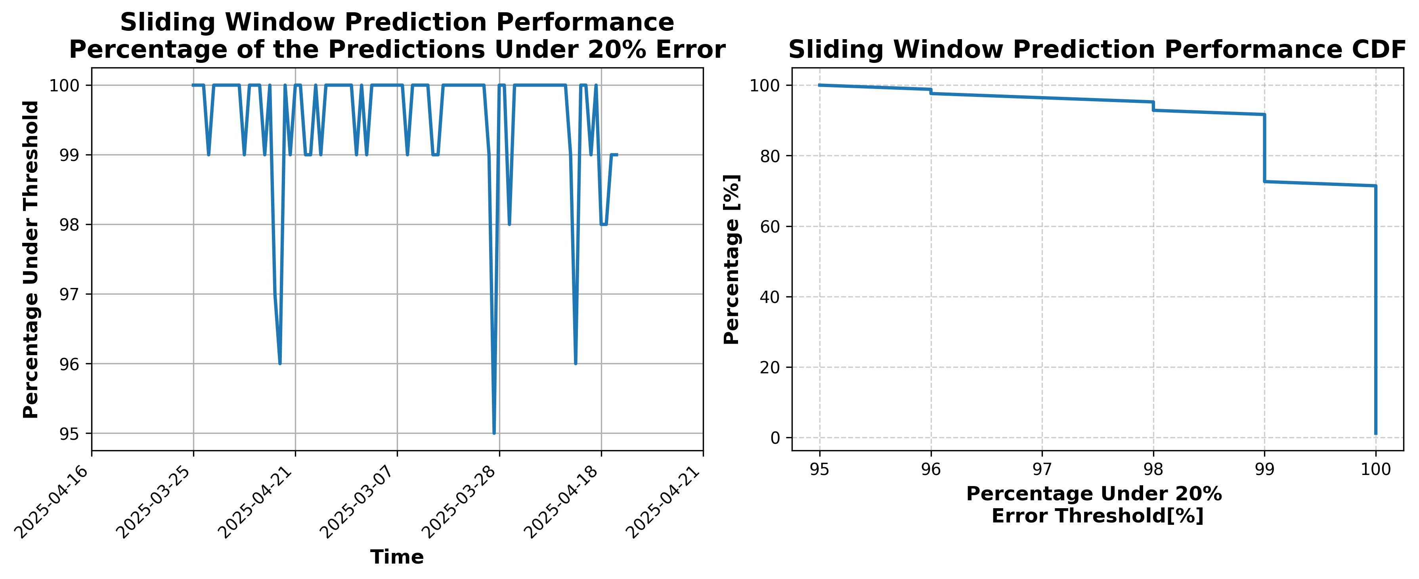

### Results for Latest_Test_2025-05-29.csv

Lines used: 9335 out of 14299 (65%)

Data sorted by: CHS Pickup Date

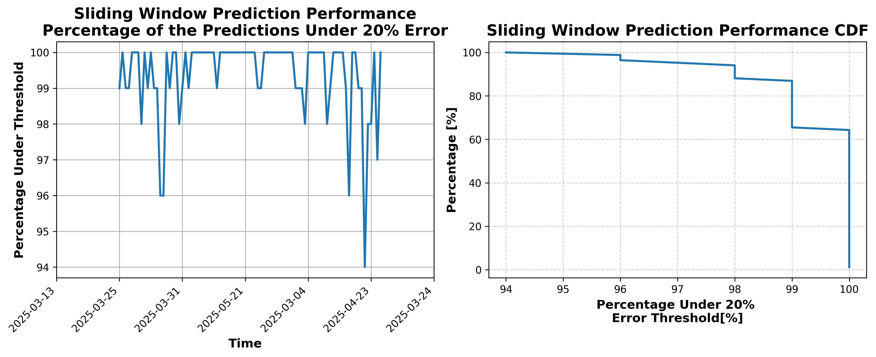

### Results for Latest_Test_2025-05-15.csv

Lines used: 9043 out of 14621 (61%)

Data sorted by: CHS Pickup Date

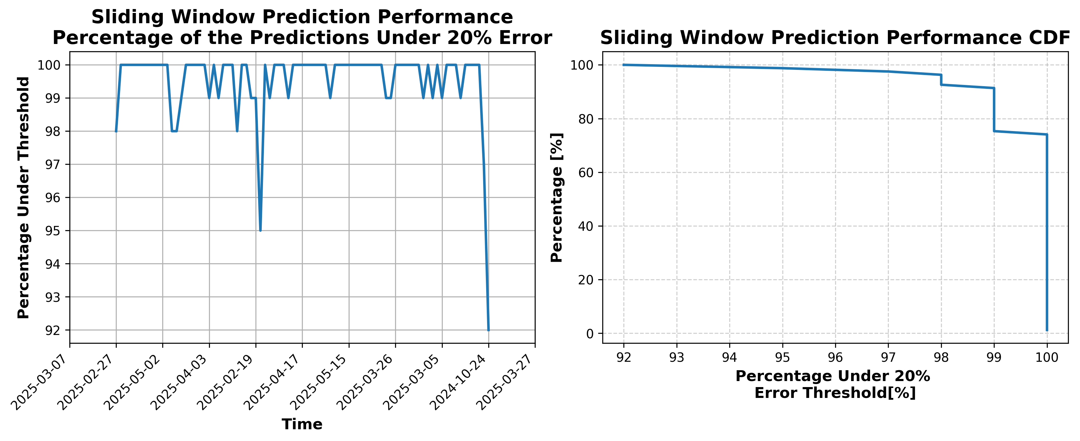

### Results for Latest_Test_2025-05-01.csv

Lines used: 8586 out of 15561 (55%)

Data sorted by: CHS Pickup Date

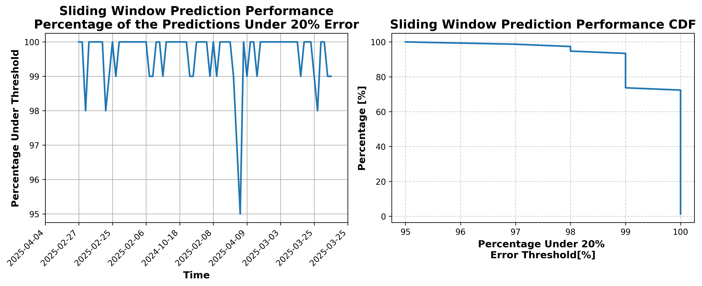

### Results for Latest_Test_2025-10-20.csv

Lines used: 7311 out of 13584 (53%)

Data sorted by: CHS Pickup Date

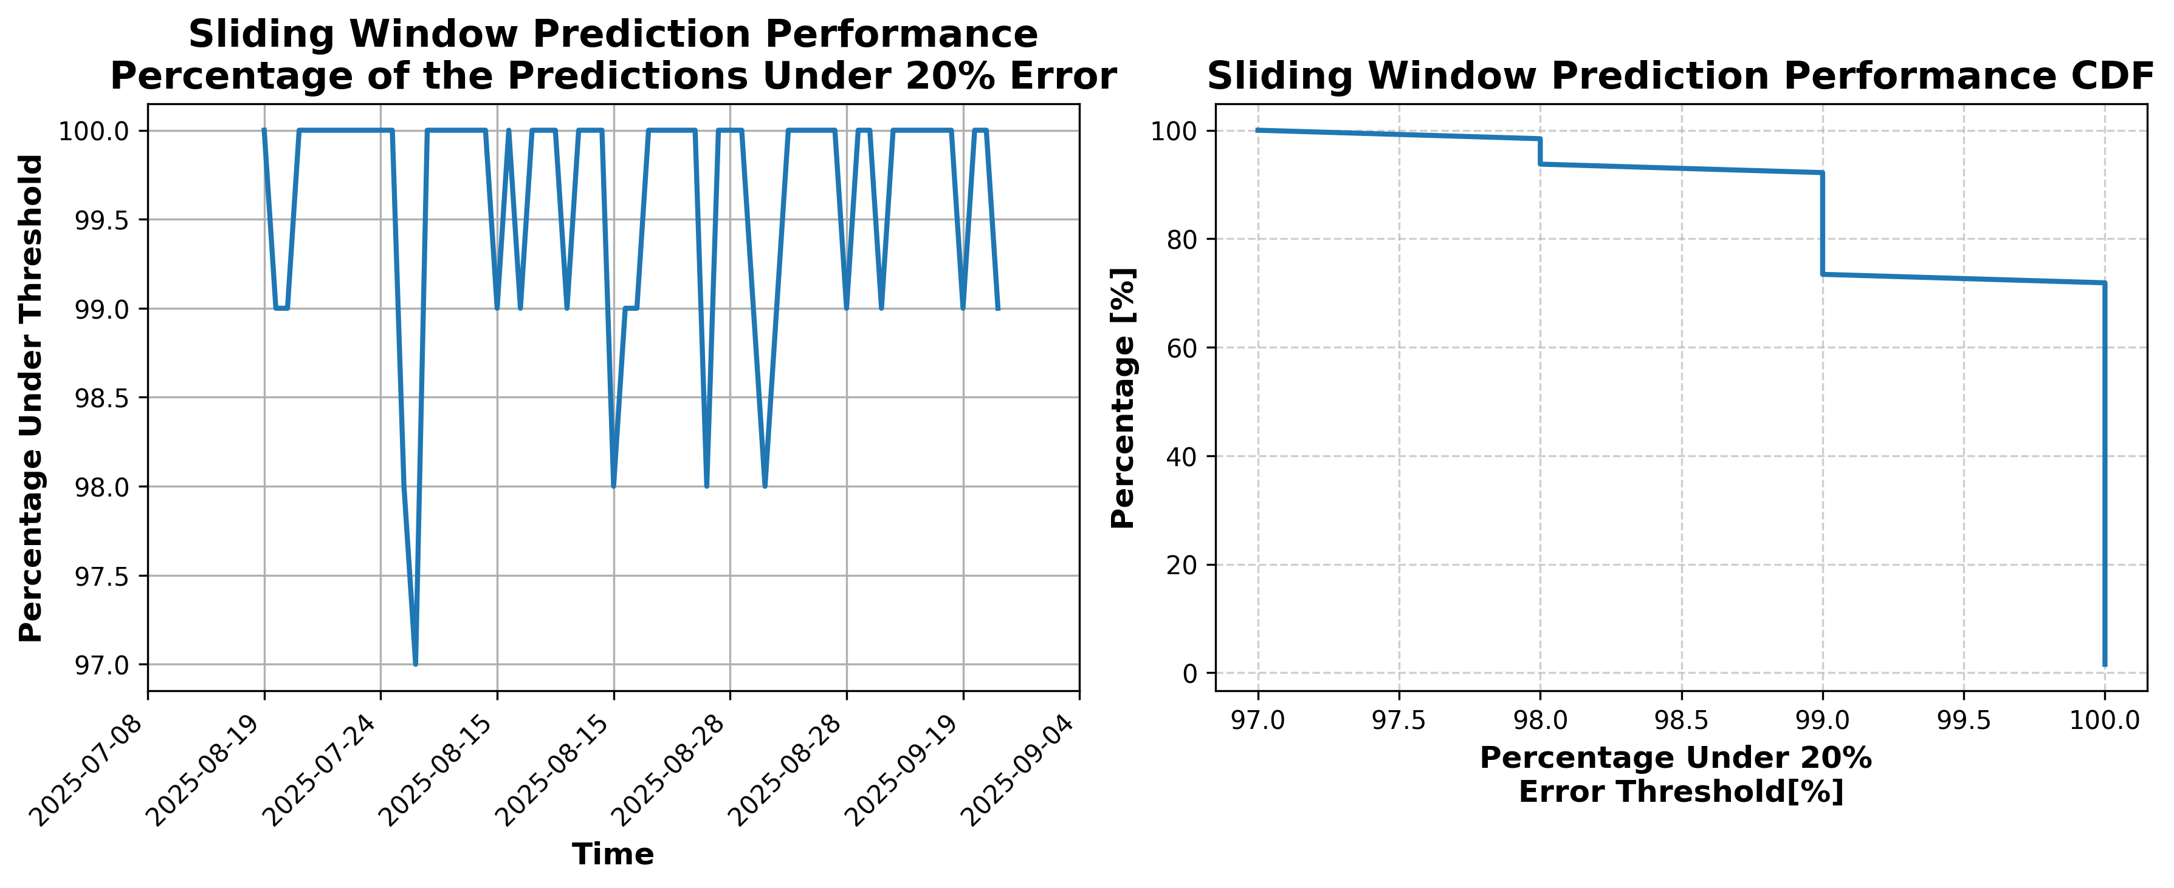

### Results for Latest_Test_2025-10-08.csv

Lines used: 7331 out of 13659 (53%)

Data sorted by: CHS Pickup Date

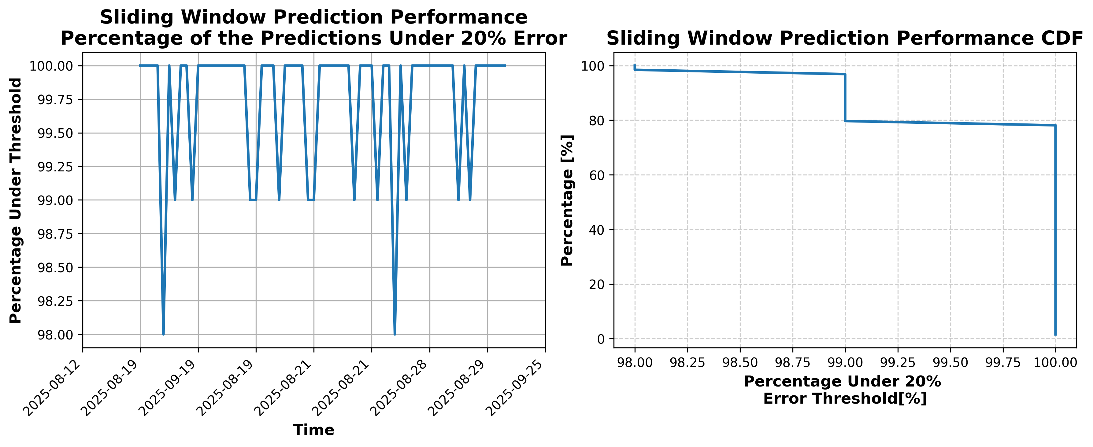

### Results for Latest_Test_2025-09-01.csv

Lines used: 7877 out of 14324 (54%)

Data sorted by: CHS Pickup Date

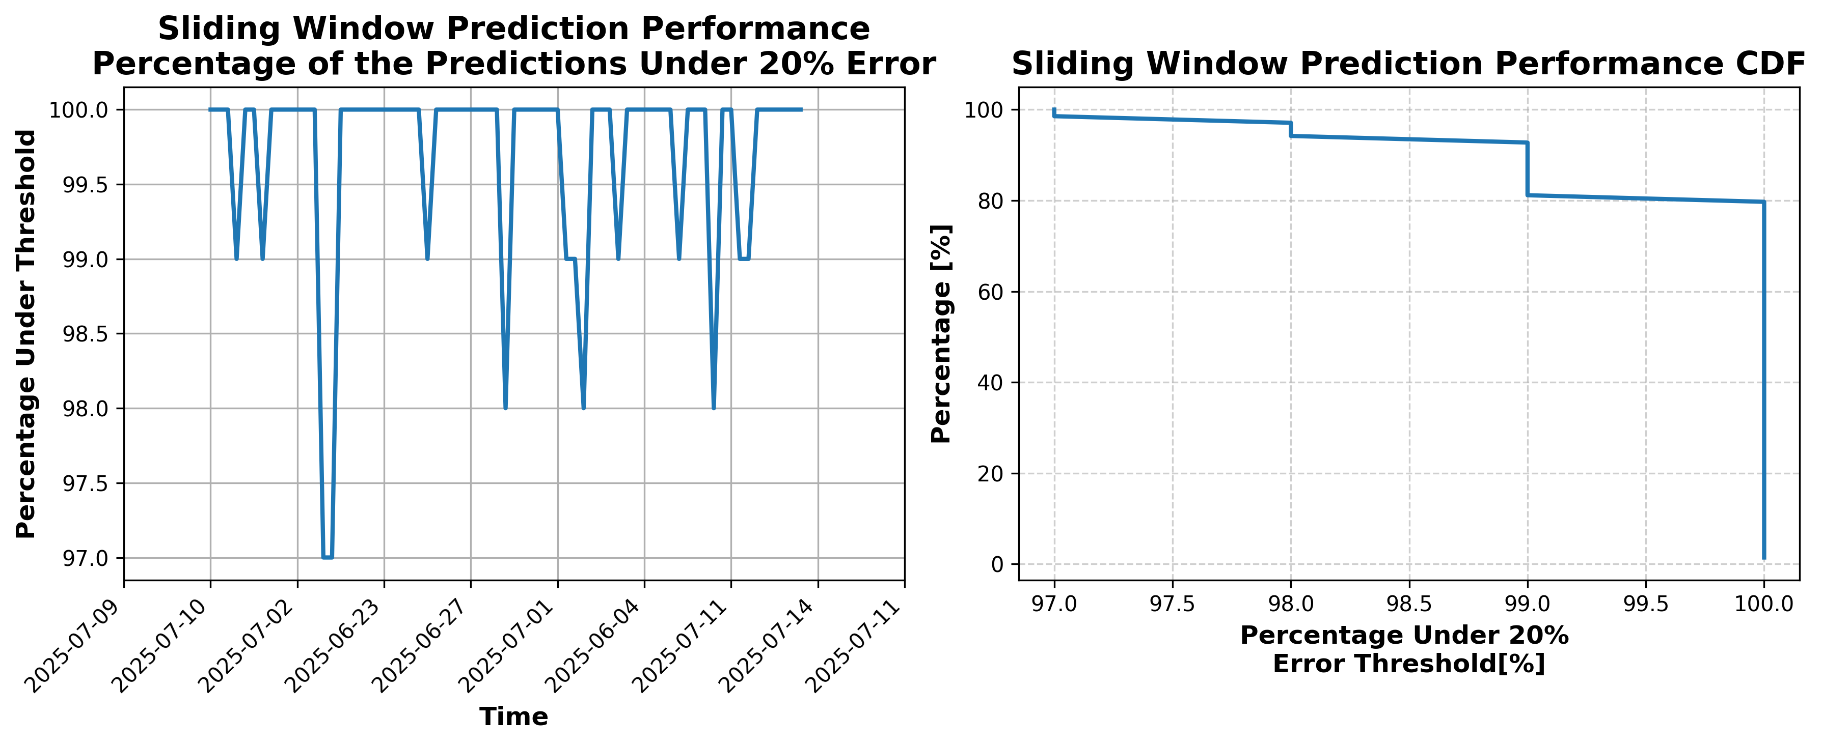

### Results for Latest_Test_2025-09-15.csv

Lines used: 8402 out of 14272 (58%)

Data sorted by: CHS Pickup Date

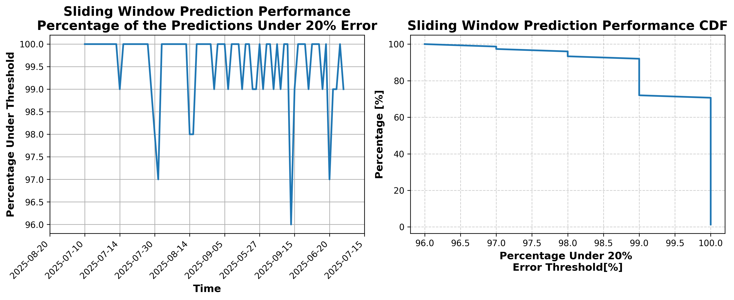

### Results for Latest_Test_2025-07-10.csv

Lines used: 8953 out of 14091 (63%)

Data sorted by: CHS Pickup Date

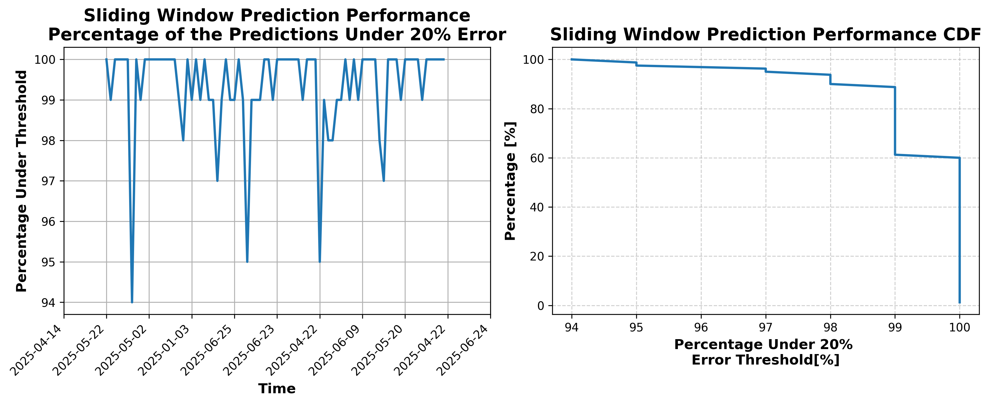

### Results for Latest_Test_2025-07-04.csv

Lines used: 9301 out of 14179 (65%)

Data sorted by: CHS Pickup Date

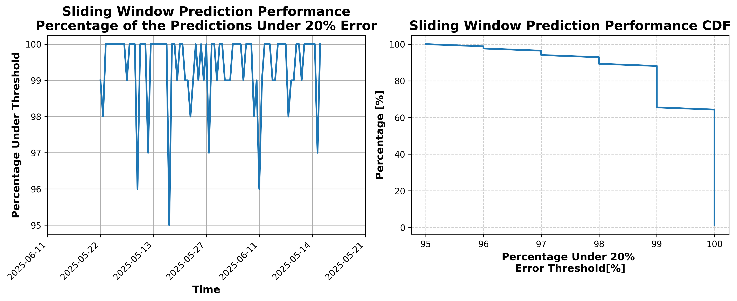

### Results for Latest_Test_2025-09-29.csv

Lines used: 7828 out of 14223 (55%)

Data sorted by: CHS Pickup Date

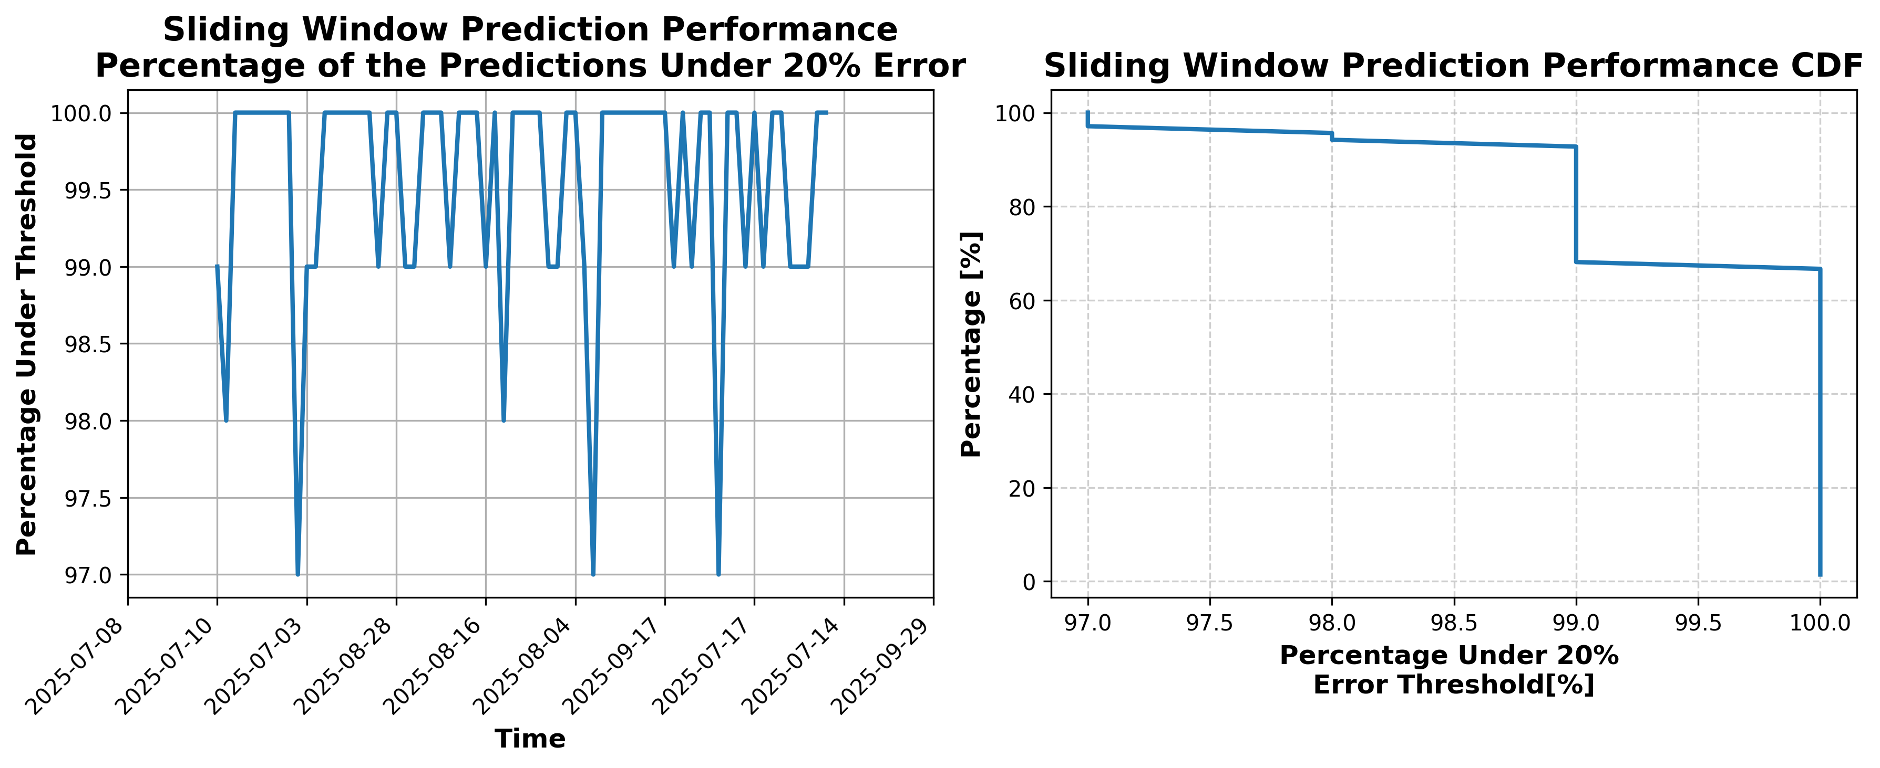

### Results for Latest_Test_2025-07-12.csv

Lines used: 9130 out of 14374 (63%)

Data sorted by: CHS Pickup Date

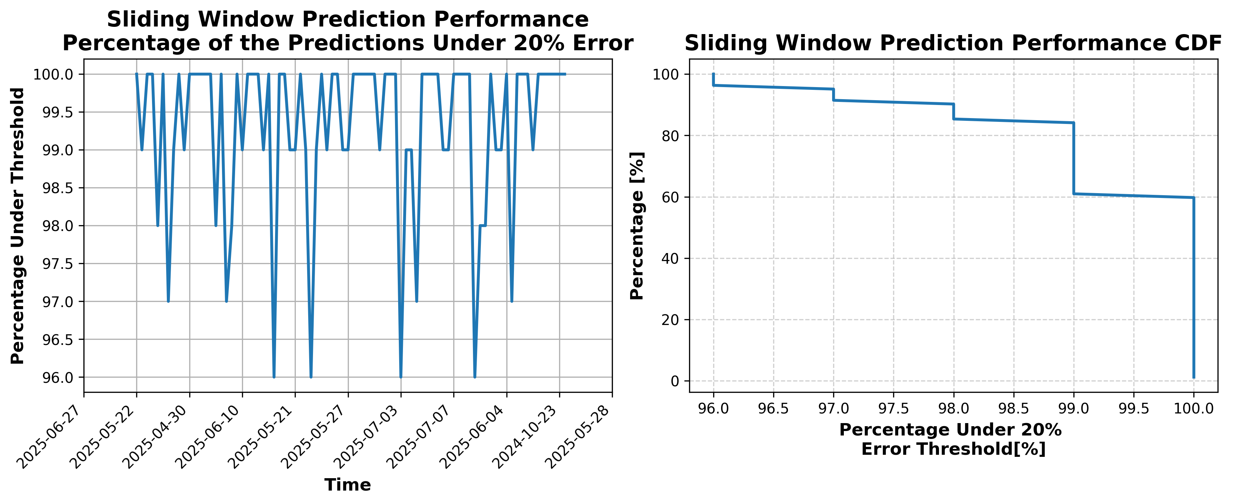

### Results for Latest_Test_2025-07-06.csv

Lines used: 9143 out of 14057 (65%)

Data sorted by: CHS Pickup Date

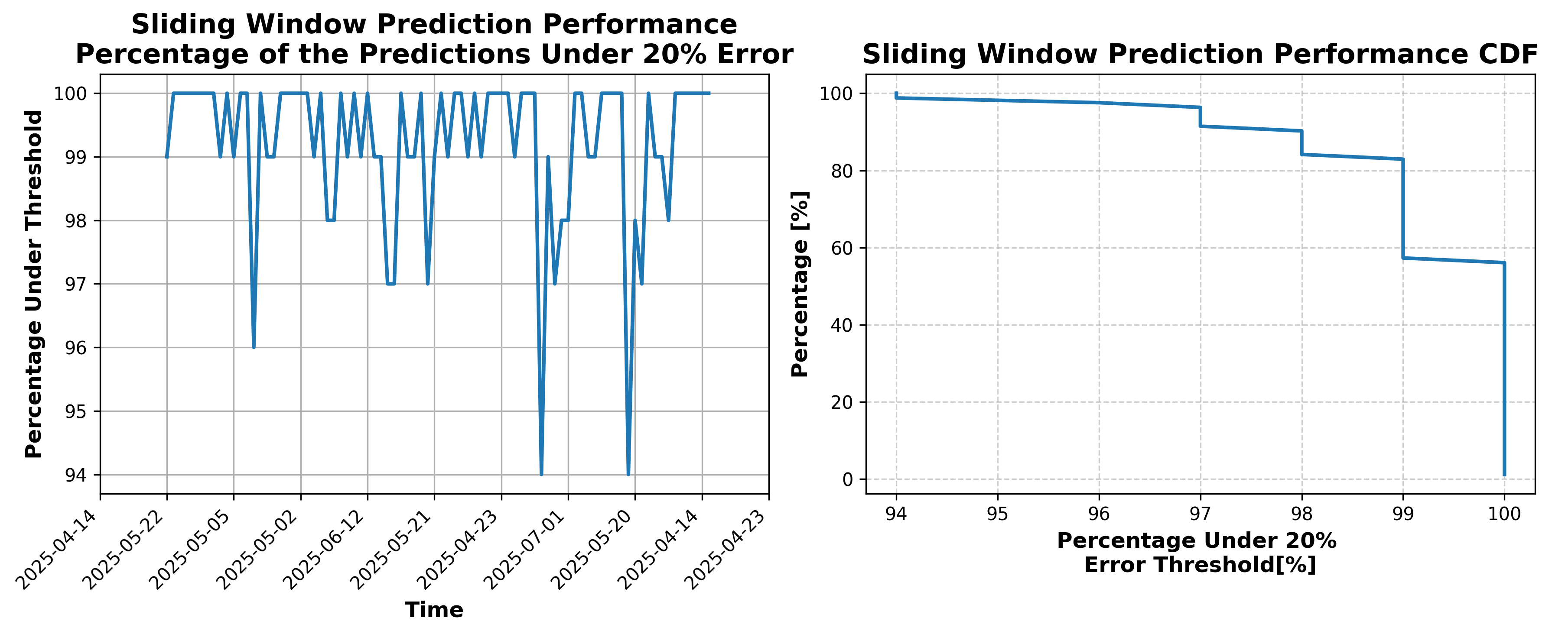

### Results for Latest_Test_2025-09-03.csv

Lines used: 7840 out of 14042 (55%)

Data sorted by: CHS Pickup Date

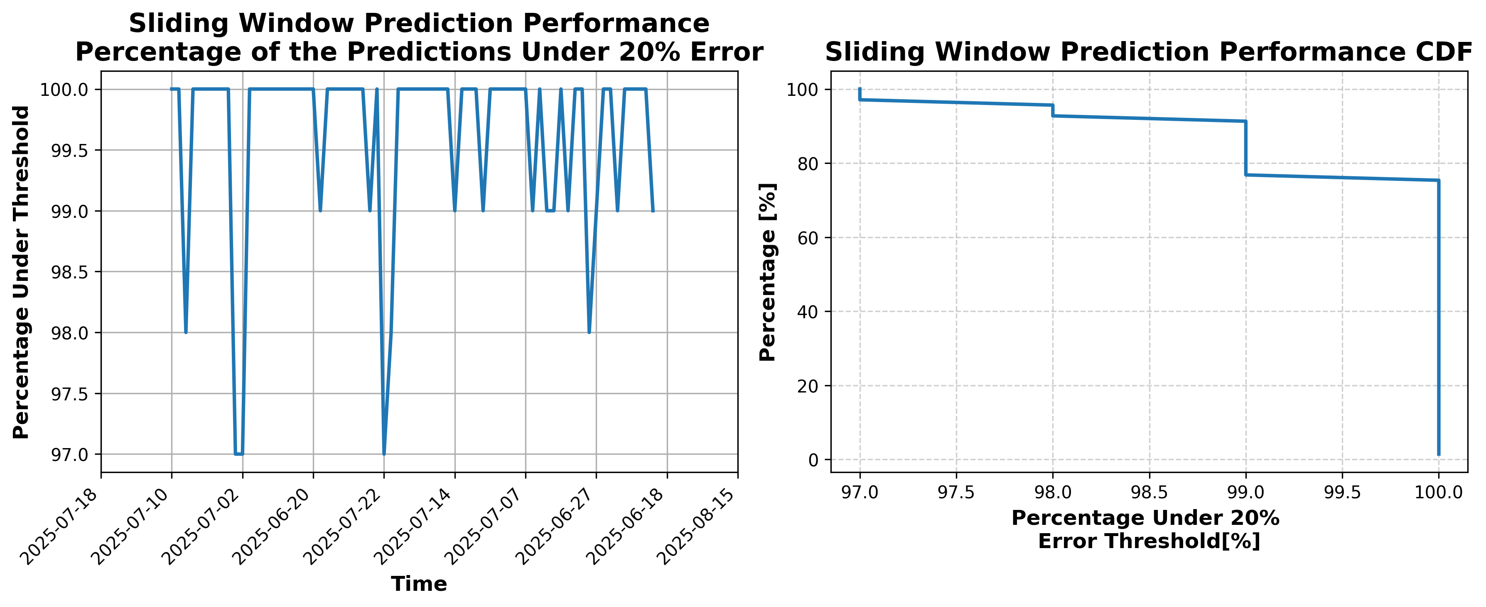

### Results for Latest_Test_2025-09-17.csv

Lines used: 8340 out of 14019 (59%)

Data sorted by: CHS Pickup Date

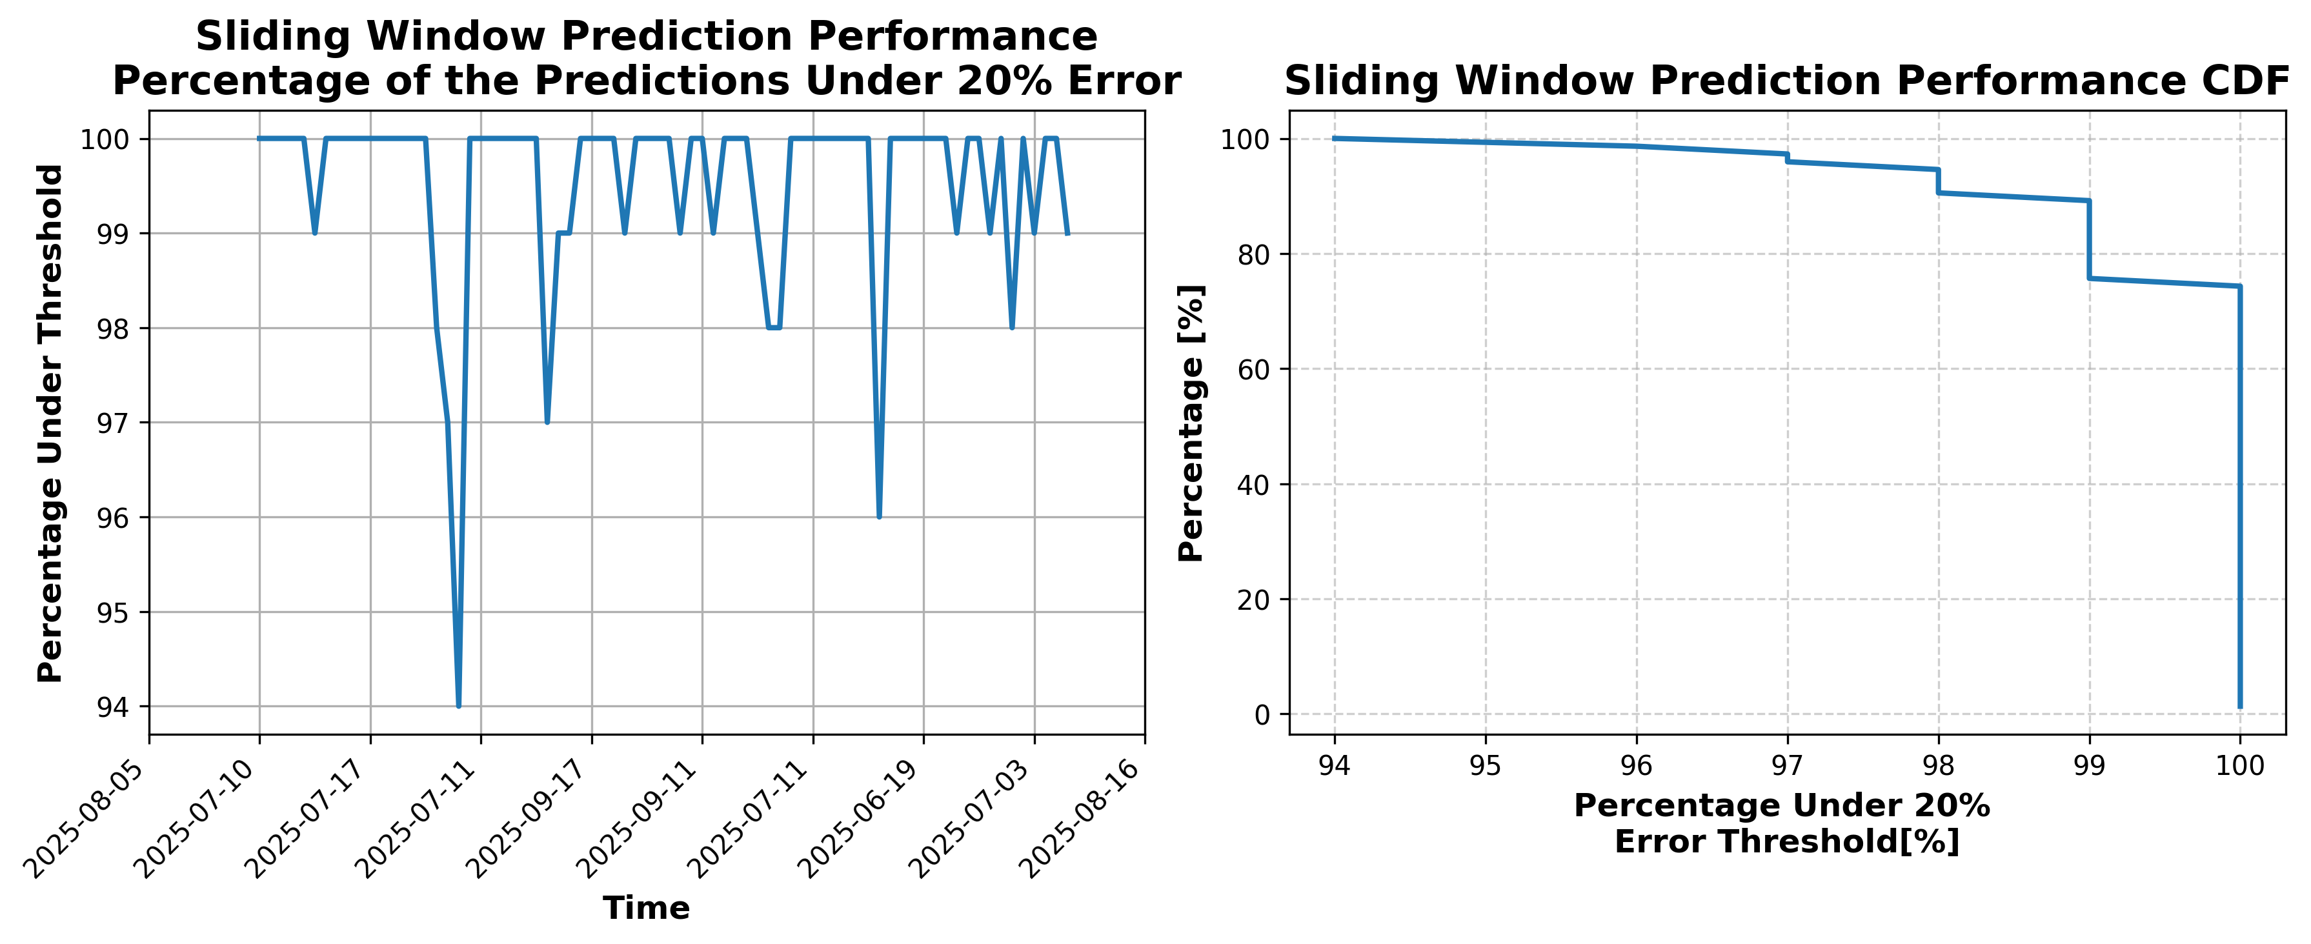

### Results for Latest_Test_2025-10-22.csv

Lines used: 7390 out of 13737 (53%)

Data sorted by: CHS Pickup Date

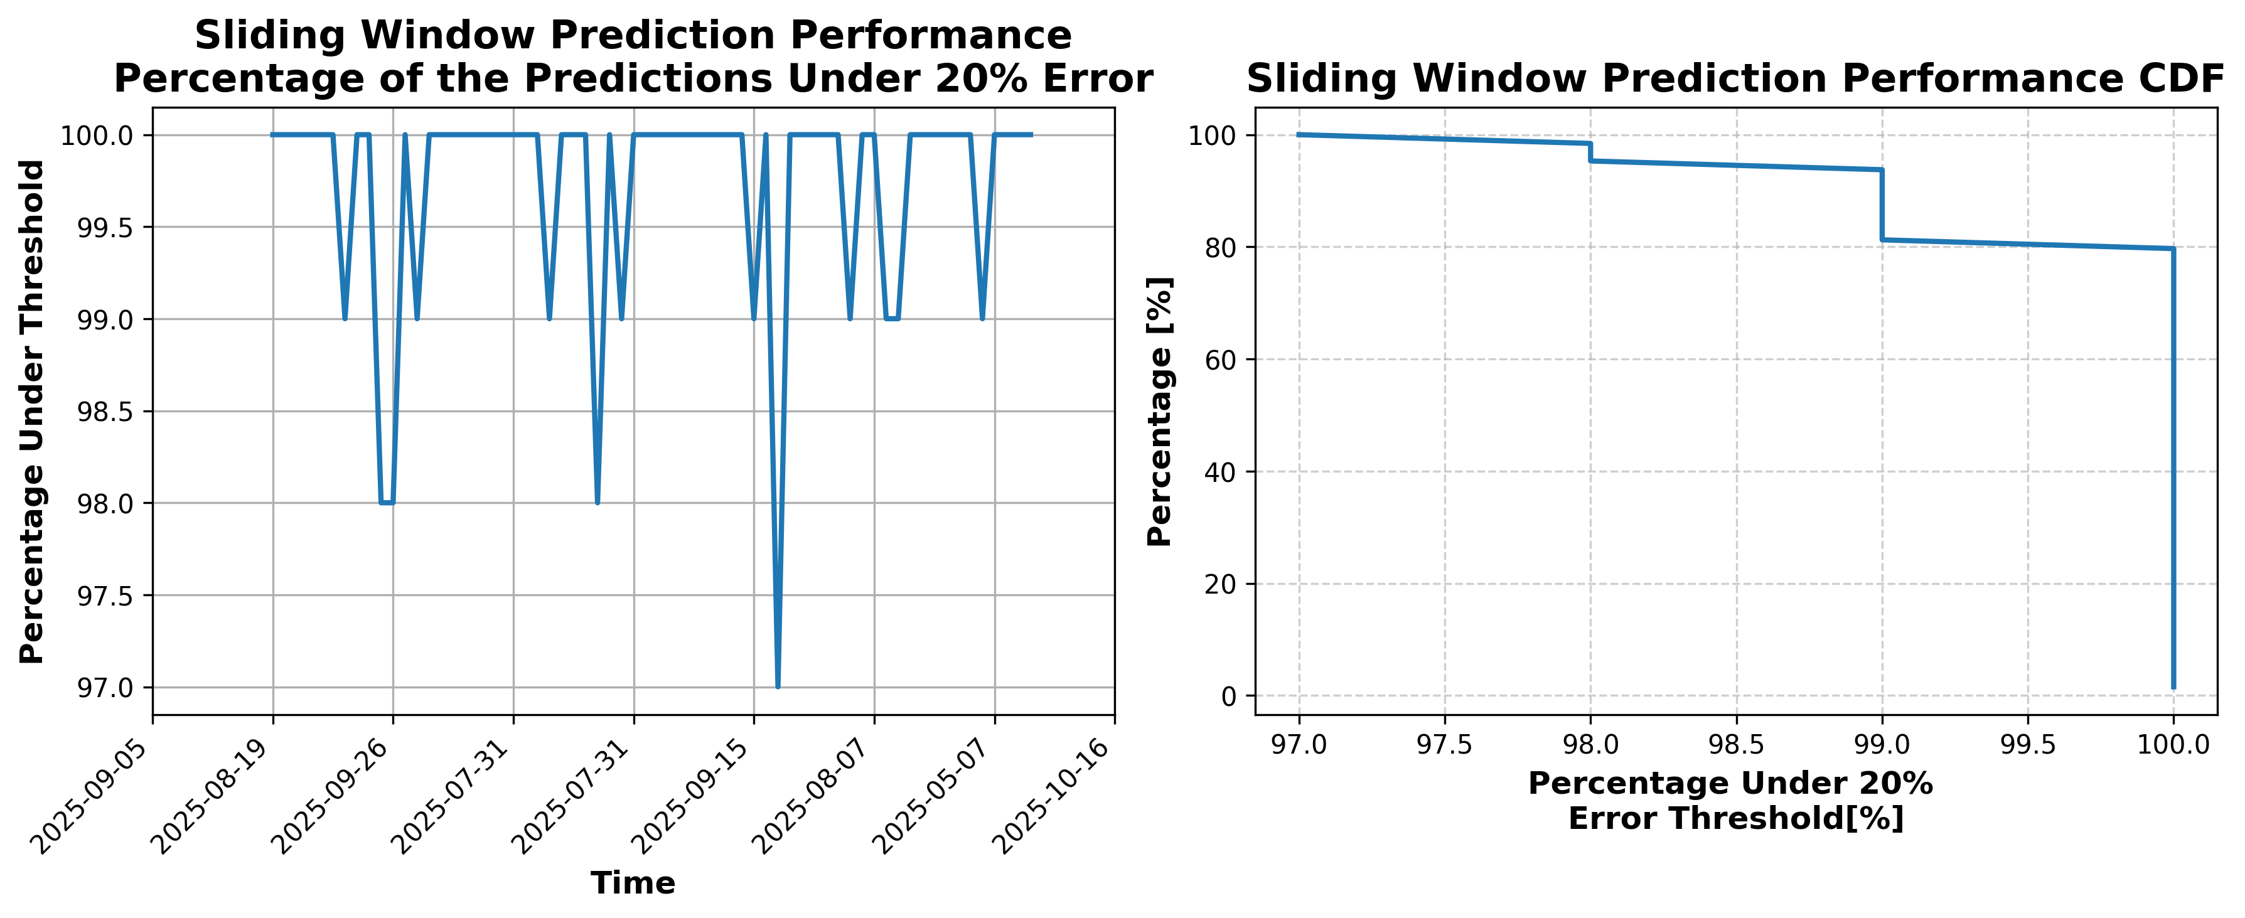

### Results for Latest_Test_2025-05-17.csv

Lines used: 9297 out of 14793 (62%)

Data sorted by: CHS Pickup Date

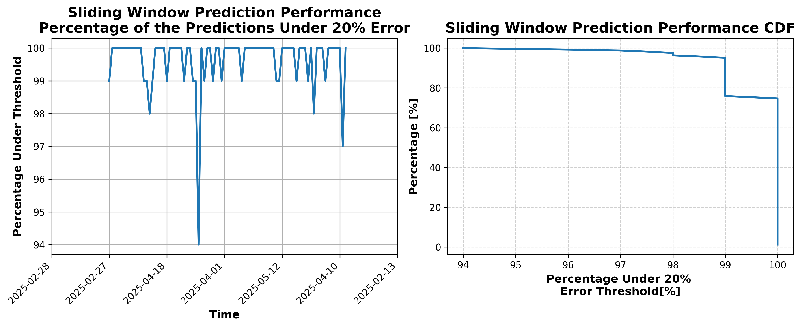

### Results for Latest_Test_2025-05-03.csv

Lines used: 8795 out of 15802 (55%)

Data sorted by: CHS Pickup Date

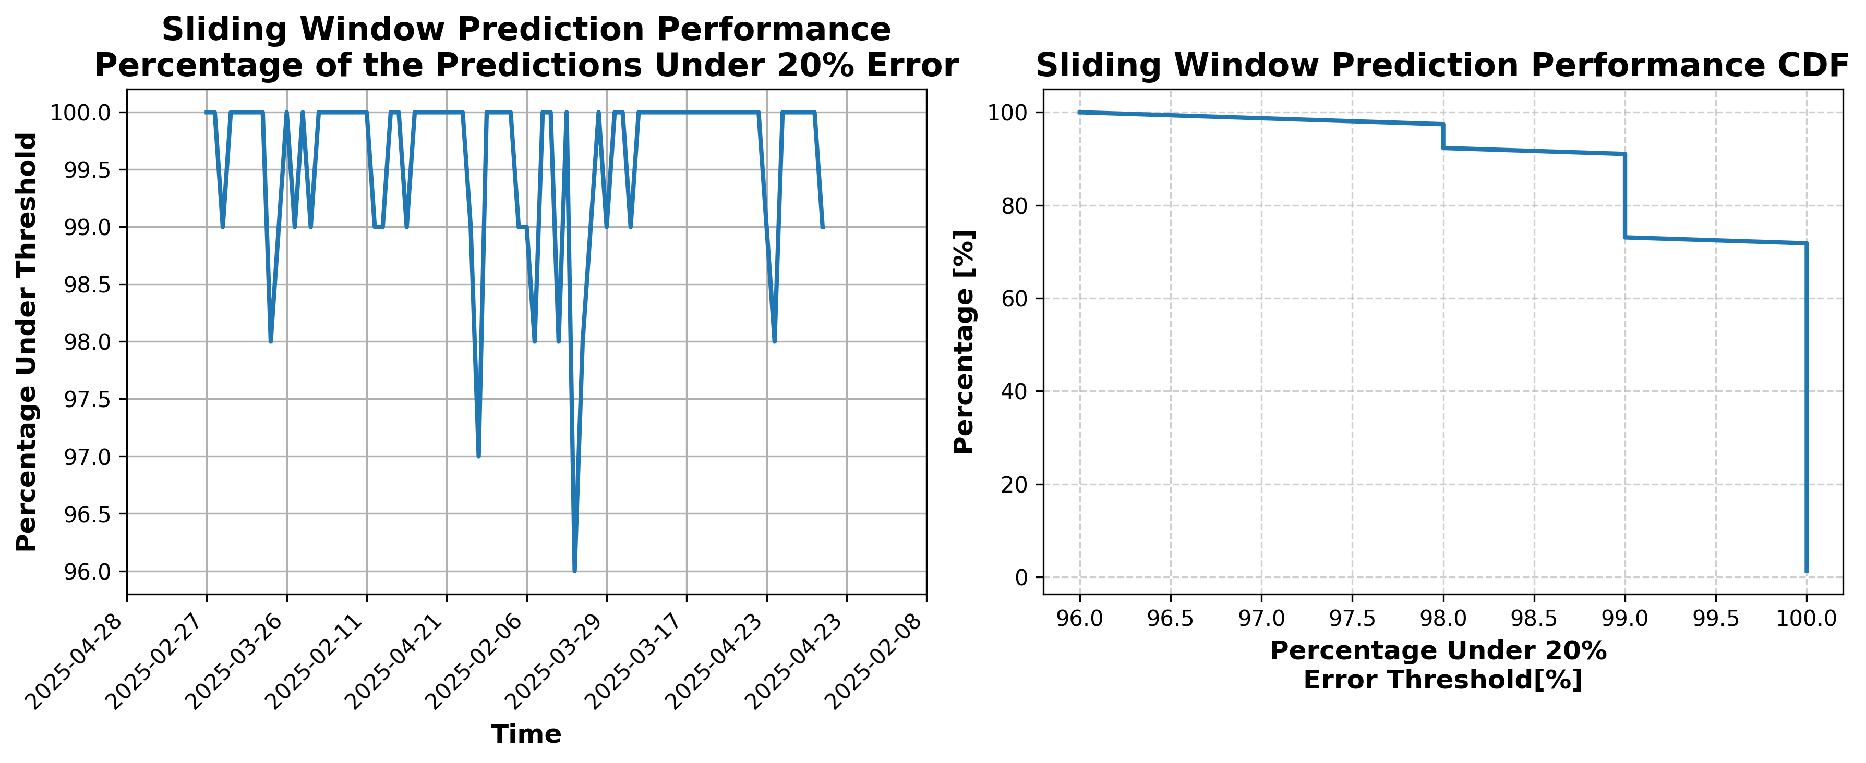

### Results for Latest_Test_2025-02-23.csv

Lines used: 124988 out of 131807 (94%)

Data sorted by: CHS Pickup Date

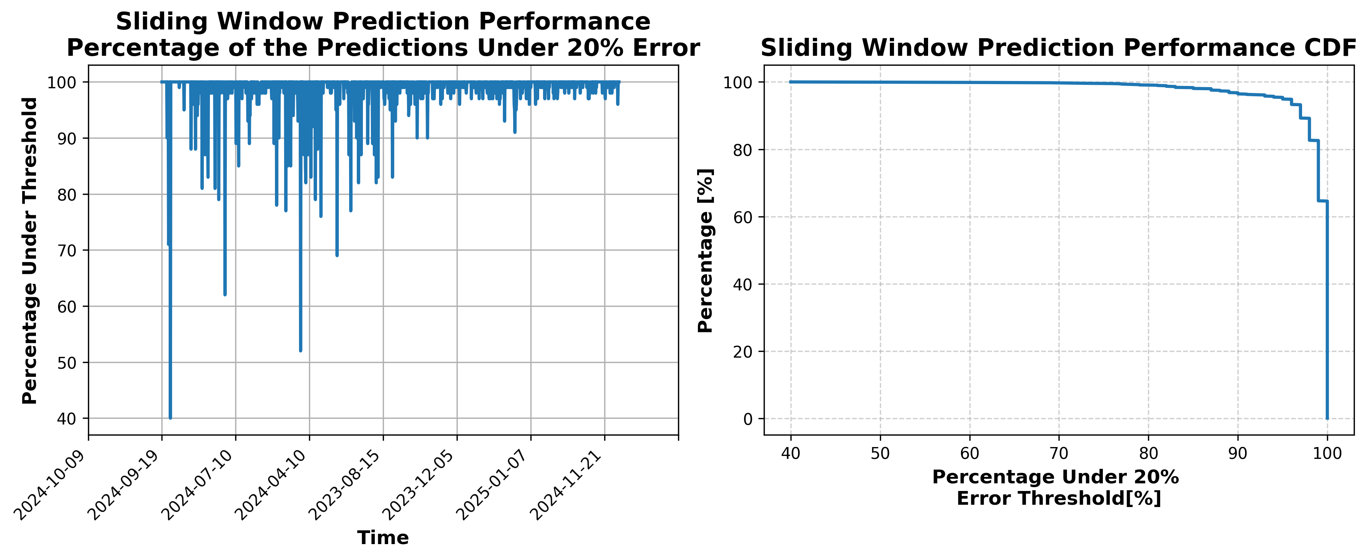

### Results for Latest_Test_2025-05-02.csv

Lines used: 8715 out of 15694 (55%)

Data sorted by: CHS Pickup Date

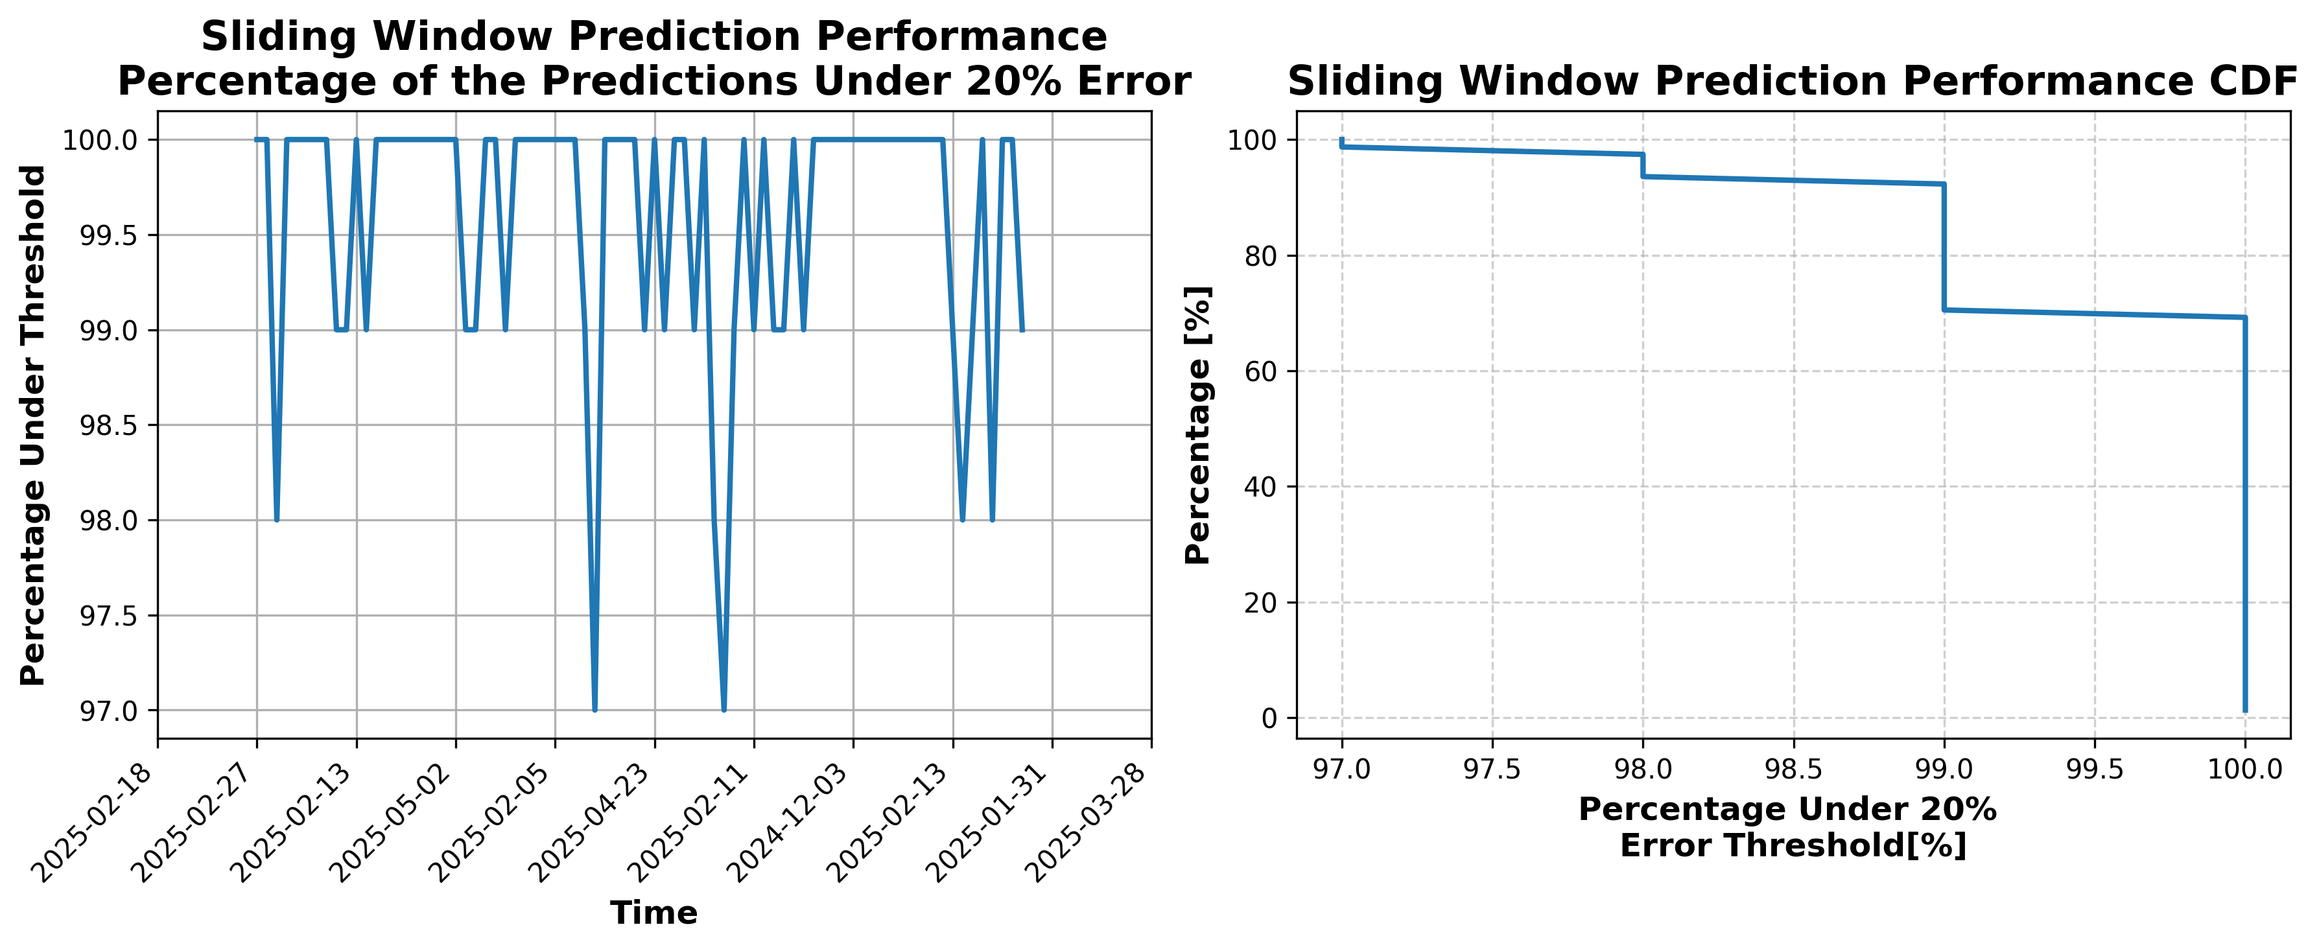

### Results for Latest_Test_2025-05-16.csv

Lines used: 9174 out of 14706 (62%)

Data sorted by: CHS Pickup Date

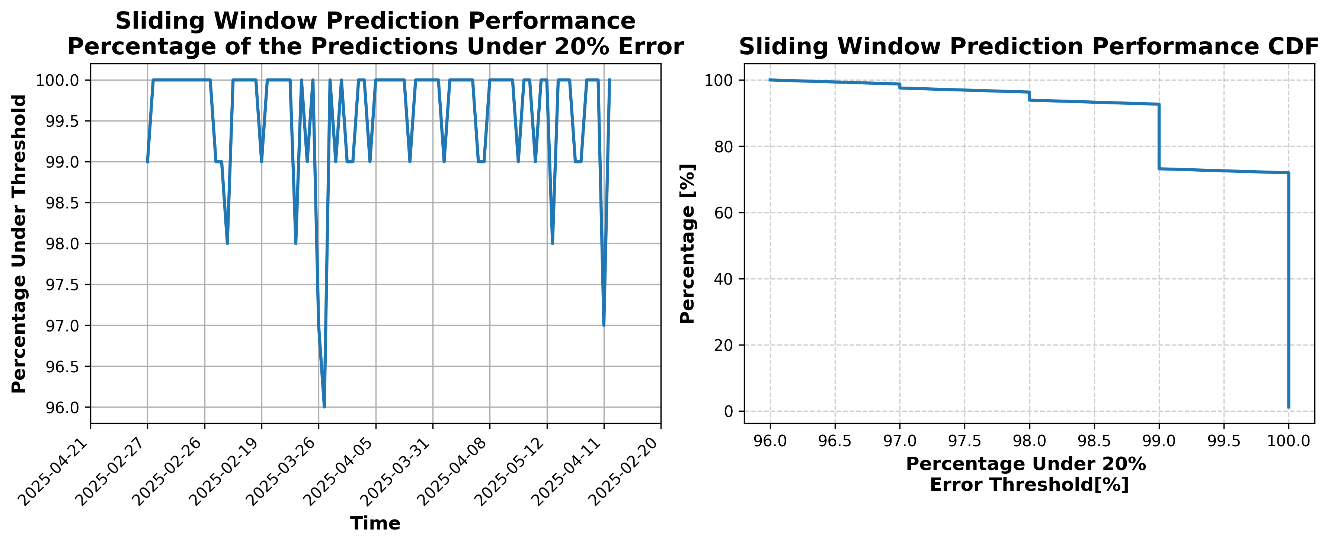

### Results for Latest_Test_2025-10-23.csv

Lines used: 7152 out of 13731 (52%)

Data sorted by: CHS Pickup Date

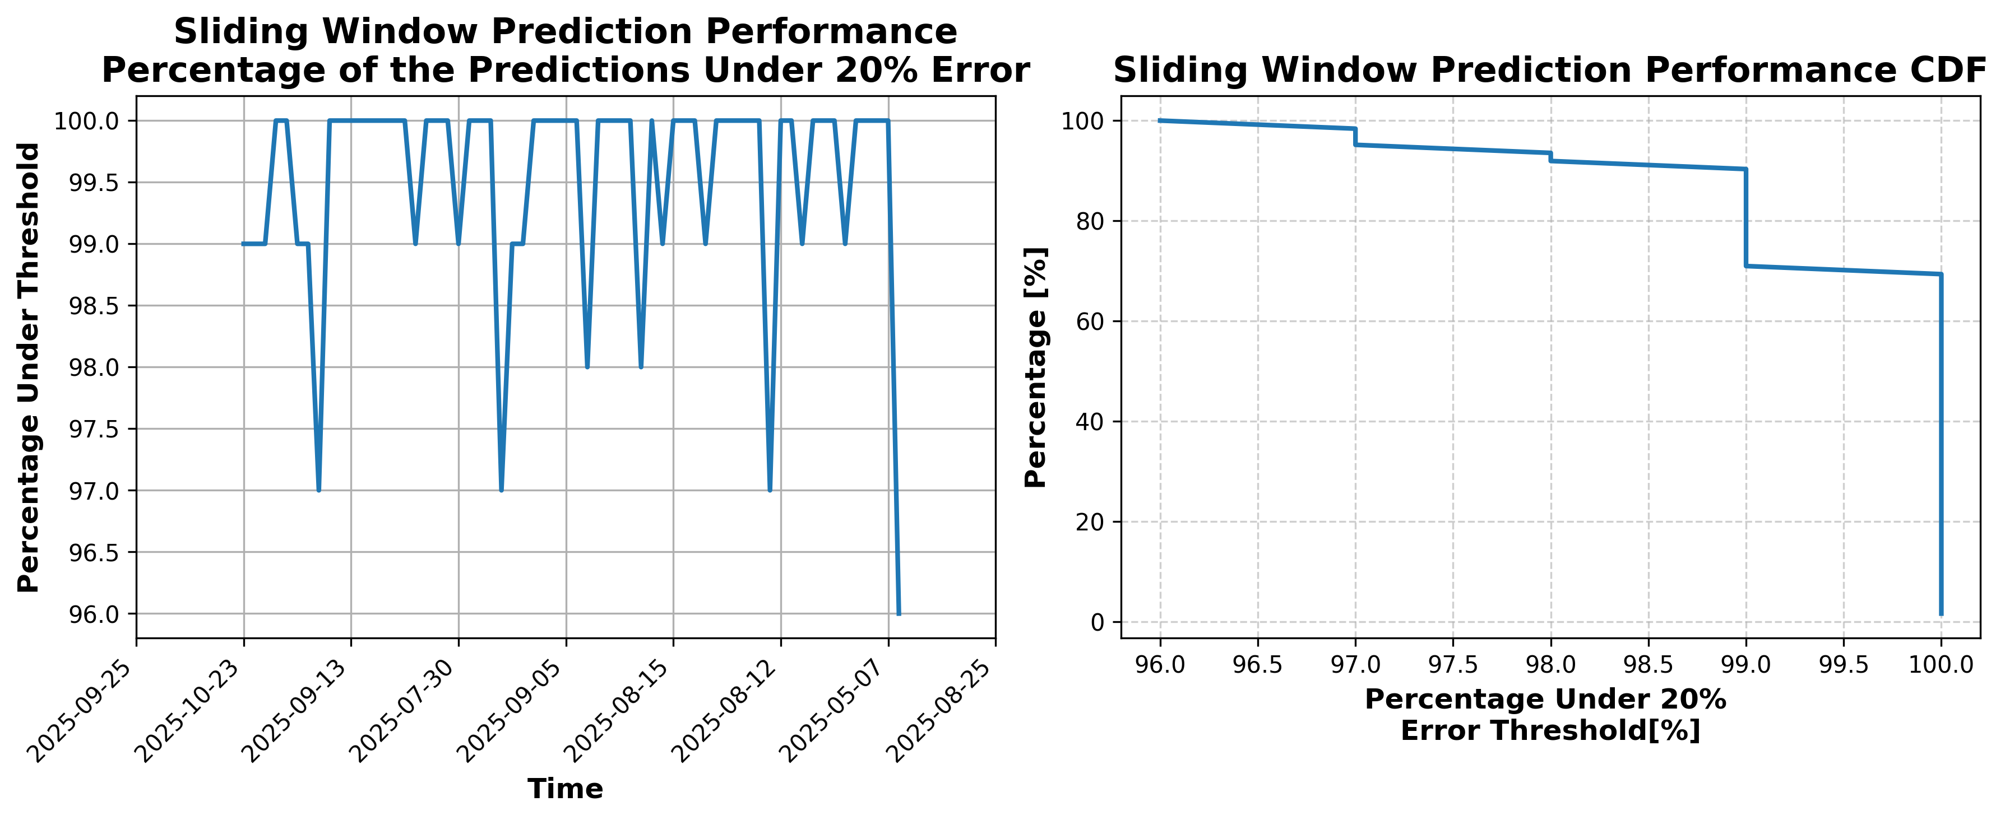

### Results for Latest_Test_2025-09-16.csv

Lines used: 8225 out of 13938 (59%)

Data sorted by: CHS Pickup Date

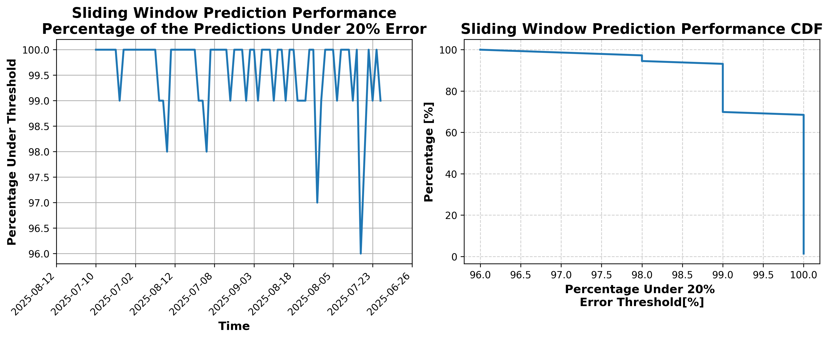

### Results for Latest_Test_2025-09-02.csv

Lines used: 7701 out of 13953 (55%)

Data sorted by: CHS Pickup Date

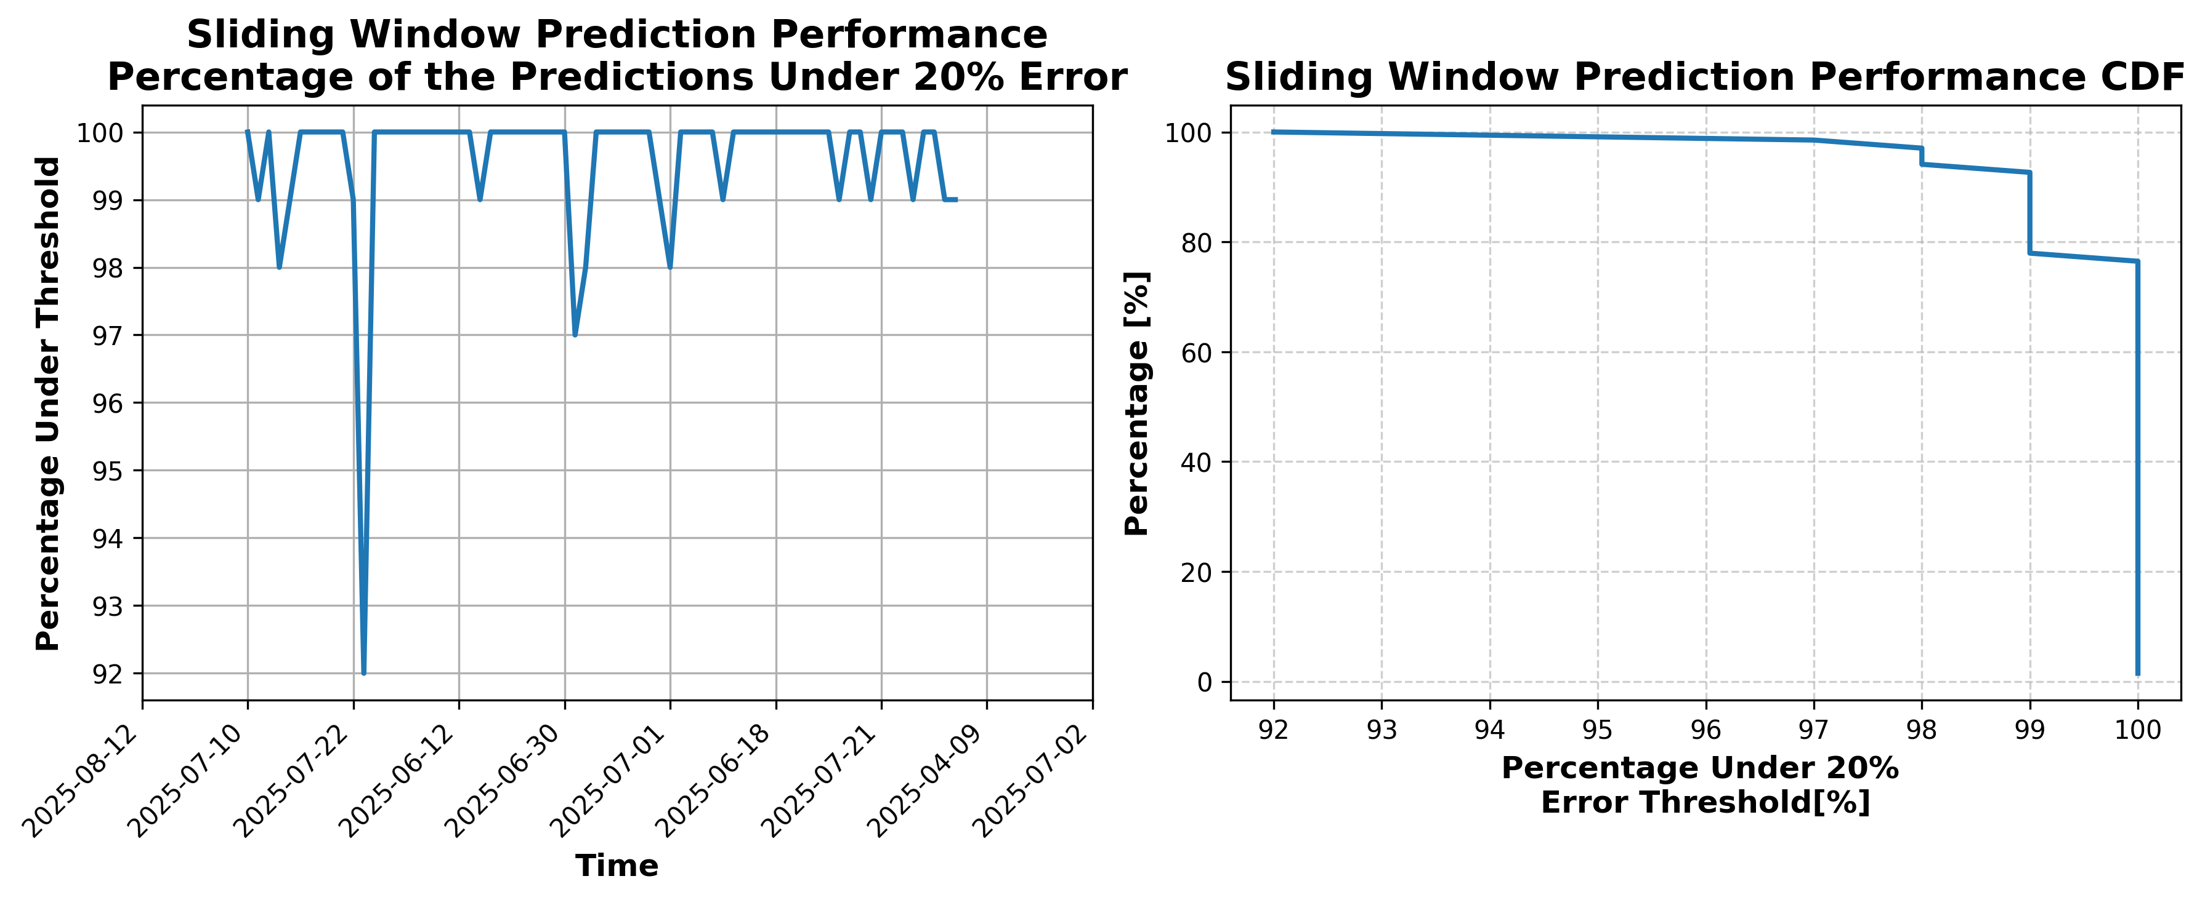

### Results for Latest_Test_2025-07-07.csv

Lines used: 9016 out of 14055 (64%)

Data sorted by: CHS Pickup Date

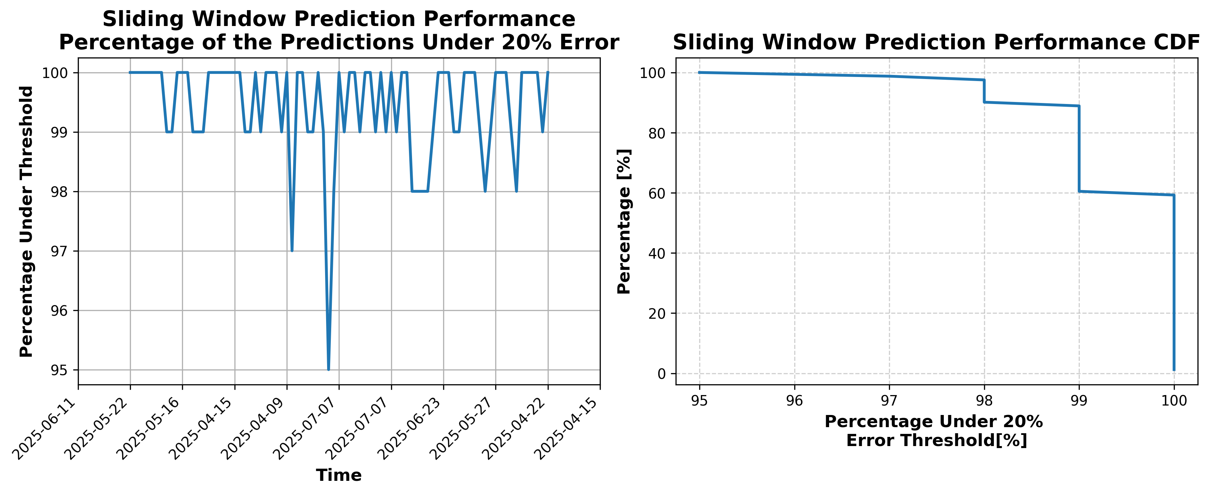

### Results for Latest_Test_2025-07-13.csv

Lines used: 8918 out of 14169 (62%)

Data sorted by: CHS Pickup Date

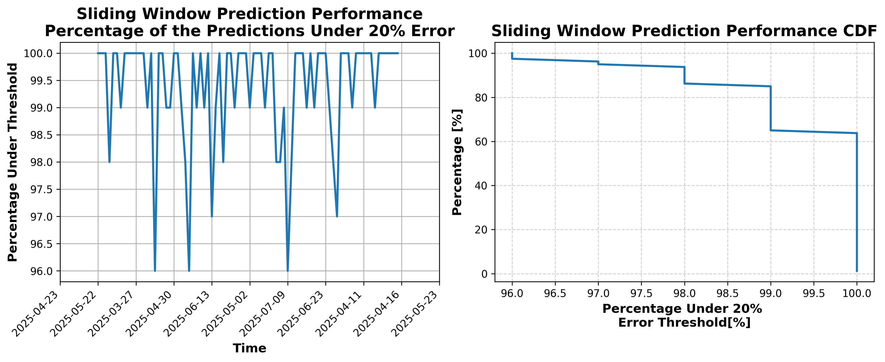

### Results for Latest_Test_2025-10-02_OTO.csv

Lines used: 38989 out of 51352 (75%)

Data sorted by: CHS Pickup Date

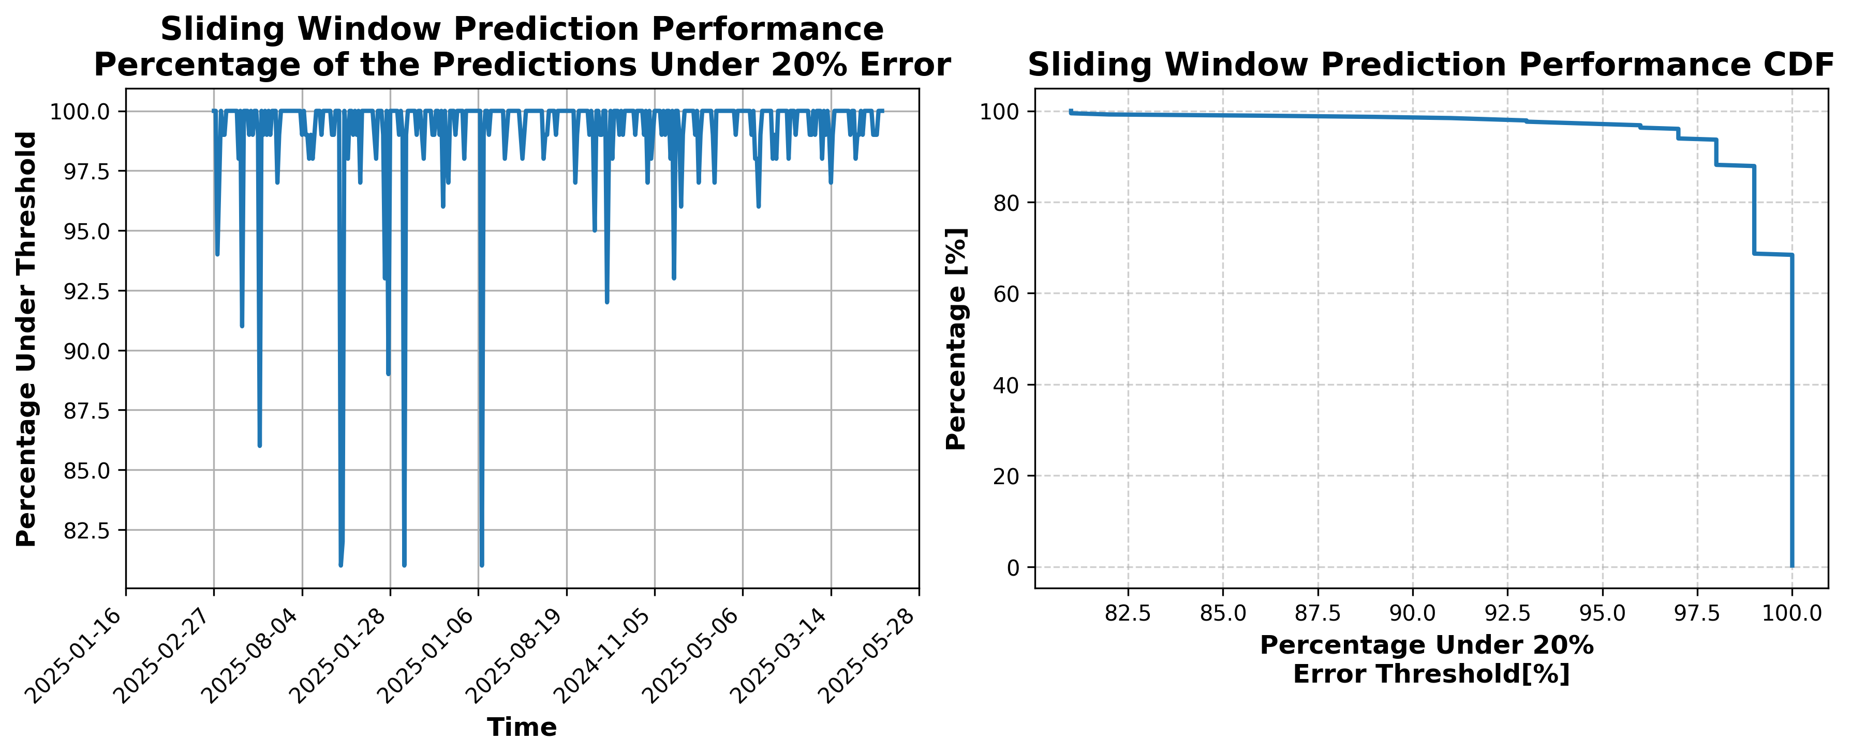

### Results for Latest_Test_2025-09-06.csv

Lines used: 8489 out of 14576 (58%)

Data sorted by: CHS Pickup Date

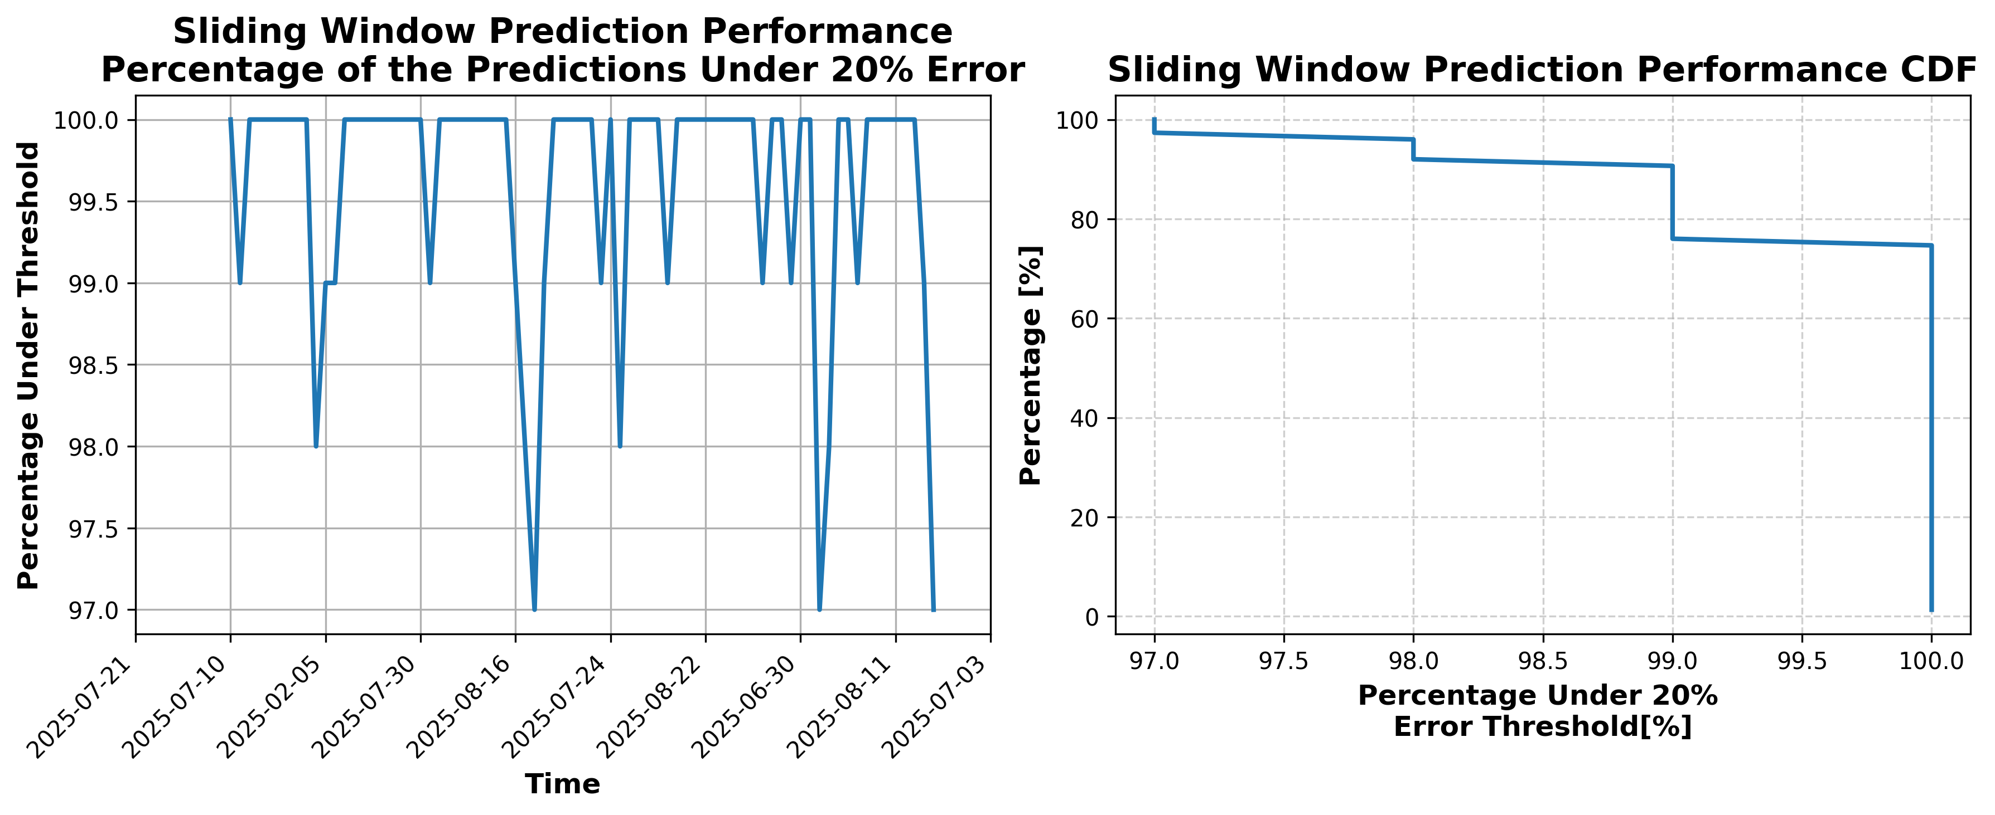

### Results for Latest_Test_2025-09-12.csv

Lines used: 8332 out of 14179 (58%)

Data sorted by: CHS Pickup Date

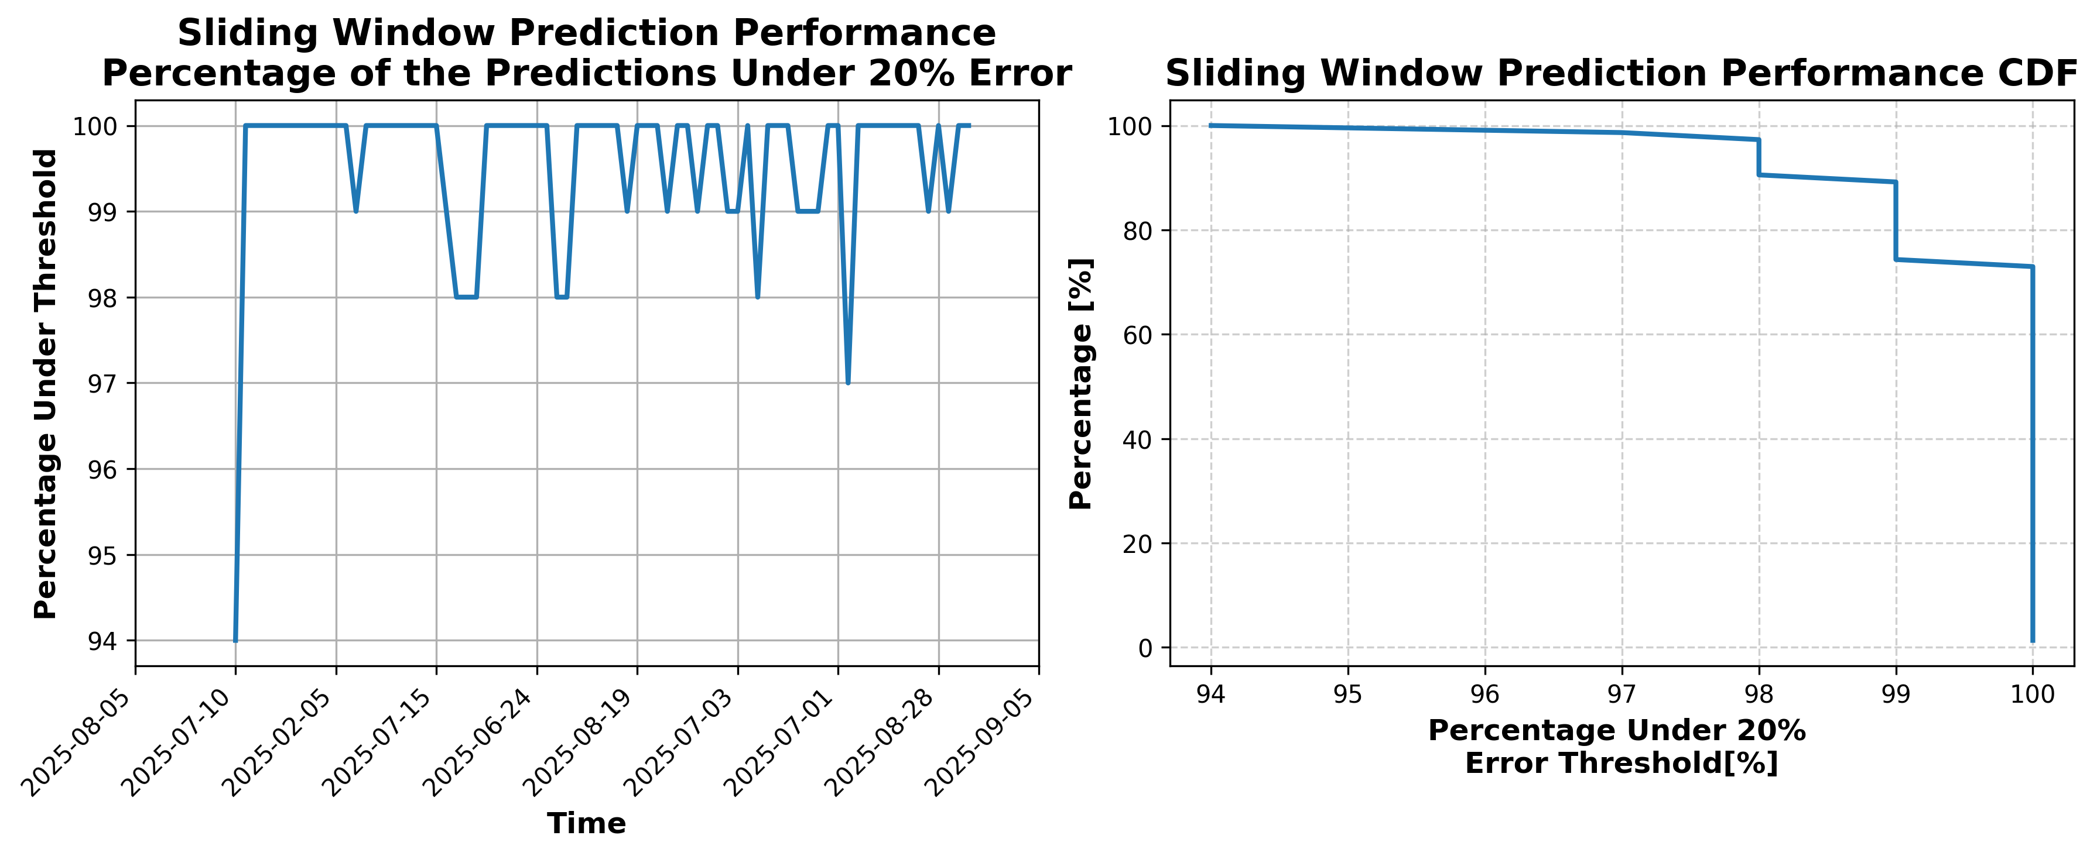

### Results for Latest_Test_2025-07-17.csv

Lines used: 8290 out of 13762 (60%)

Data sorted by: CHS Pickup Date

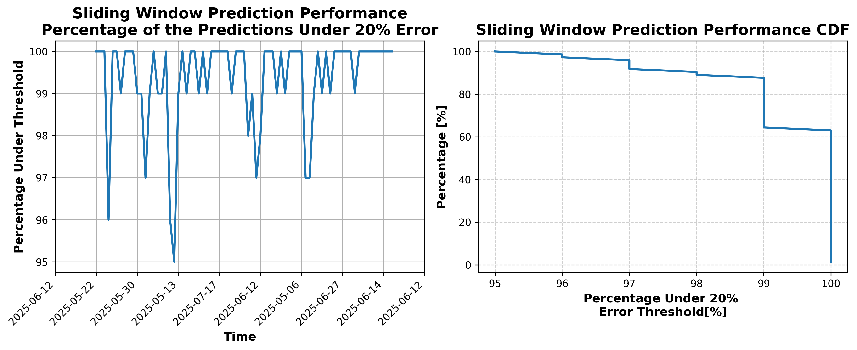

### Results for Latest_Test_2025-07-03.csv

Lines used: 9214 out of 14091 (65%)

Data sorted by: CHS Pickup Date

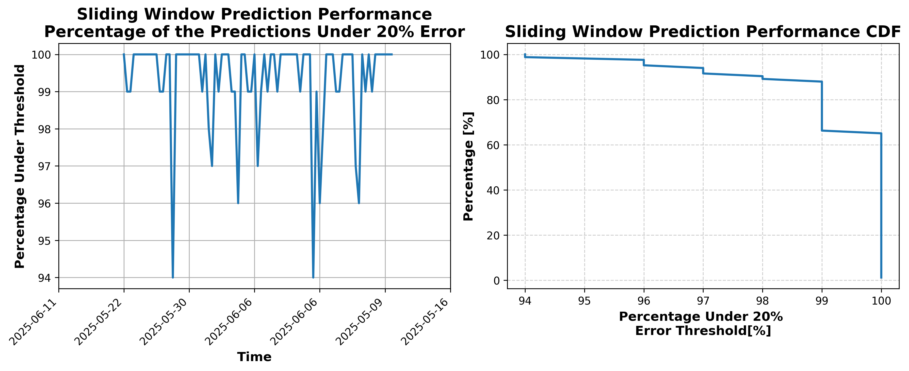

### Results for Latest_Test_2025-10-27.csv

Lines used: 7179 out of 13985 (51%)

Data sorted by: CHS Pickup Date

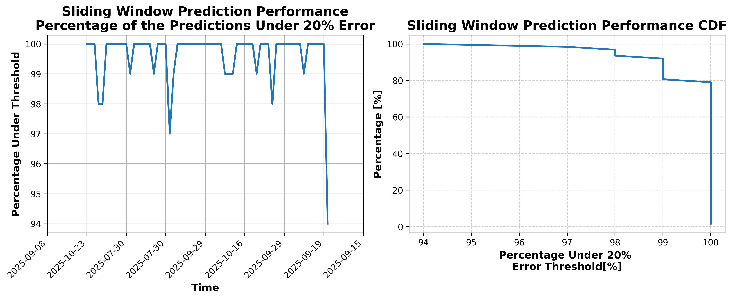

### Results for Latest_Test_2025-05-12.csv

Lines used: 8786 out of 14869 (59%)

Data sorted by: CHS Pickup Date

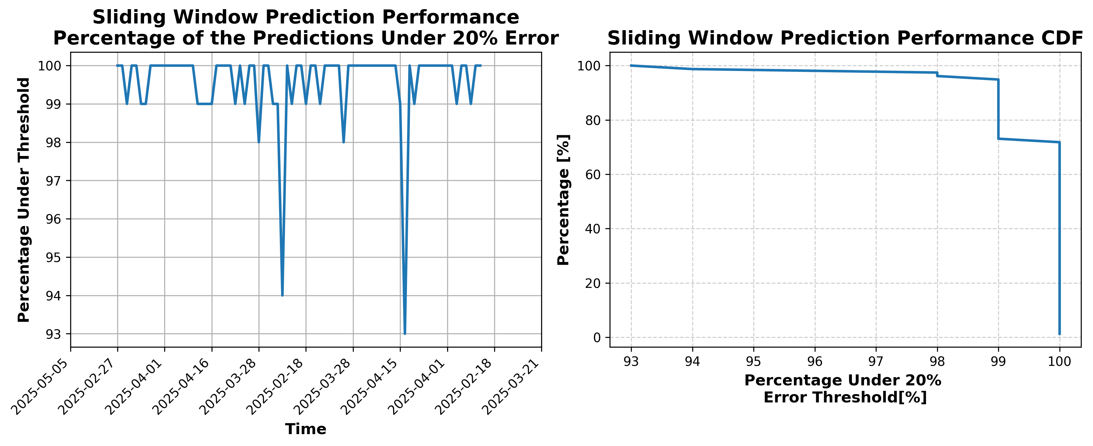

### Results for Latest_Test_2025-05-06.csv

Lines used: 8600 out of 15235 (56%)

Data sorted by: CHS Pickup Date

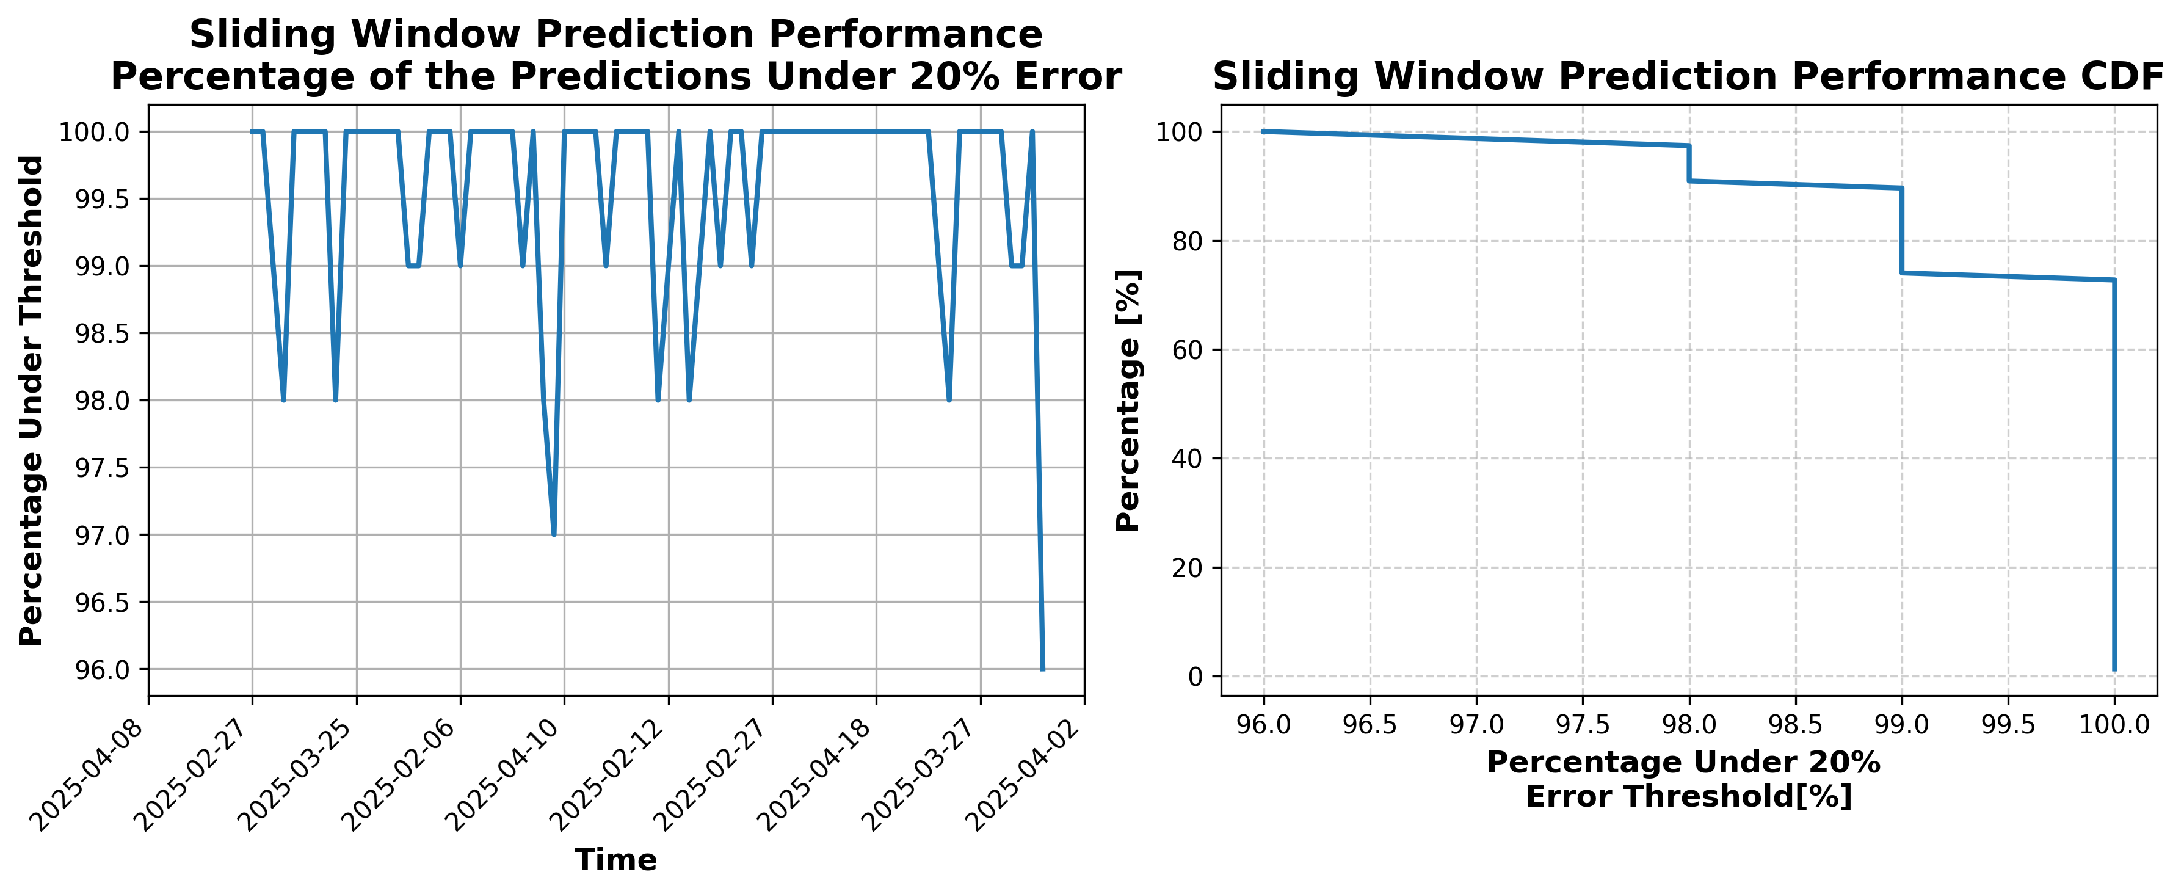

### Results for Latest_Test_2025-05-07.csv

Lines used: 8737 out of 15179 (57%)

Data sorted by: CHS Pickup Date

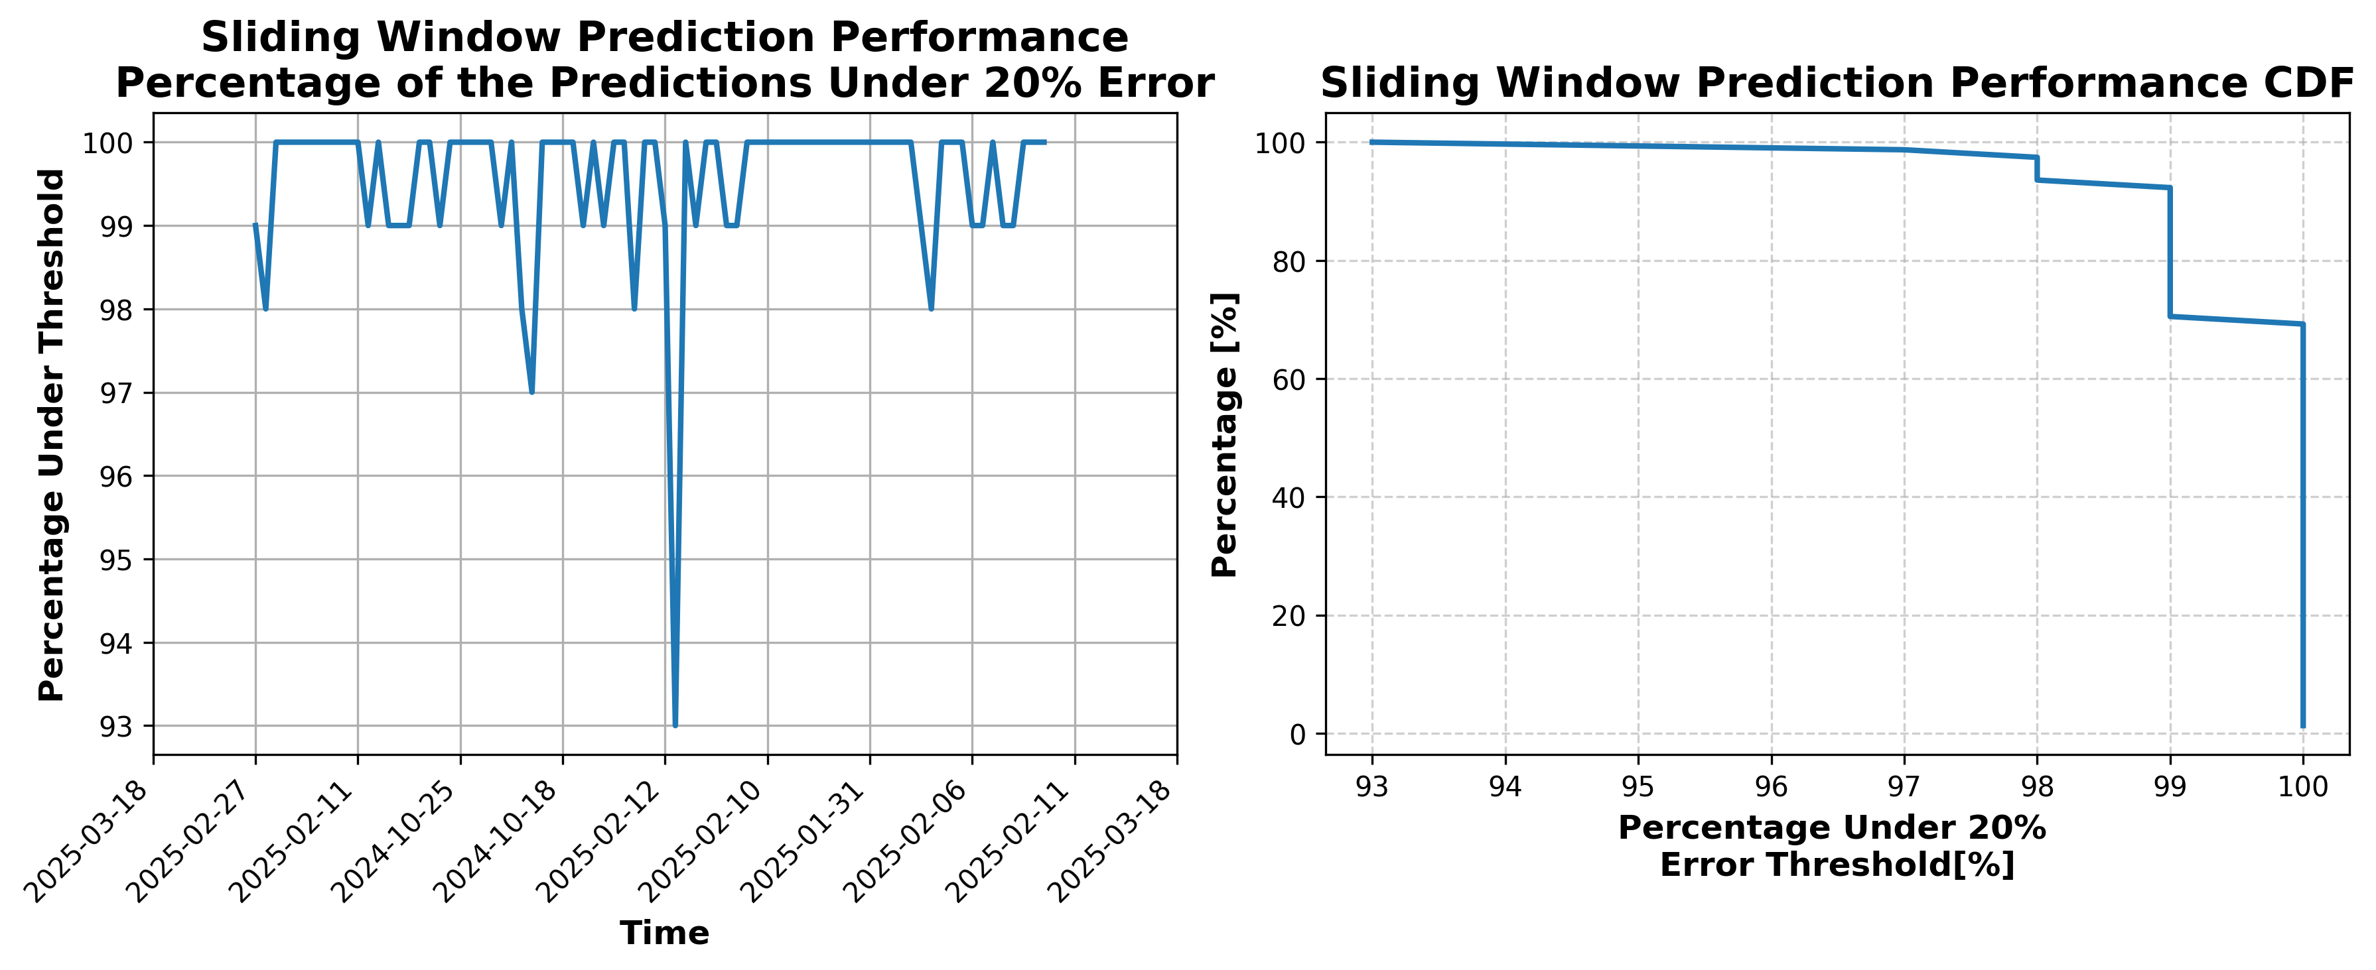

### Results for Latest_Test_2025-05-13.csv

Lines used: 8920 out of 14753 (60%)

Data sorted by: CHS Pickup Date

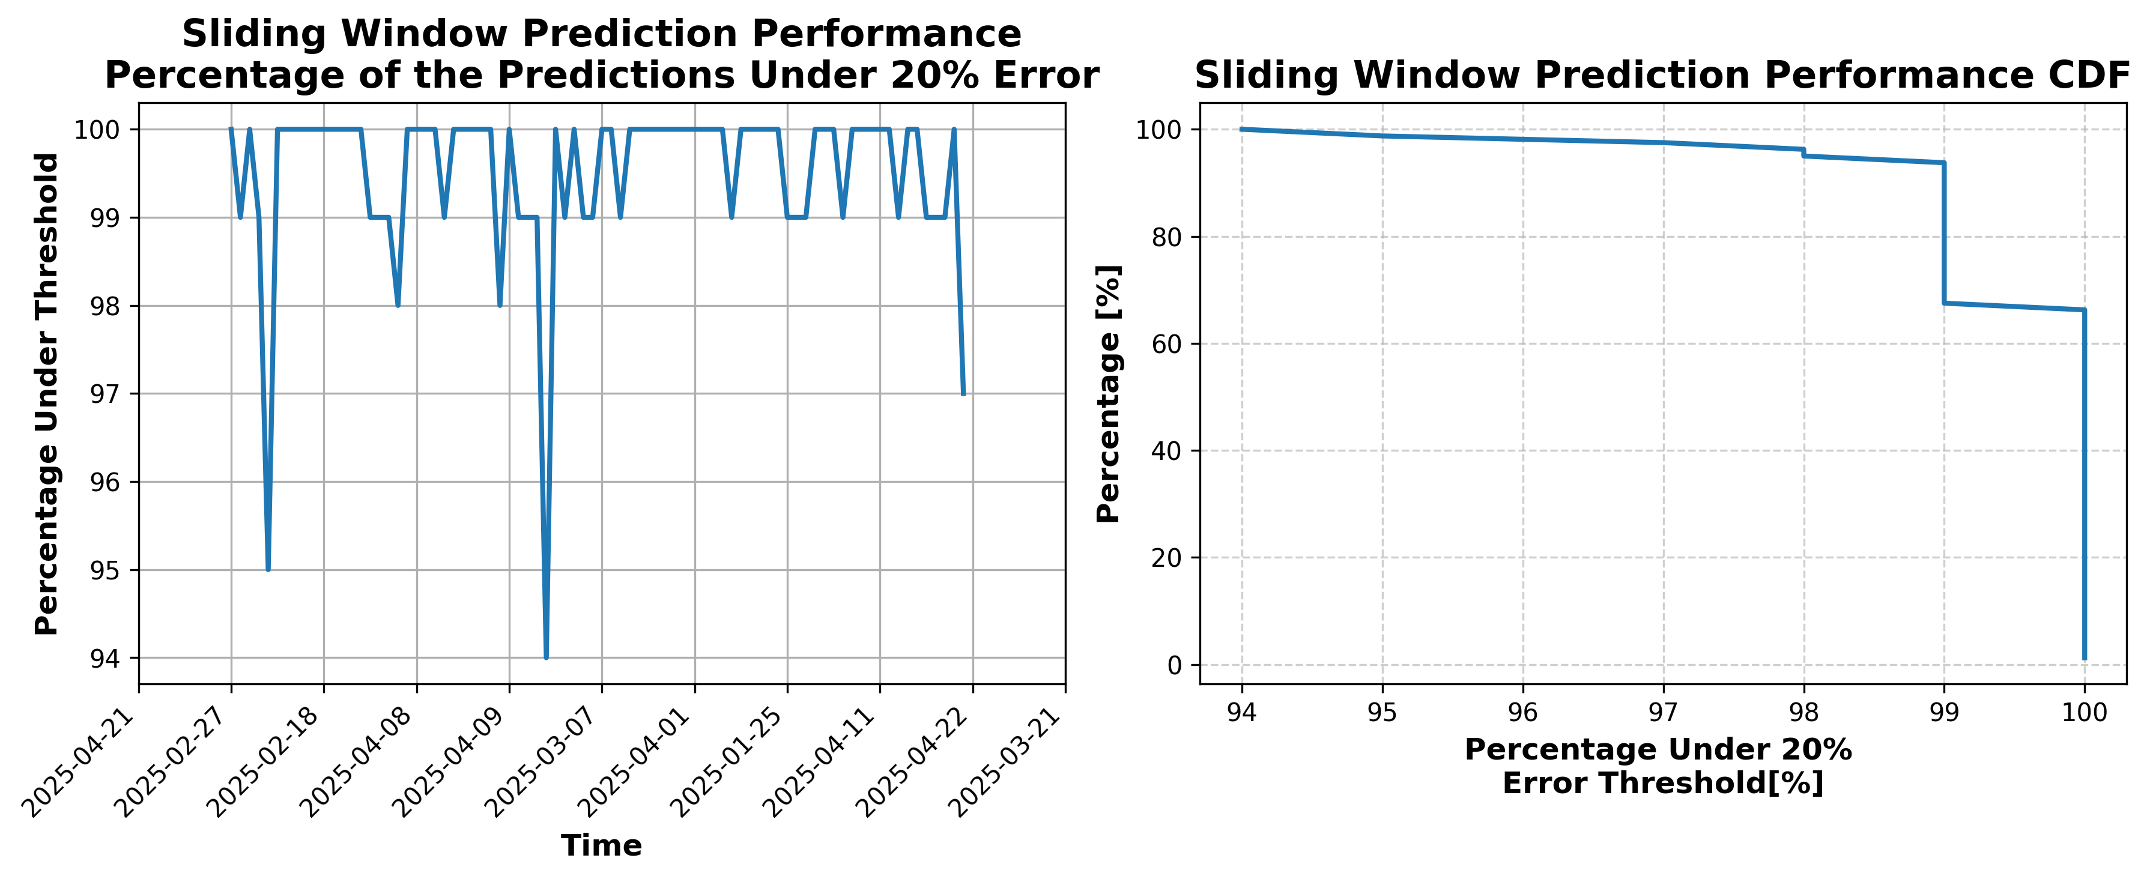

### Results for Latest_Test_2025-10-26.csv

Lines used: 7221 out of 14026 (51%)

Data sorted by: CHS Pickup Date

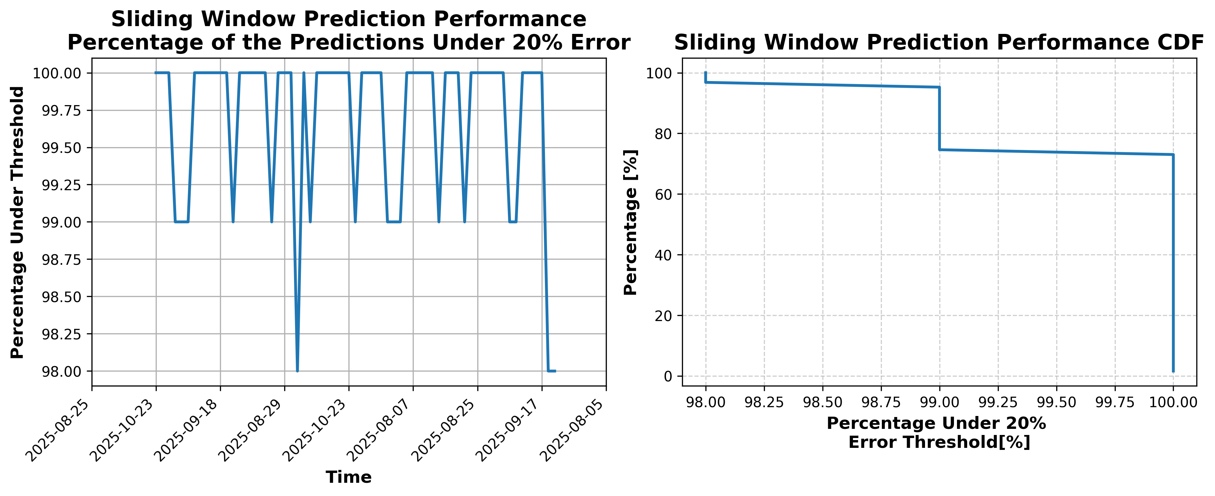

### Results for Latest_Test_2025-07-02.csv

Lines used: 9165 out of 13941 (65%)

Data sorted by: CHS Pickup Date

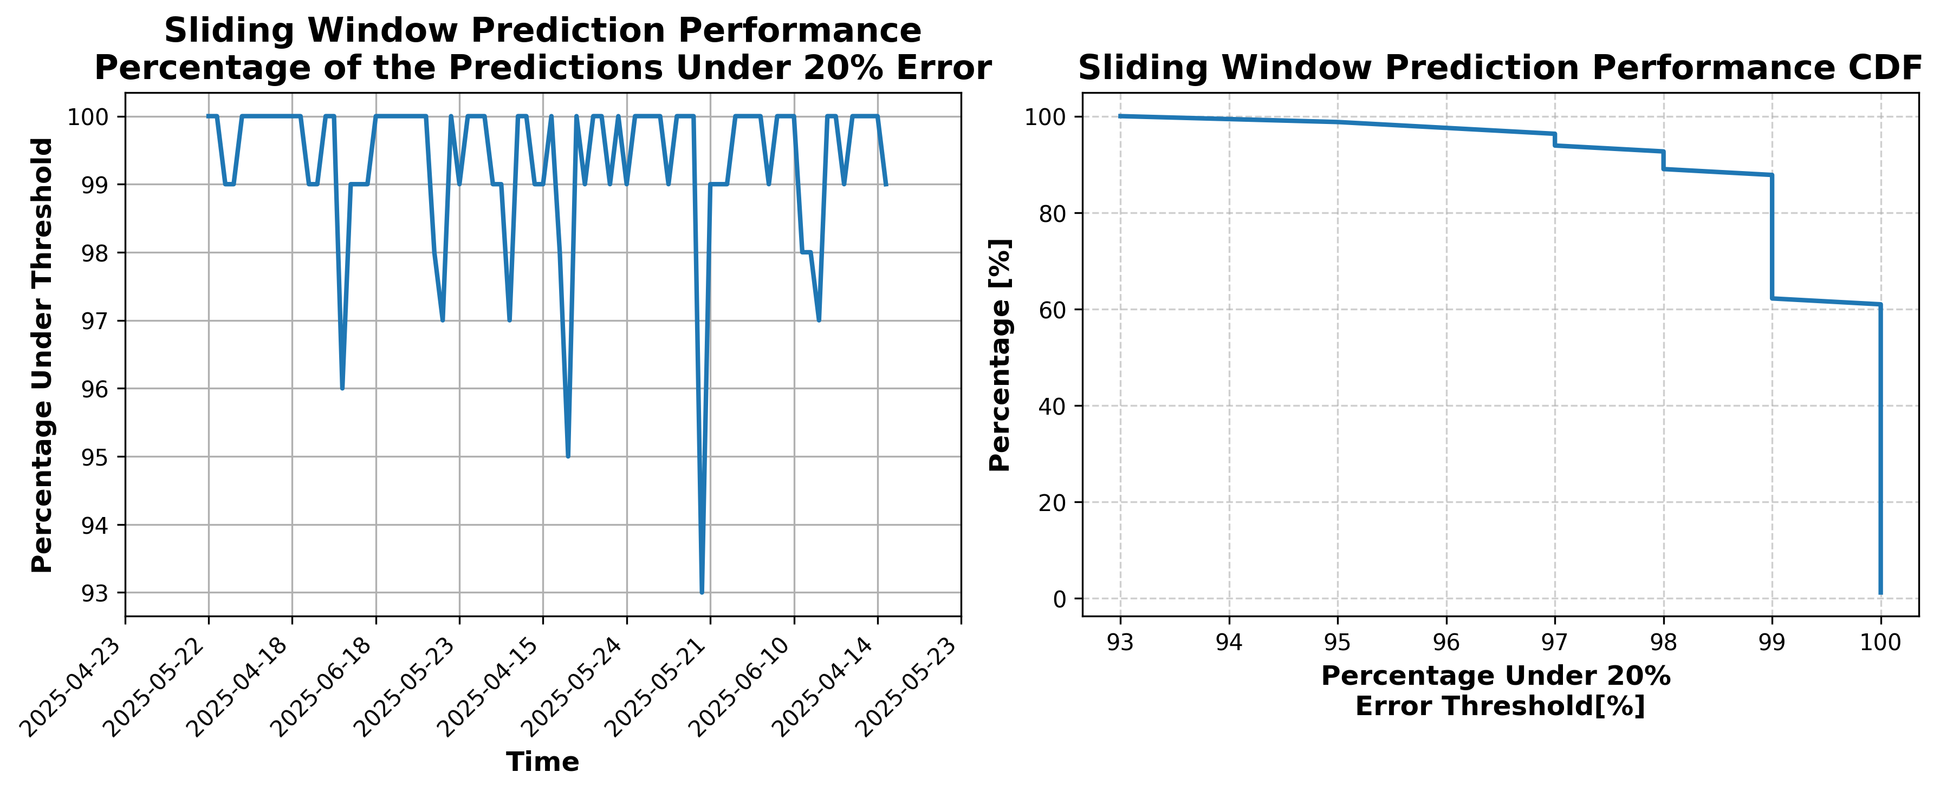

### Results for Latest_Test_2025-07-16.csv

Lines used: 8379 out of 13762 (60%)

Data sorted by: CHS Pickup Date

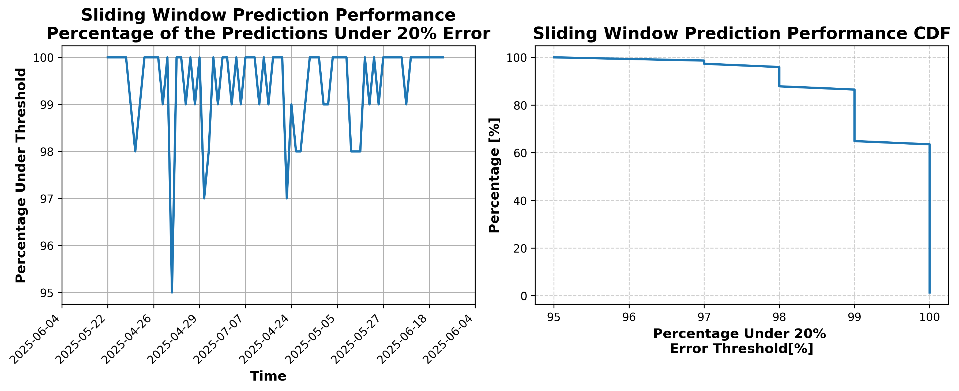

### Results for Latest_Test_2025-09-13.csv

Lines used: 8547 out of 14461 (59%)

Data sorted by: CHS Pickup Date

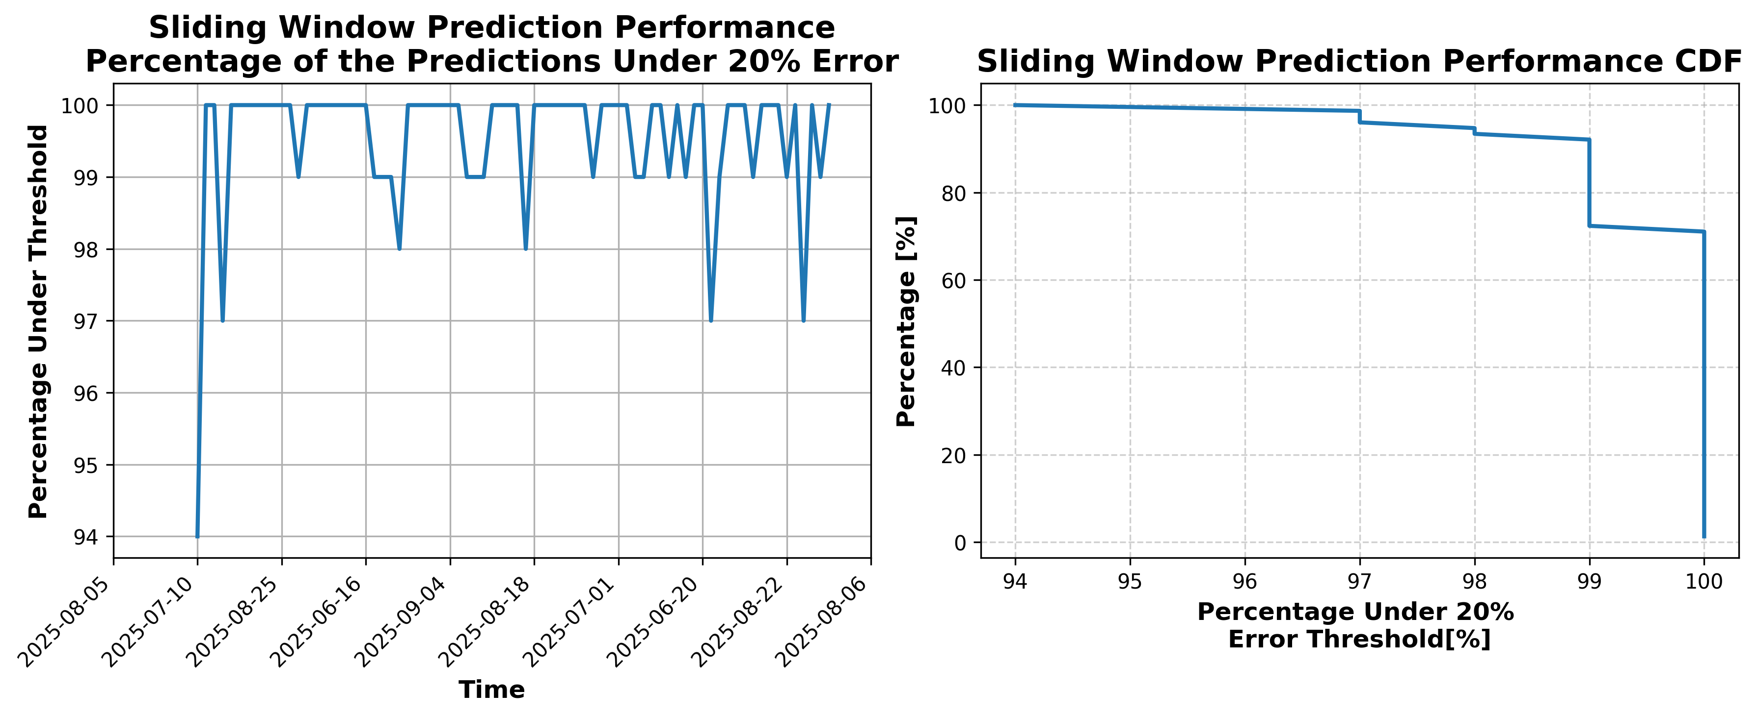

### Results for Latest_Test_2025-09-07.csv

Lines used: 8437 out of 14490 (58%)

Data sorted by: CHS Pickup Date

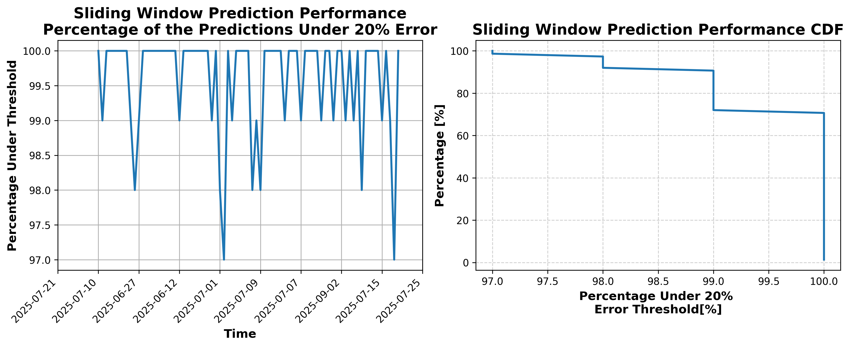

### Results for Latest_Test_2025-09-11.csv

Lines used: 8264 out of 14177 (58%)

Data sorted by: CHS Pickup Date

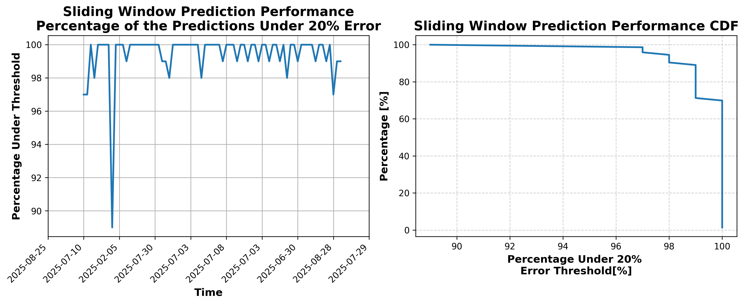

### Results for Latest_Test_2025-09-05.csv

Lines used: 8334 out of 14402 (57%)

Data sorted by: CHS Pickup Date

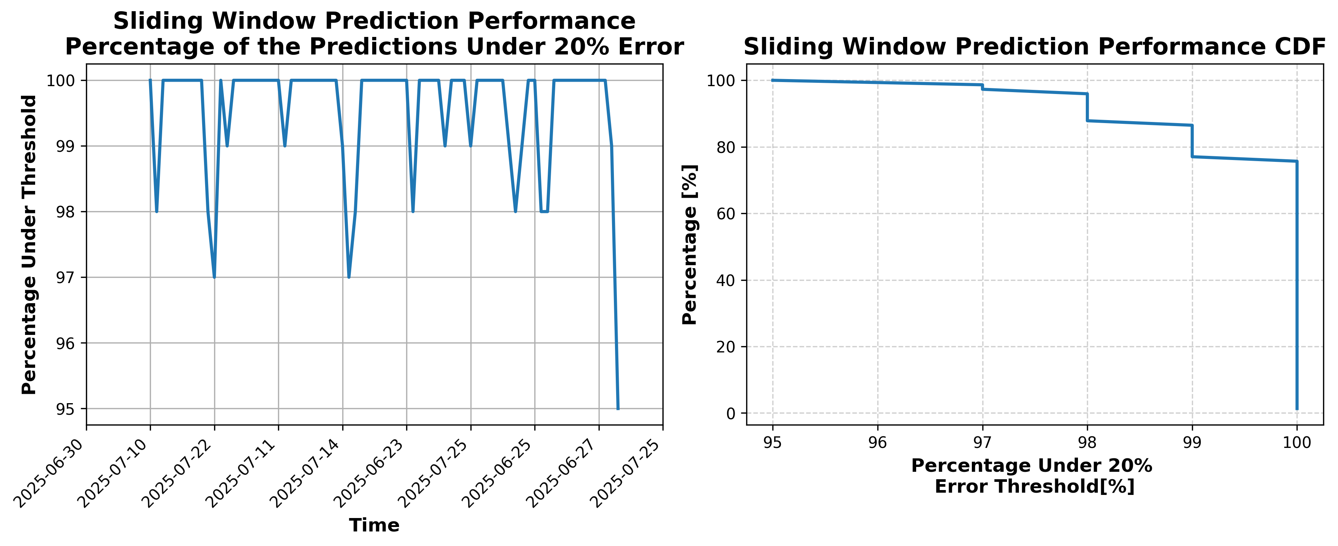

### Results for Latest_Test_2025-07-28.csv

Lines used: 8184 out of 13841 (59%)

Data sorted by: CHS Pickup Date

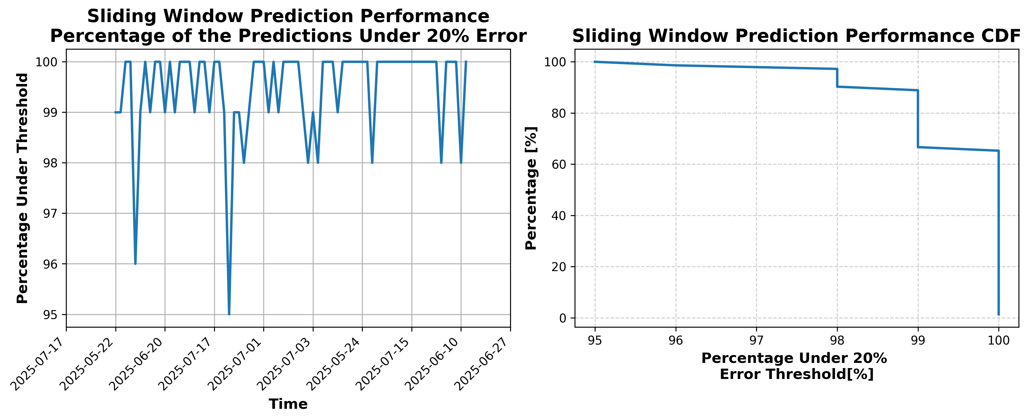

### Results for Latest_Test_2025-07-14.csv

Lines used: 8615 out of 13974 (61%)

Data sorted by: CHS Pickup Date

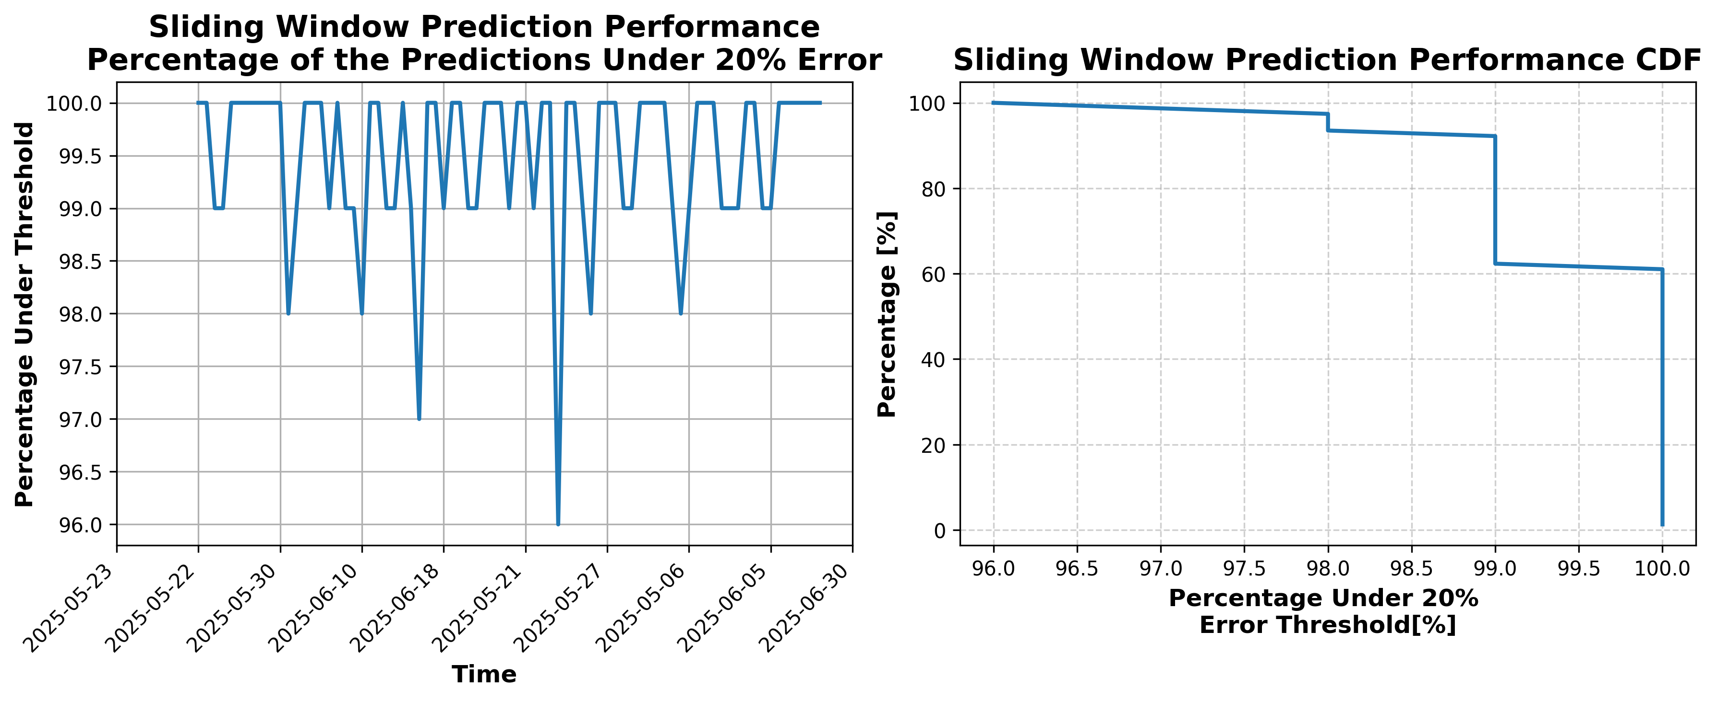

### Results for Latest_Test_2025-10-24.csv

Lines used: 7265 out of 14028 (51%)

Data sorted by: CHS Pickup Date

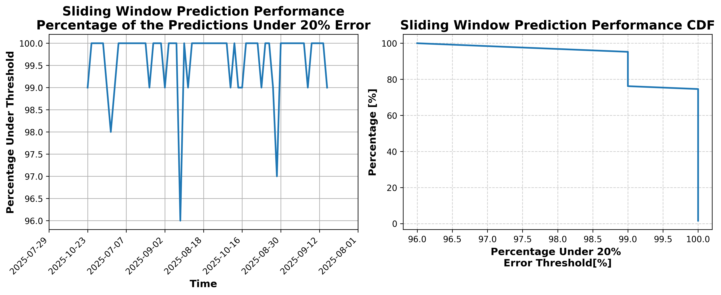

### Results for Latest_Test_2025-10-30.csv

Lines used: 7080 out of 14303 (49%)

Data sorted by: CHS Pickup Date

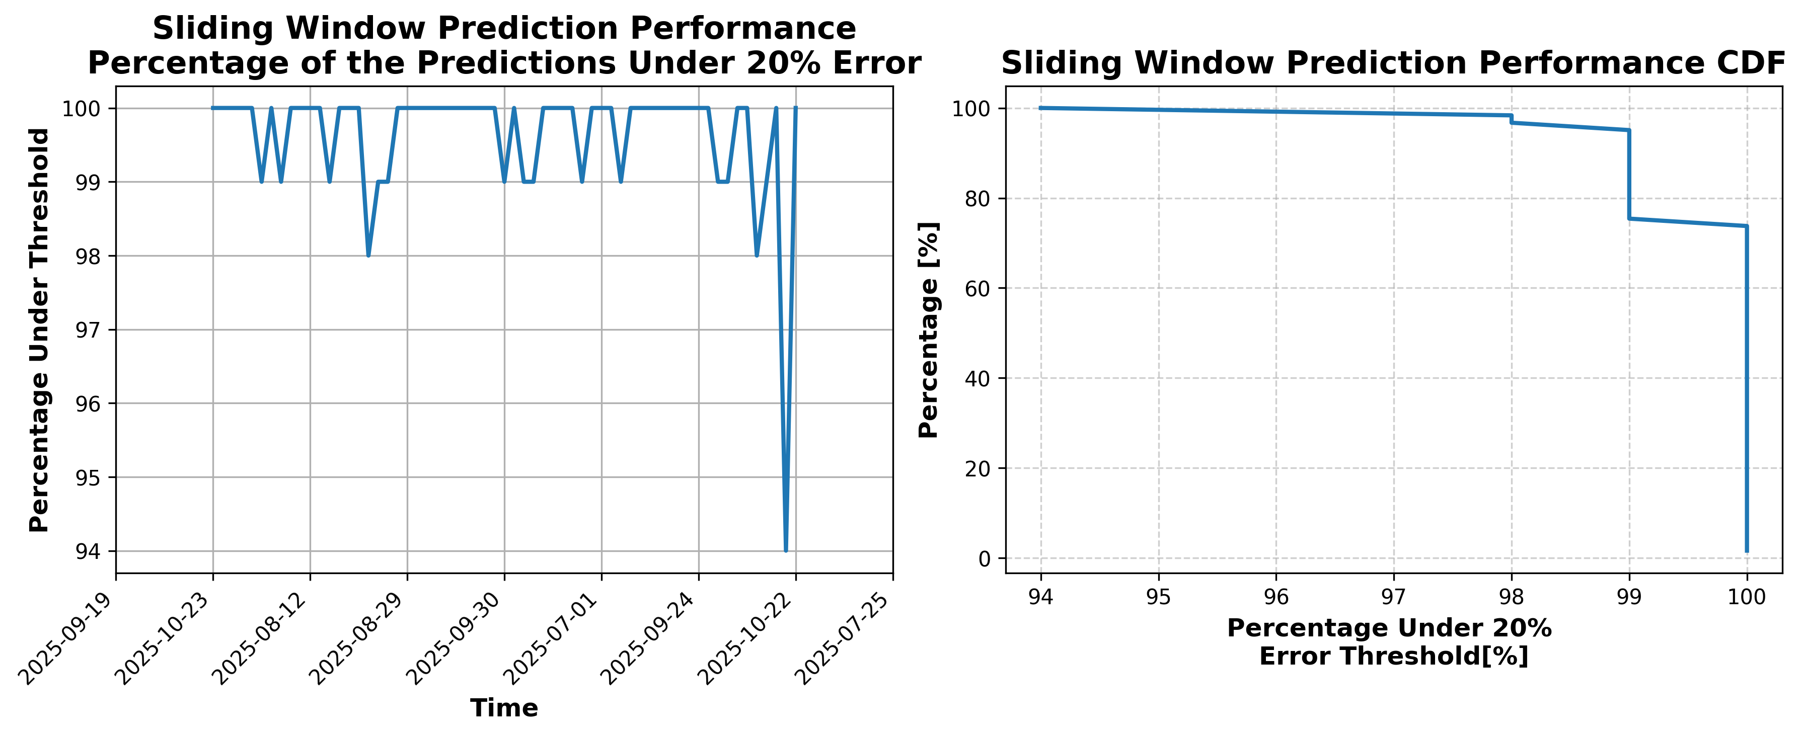

### Results for Latest_Test_2025-10-18.csv

Lines used: 7847 out of 14147 (55%)

Data sorted by: CHS Pickup Date

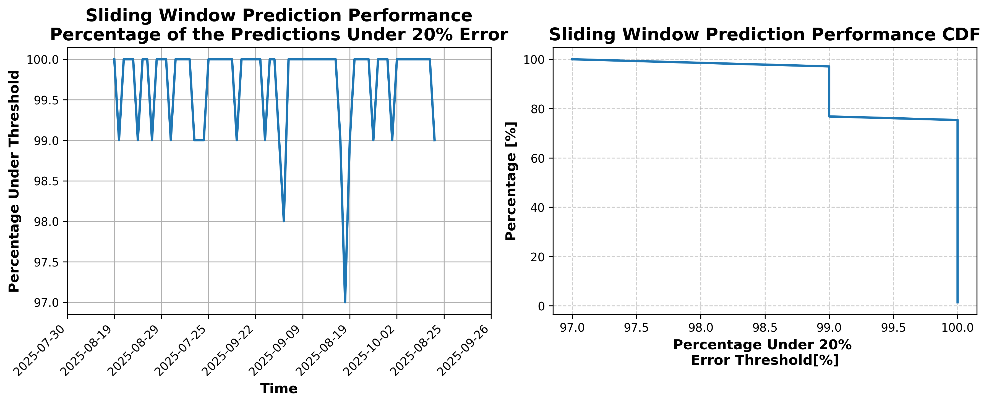

### Results for Latest_Test_2025-05-05.csv

Lines used: 8461 out of 15345 (55%)

Data sorted by: CHS Pickup Date

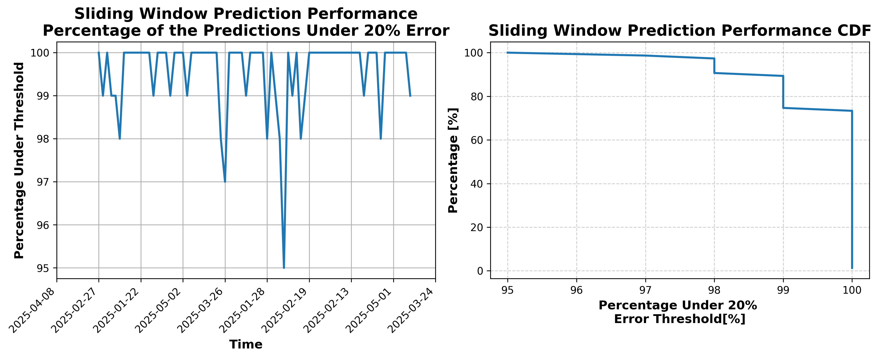

### Results for Latest_Test_2025-05-11.csv

Lines used: 8897 out of 15083 (58%)

Data sorted by: CHS Pickup Date

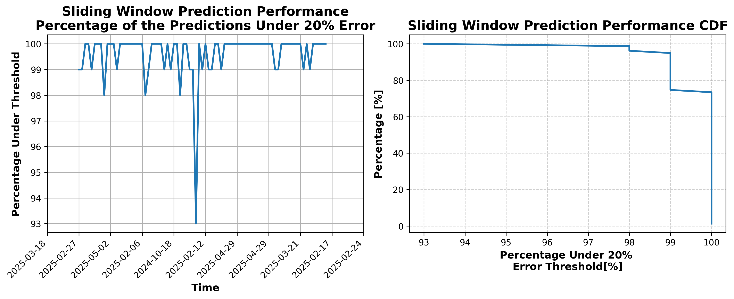

### Results for Latest_Test_2025-05-10.csv

Lines used: 9173 out of 15416 (59%)

Data sorted by: CHS Pickup Date

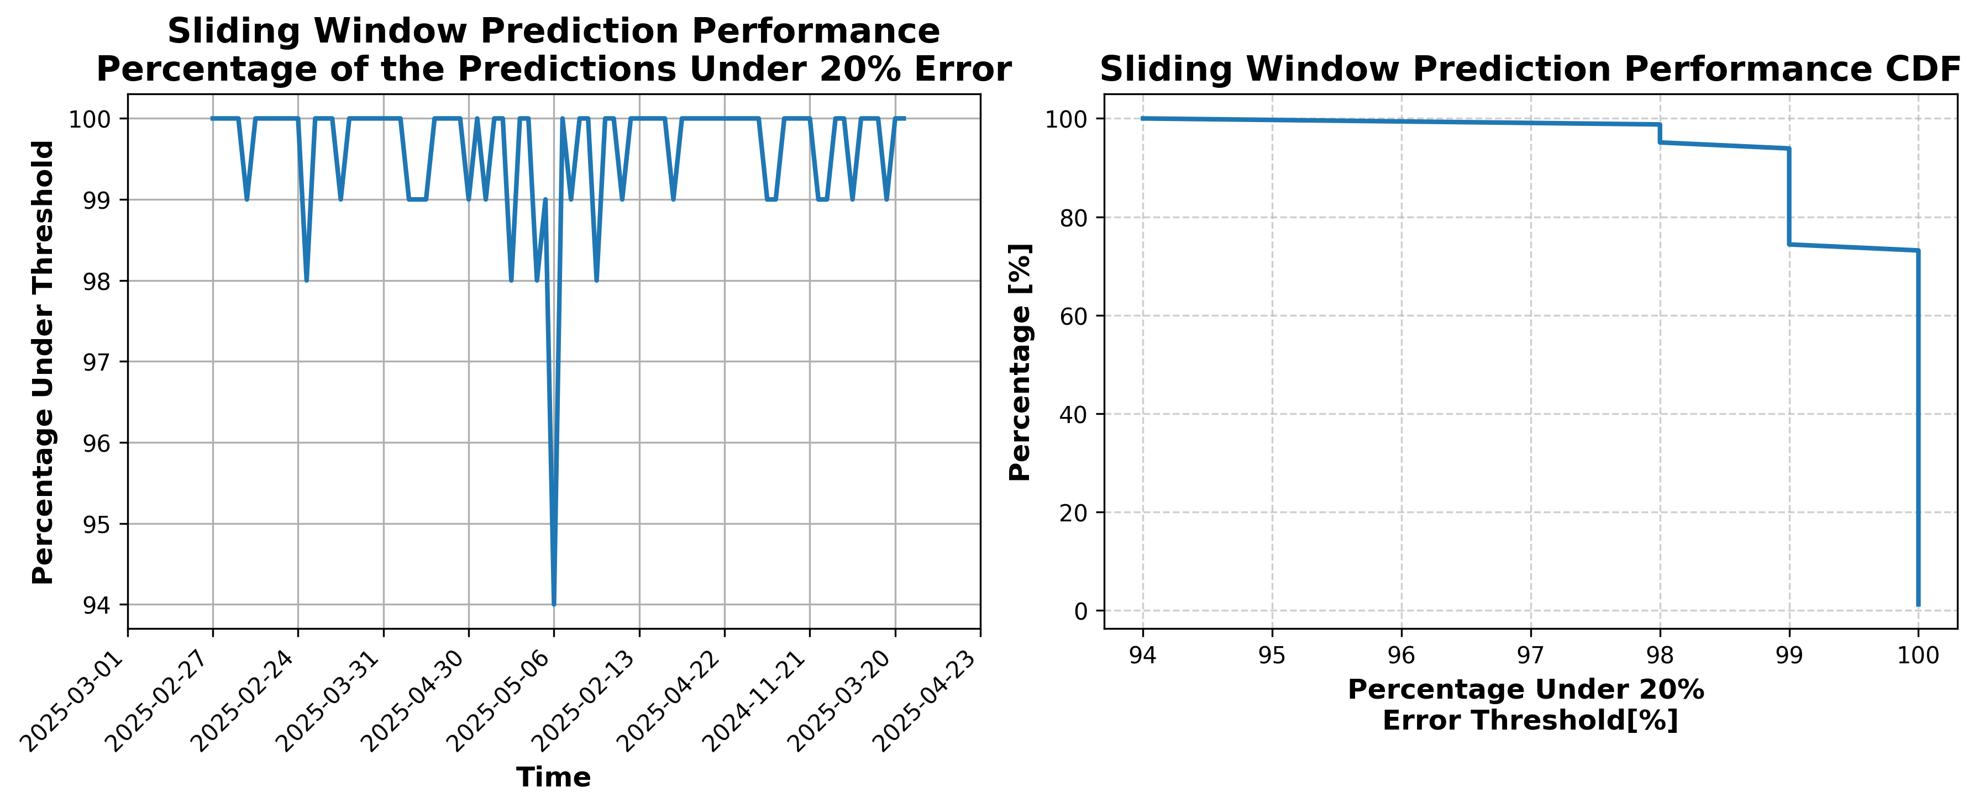

### Results for Latest_Test_2025-05-04.csv

Lines used: 8532 out of 15519 (54%)

Data sorted by: CHS Pickup Date

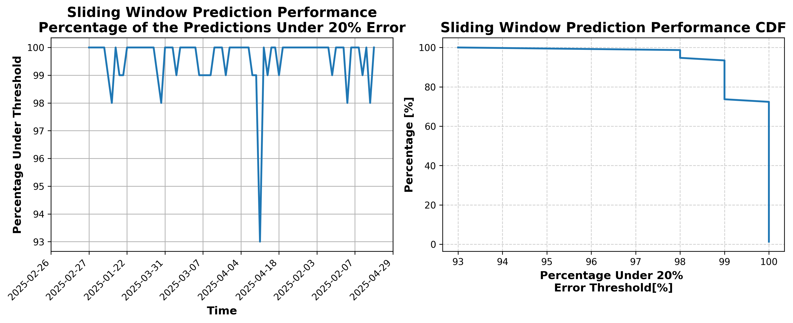

### Results for Latest_Test_2025-02-25.csv

Lines used: 8681 out of 17236 (50%)

Data sorted by: CHS Pickup Date

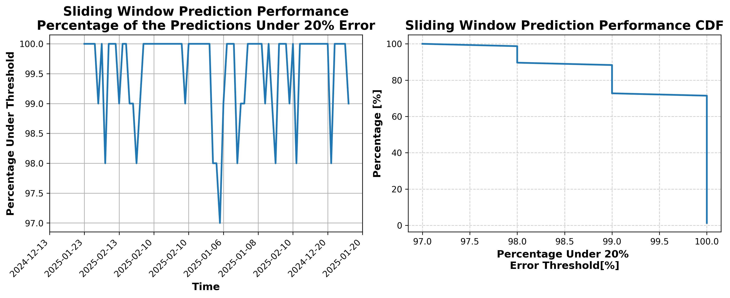

### Results for Latest_Test_2025-10-19.csv

Lines used: 7504 out of 13761 (54%)

Data sorted by: CHS Pickup Date

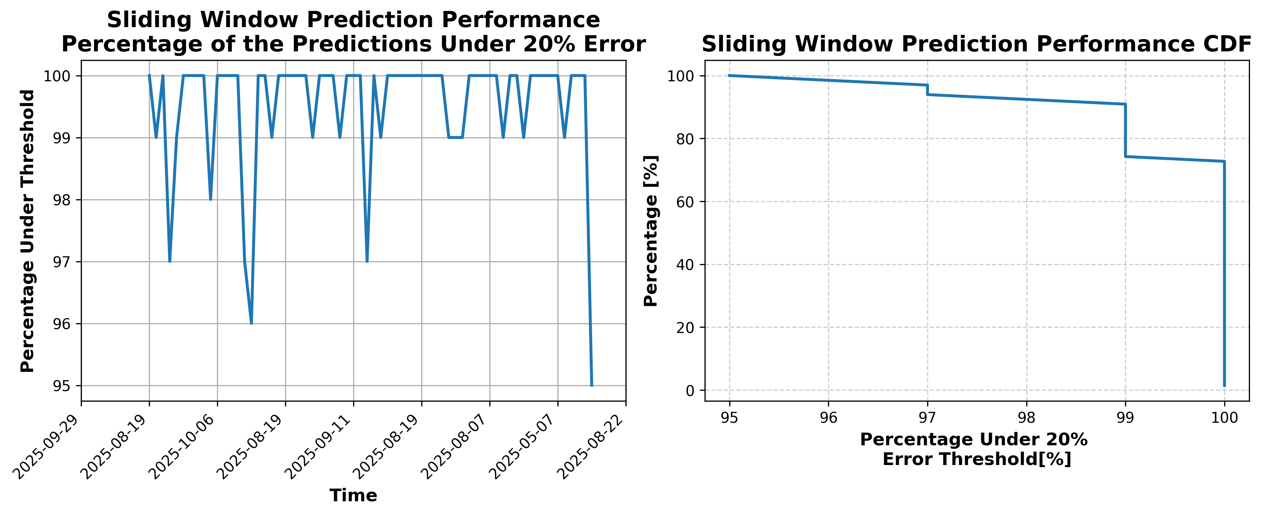

### Results for Latest_Test_2025-10-31.csv

Lines used: 7180 out of 14588 (49%)

Data sorted by: CHS Pickup Date

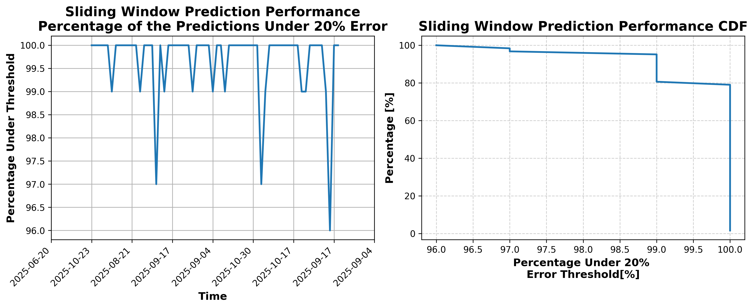

### Results for Latest_Test_2025-10-25.csv

Lines used: 7390 out of 14219 (51%)

Data sorted by: CHS Pickup Date

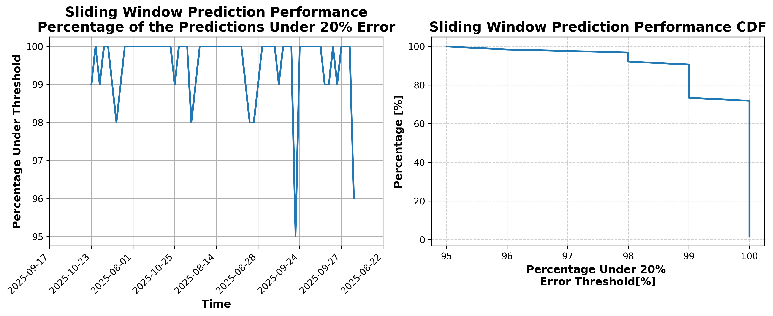

### Results for Latest_Test_2025-07-15.csv

Lines used: 8510 out of 13887 (61%)

Data sorted by: CHS Pickup Date

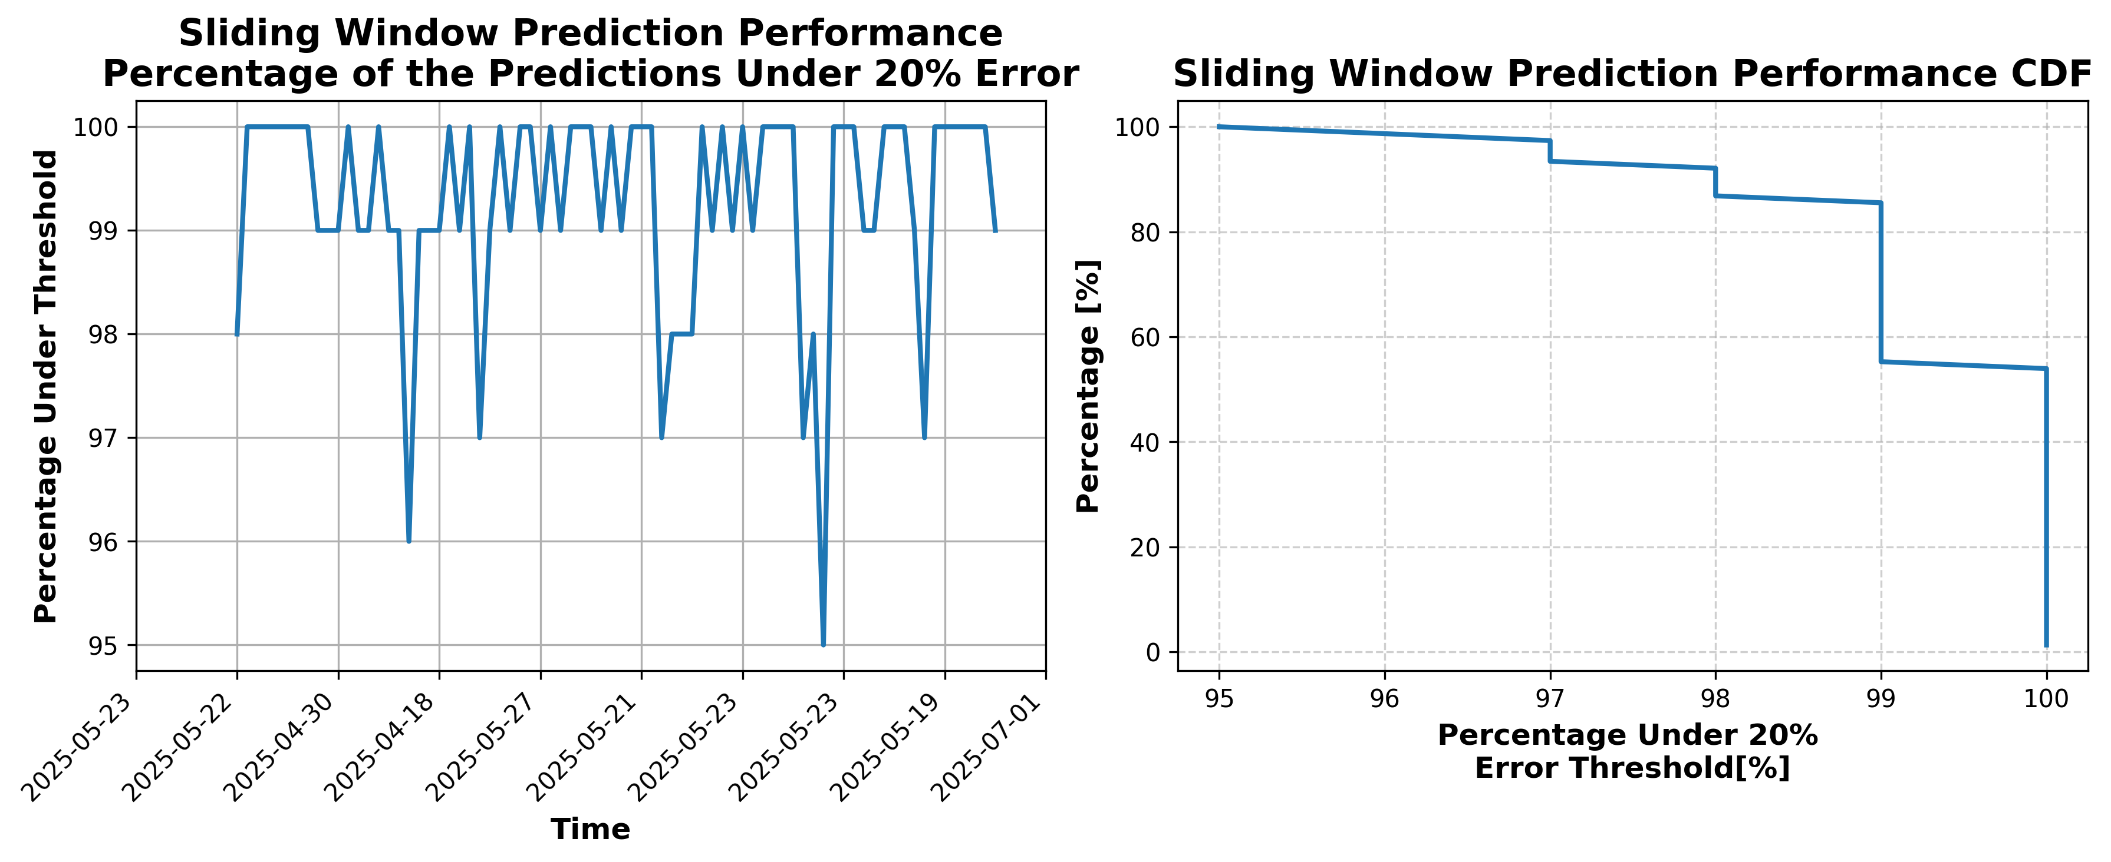

### Results for Latest_Test_2025-07-01.csv

Lines used: 9226 out of 13916 (66%)

Data sorted by: CHS Pickup Date

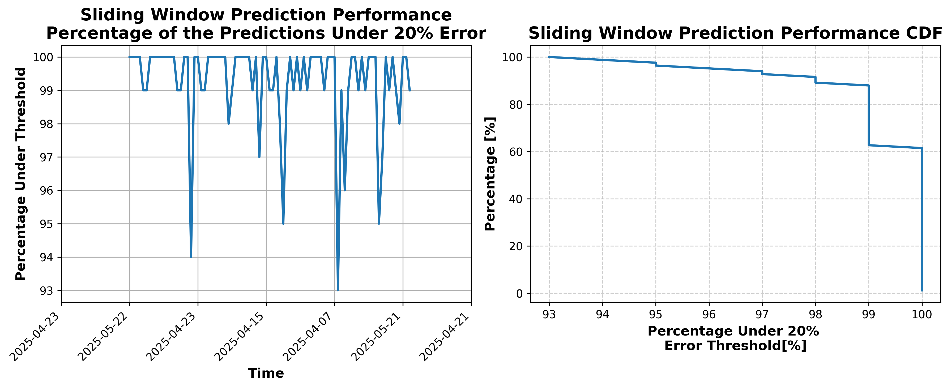

### Results for Latest_Test_2025-07-29.csv

Lines used: 8113 out of 13822 (58%)

Data sorted by: CHS Pickup Date

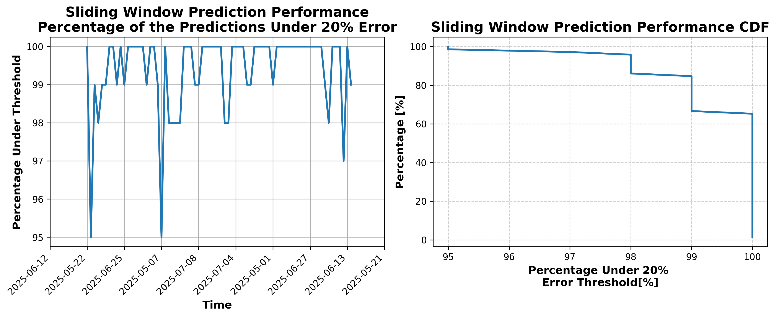

### Results for Latest_Test_2025-09-04.csv

Lines used: 8123 out of 14241 (57%)

Data sorted by: CHS Pickup Date

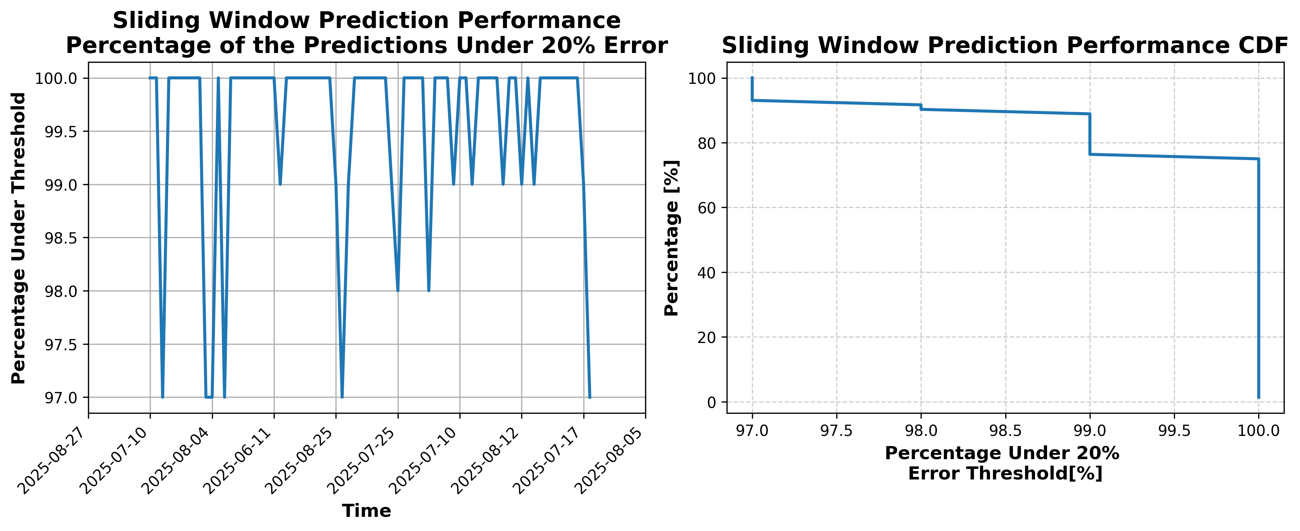

### Results for Latest_Test_2025-09-10.csv

Lines used: 7971 out of 13927 (57%)

Data sorted by: CHS Pickup Date

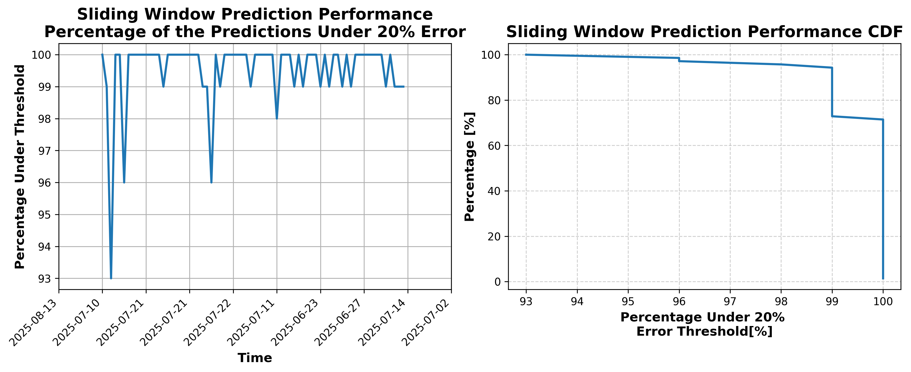

### Results for Latest_Test_2025-03-02.csv

Lines used: 9139 out of 17664 (51%)

Data sorted by: CHS Pickup Date

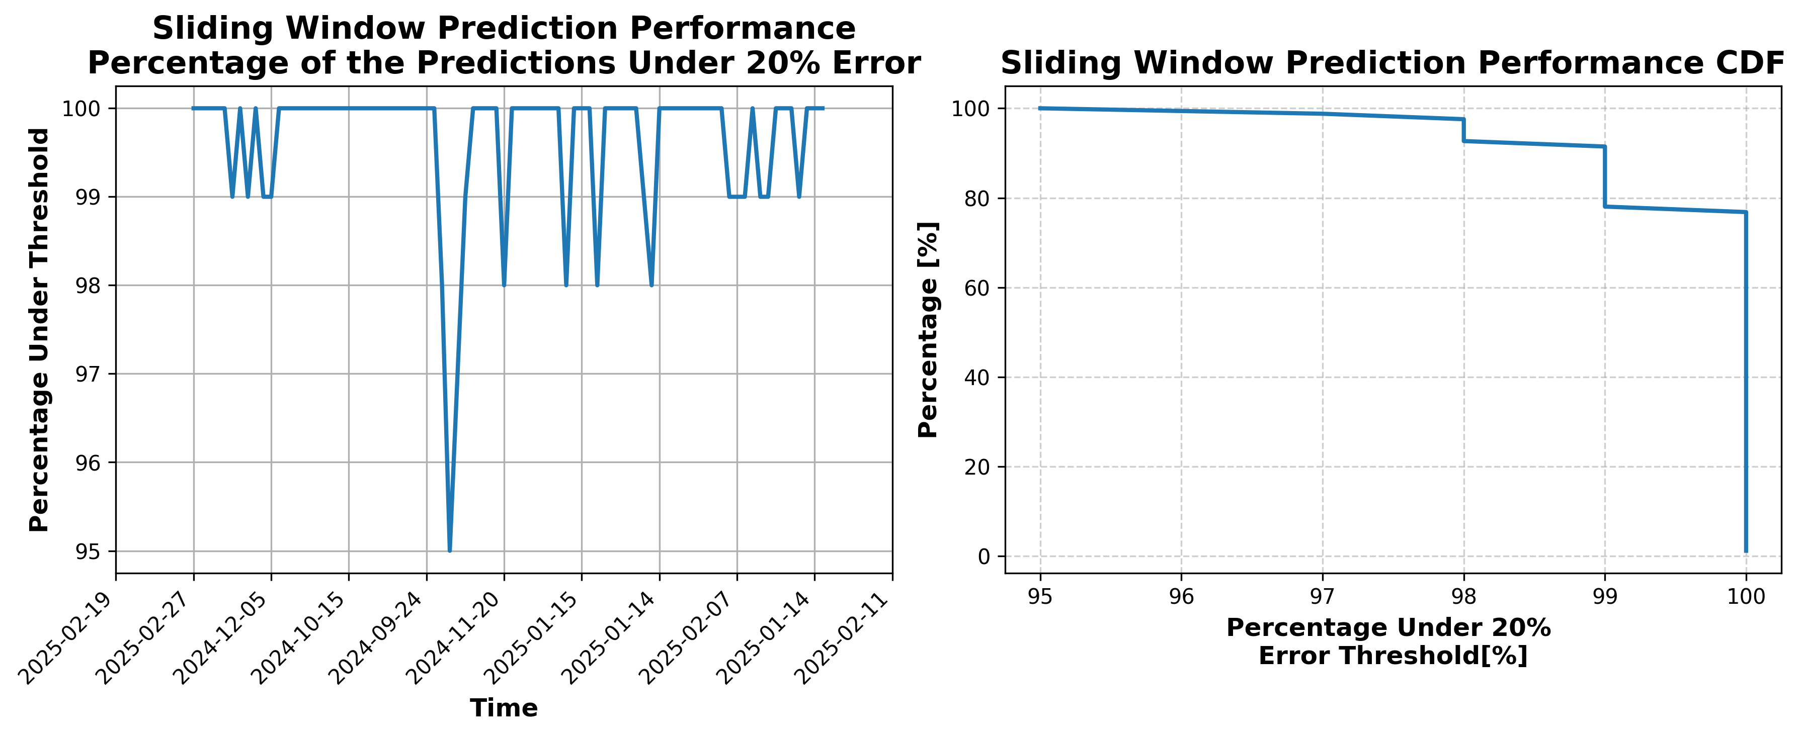

### Results for Latest_Test_2025-03-16.csv

Lines used: 8797 out of 16873 (52%)

Data sorted by: CHS Pickup Date

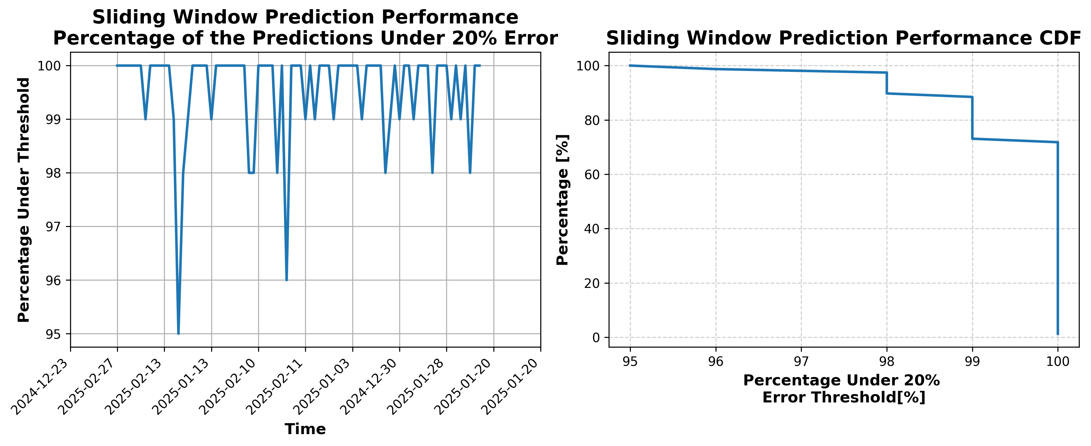

### Results for Latest_Test_2025-04-23.csv

Lines used: 9004 out of 16107 (55%)

Data sorted by: CHS Pickup Date

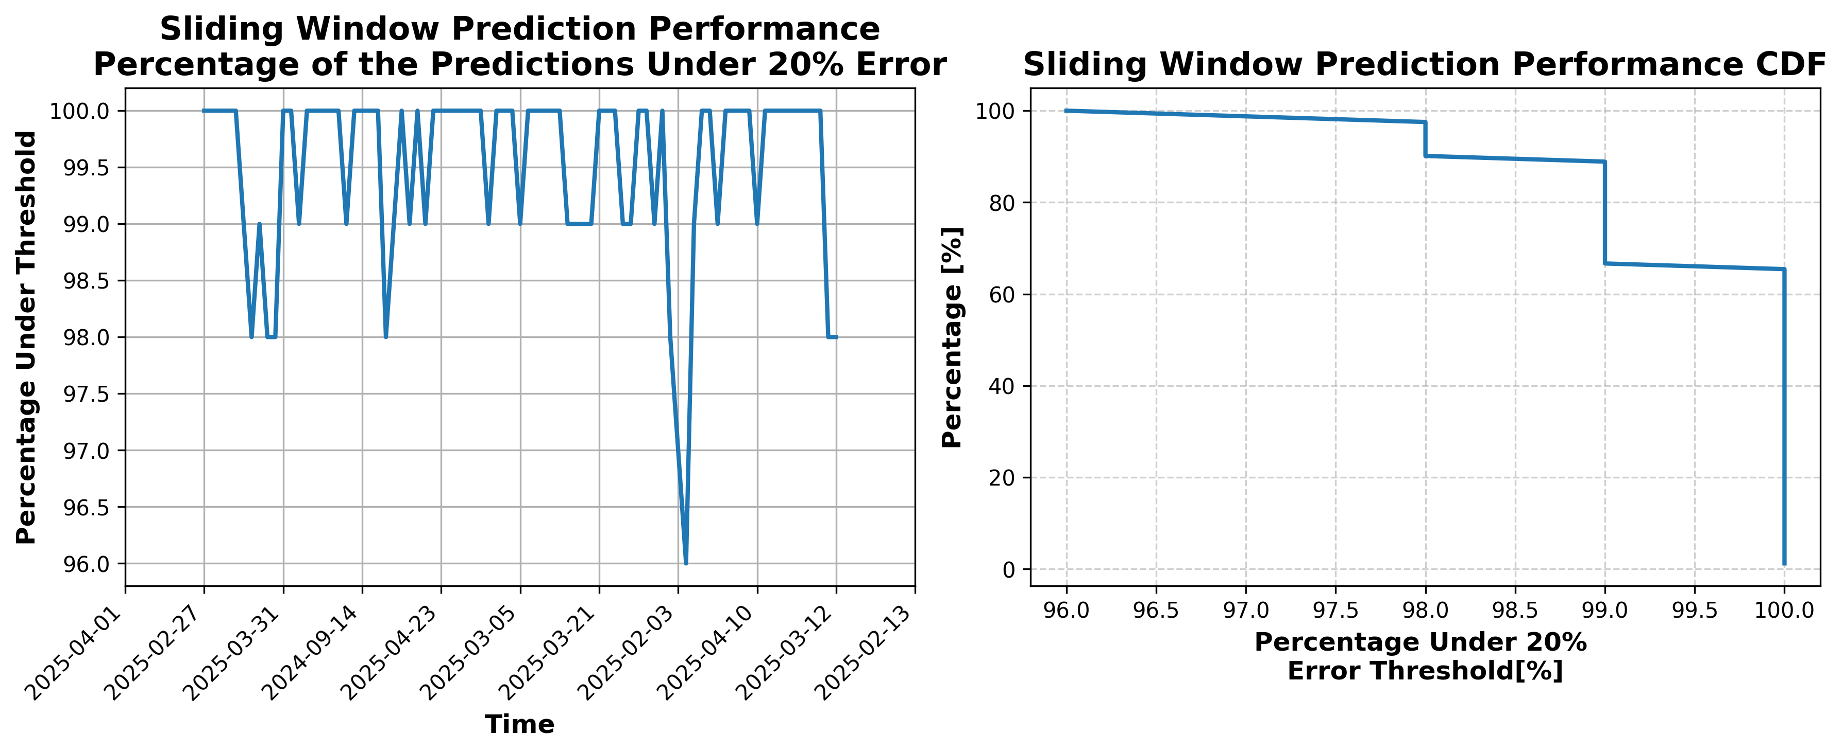

### Results for Latest_Test_2025-08-23.csv

Lines used: 8251 out of 14721 (56%)

Data sorted by: CHS Pickup Date

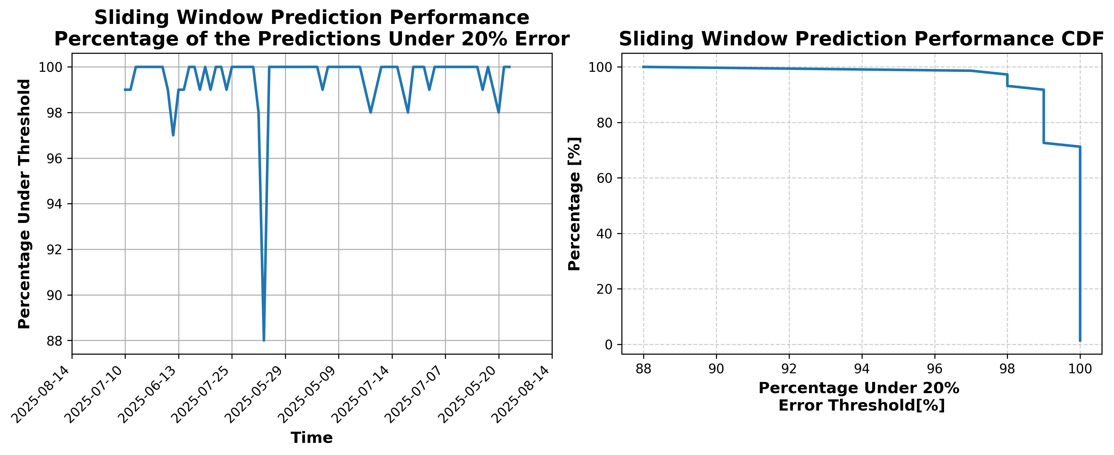

### Results for Latest_Test_2025-06-26.csv

Lines used: 9161 out of 13618 (67%)

Data sorted by: CHS Pickup Date

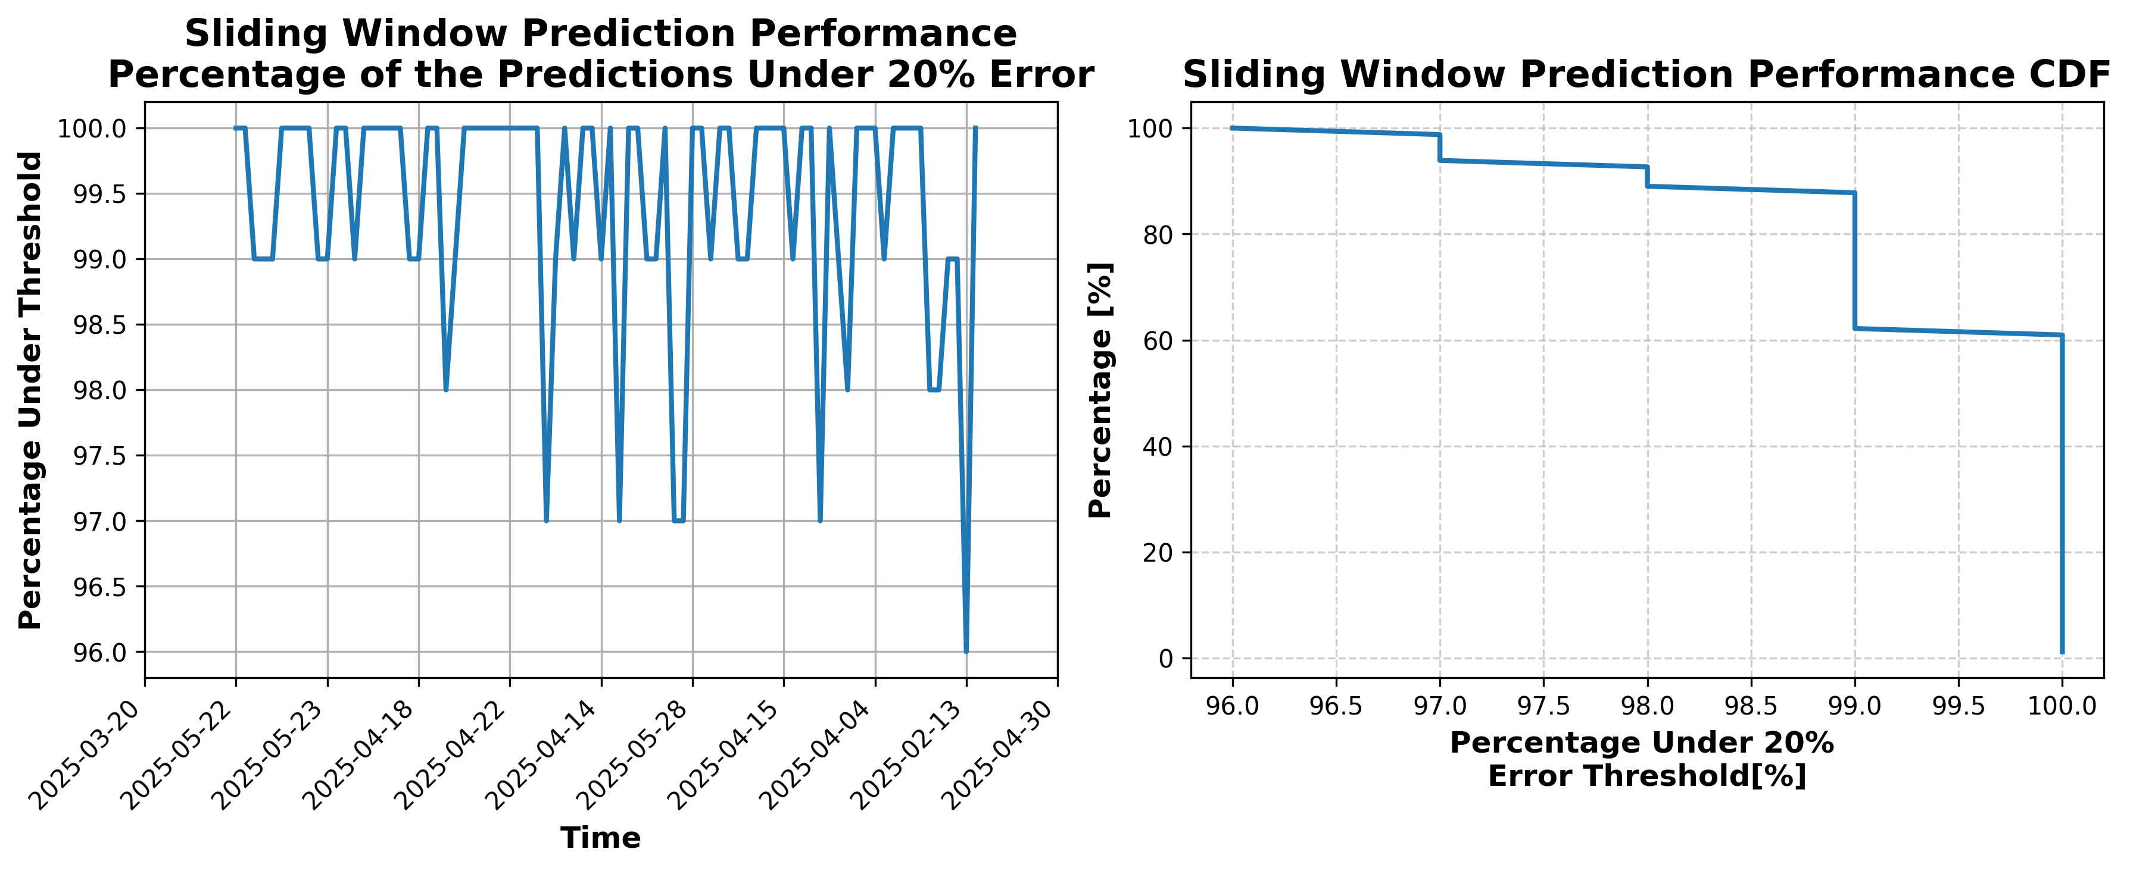

### Results for Latest_Test_2025-11-02.csv

Lines used: 7086 out of 14580 (48%)

Data sorted by: CHS Pickup Date

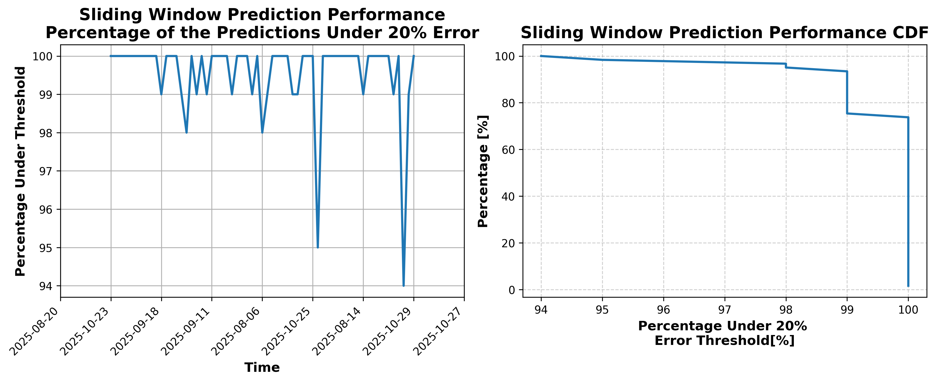

### Results for Latest_Test_2025-06-27.csv

Lines used: 9301 out of 13880 (67%)

Data sorted by: CHS Pickup Date

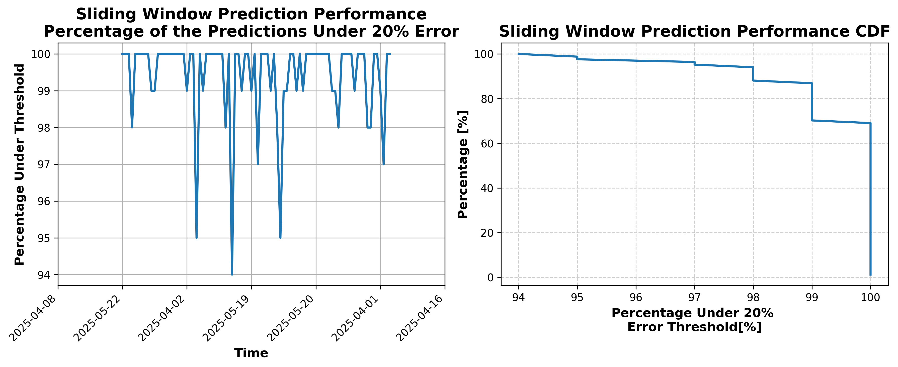

### Results for Latest_Test_2025-08-22.csv

Lines used: 8159 out of 14581 (55%)

Data sorted by: CHS Pickup Date

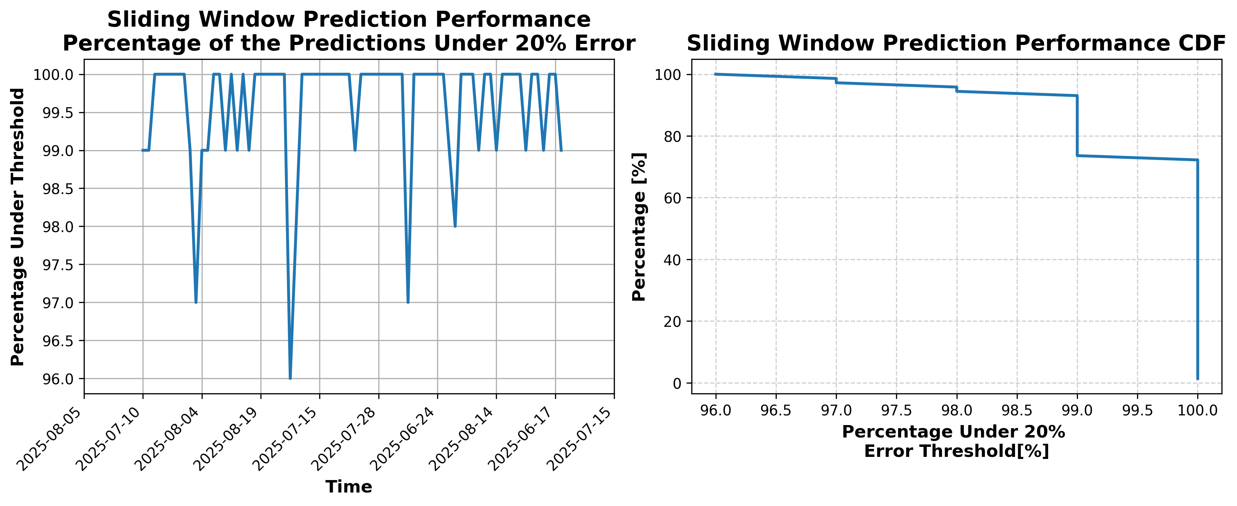

### Results for Latest_Test_2025-04-22.csv

Lines used: 9072 out of 16197 (56%)

Data sorted by: CHS Pickup Date

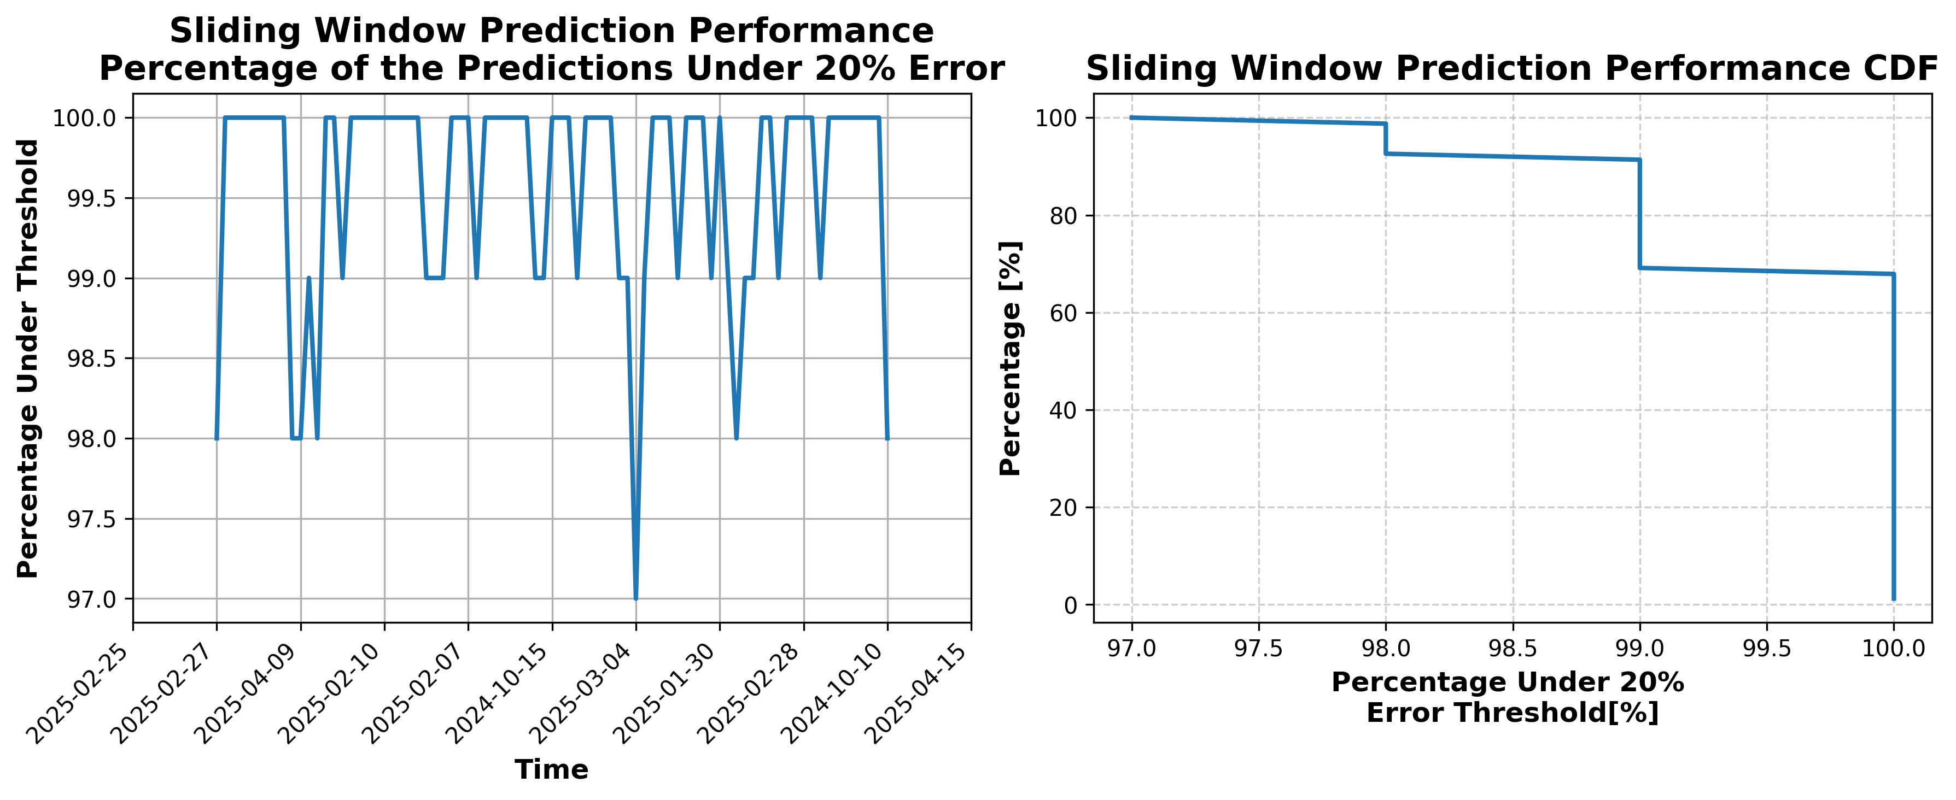

### Results for Latest_Test_2025-03-17.csv

Lines used: 9178 out of 16939 (54%)

Data sorted by: CHS Pickup Date

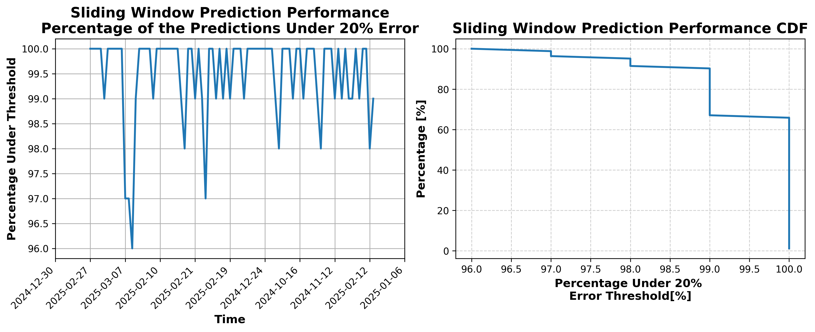

### Results for Latest_Test_2025-03-03.csv

Lines used: 8975 out of 17488 (51%)

Data sorted by: CHS Pickup Date

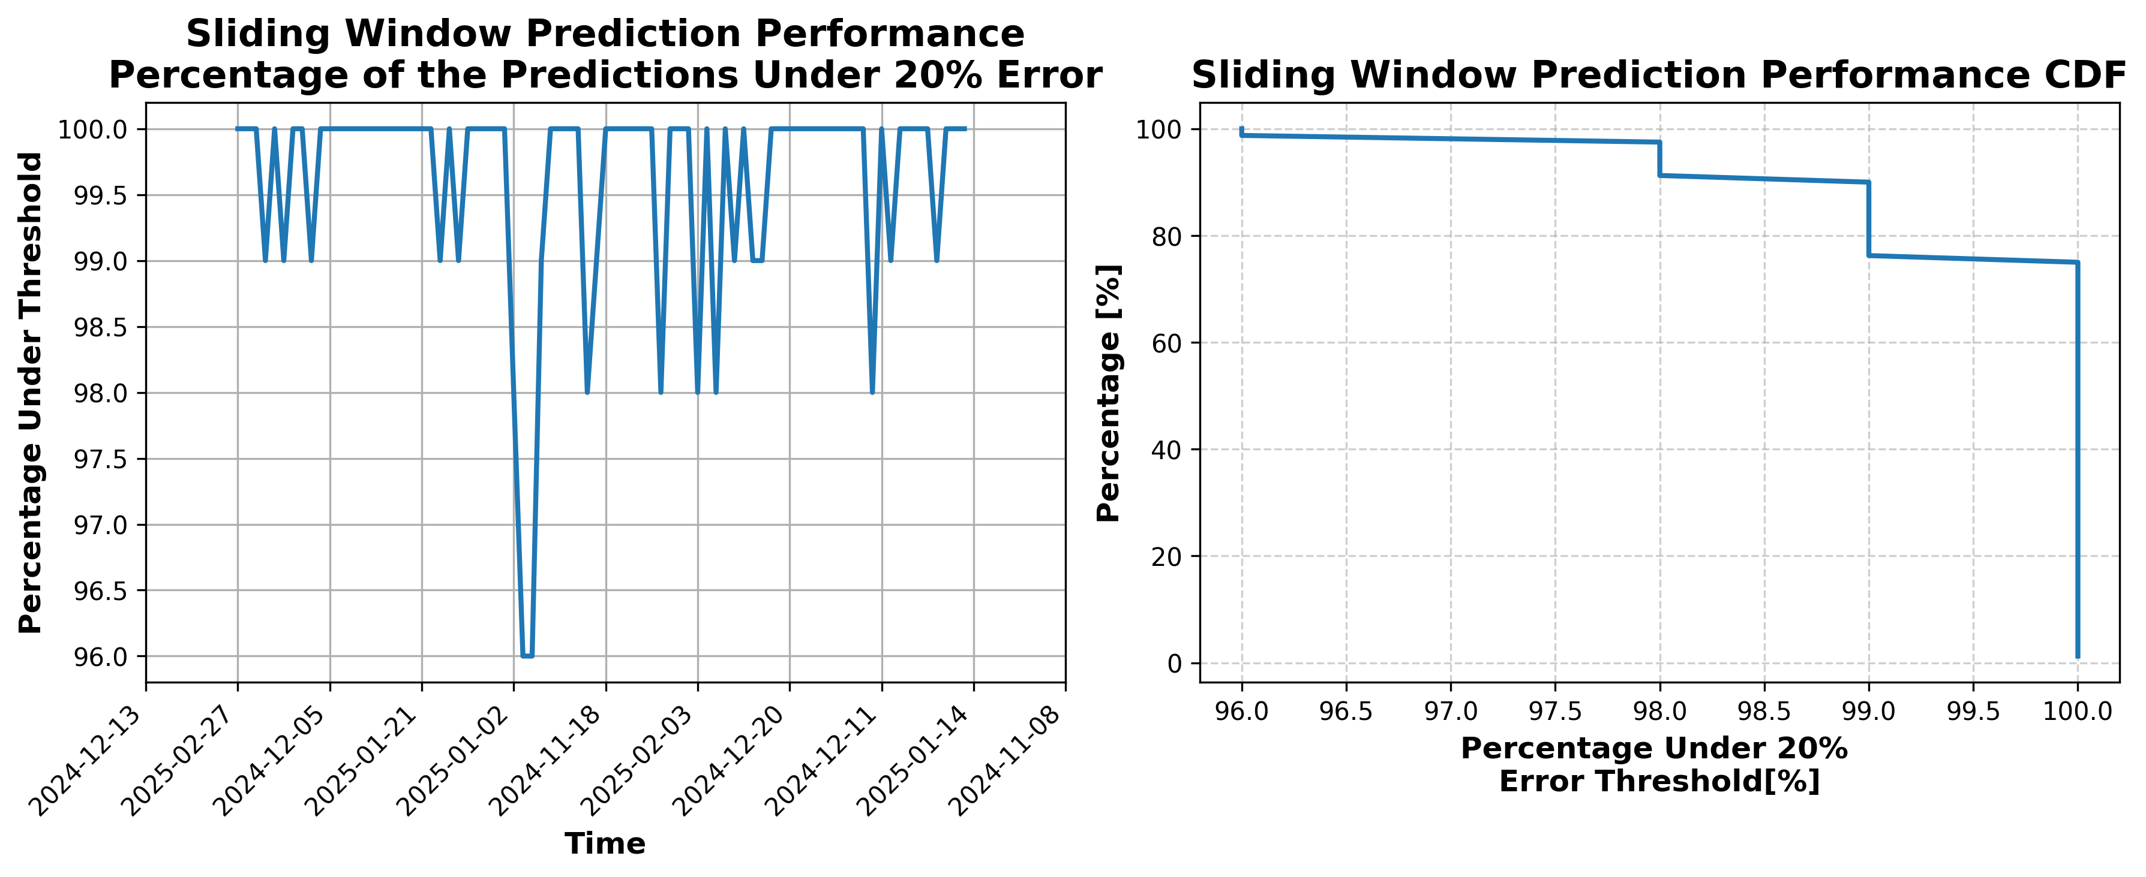

### Results for Latest_Test_2025-03-15.csv

Lines used: 9323 out of 17639 (52%)

Data sorted by: CHS Pickup Date

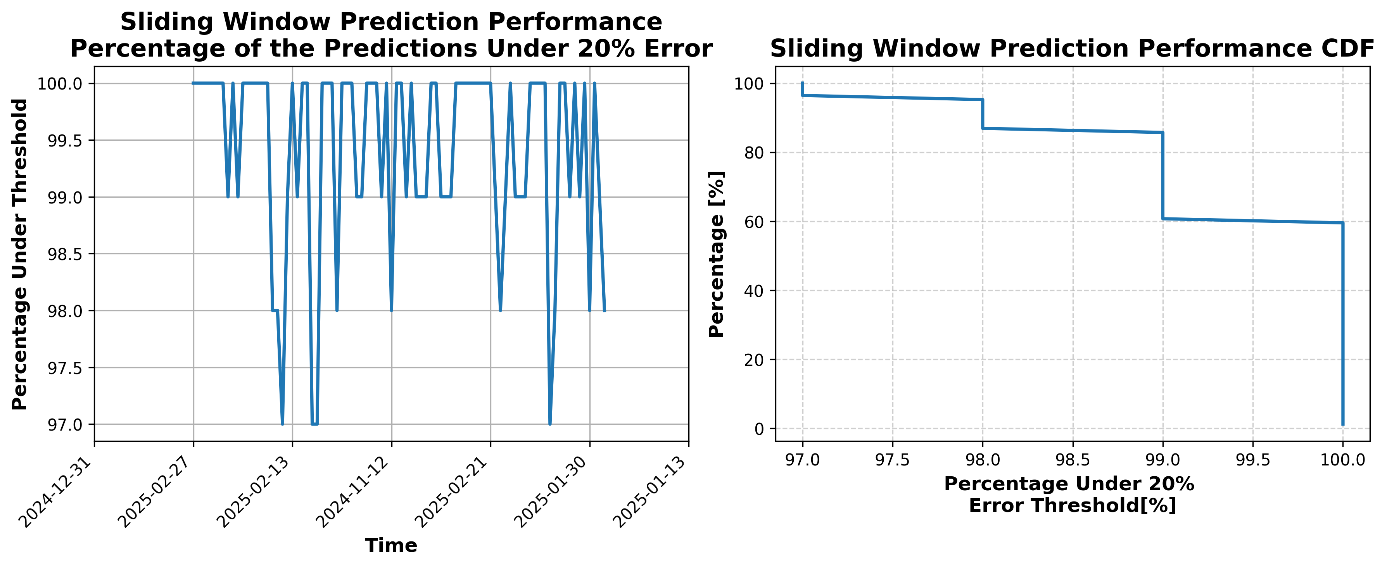

### Results for Latest_Test_2025-04-08.csv

Lines used: 9750 out of 16626 (58%)

Data sorted by: CHS Pickup Date

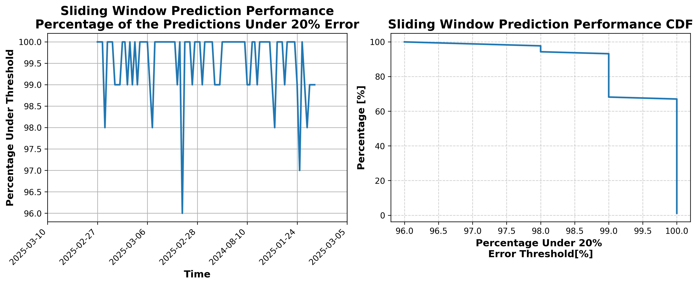

### Results for Latest_Test_2025-04-20.csv

Lines used: 9371 out of 16493 (56%)

Data sorted by: CHS Pickup Date

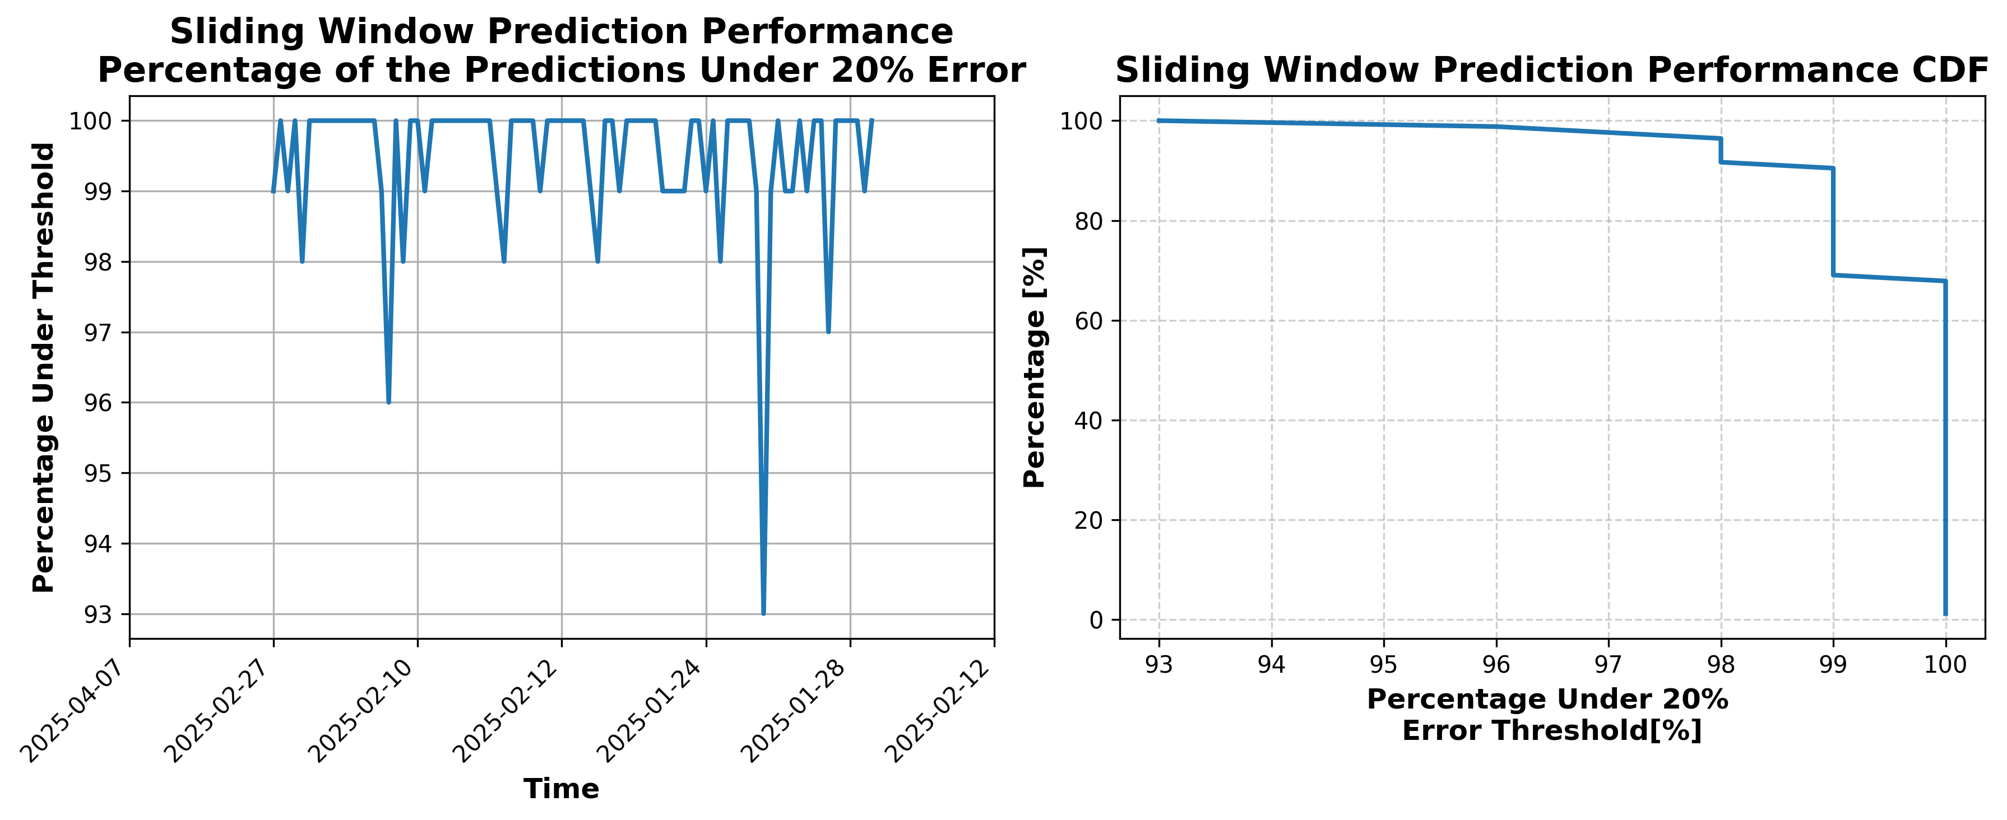

### Results for Latest_Test_2025-03-29.csv

Lines used: 9763 out of 17024 (57%)

Data sorted by: CHS Pickup Date

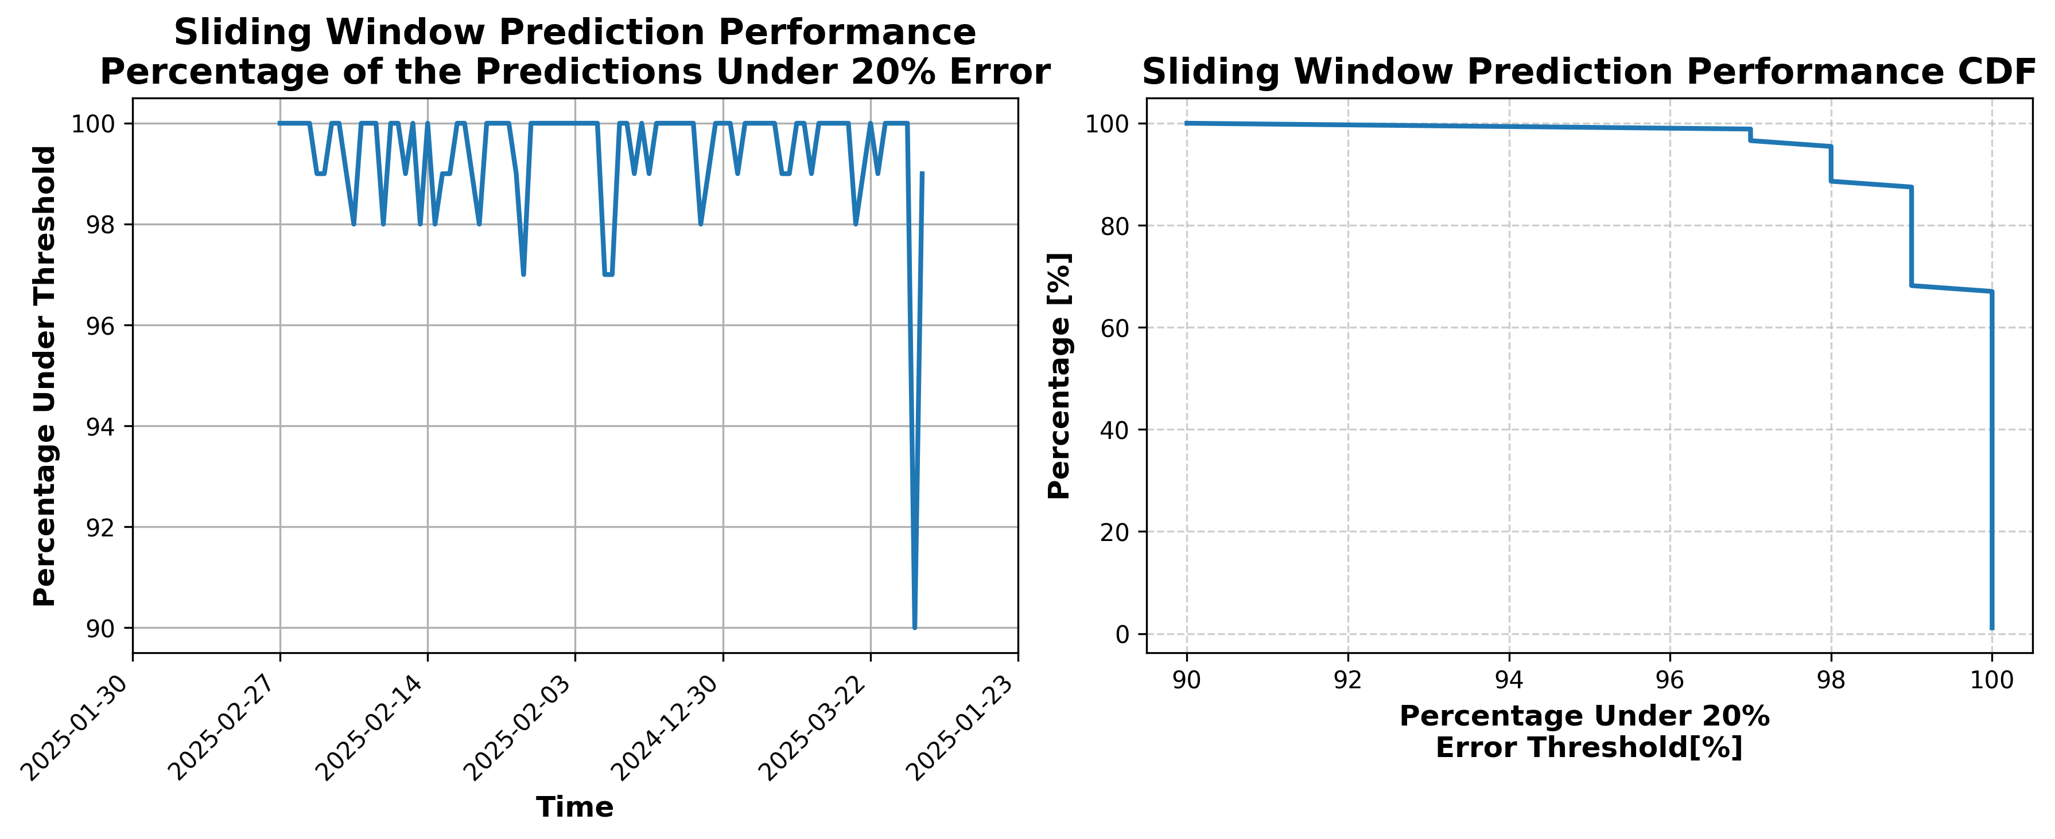

### Results for Latest_Test_2025-06-19.csv

Lines used: 9130 out of 13787 (66%)

Data sorted by: CHS Pickup Date

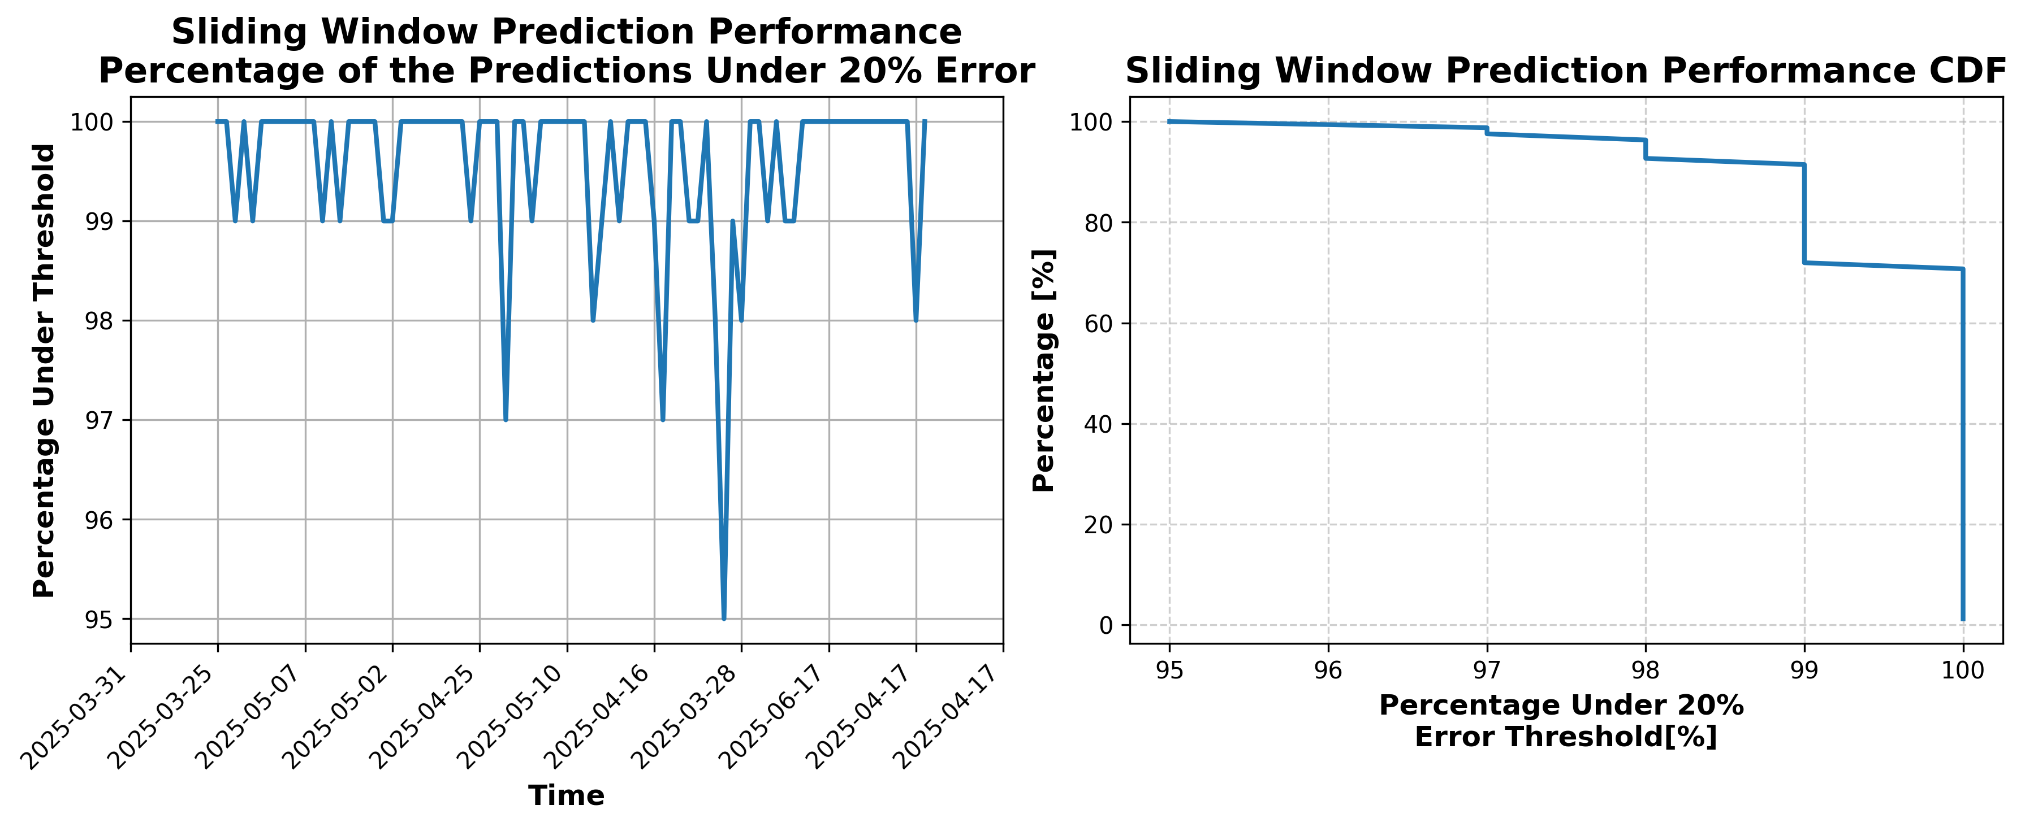

### Results for Latest_Test_2025-08-20.csv

Lines used: 8491 out of 14578 (58%)

Data sorted by: CHS Pickup Date

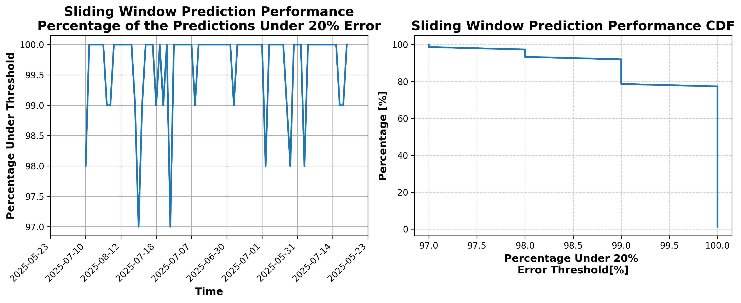

### Results for Latest_Test_2025-06-25.csv

Lines used: 9276 out of 13849 (66%)

Data sorted by: CHS Pickup Date

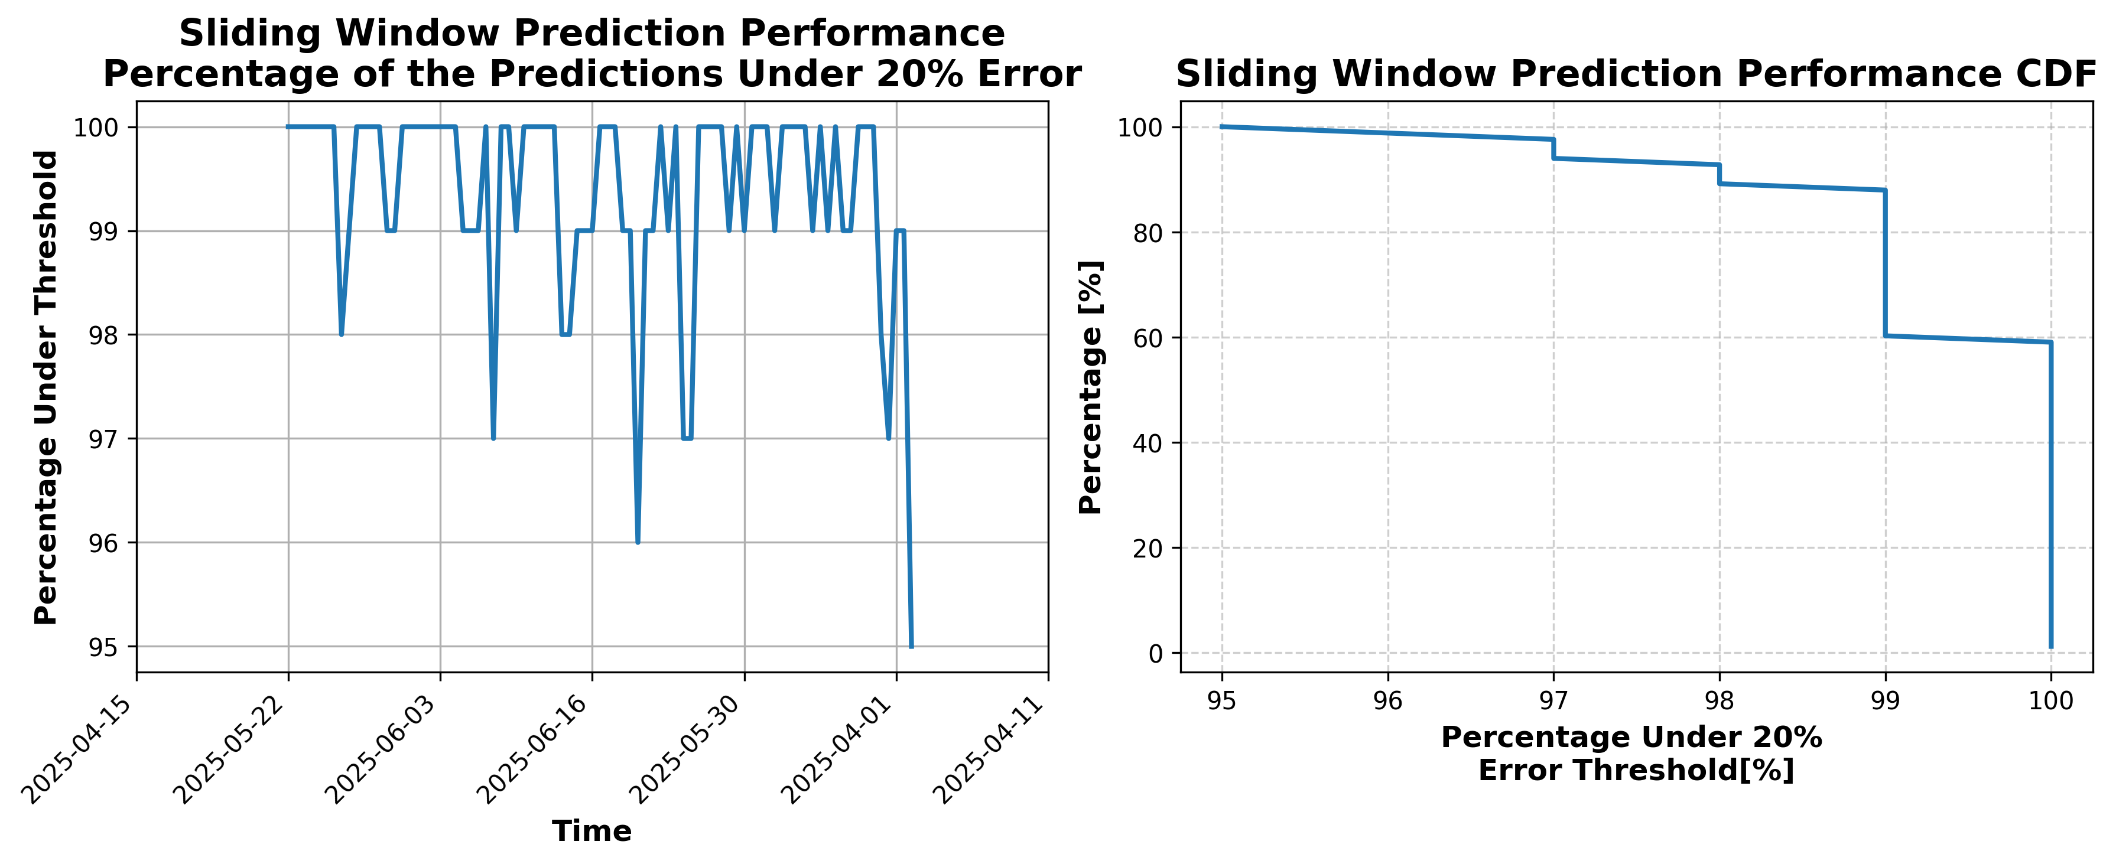

### Results for Latest_Test_2025-08-08.csv

Lines used: 8608 out of 14352 (59%)

Data sorted by: CHS Pickup Date

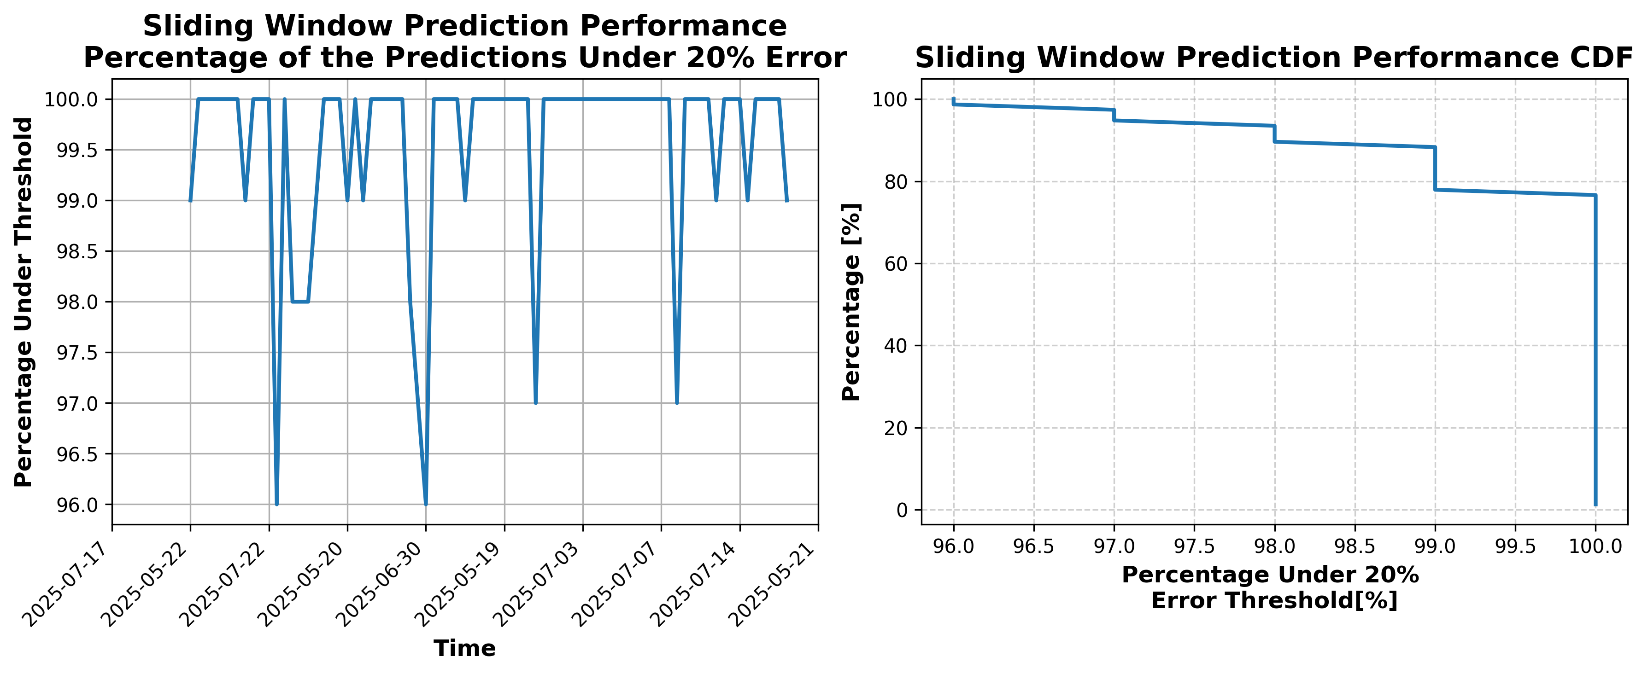

### Results for Latest_Test_2025-11-01.csv

Lines used: 7235 out of 14725 (49%)

Data sorted by: CHS Pickup Date

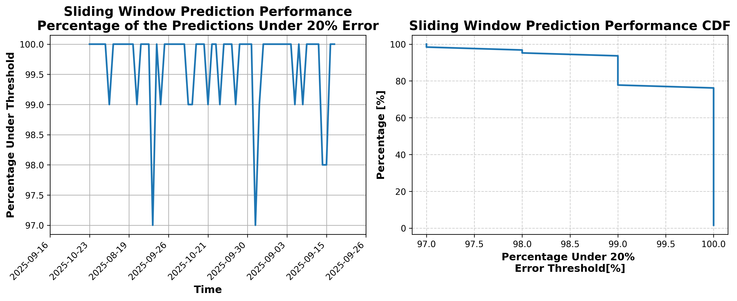

### Results for Latest_Test_2025-06-30.csv

Lines used: 9218 out of 13911 (66%)

Data sorted by: CHS Pickup Date

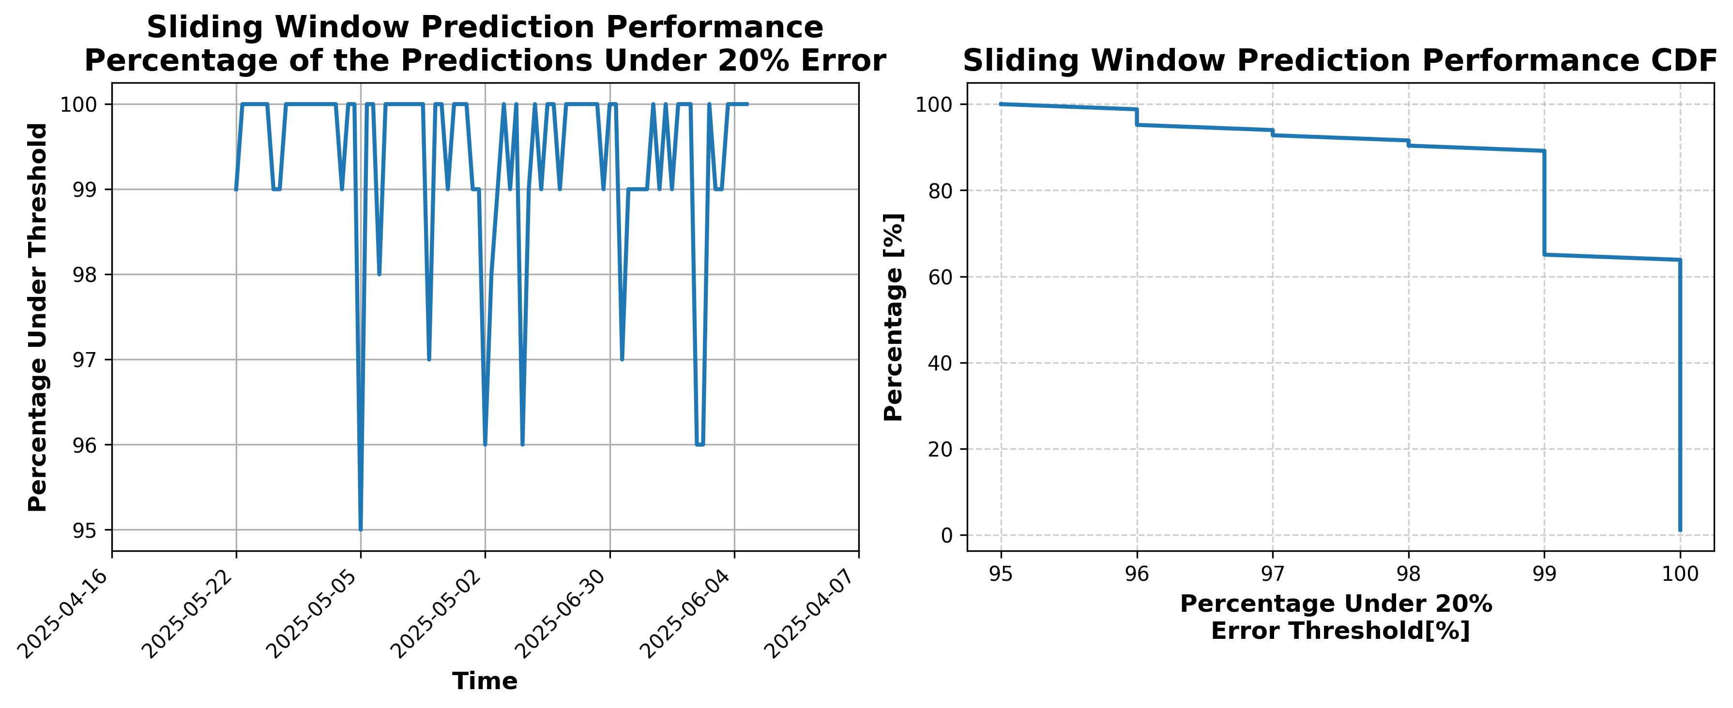

### Results for Latest_Test_2025-08-09.csv

Lines used: 8670 out of 14478 (59%)

Data sorted by: CHS Pickup Date

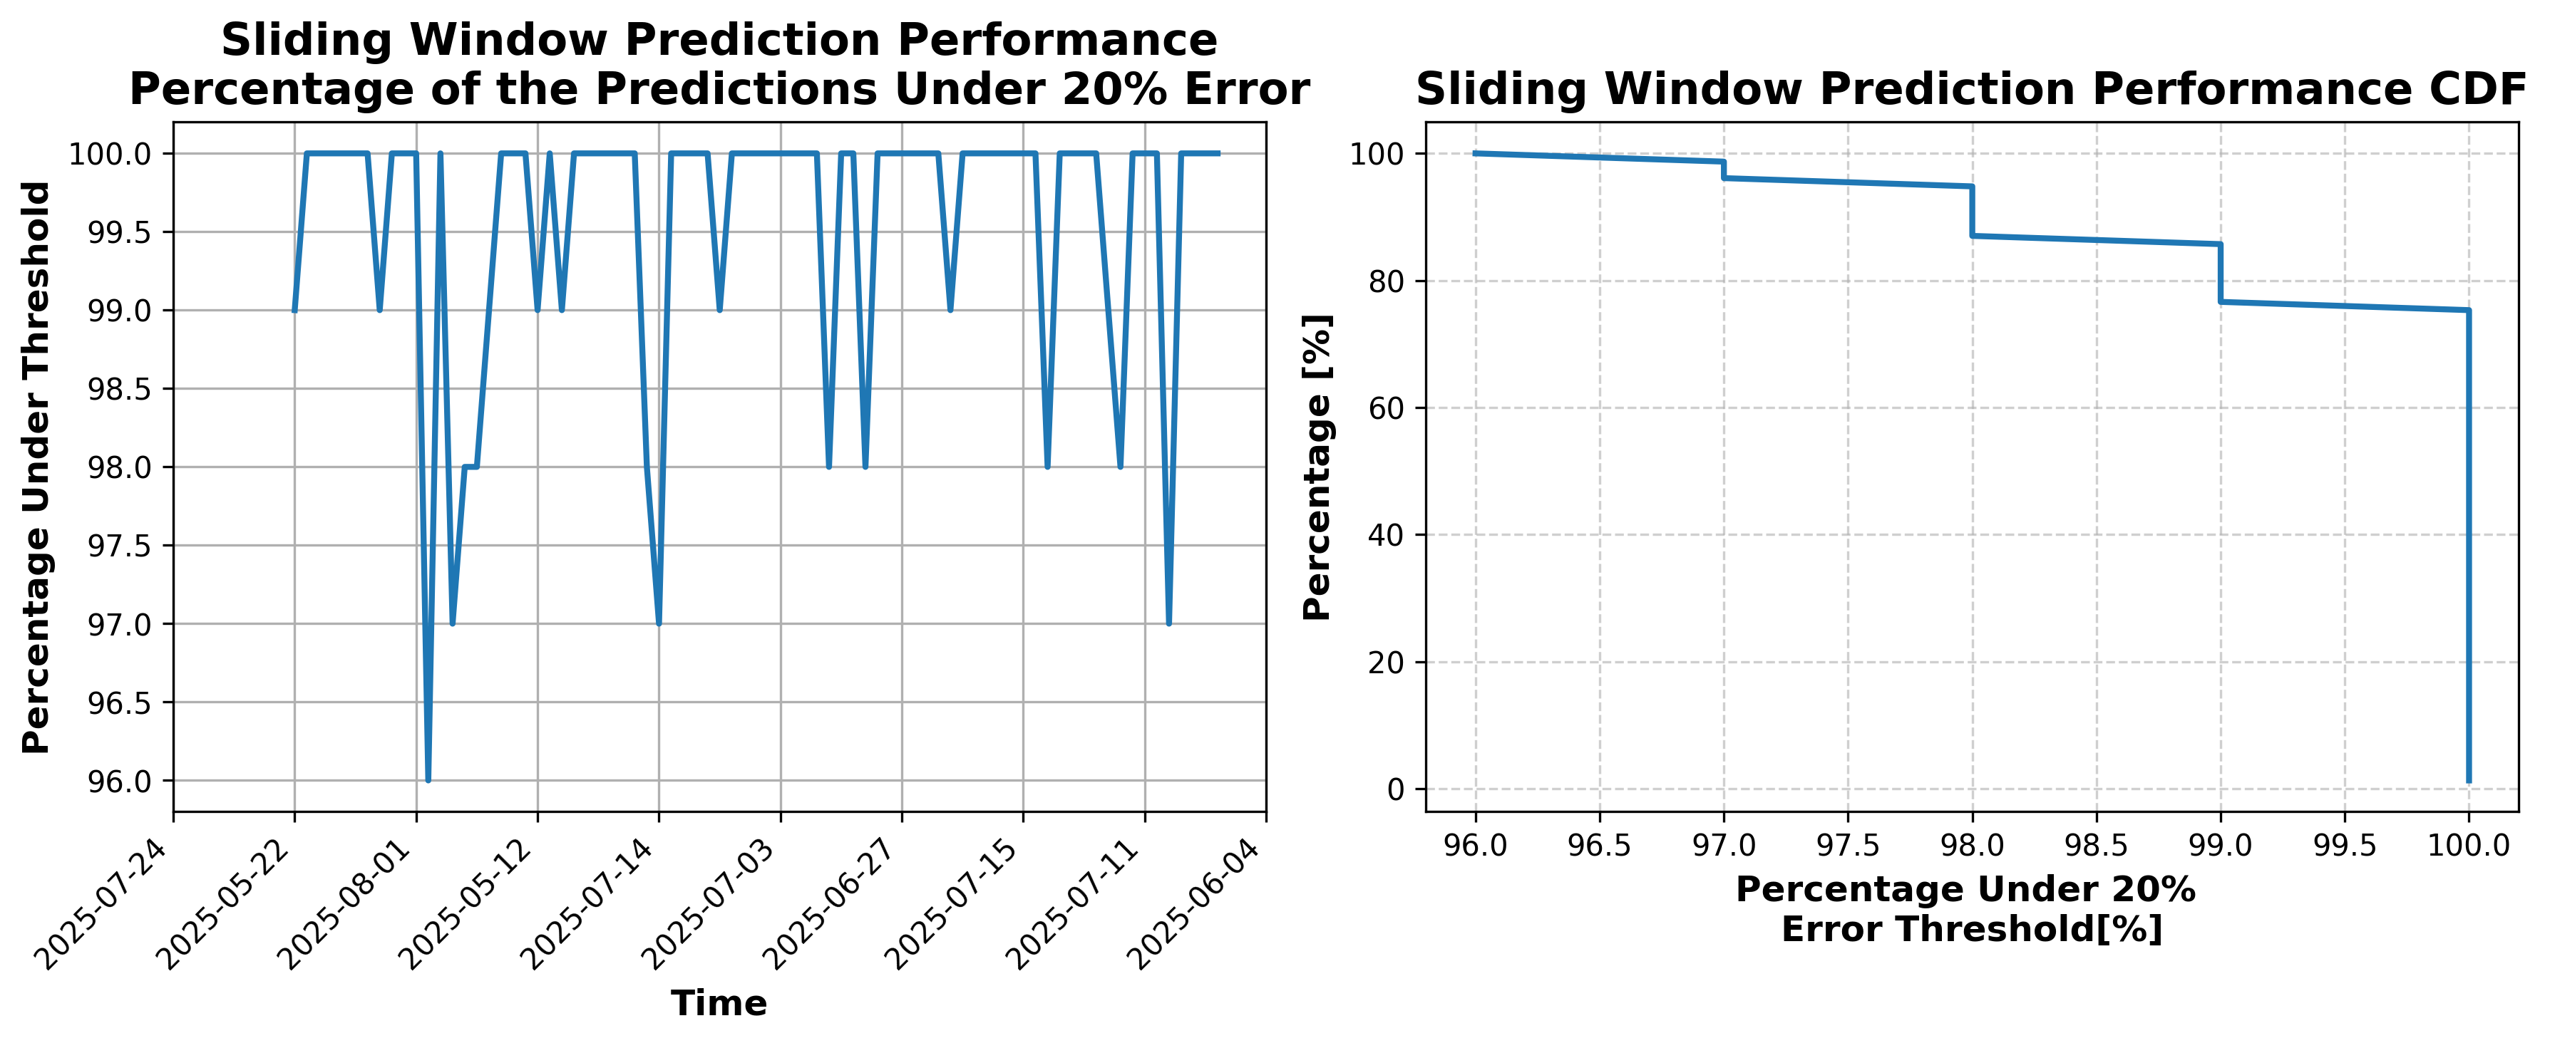

### Results for Latest_Test_2025-06-24.csv

Lines used: 9131 out of 13867 (65%)

Data sorted by: CHS Pickup Date

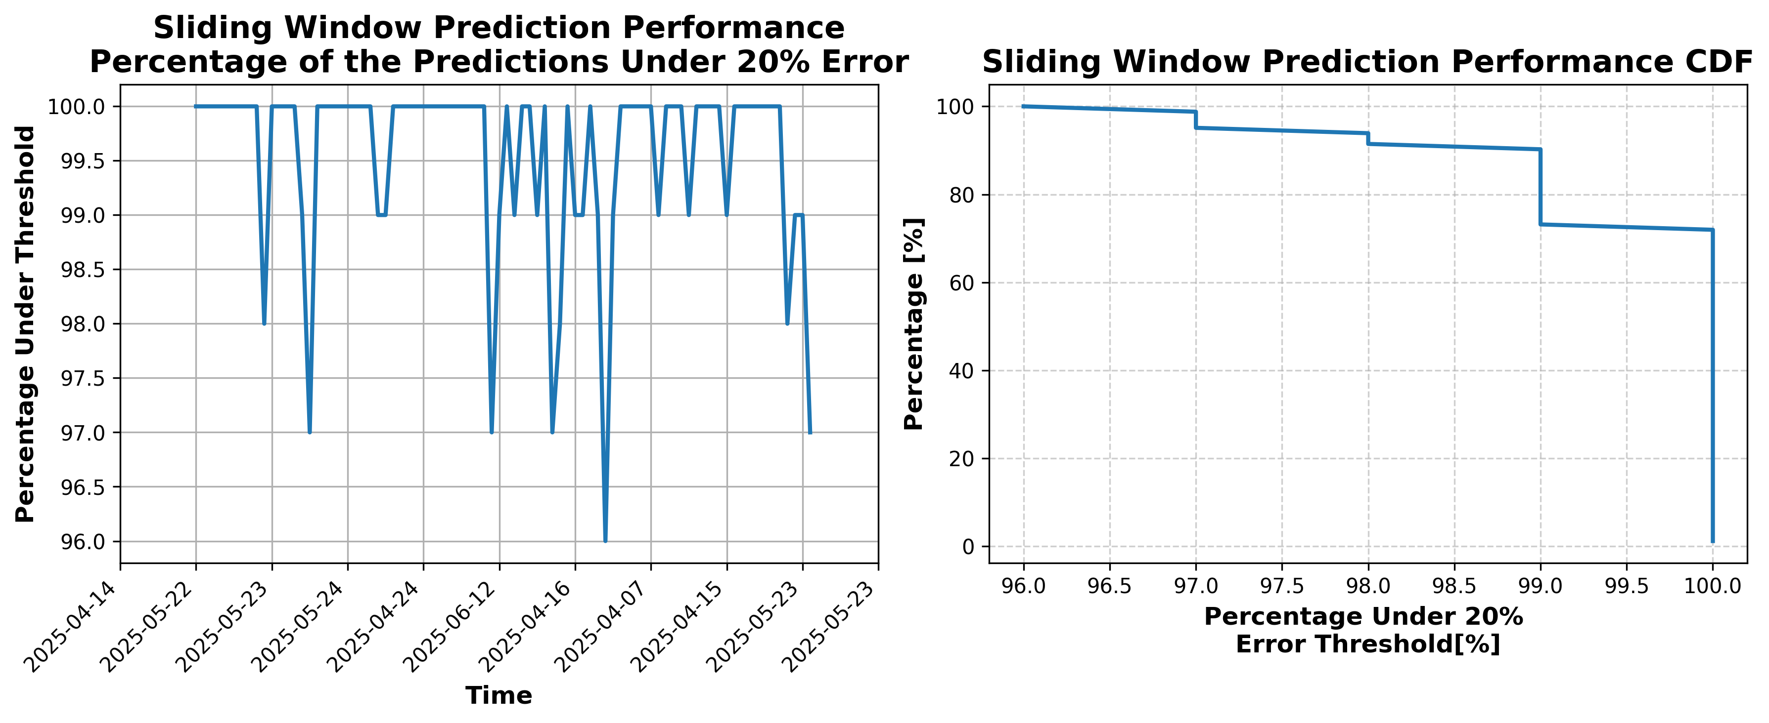

### Results for Latest_Test_2025-08-21.csv

Lines used: 8071 out of 14308 (56%)

Data sorted by: CHS Pickup Date

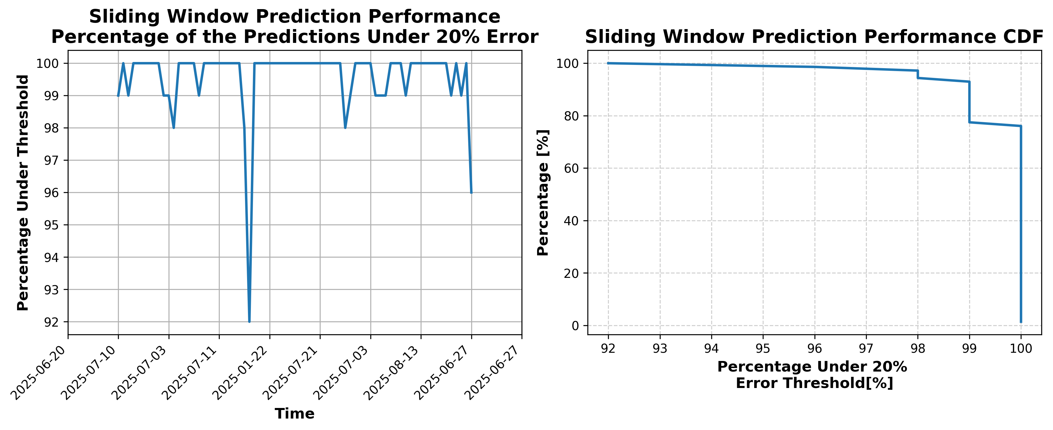

### Results for Latest_Test_2025-06-18.csv

Lines used: 9188 out of 13913 (66%)

Data sorted by: CHS Pickup Date

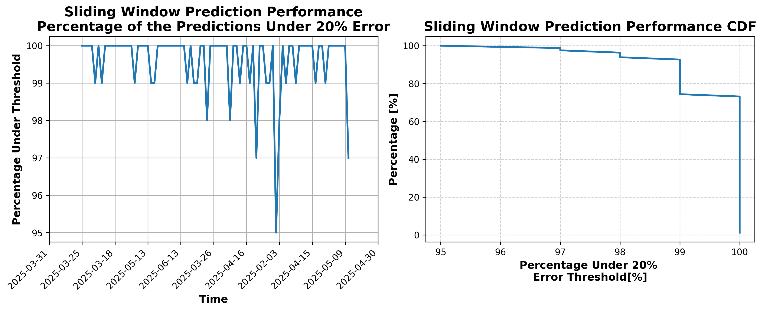

### Results for Latest_Test_2025-04-21.csv

Lines used: 9178 out of 16301 (56%)

Data sorted by: CHS Pickup Date

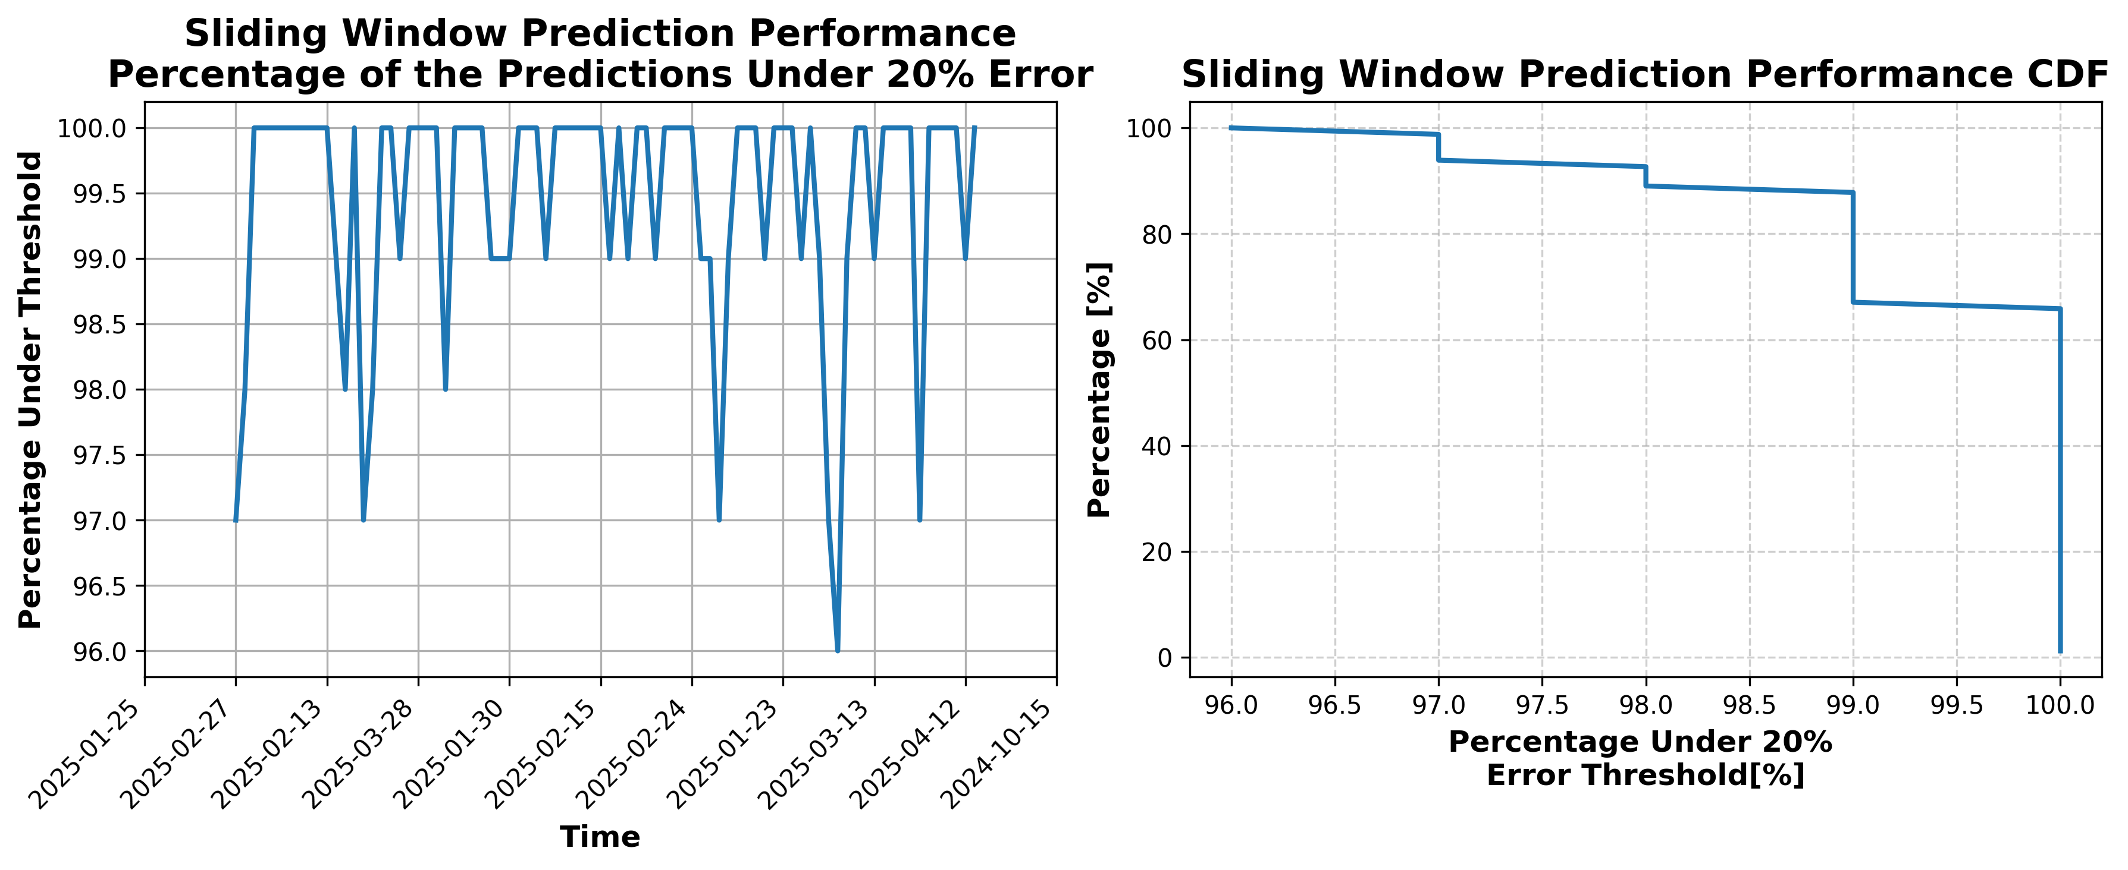

### Results for Latest_Test_2025-03-28.csv

Lines used: 9668 out of 16905 (57%)

Data sorted by: CHS Pickup Date

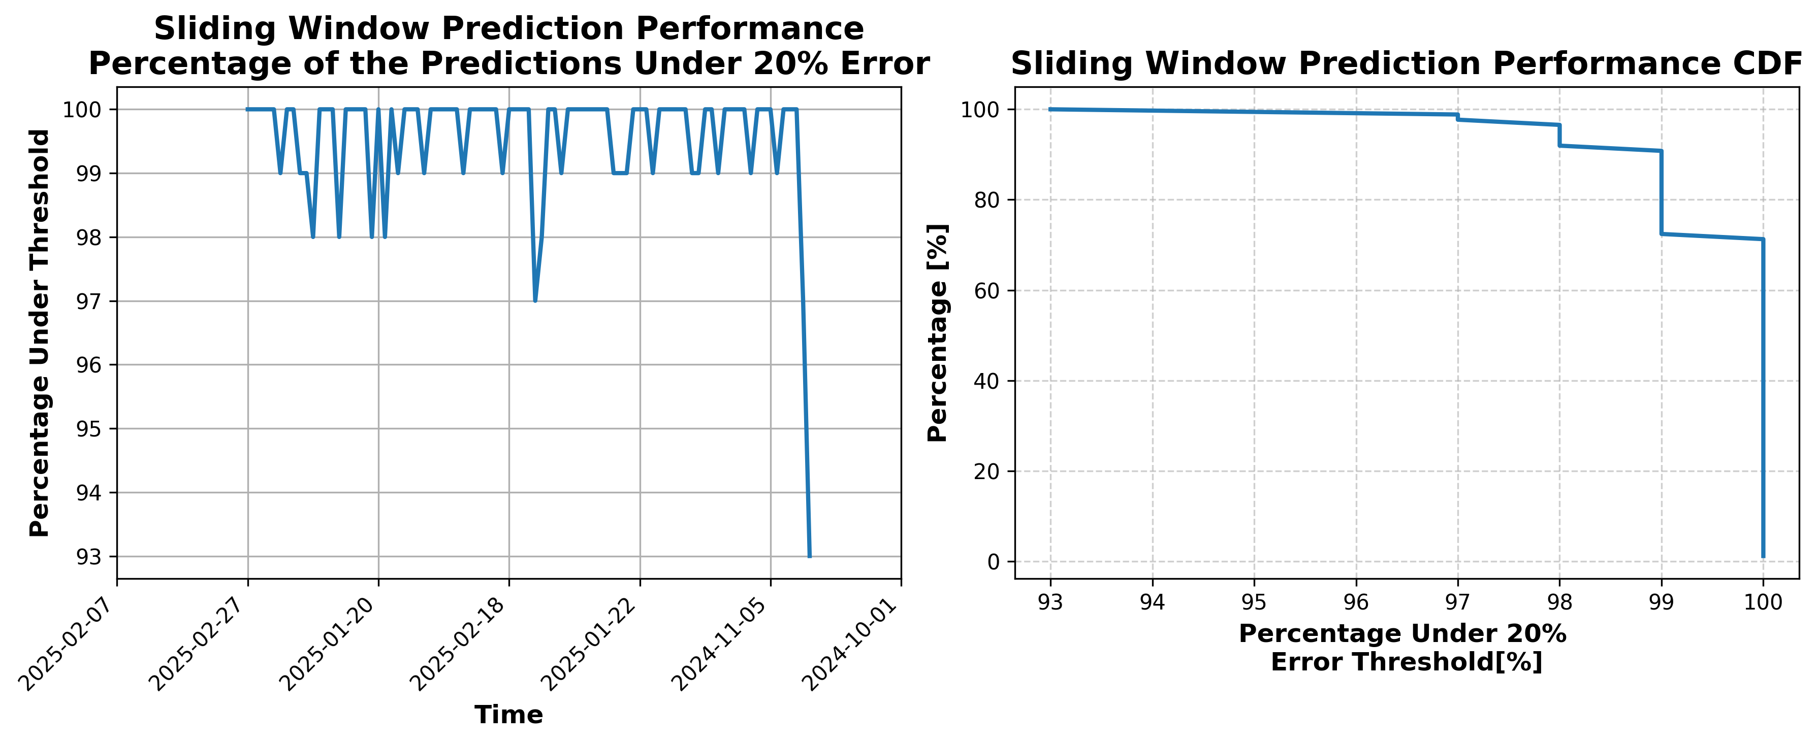

### Results for Latest_Test_2025-04-09.csv

Lines used: 9828 out of 16773 (58%)

Data sorted by: CHS Pickup Date

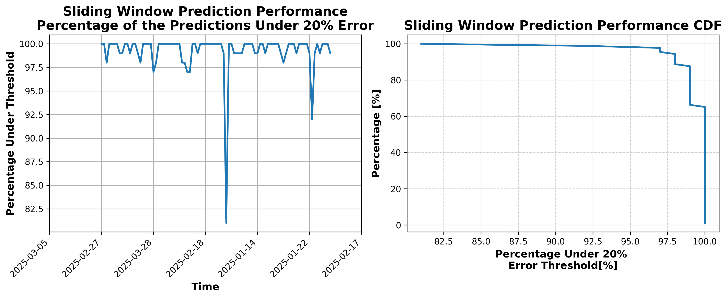

### Results for Latest_Test_2025-03-14.csv

Lines used: 9541 out of 18280 (52%)

Data sorted by: CHS Pickup Date

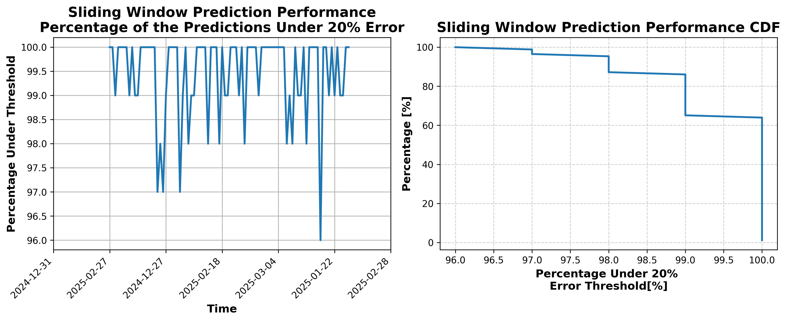

### Results for Latest_Test_2025-04-25.csv

Lines used: 8949 out of 16059 (55%)

Data sorted by: CHS Pickup Date

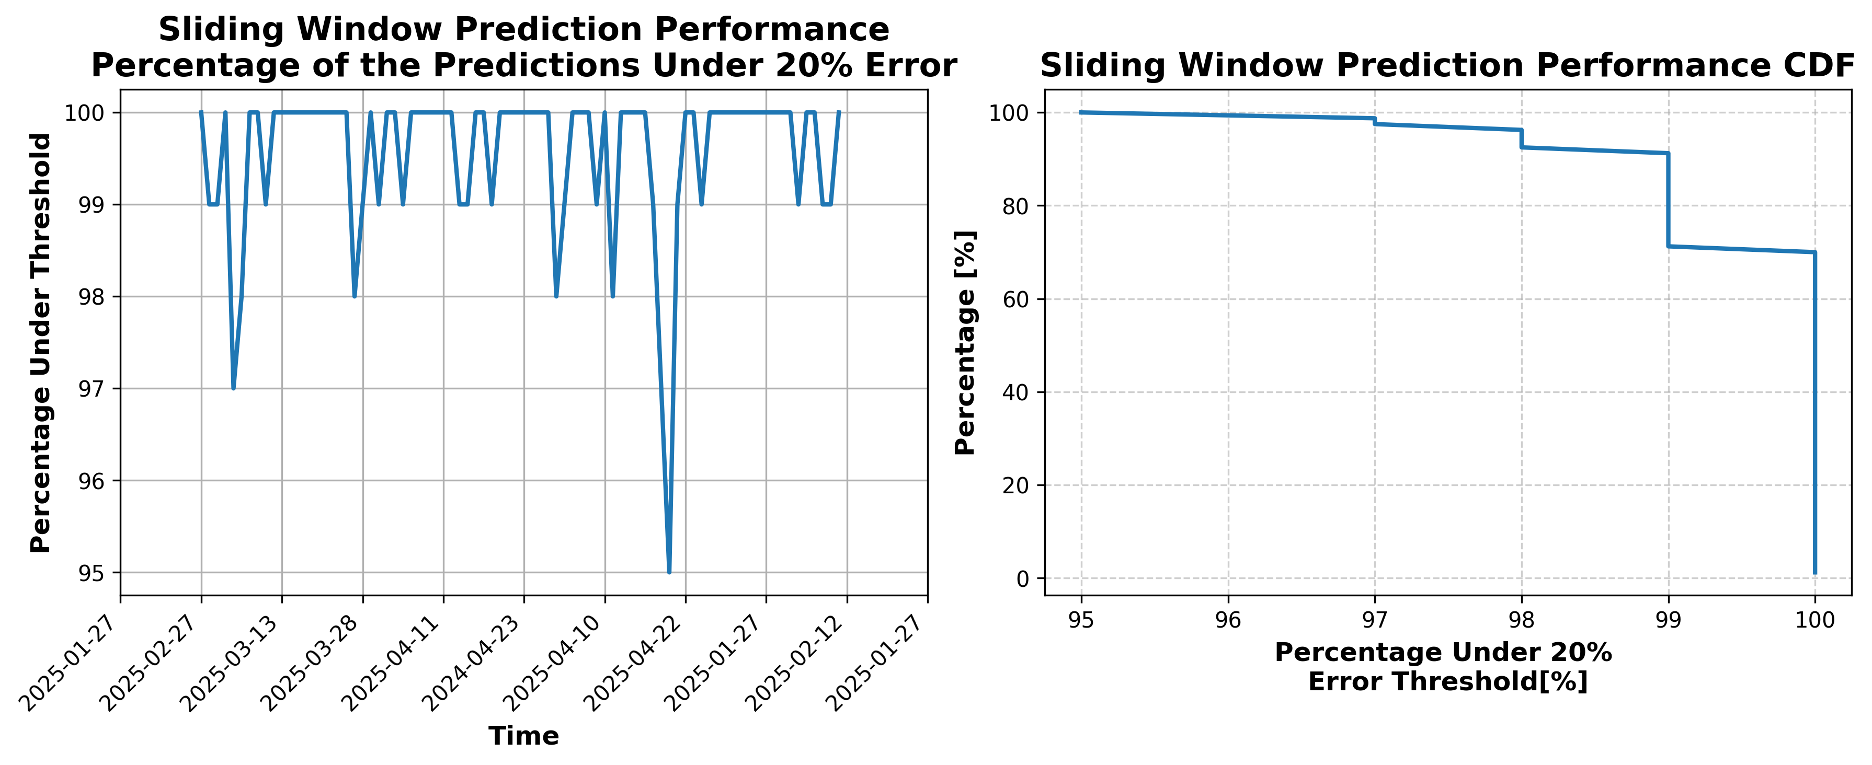

### Results for Latest_Test_2025-03-10.csv

Lines used: 10021 out of 19101 (52%)

Data sorted by: CHS Pickup Date

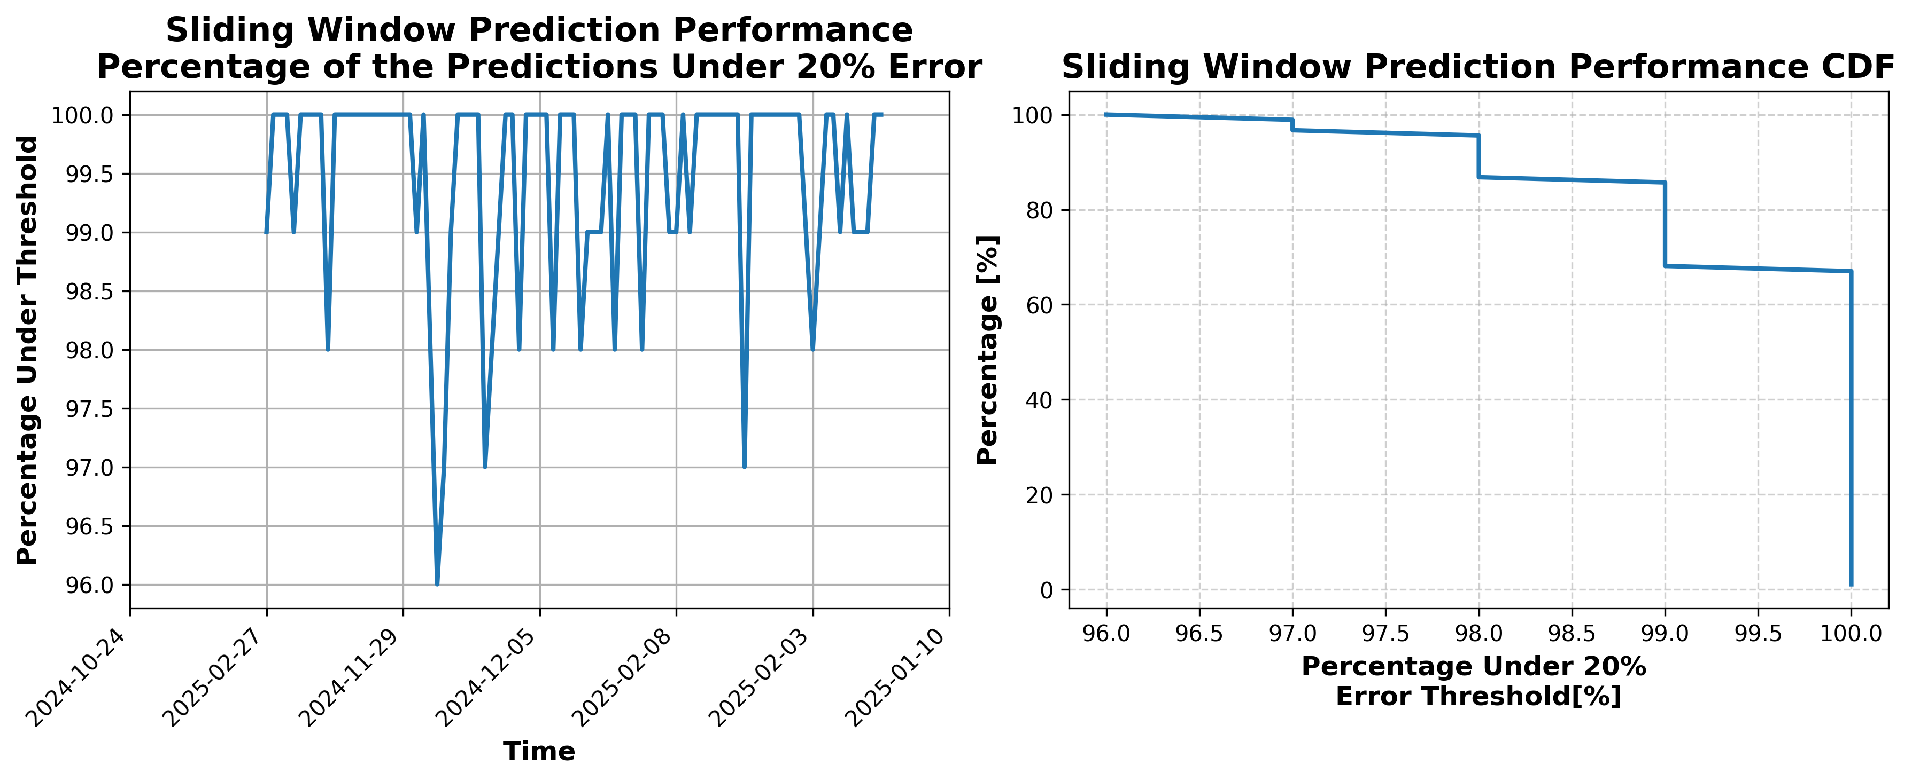

### Results for Latest_Test_2025-04-19.csv

Lines used: 9573 out of 16743 (57%)

Data sorted by: CHS Pickup Date

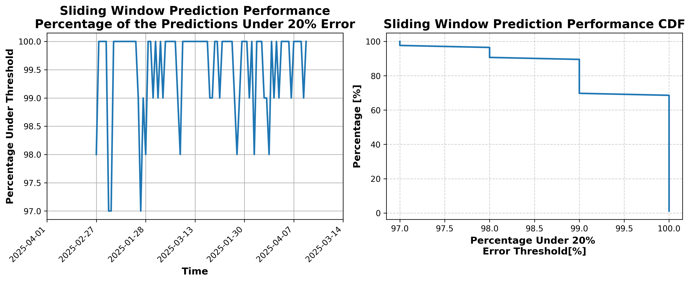

### Results for Latest_Test_2025-03-04.csv

Lines used: 8942 out of 17429 (51%)

Data sorted by: CHS Pickup Date

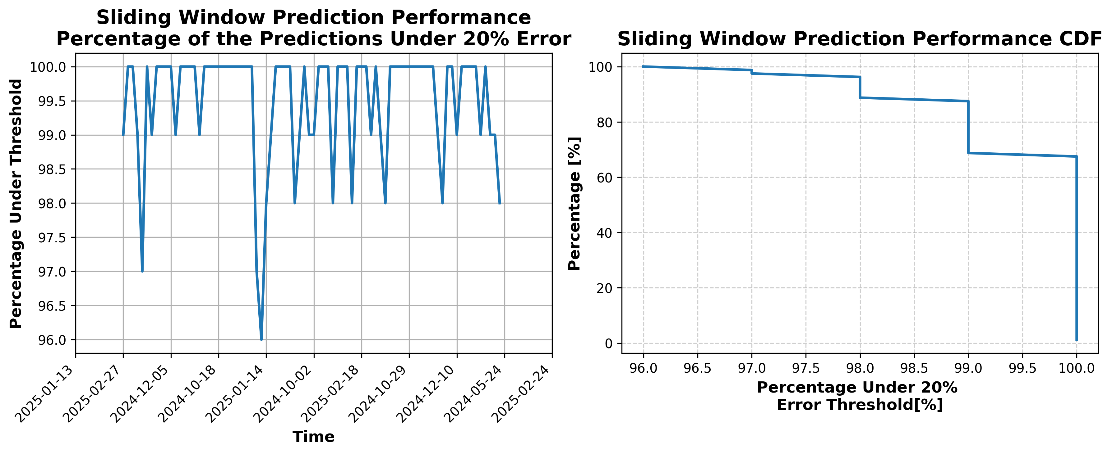

### Results for Latest_Test_2025-06-20.csv

Lines used: 9159 out of 13904 (65%)

Data sorted by: CHS Pickup Date

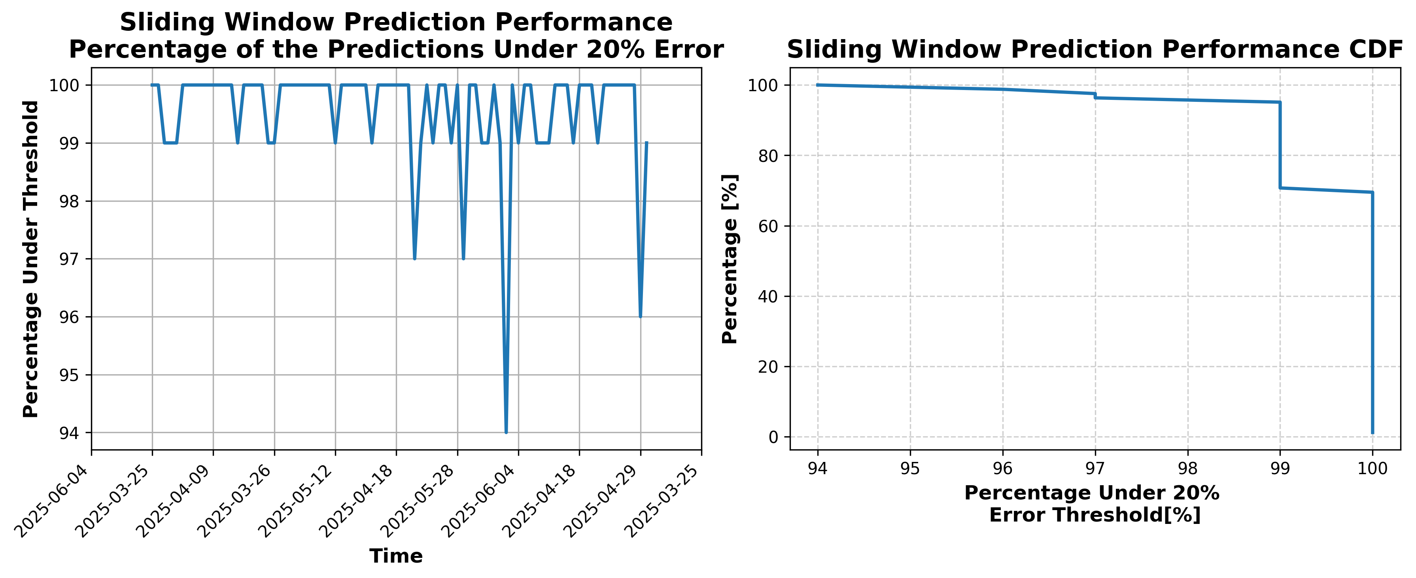

### Results for Latest_Test_2025-08-19.csv

Lines used: 8512 out of 14516 (58%)

Data sorted by: CHS Pickup Date

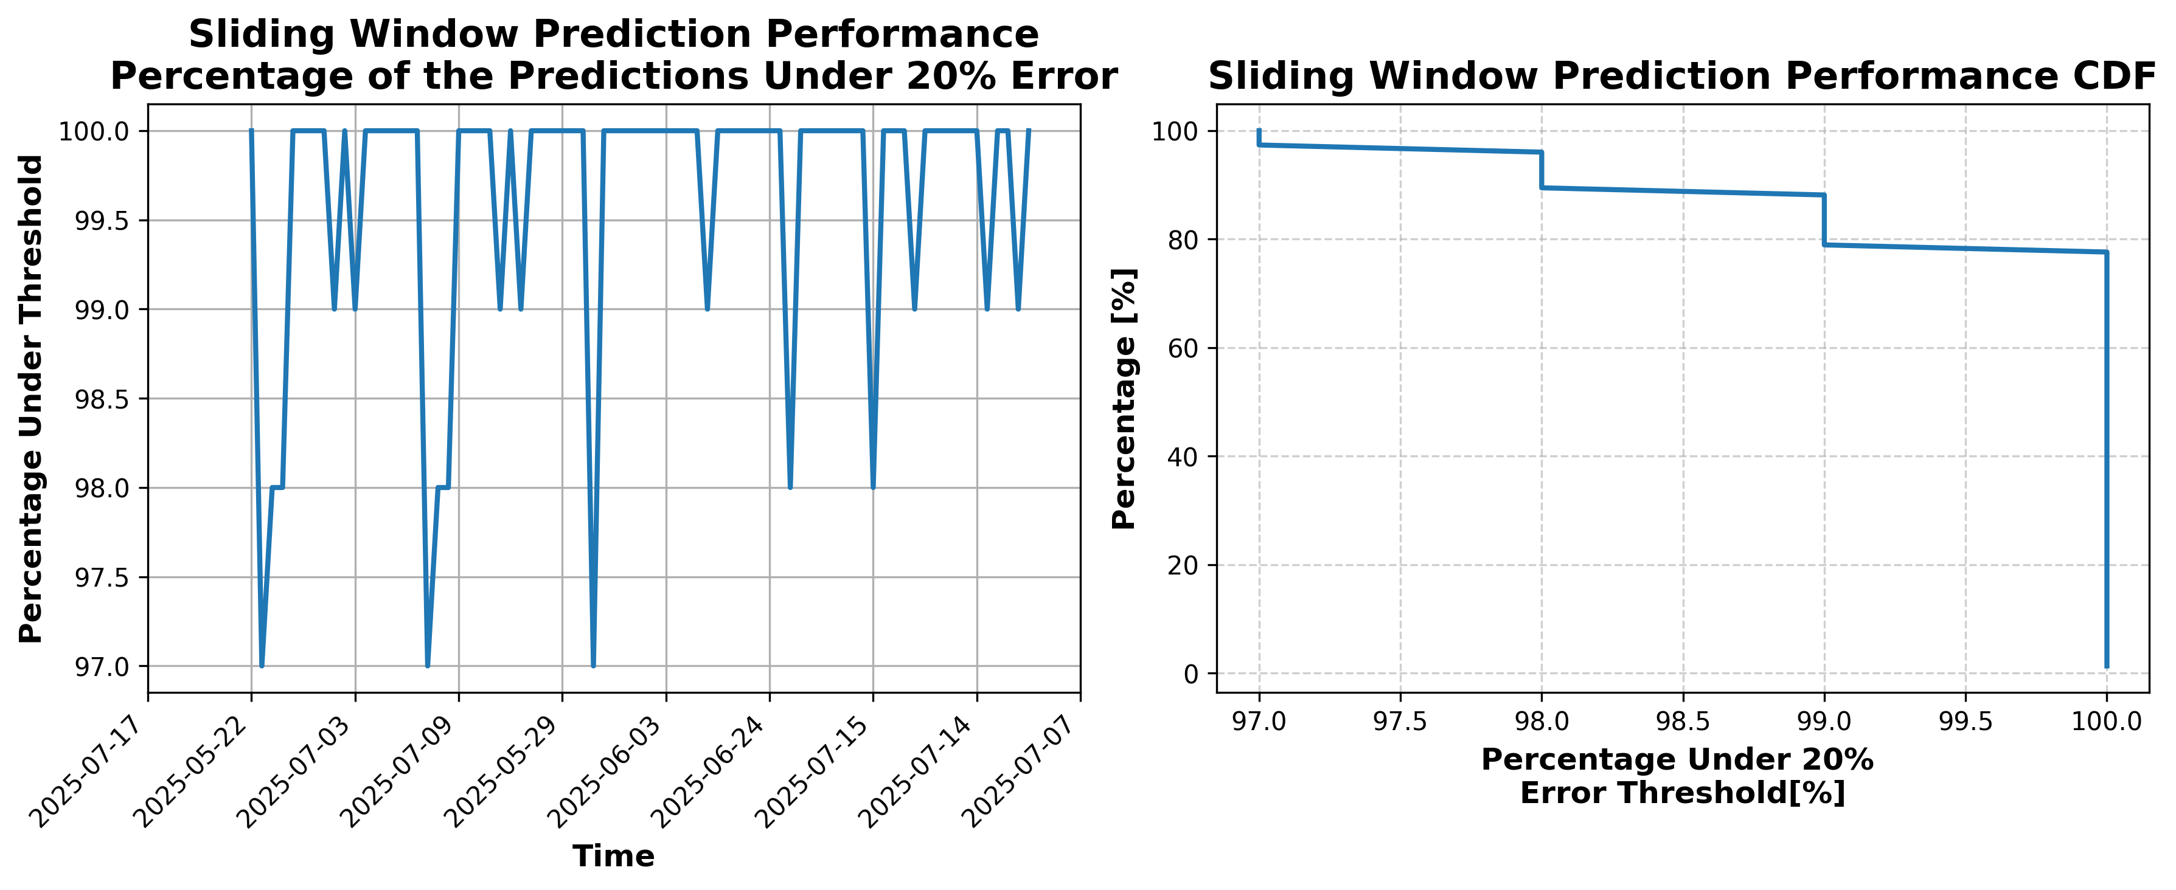

### Results for Latest_Test_2025-08-31.csv

Lines used: 8048 out of 14505 (55%)

Data sorted by: CHS Pickup Date

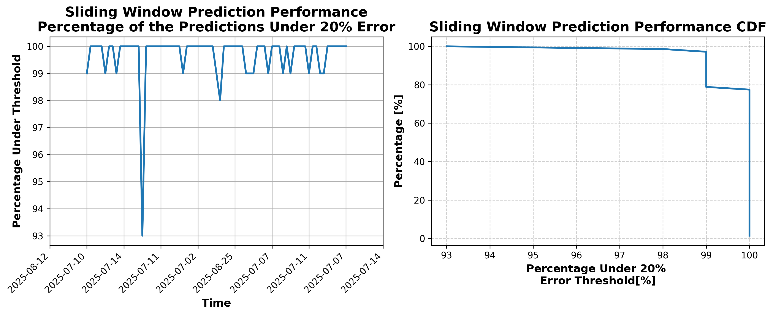

### Results for Latest_Test_2025-06-08.csv

Lines used: 9338 out of 14060 (66%)

Data sorted by: CHS Pickup Date

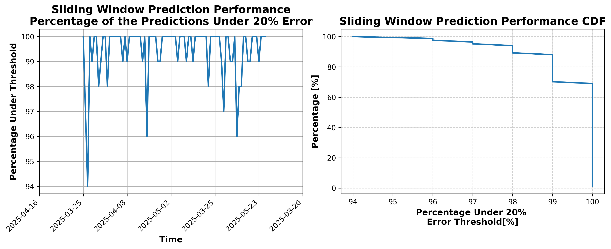

### Results for Latest_Test_2025-08-25.csv

Lines used: 7984 out of 14414 (55%)

Data sorted by: CHS Pickup Date

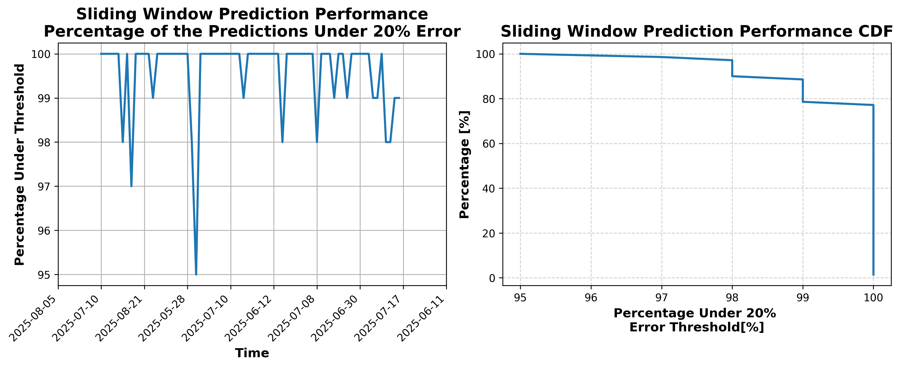

### Results for Latest_Test_2025-08-24.csv

Lines used: 8286 out of 14731 (56%)

Data sorted by: CHS Pickup Date

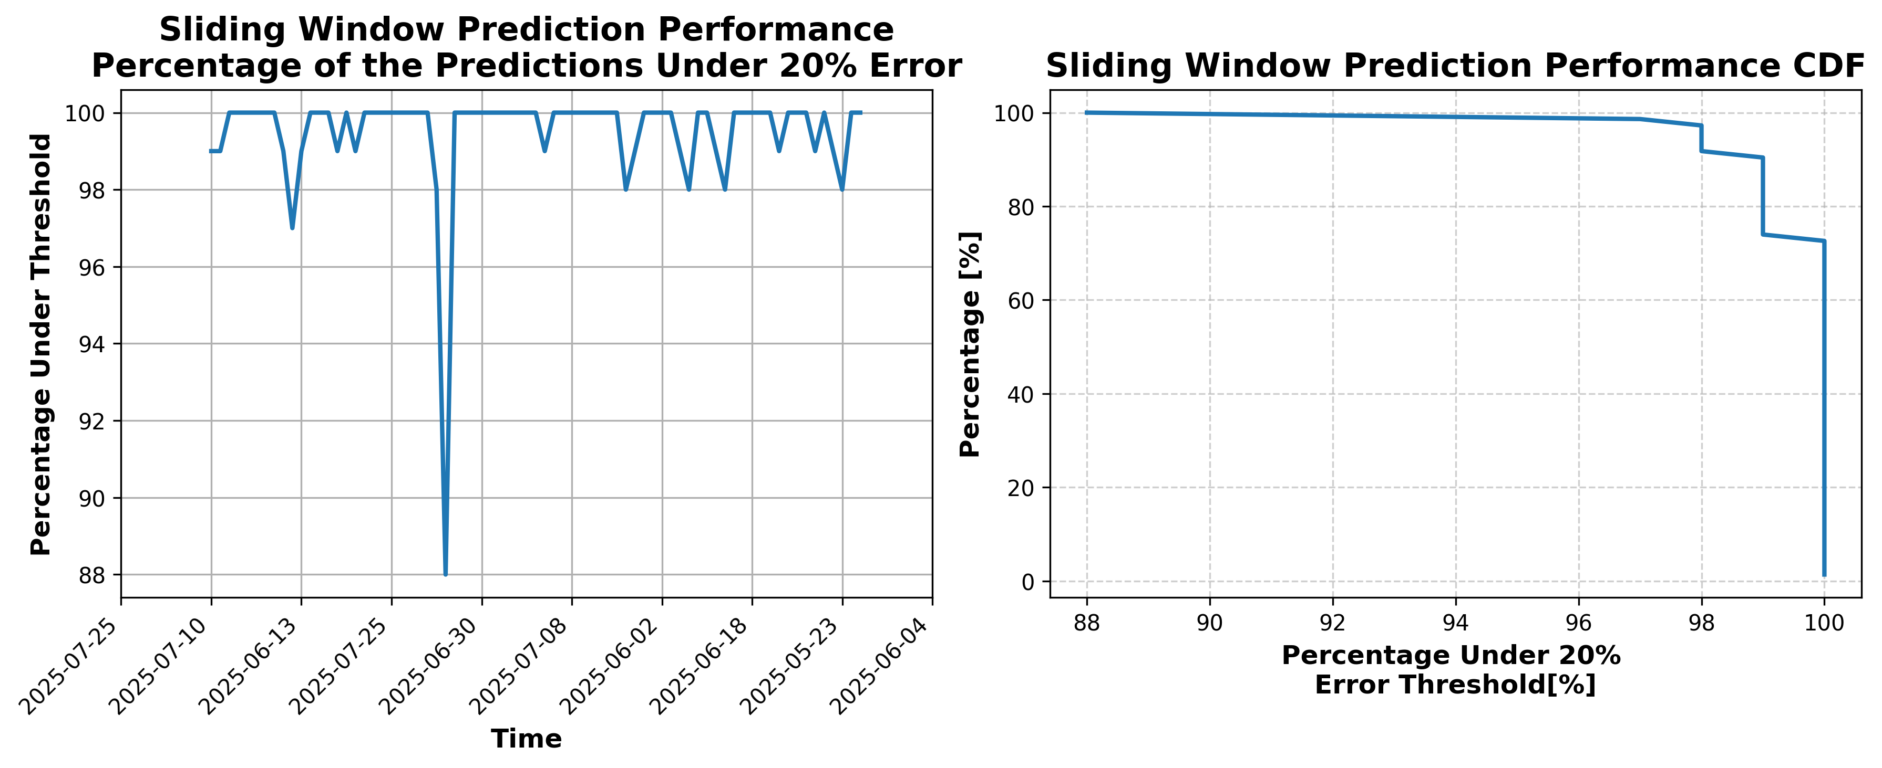

### Results for Latest_Test_2025-06-09.csv

Lines used: 9281 out of 13979 (66%)

Data sorted by: CHS Pickup Date

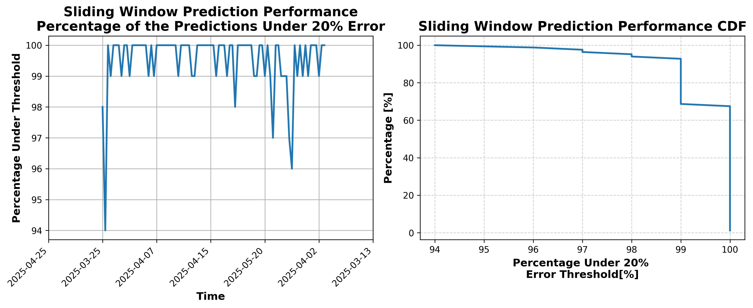

### Results for Latest_Test_2025-08-30.csv

Lines used: 8220 out of 14709 (55%)

Data sorted by: CHS Pickup Date

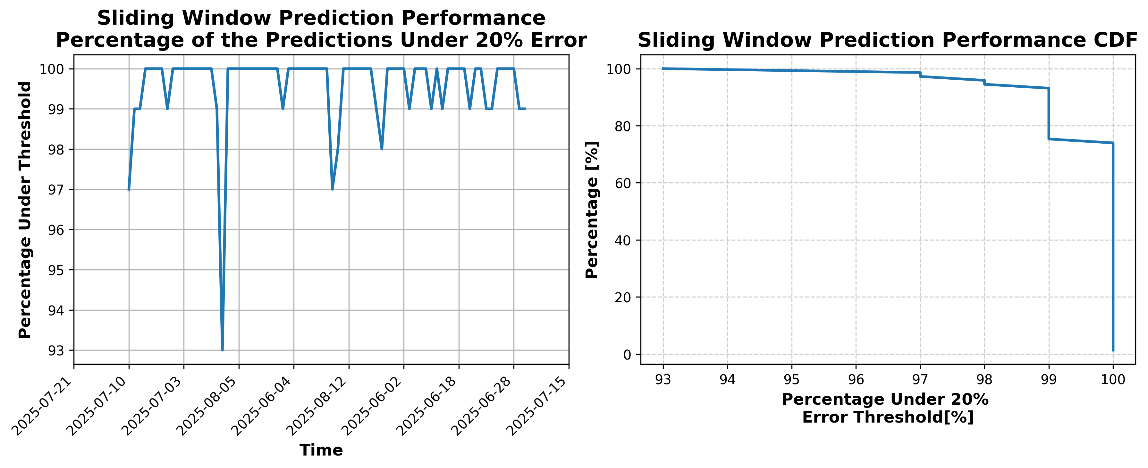

### Results for Latest_Test_2025-08-18.csv

Lines used: 8643 out of 14610 (59%)

Data sorted by: CHS Pickup Date

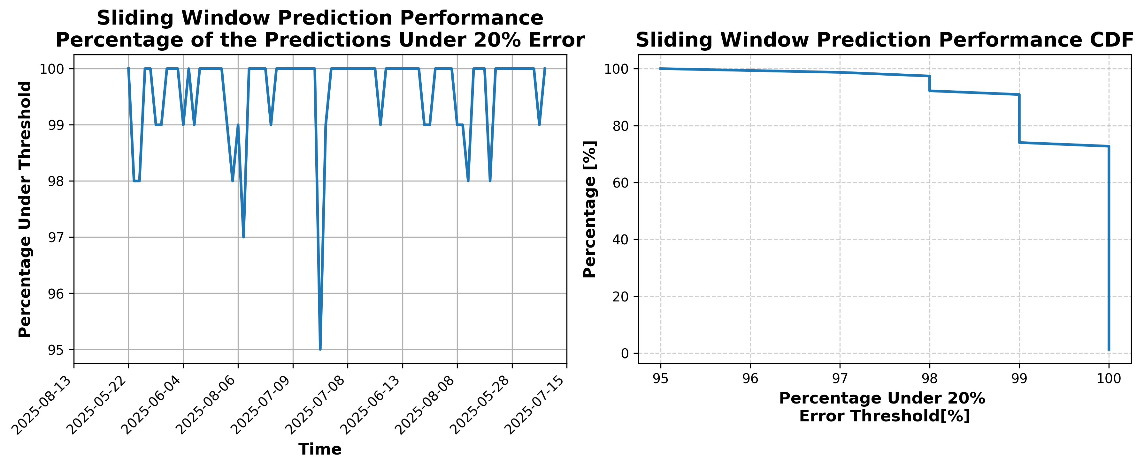

### Results for Latest_Test_2025-06-21.csv

Lines used: 9314 out of 14084 (66%)

Data sorted by: CHS Pickup Date

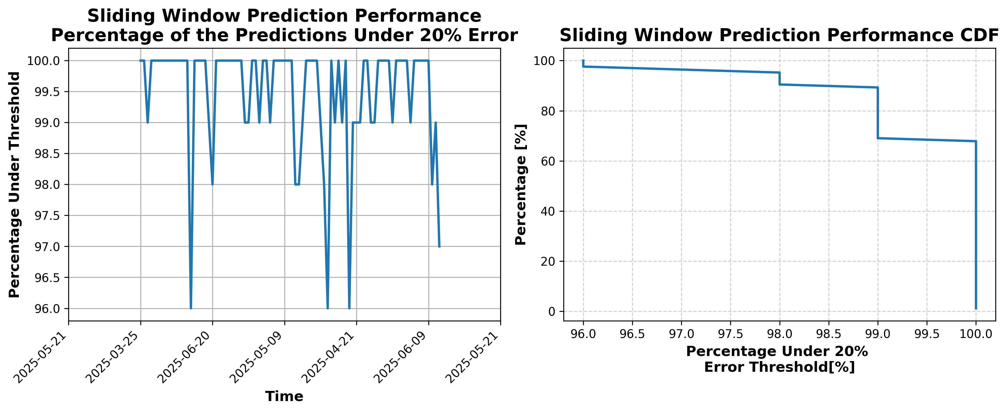

### Results for Latest_Test_2025-03-05.csv

Lines used: 8906 out of 17475 (50%)

Data sorted by: CHS Pickup Date

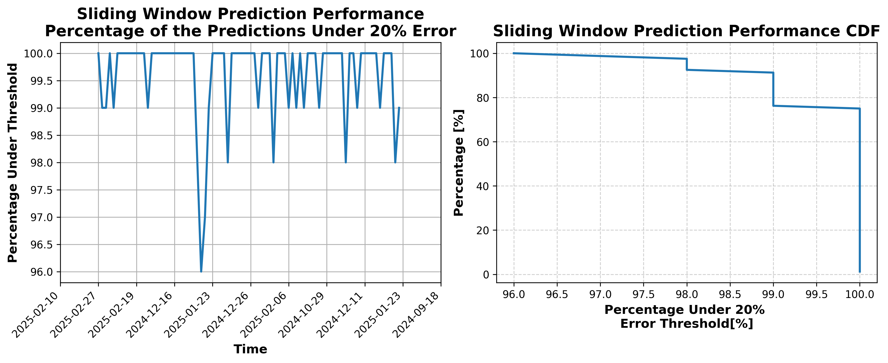

### Results for Latest_Test_2025-03-11.csv

Lines used: 9823 out of 18816 (52%)

Data sorted by: CHS Pickup Date

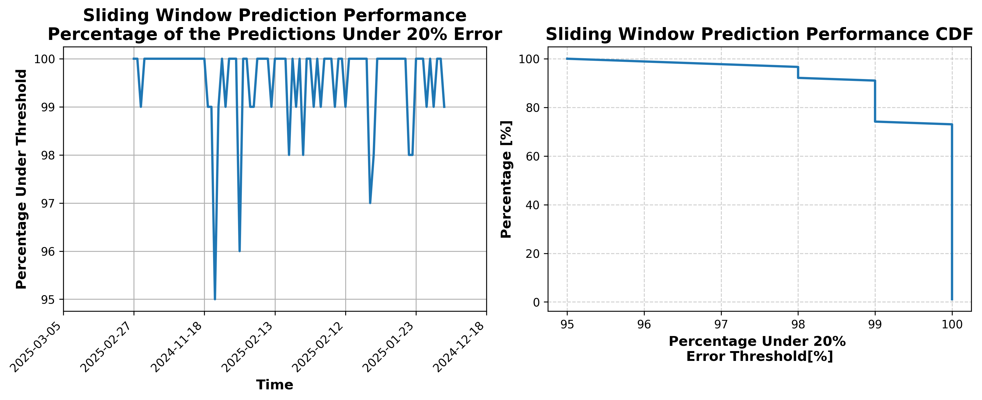

### Results for Latest_Test_2025-04-18.csv

Lines used: 9532 out of 16602 (57%)

Data sorted by: CHS Pickup Date

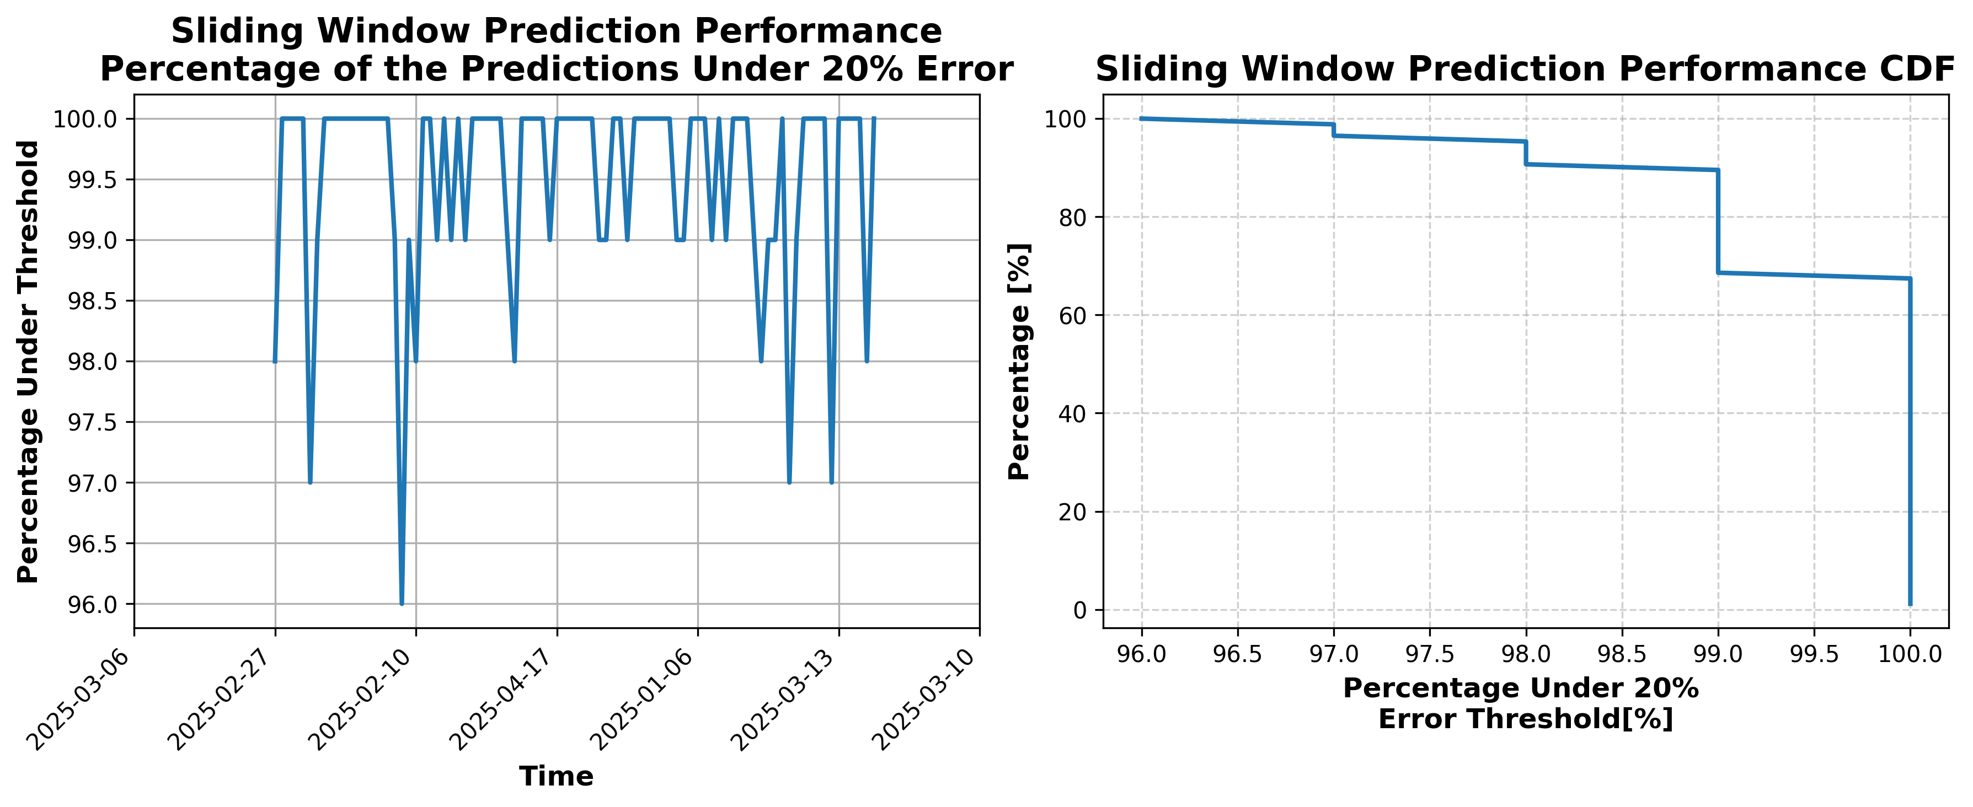

### Results for Latest_Test_2025-04-30.csv

Lines used: 8577 out of 15671 (54%)

Data sorted by: CHS Pickup Date

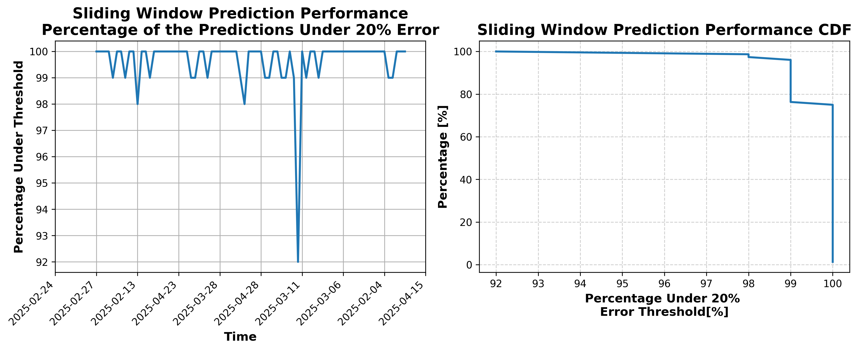

### Results for Latest_Test_2025-04-24.csv

Lines used: 8888 out of 15852 (56%)

Data sorted by: CHS Pickup Date

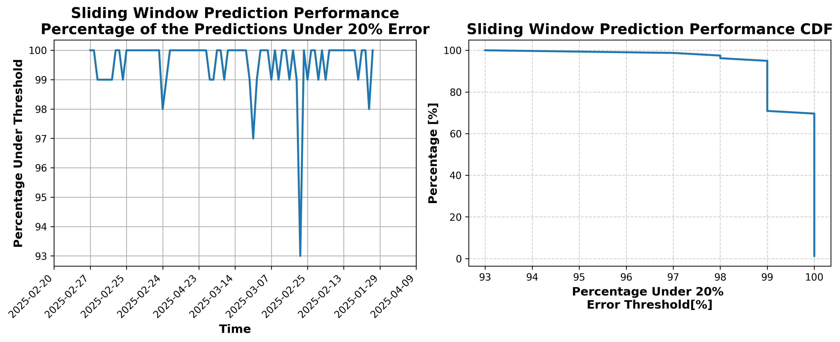

### Results for Latest_Test_2025-04-26.csv

Lines used: 9081 out of 16206 (56%)

Data sorted by: CHS Pickup Date

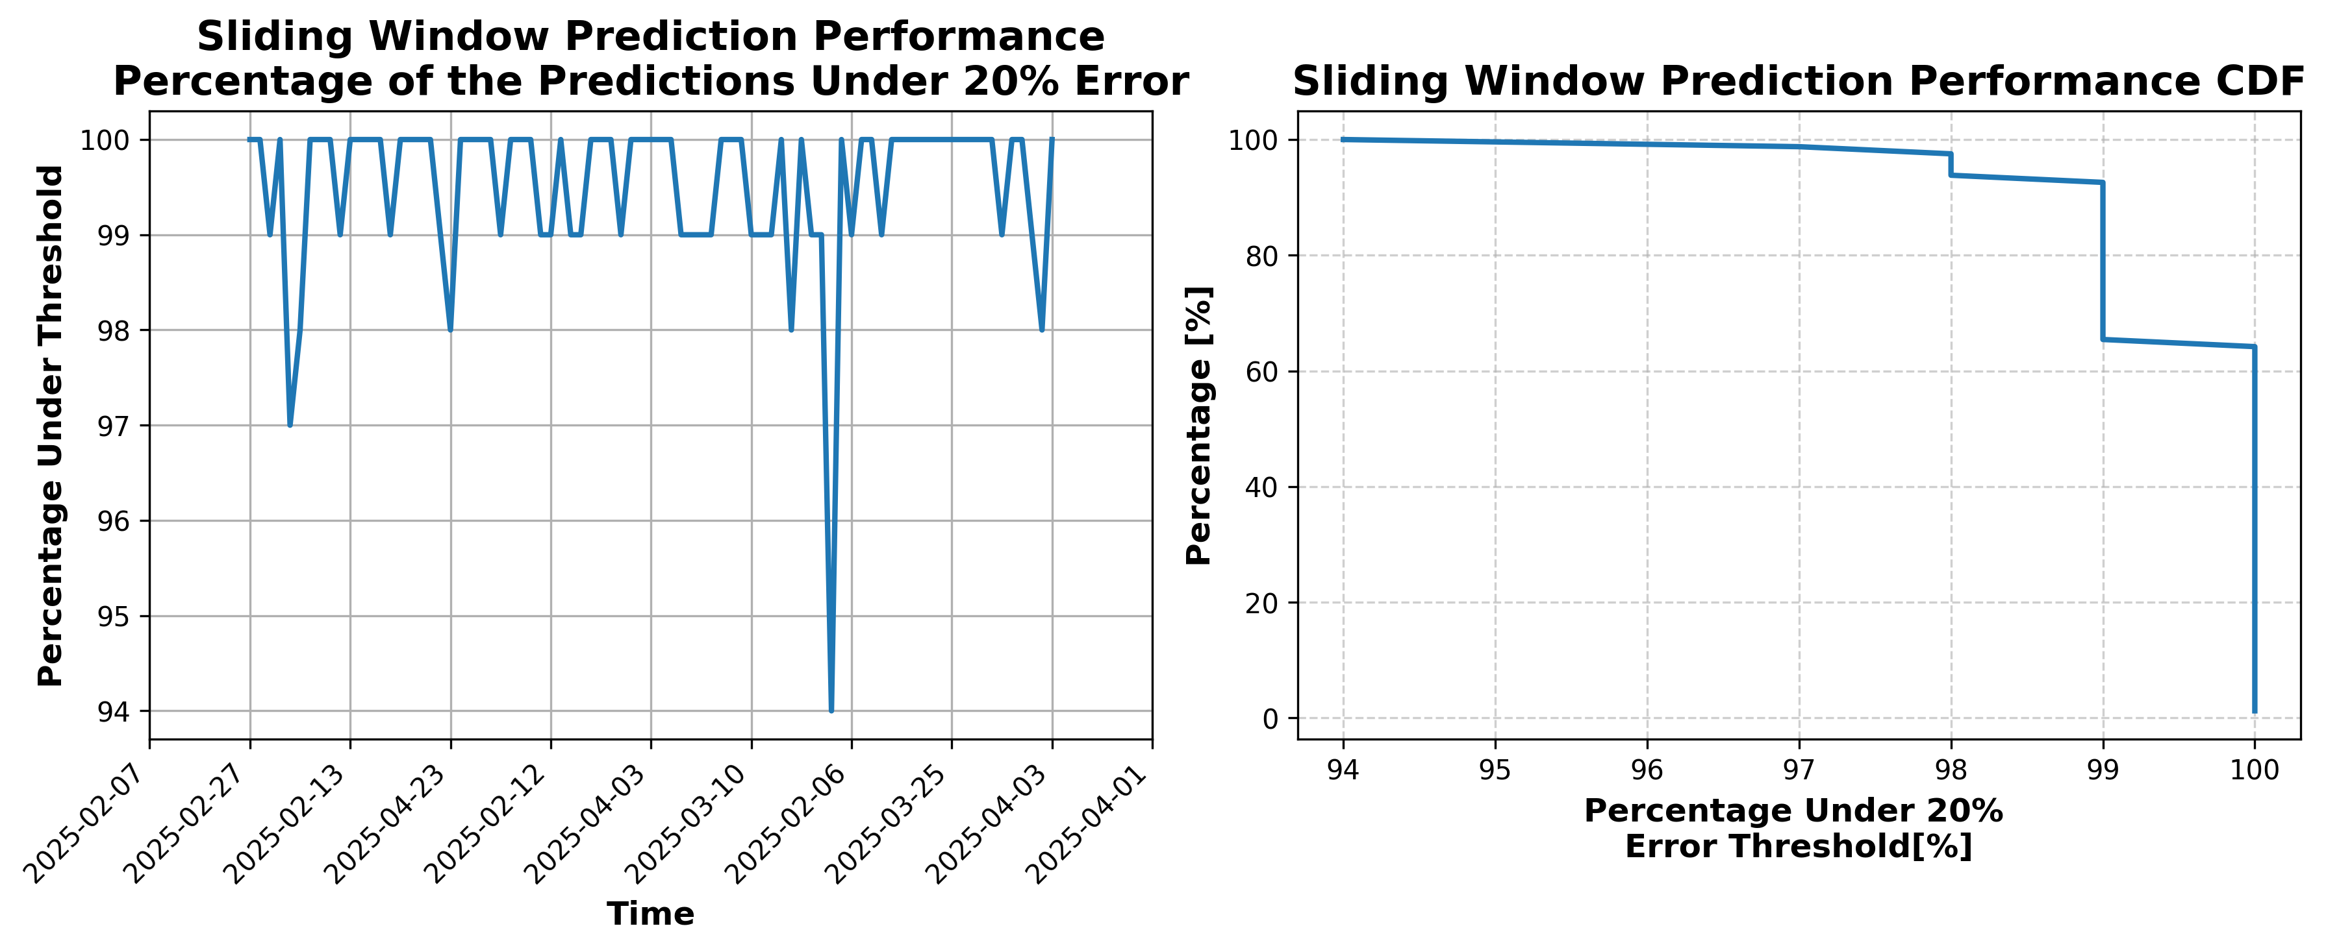

### Results for Latest_Test_2025-03-07.csv

Lines used: 9262 out of 17735 (52%)

Data sorted by: CHS Pickup Date

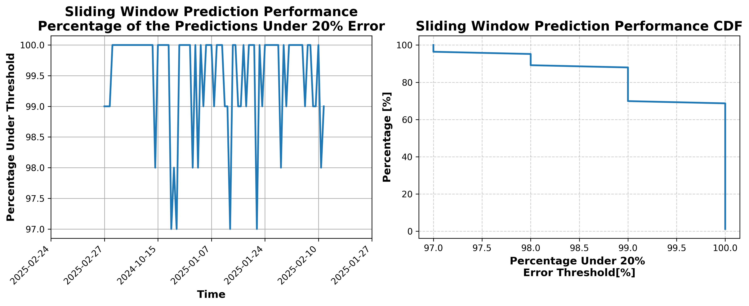

### Results for Latest_Test_2025-03-13.csv

Lines used: 9496 out of 18373 (51%)

Data sorted by: CHS Pickup Date

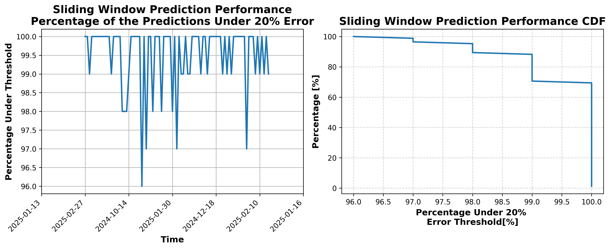

### Results for Latest_Test_2025-06-23.csv

Lines used: 9098 out of 13860 (65%)

Data sorted by: CHS Pickup Date

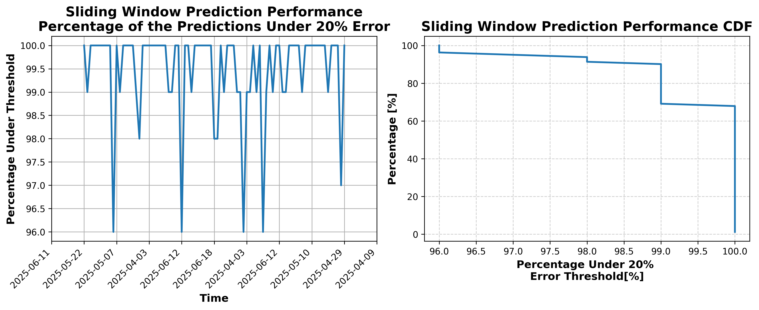

### Results for Latest_Test_2025-08-26.csv

Lines used: 7957 out of 14274 (55%)

Data sorted by: CHS Pickup Date

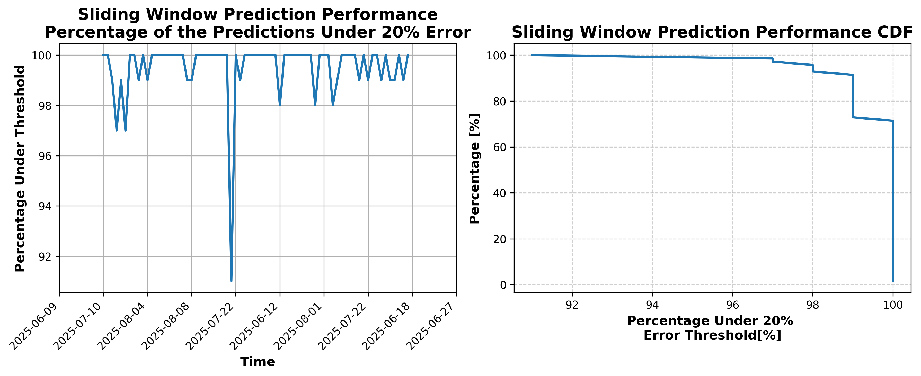

### Results for Latest_Test_2025-08-27.csv

Lines used: 7982 out of 14251 (56%)

Data sorted by: CHS Pickup Date

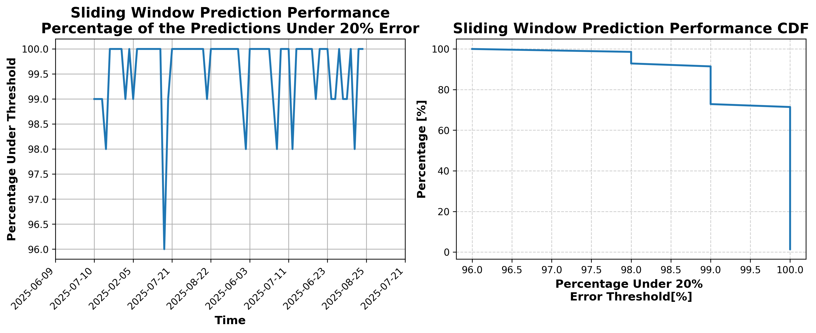

### Results for Latest_Test_2025-06-22.csv

Lines used: 9194 out of 13916 (66%)

Data sorted by: CHS Pickup Date

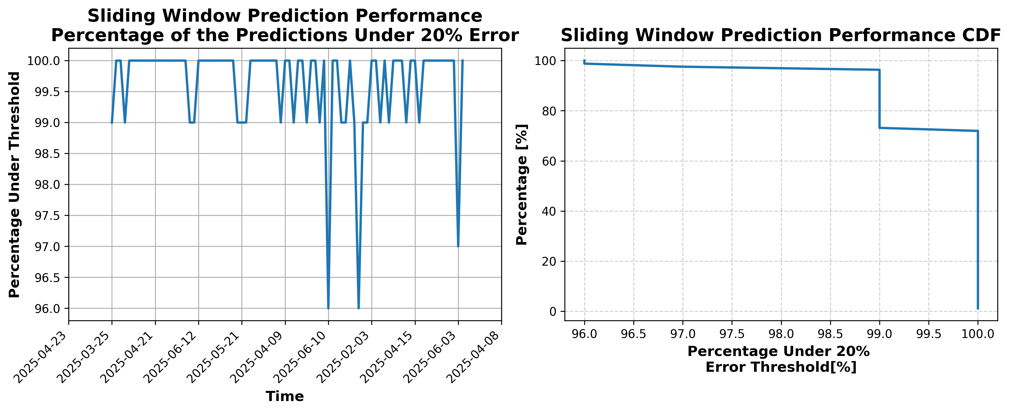

### Results for Latest_Test_2025-03-12.csv

Lines used: 9616 out of 18568 (51%)

Data sorted by: CHS Pickup Date

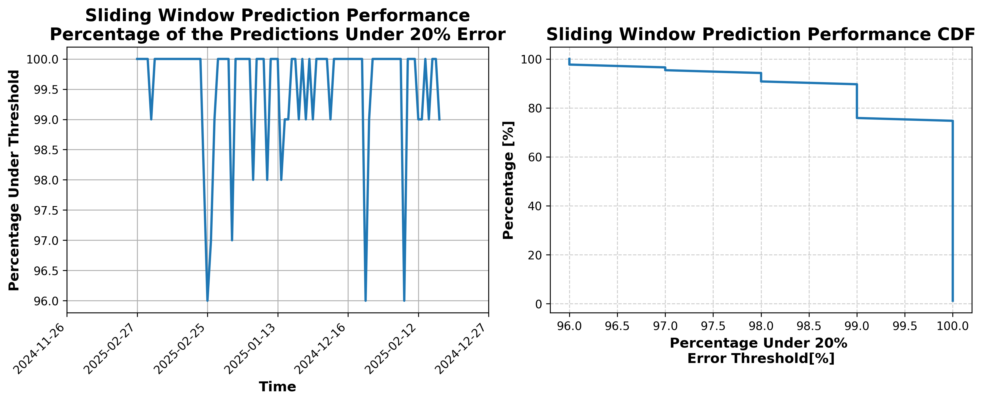

### Results for Latest_Test_2025-03-06.csv

Lines used: 9203 out of 17765 (51%)

Data sorted by: CHS Pickup Date

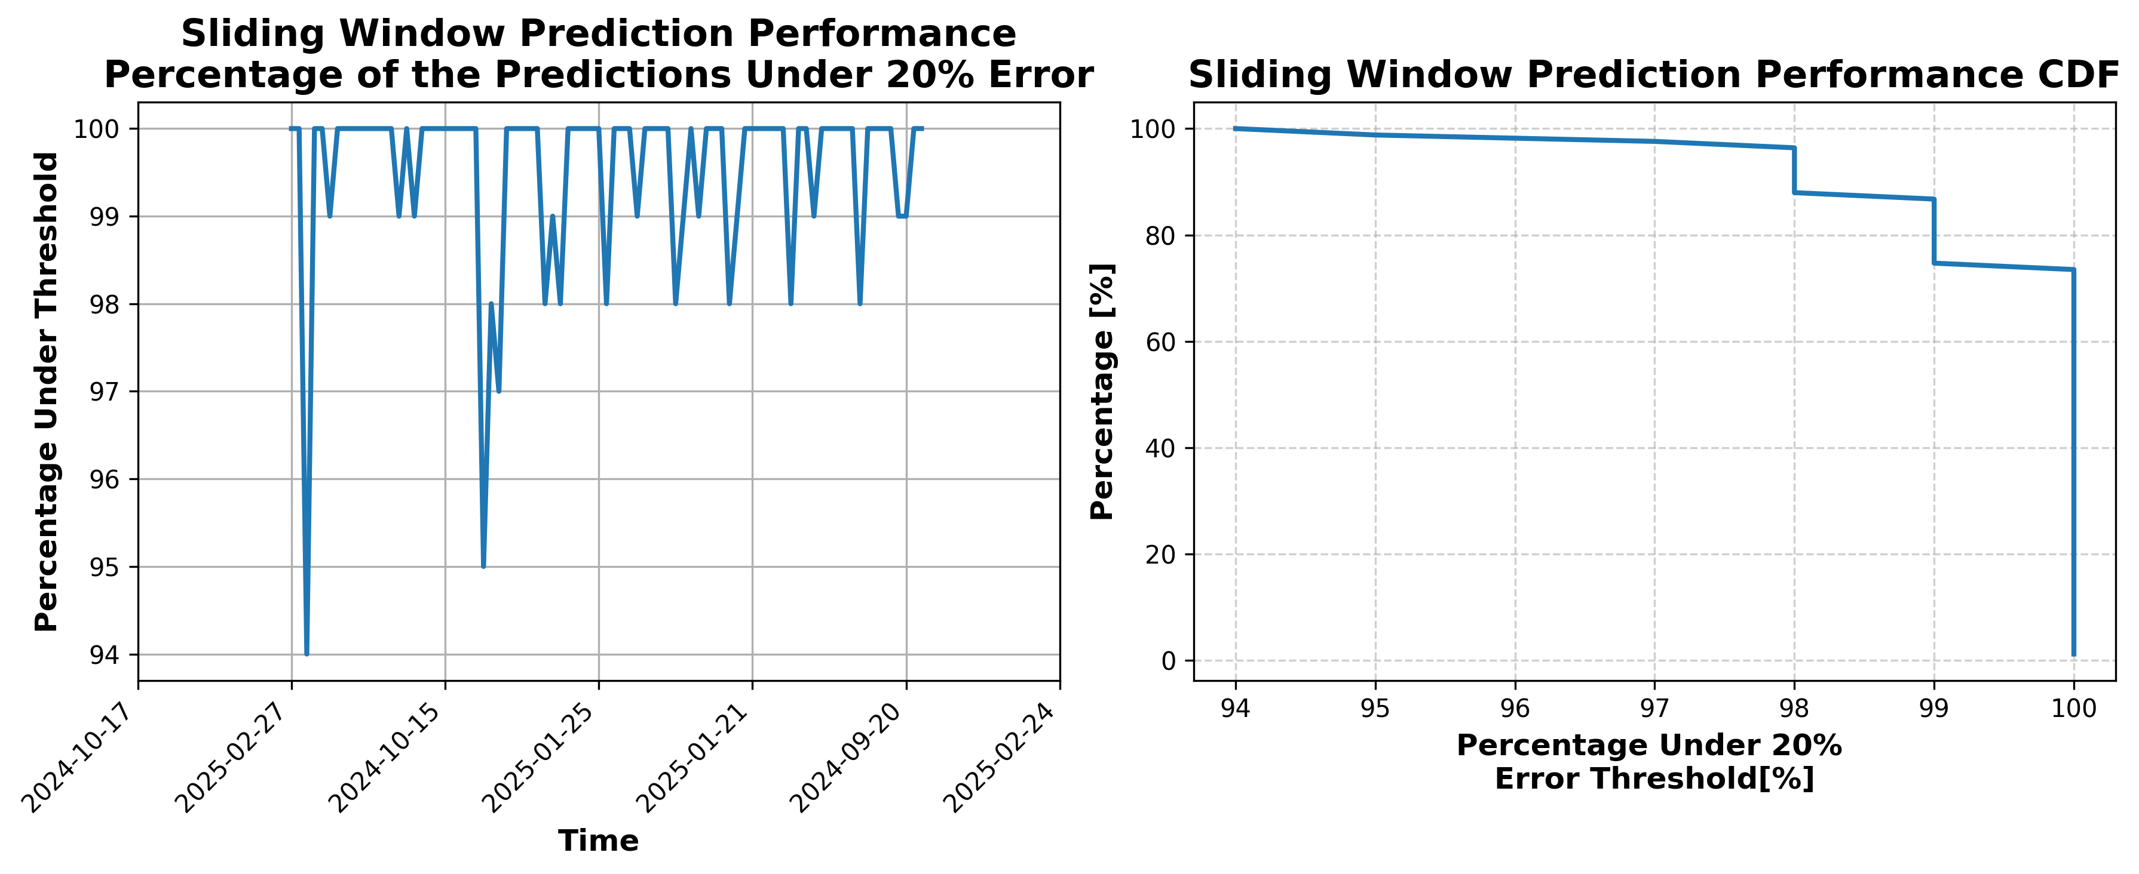

### Results for Latest_Test_2025-04-27.csv

Lines used: 8899 out of 15958 (55%)

Data sorted by: CHS Pickup Date

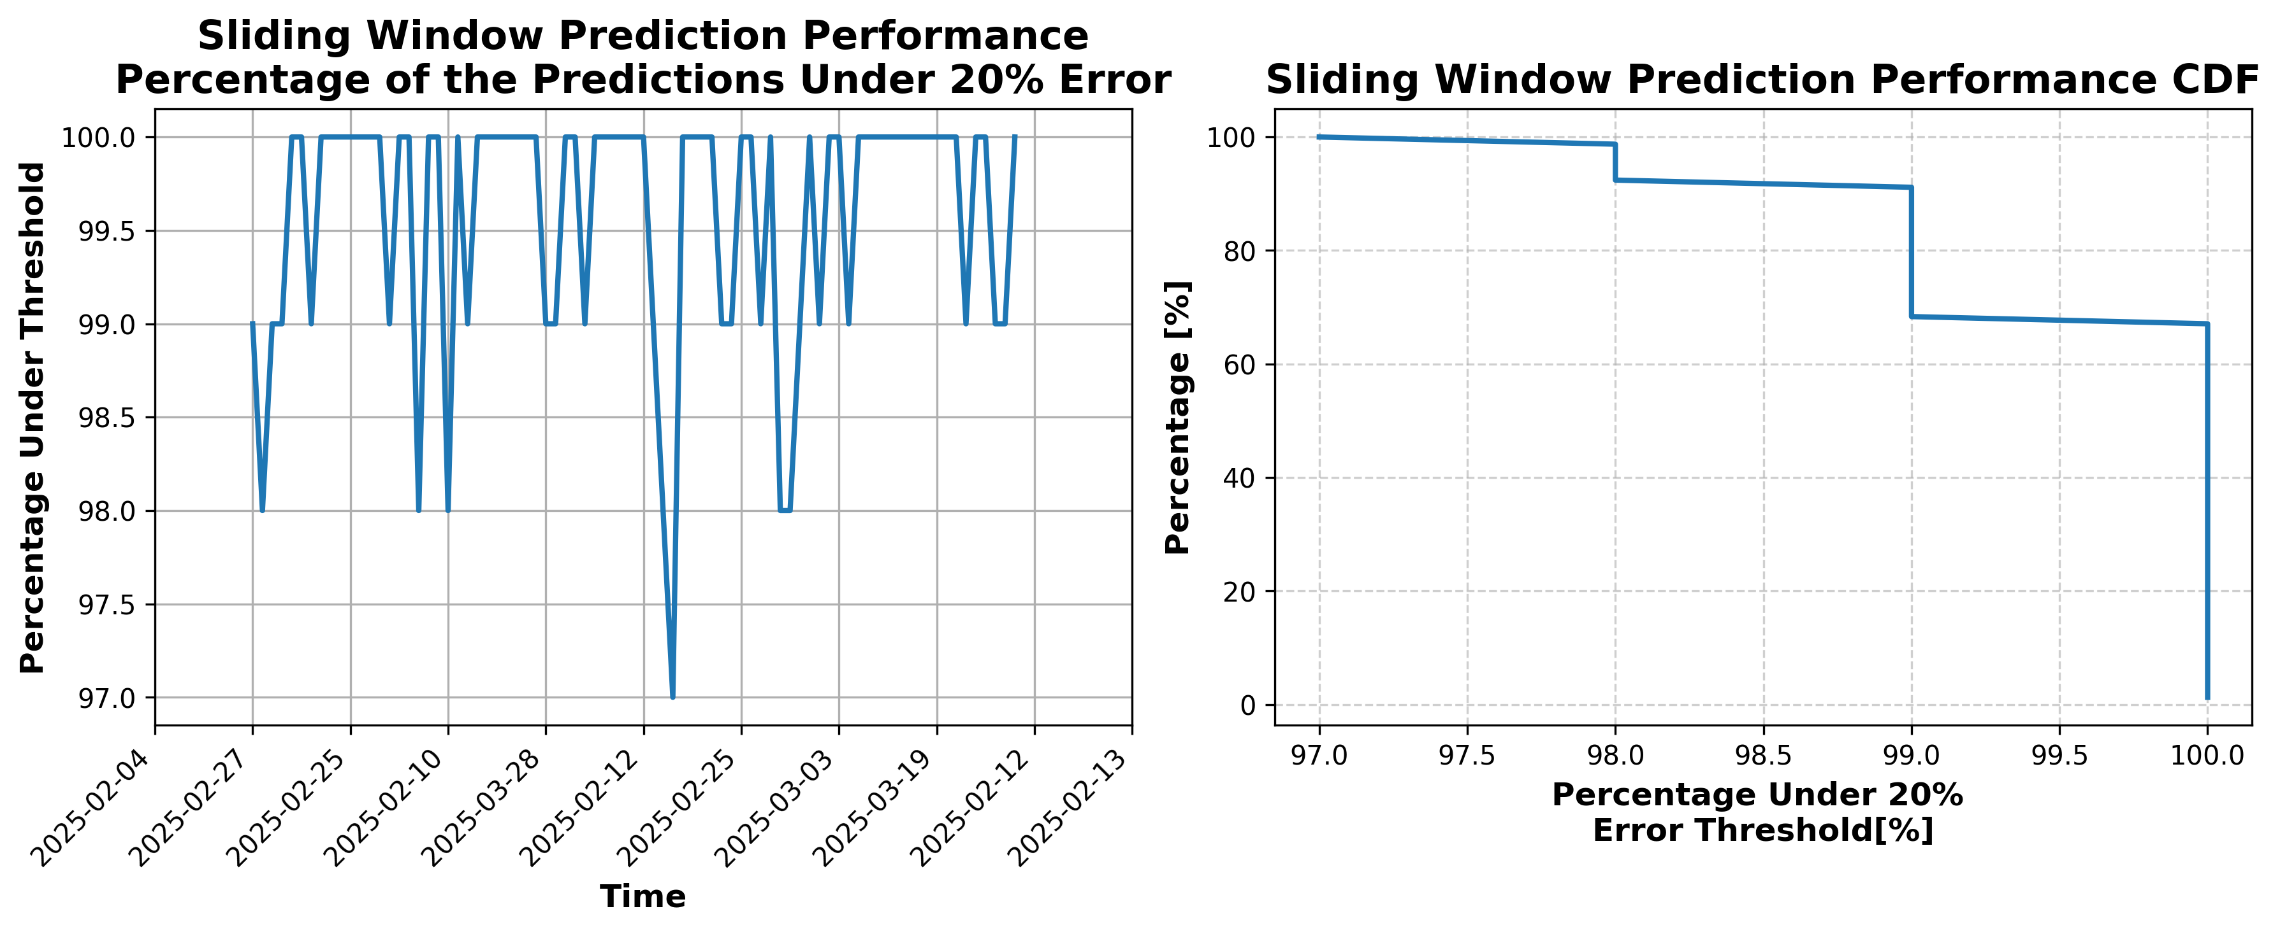

### Results for Latest_Test_2025-03-23.csv

Lines used: 9390 out of 16641 (56%)

Data sorted by: CHS Pickup Date

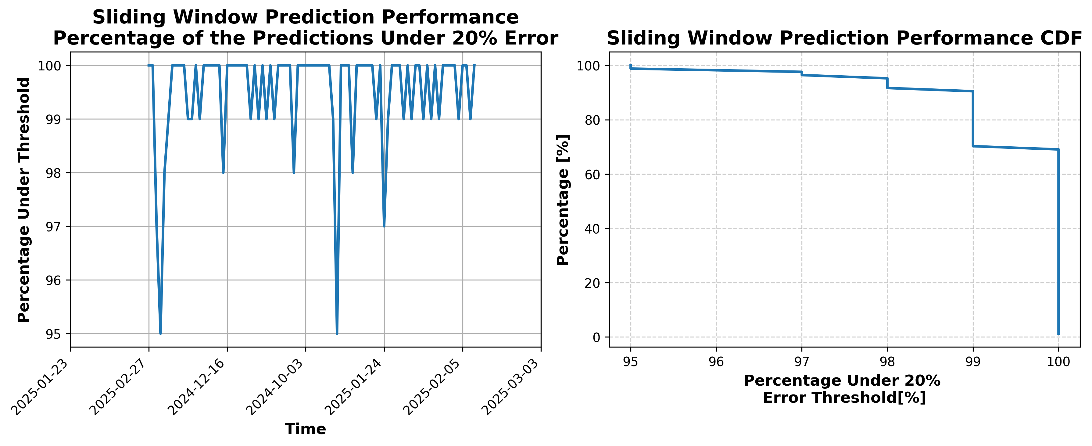

### Results for Latest_Test_2025-04-16.csv

Lines used: 9454 out of 16404 (57%)

Data sorted by: CHS Pickup Date

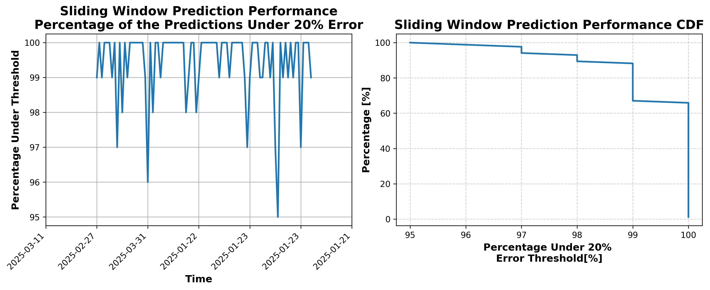

### Results for Latest_Test_2025-04-02.csv

Lines used: 9734 out of 16634 (58%)

Data sorted by: CHS Pickup Date

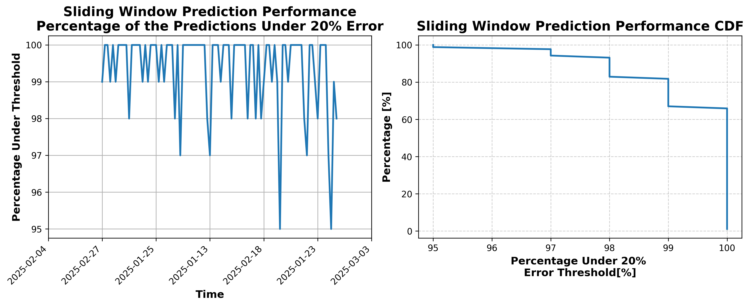

### Results for Latest_Test_2025-08-02.csv

Lines used: 8501 out of 14265 (59%)

Data sorted by: CHS Pickup Date

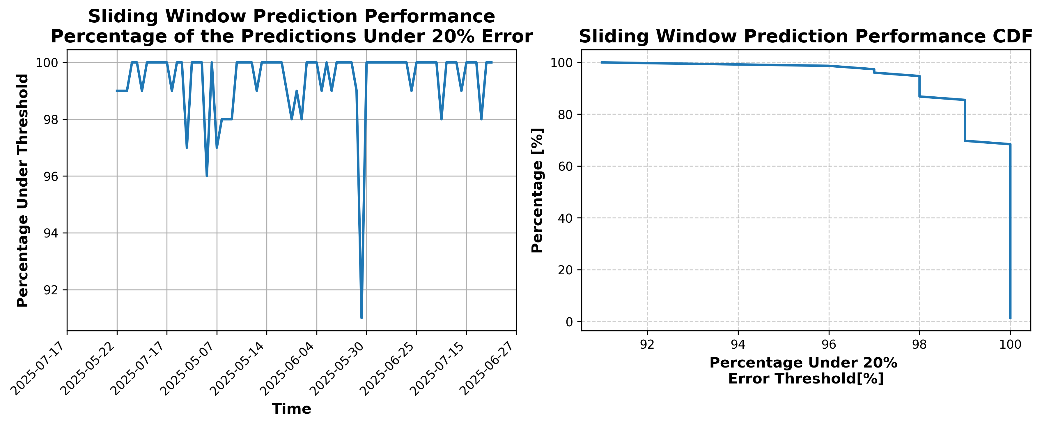

### Results for Latest_Test_2025-08-16.csv

Lines used: 8953 out of 14974 (59%)

Data sorted by: CHS Pickup Date

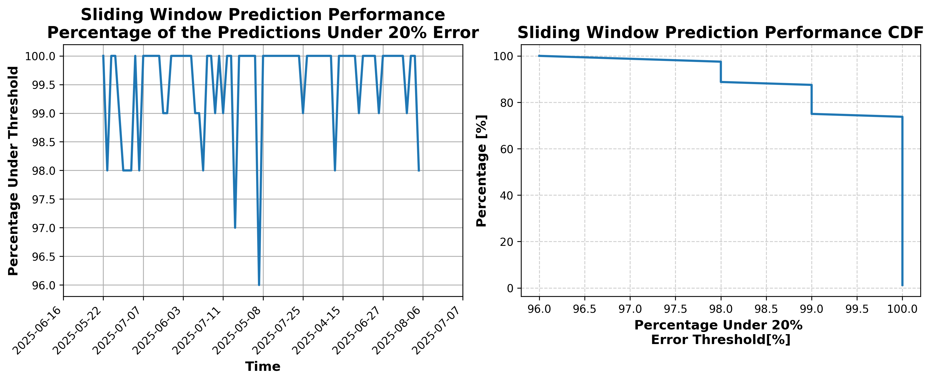

### Results for Latest_Test_2025-06-13.csv

Lines used: 9341 out of 14033 (66%)

Data sorted by: CHS Pickup Date

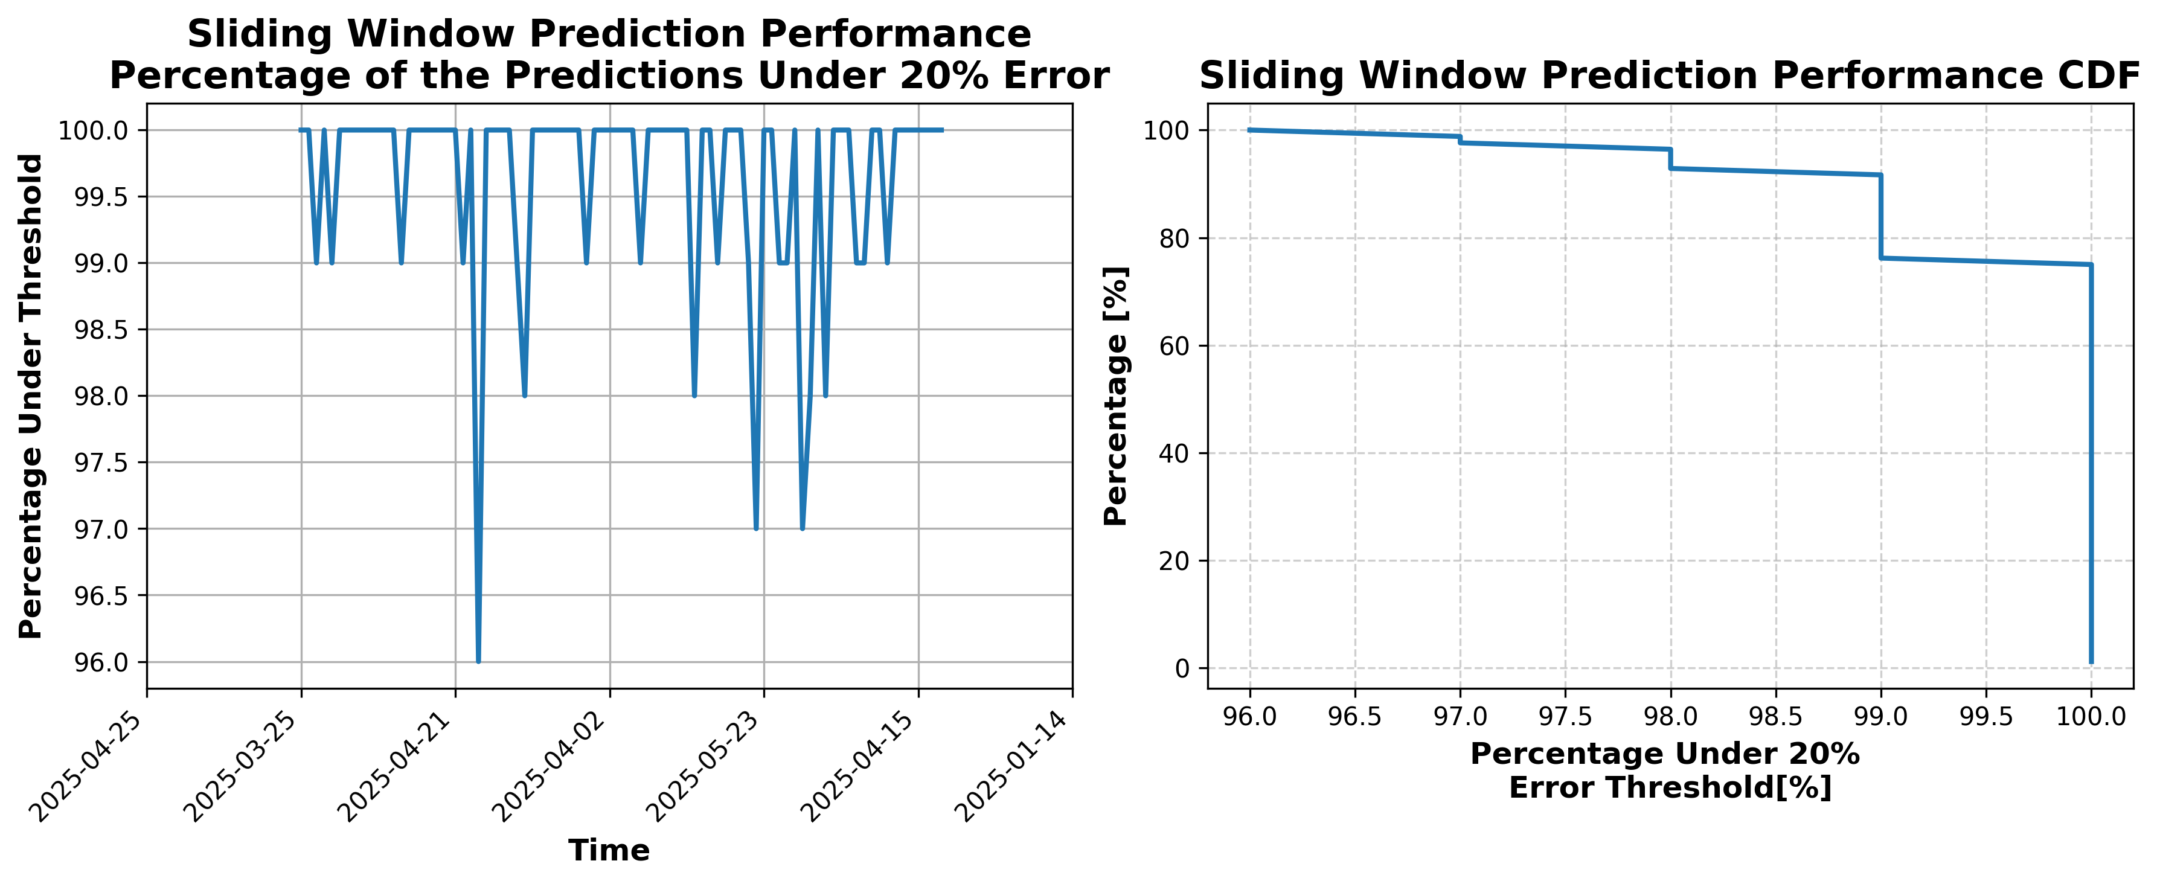

### Results for Latest_Test_2025-06-07.csv

Lines used: 9382 out of 14131 (66%)

Data sorted by: CHS Pickup Date

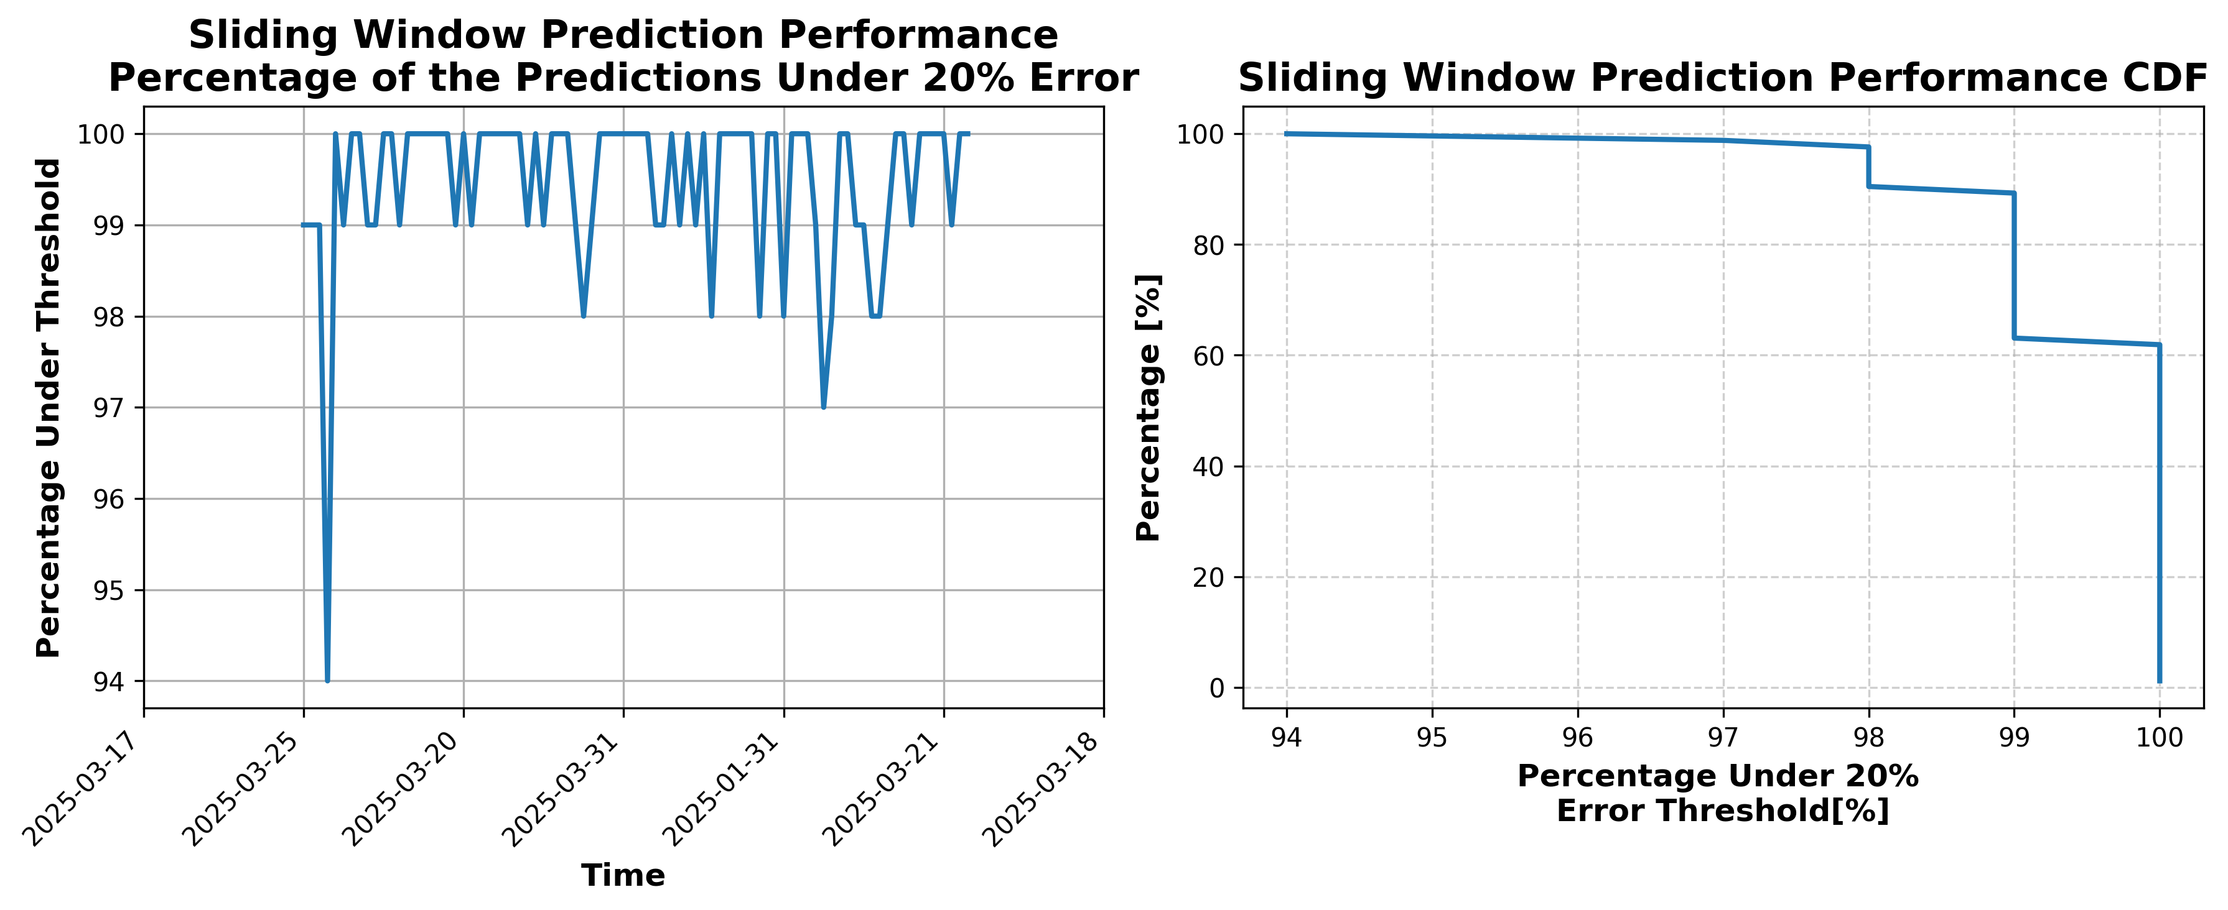

### Results for Latest_Test_2025-06-06.csv

Lines used: 9263 out of 14041 (65%)

Data sorted by: CHS Pickup Date

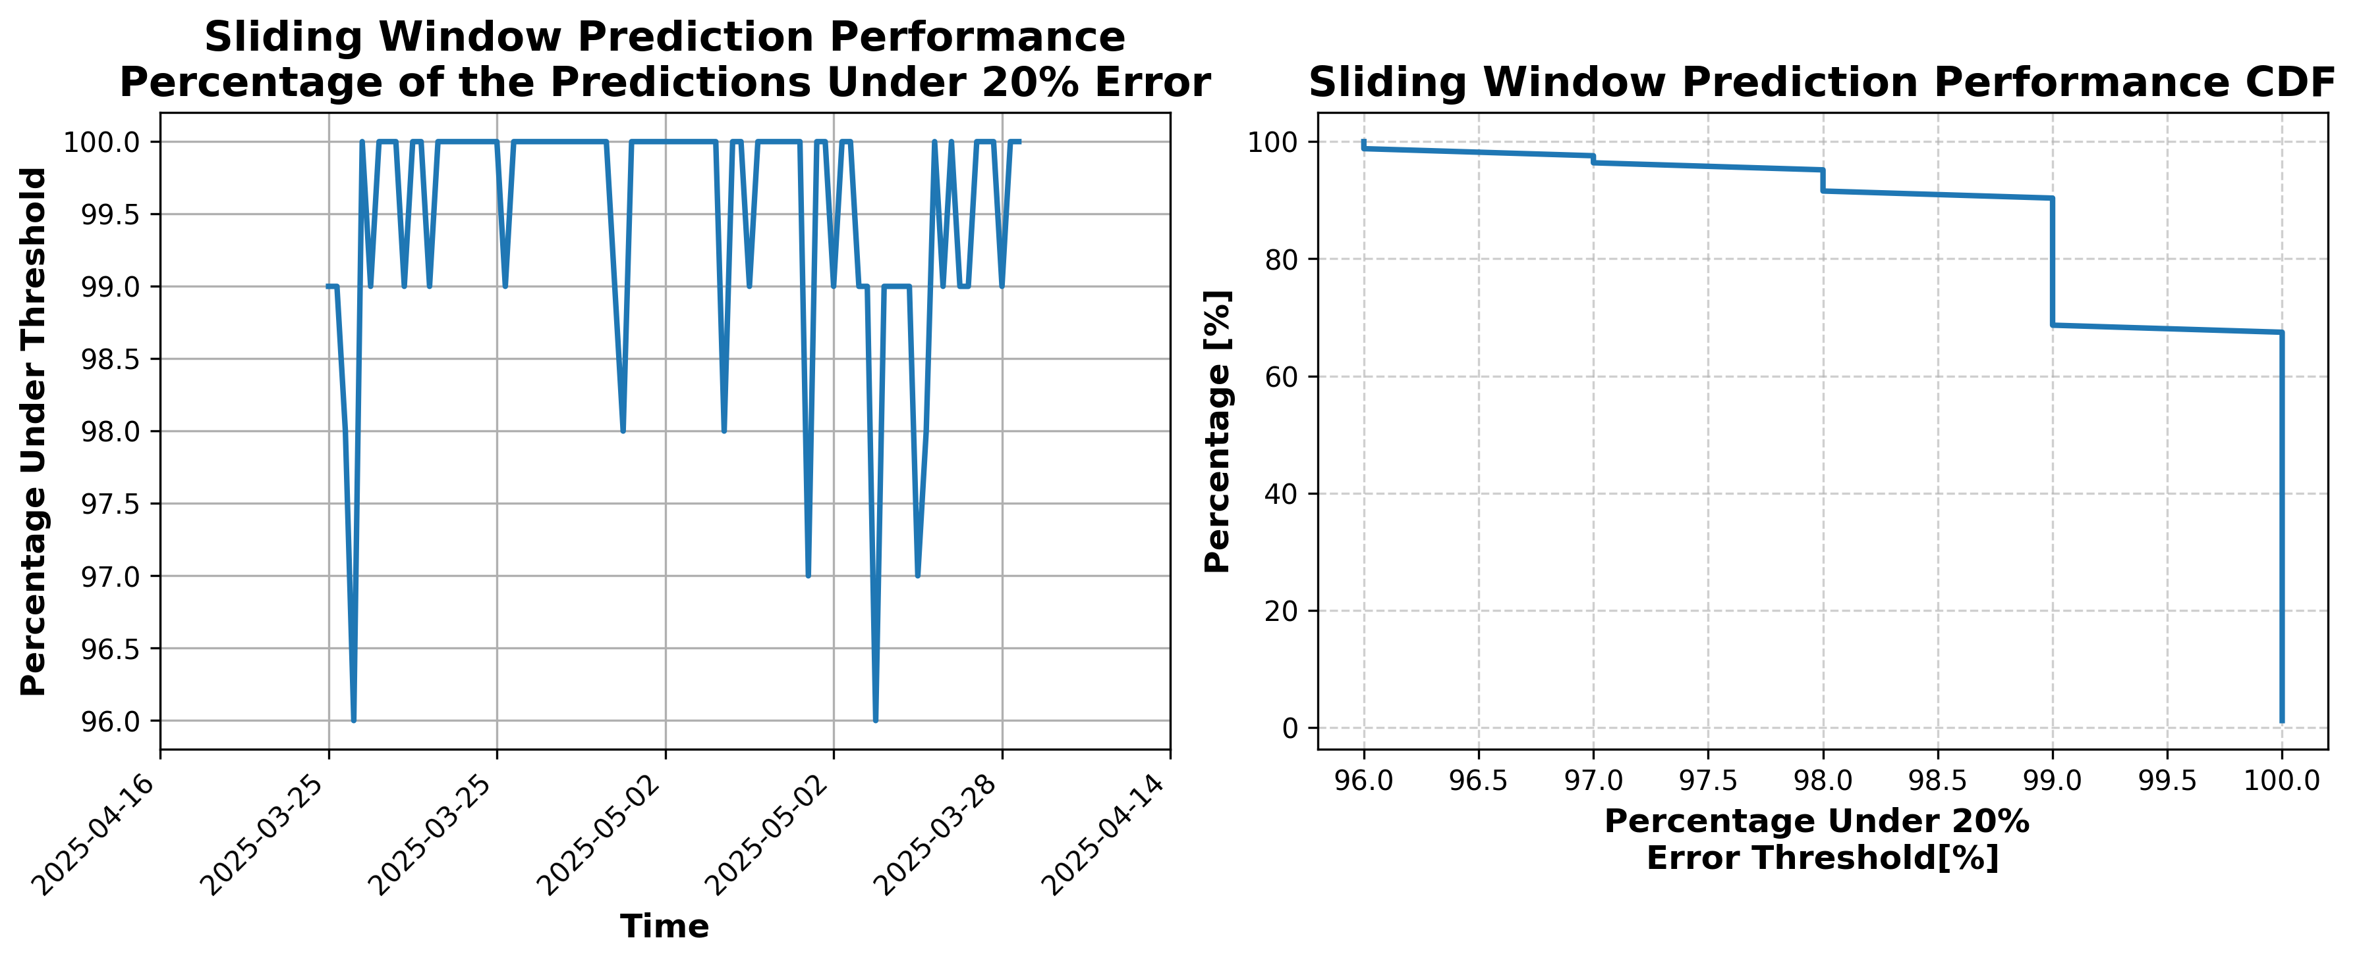

### Results for Latest_Test_2025-06-12.csv

Lines used: 9225 out of 13860 (66%)

Data sorted by: CHS Pickup Date

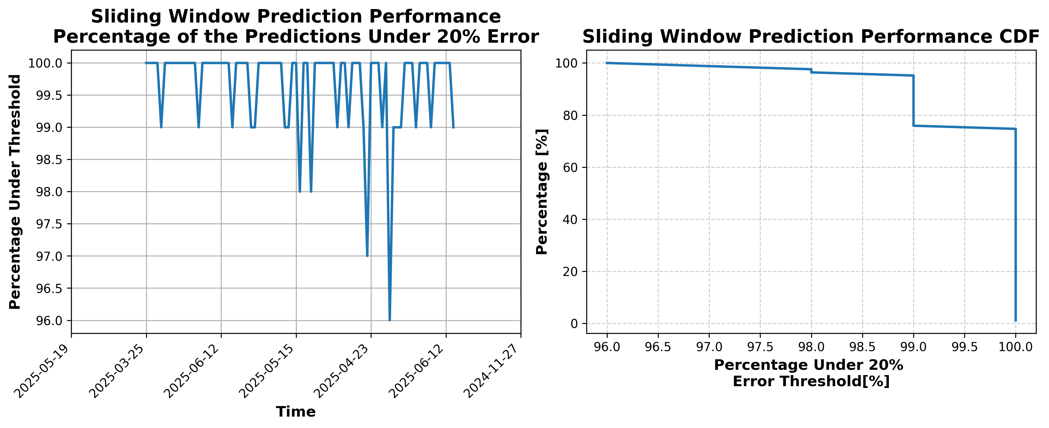

### Results for Latest_Test_2025-08-17.csv

Lines used: 8818 out of 14823 (59%)

Data sorted by: CHS Pickup Date

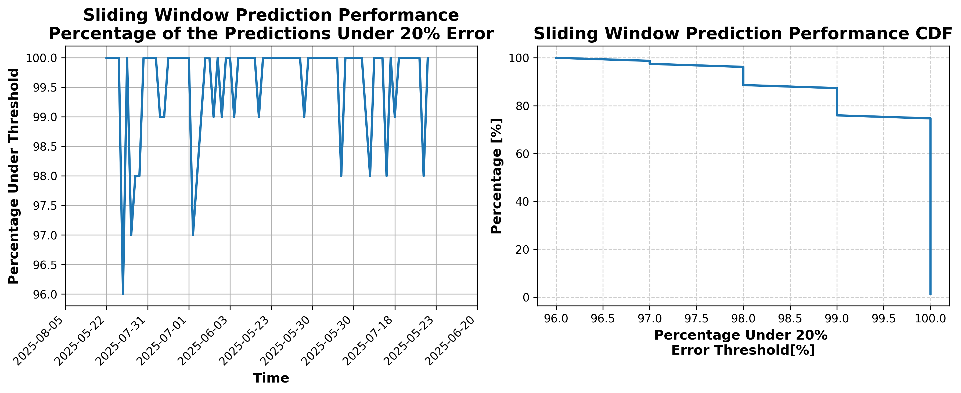

### Results for Latest_Test_2025-08-03.csv

Lines used: 8398 out of 14173 (59%)

Data sorted by: CHS Pickup Date

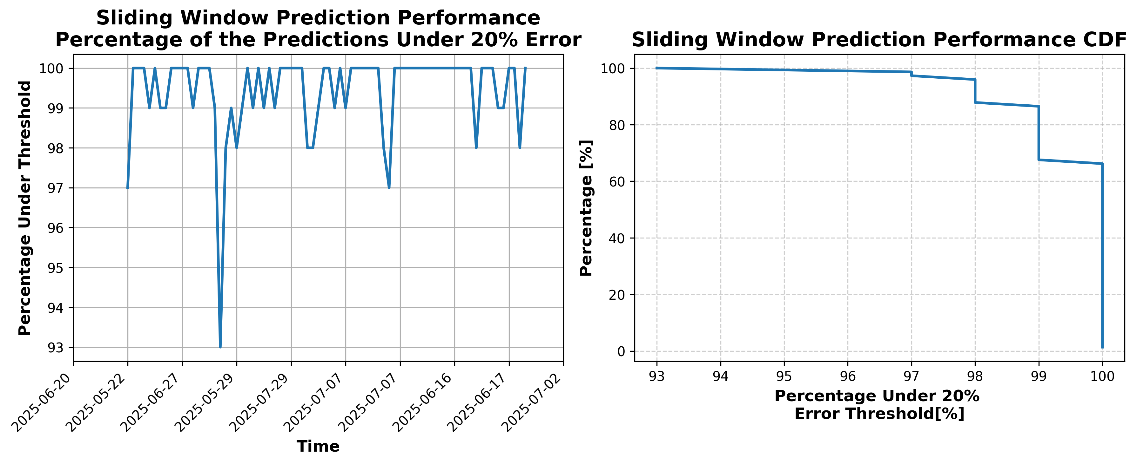

### Results for Latest_Test_2025-04-03.csv

Lines used: 9807 out of 16751 (58%)

Data sorted by: CHS Pickup Date

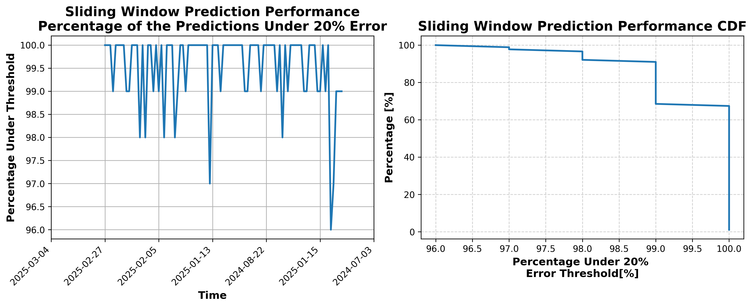

### Results for Latest_Test_2025-04-17.csv

Lines used: 9445 out of 16384 (57%)

Data sorted by: CHS Pickup Date

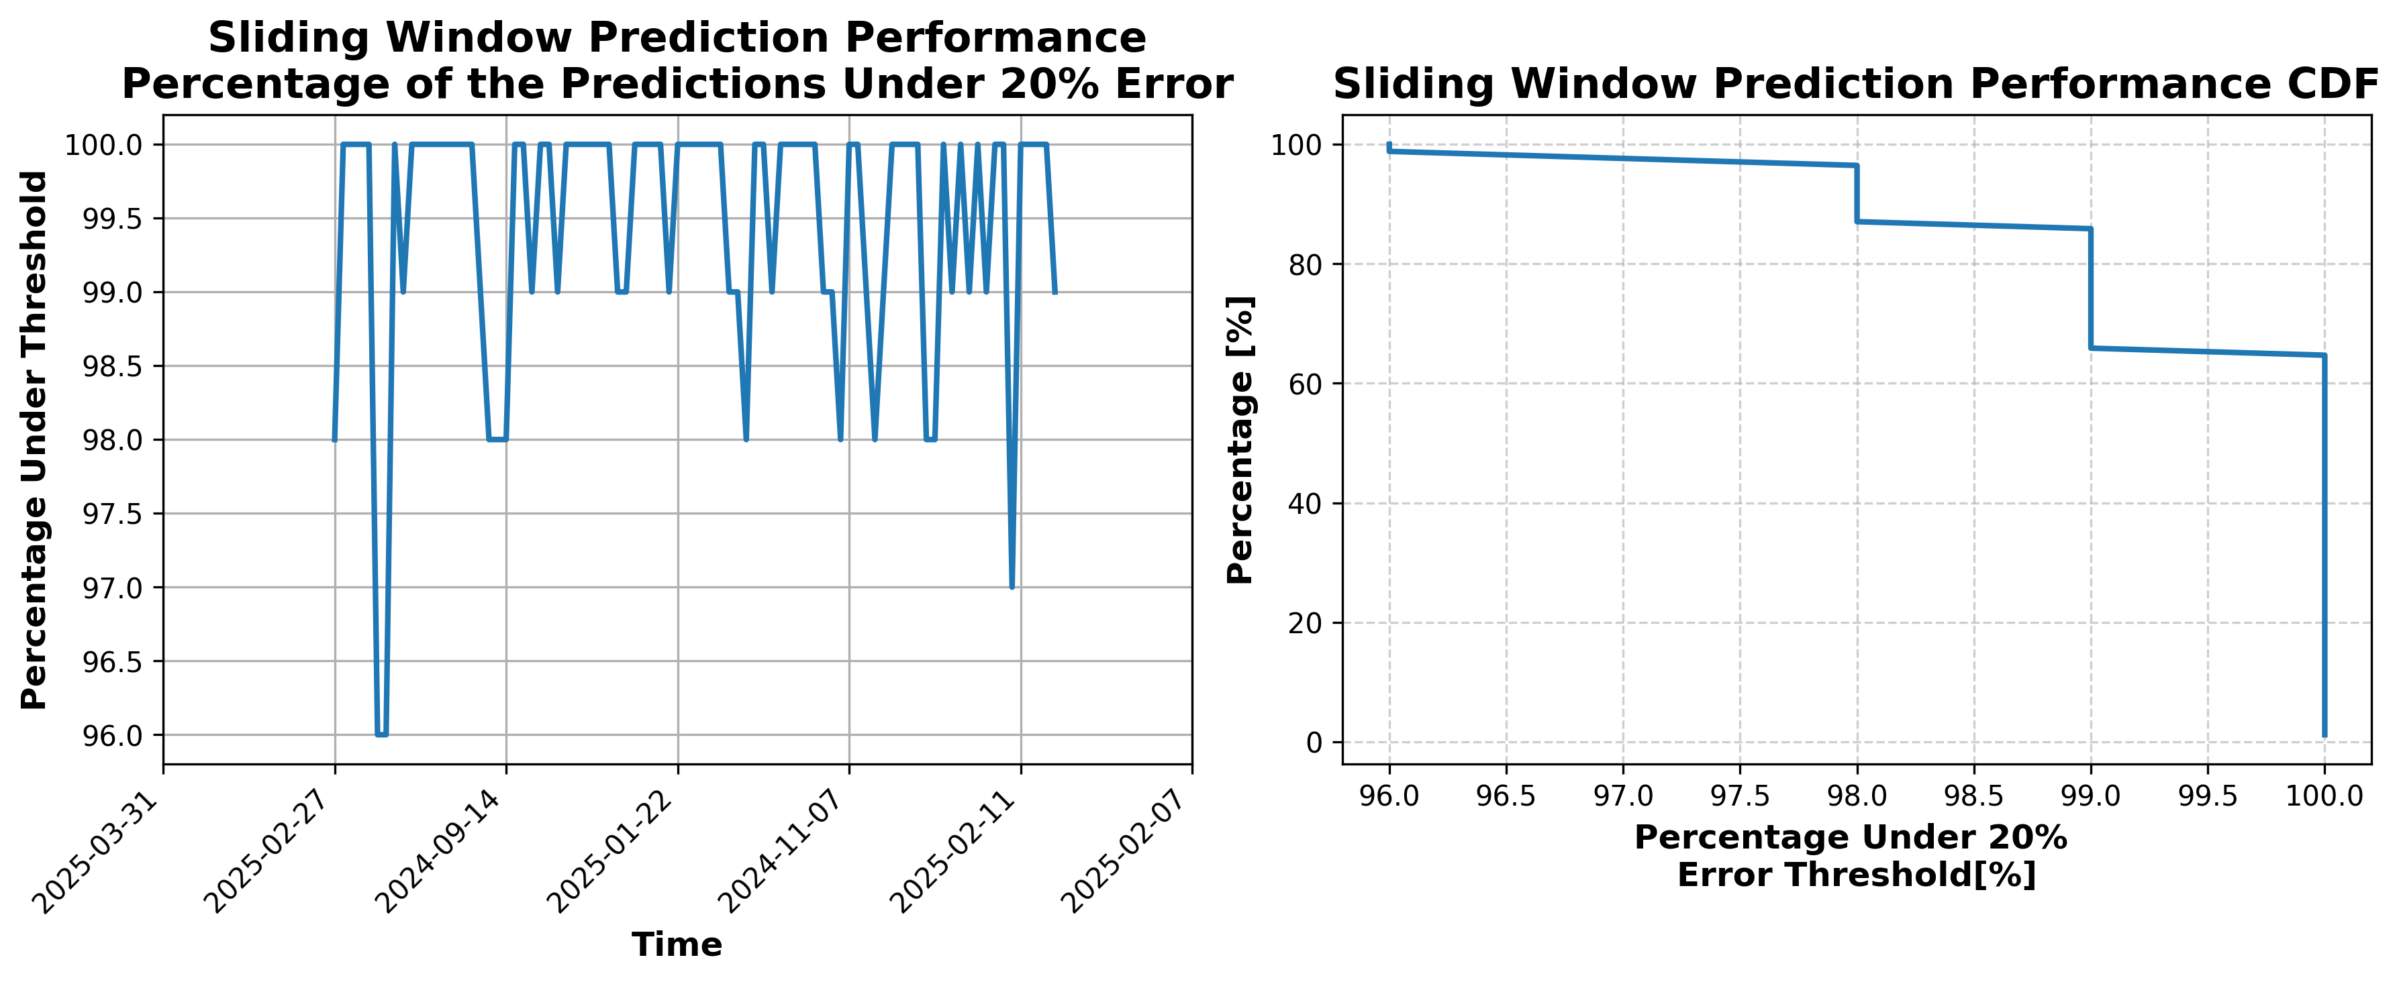

### Results for Latest_Test_2025-03-22.csv

Lines used: 9568 out of 16910 (56%)

Data sorted by: CHS Pickup Date

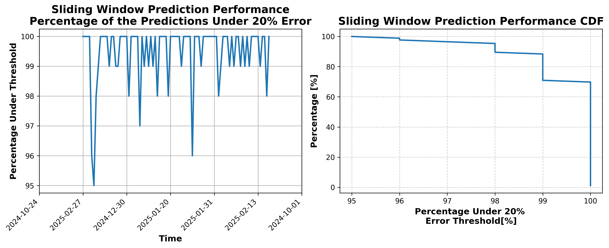

### Results for Latest_Test_2025-03-20.csv

Lines used: 9388 out of 16620 (56%)

Data sorted by: CHS Pickup Date

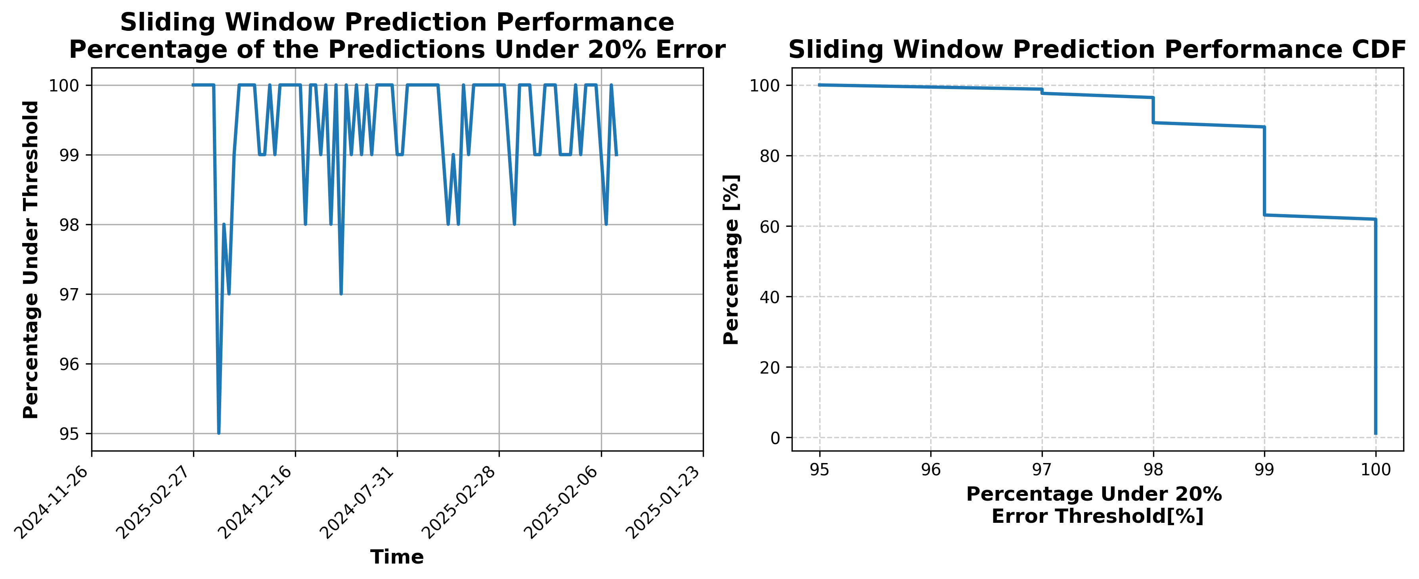

### Results for Latest_Test_2025-04-29.csv

Lines used: 8835 out of 15855 (55%)

Data sorted by: CHS Pickup Date

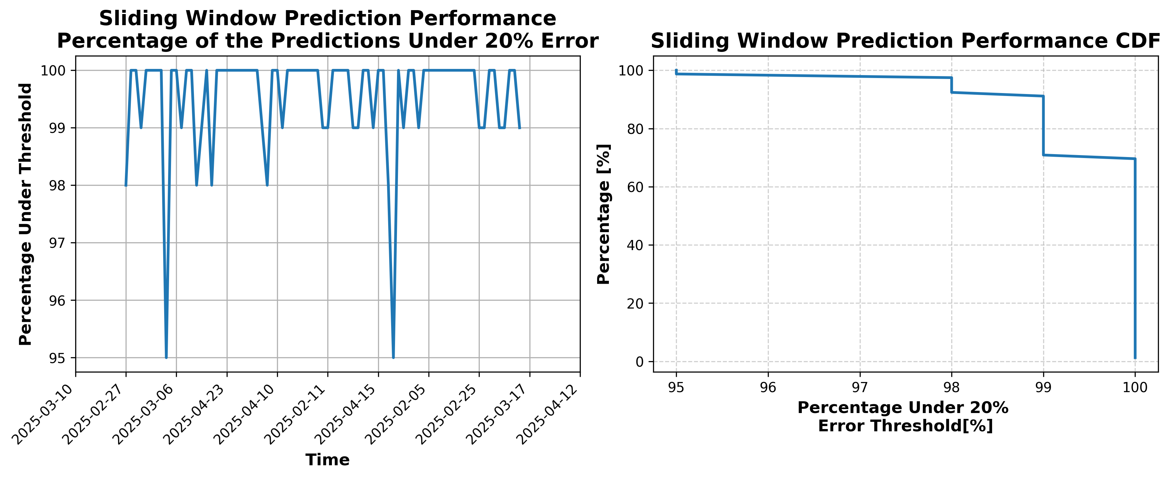

### Results for Latest_Test_2025-04-01.csv

Lines used: 9684 out of 16755 (57%)

Data sorted by: CHS Pickup Date

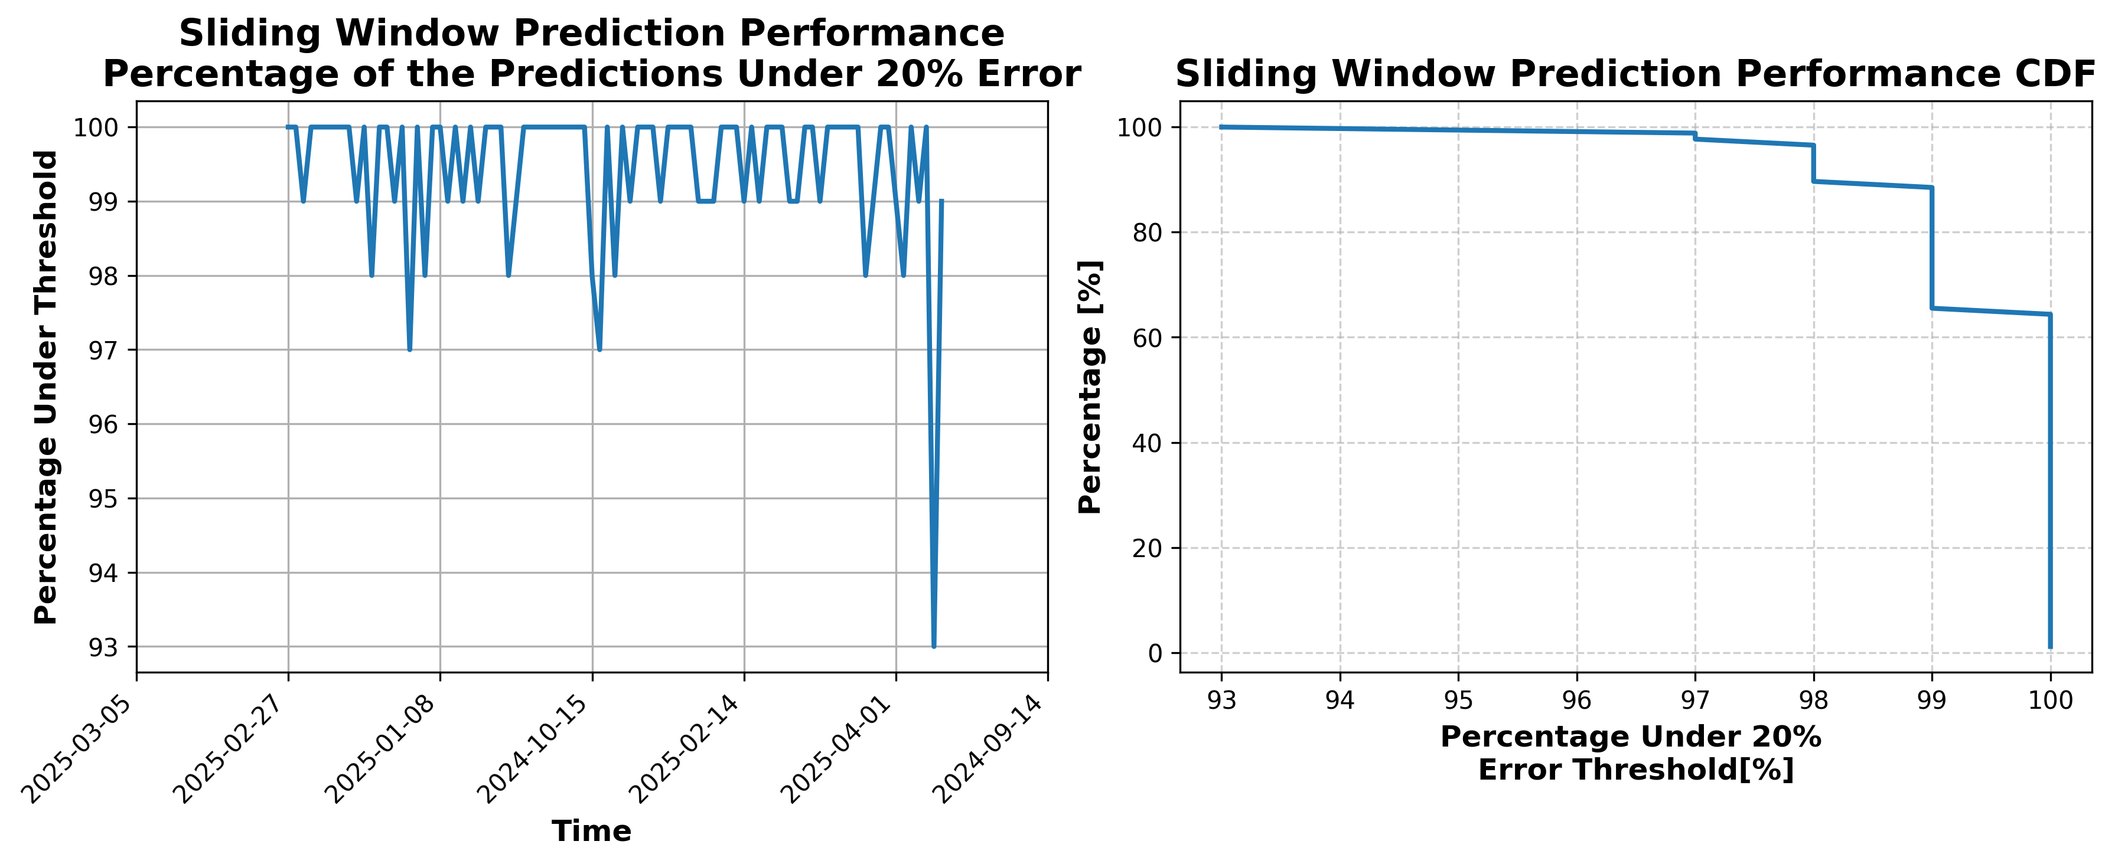

### Results for Latest_Test_2025-03-08.csv

Lines used: 9755 out of 18411 (52%)

Data sorted by: CHS Pickup Date

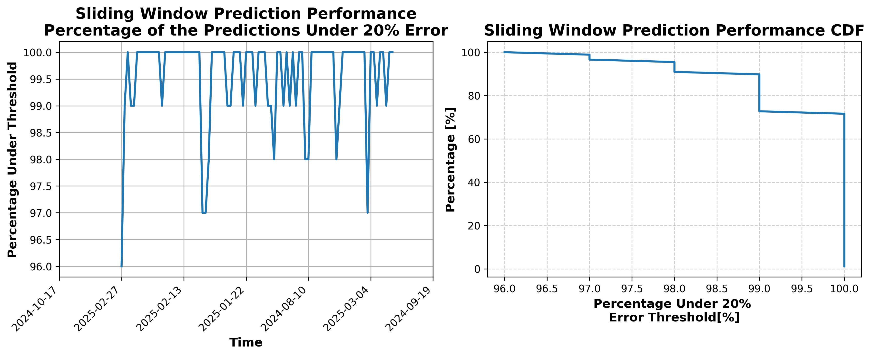

### Results for Latest_Test_2025-04-15.csv

Lines used: 9453 out of 16422 (57%)

Data sorted by: CHS Pickup Date

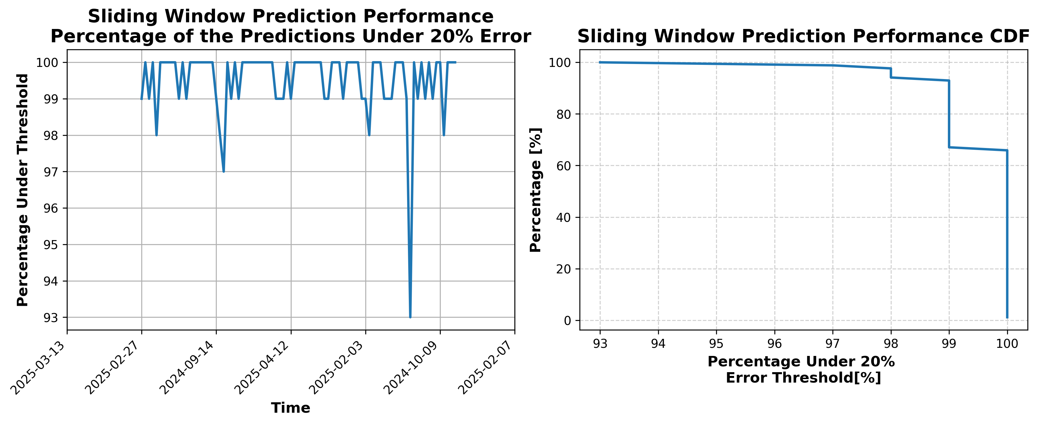

### Results for Latest_Test_2025-08-15.csv

Lines used: 8884 out of 14814 (59%)

Data sorted by: CHS Pickup Date

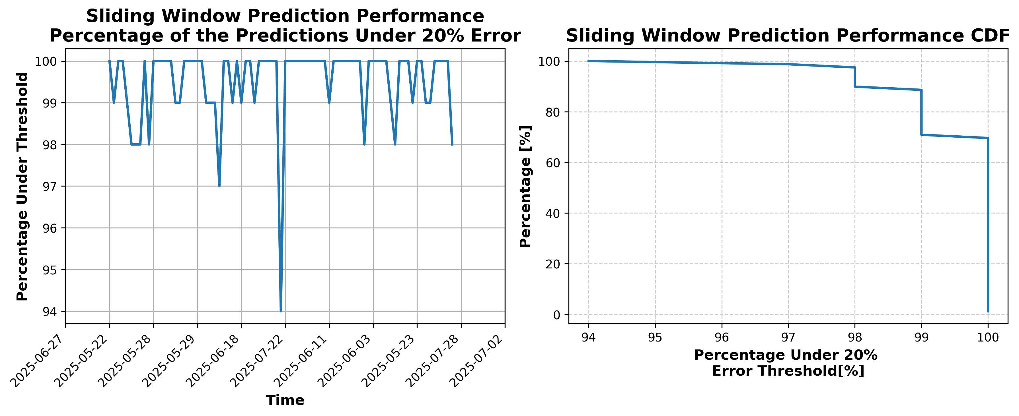

### Results for Latest_Test_2025-08-01.csv

Lines used: 8397 out of 14156 (59%)

Data sorted by: CHS Pickup Date

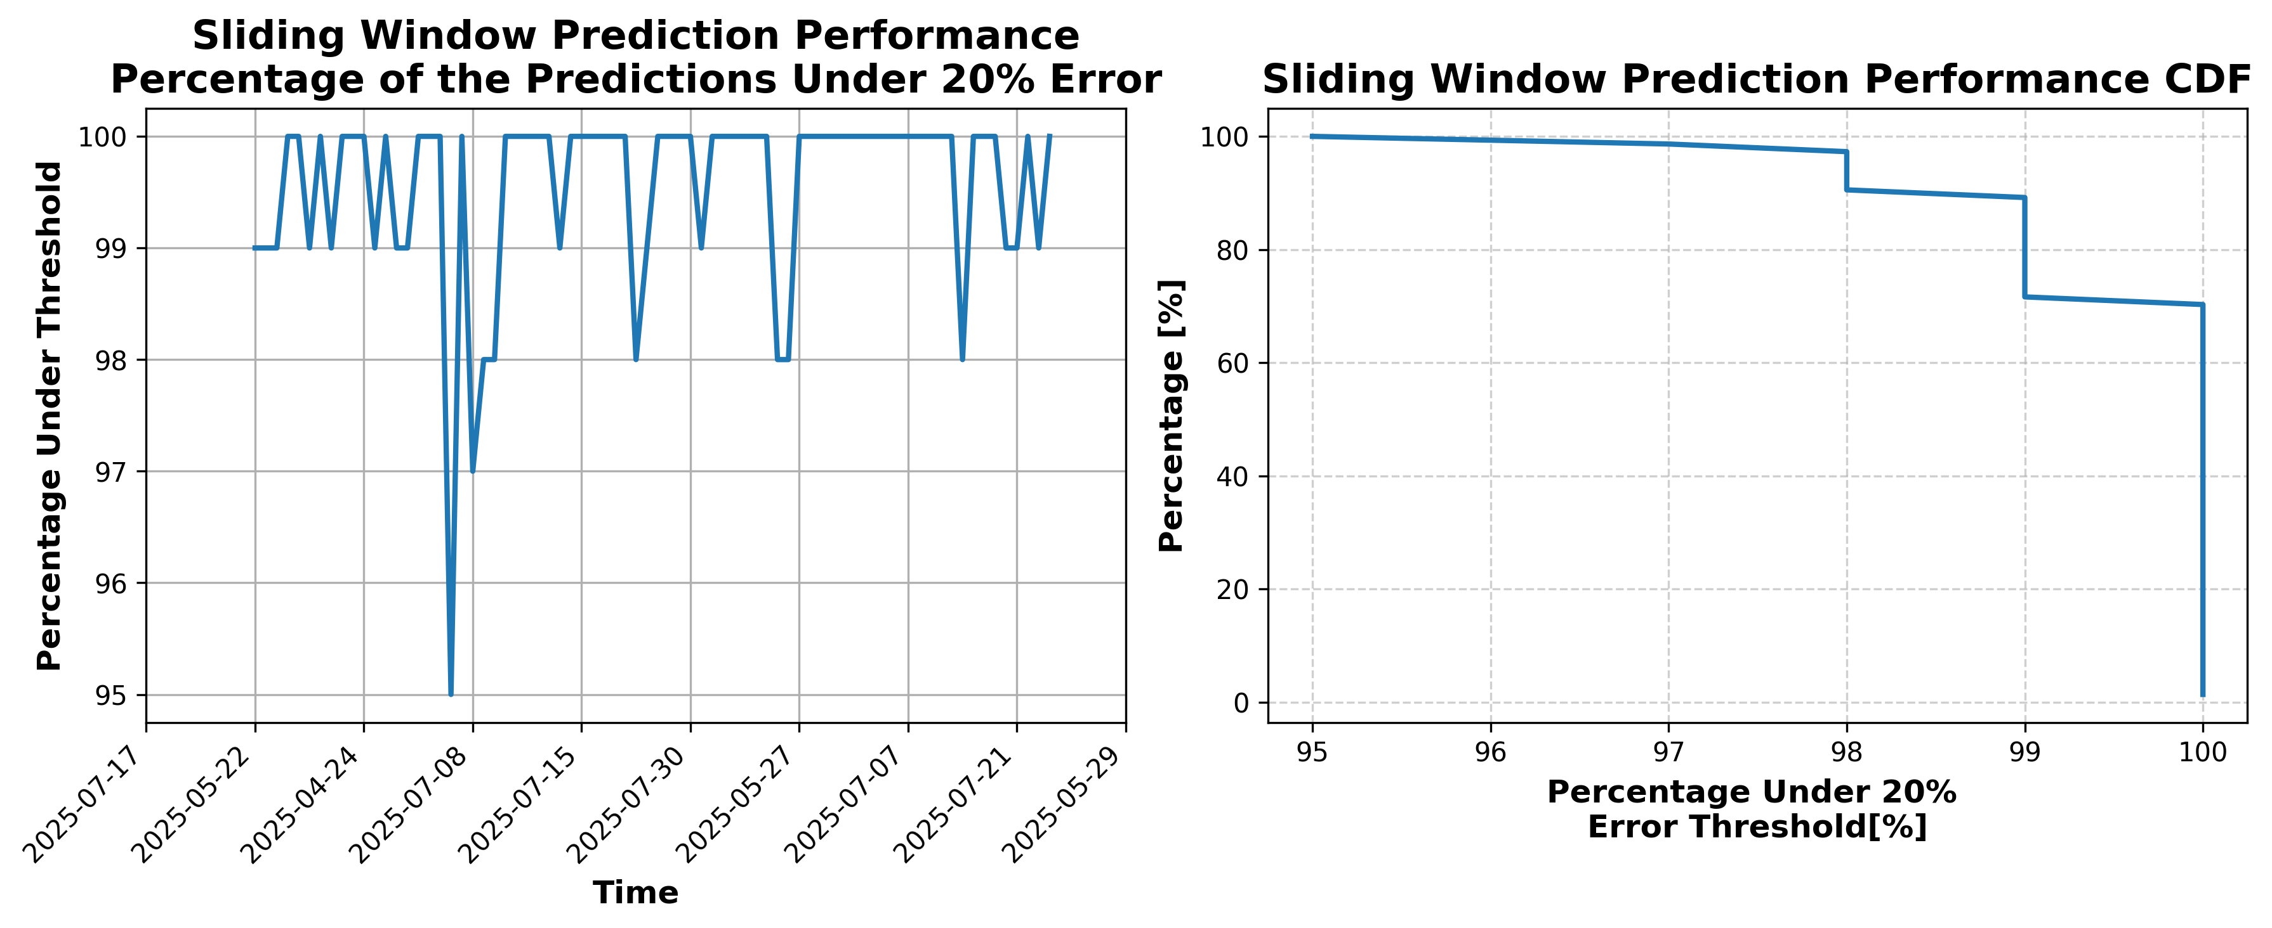

### Results for Latest_Test_2025-06-04.csv

Lines used: 9237 out of 14004 (65%)

Data sorted by: CHS Pickup Date

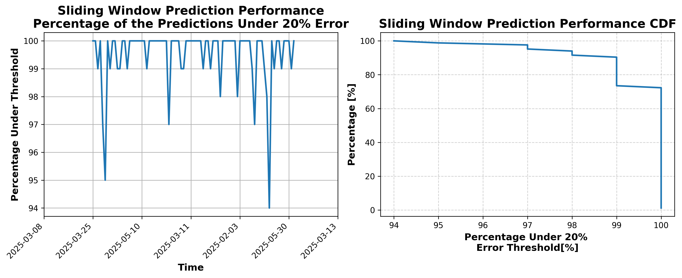

### Results for Latest_Test_2025-08-29.csv

Lines used: 8179 out of 14592 (56%)

Data sorted by: CHS Pickup Date

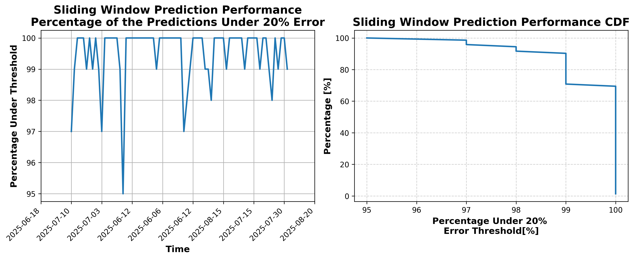

### Results for Latest_Test_2025-06-10.csv

Lines used: 9204 out of 13880 (66%)

Data sorted by: CHS Pickup Date

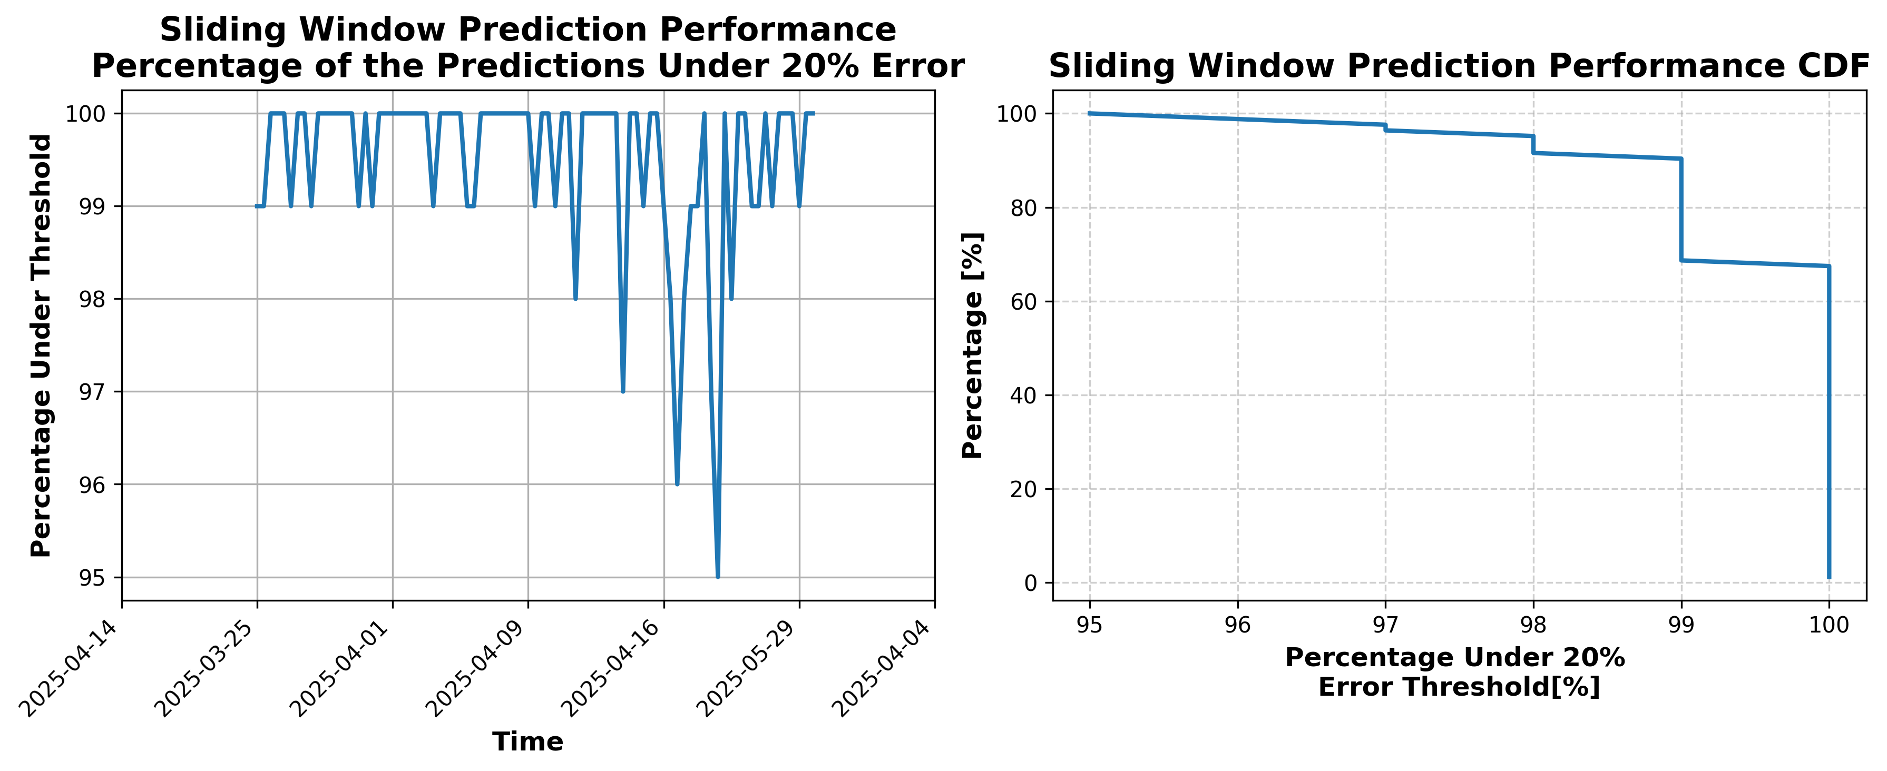

### Results for Latest_Test_2025-06-11.csv

Lines used: 9289 out of 13910 (66%)

Data sorted by: CHS Pickup Date

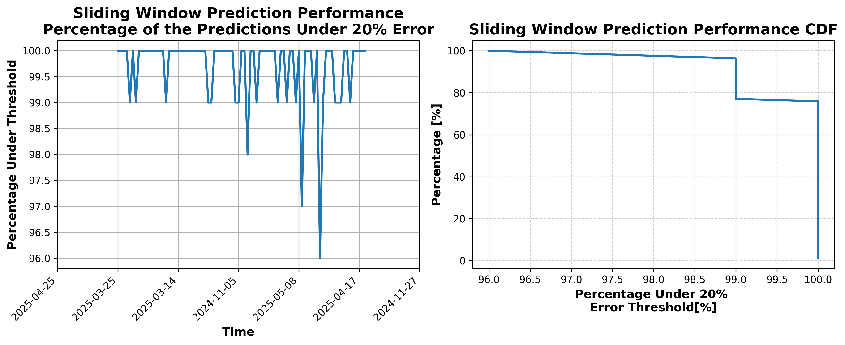

### Results for Latest_Test_2025-08-28.csv

Lines used: 8101 out of 14377 (56%)

Data sorted by: CHS Pickup Date

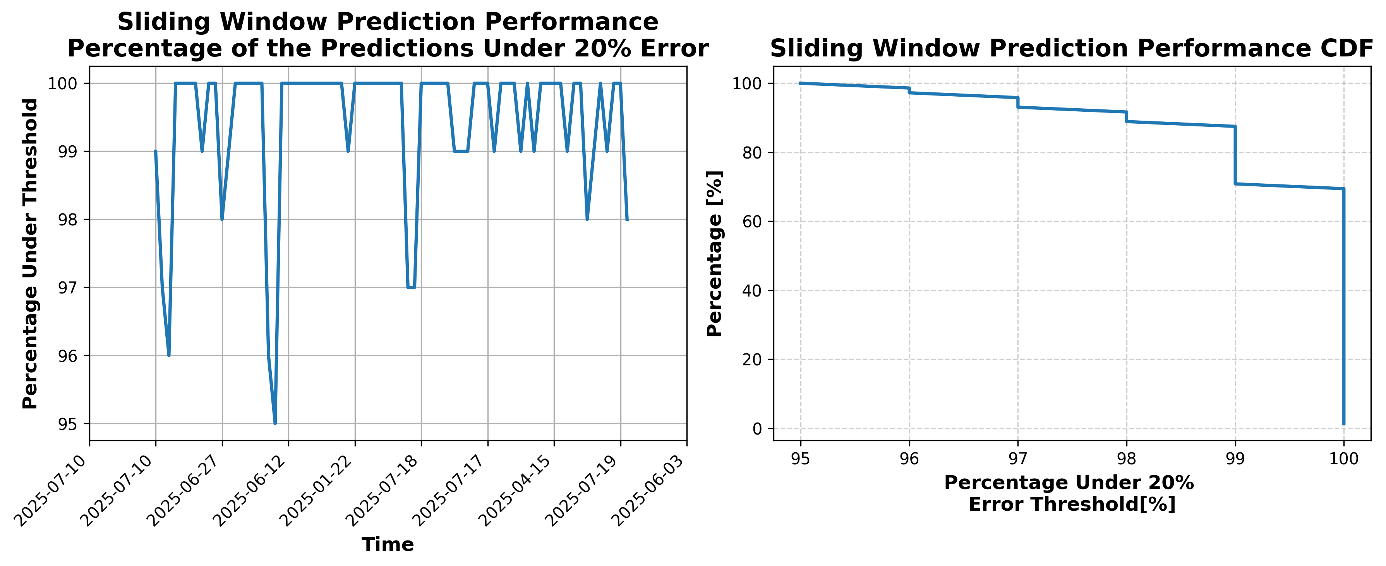

### Results for Latest_Test_2025-06-05.csv

Lines used: 9151 out of 13950 (65%)

Data sorted by: CHS Pickup Date

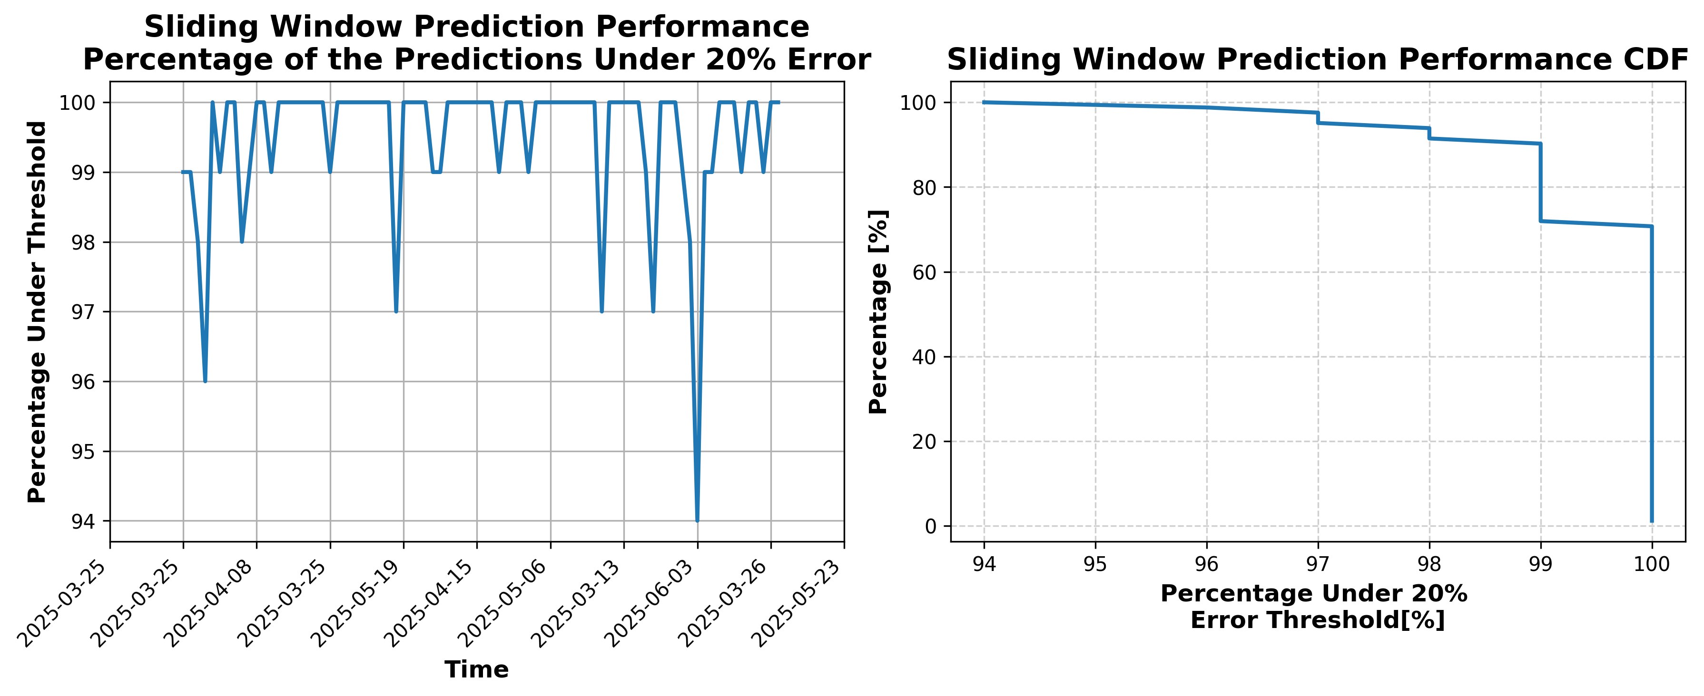

### Results for Latest_Test_2025-08-14.csv

Lines used: 8766 out of 14670 (59%)

Data sorted by: CHS Pickup Date

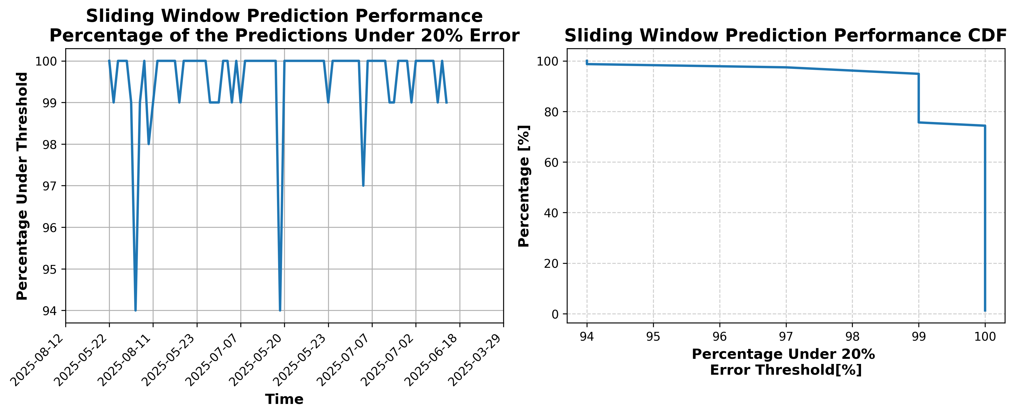

### Results for Latest_Test_2025-04-14.csv

Lines used: 9531 out of 16462 (57%)

Data sorted by: CHS Pickup Date

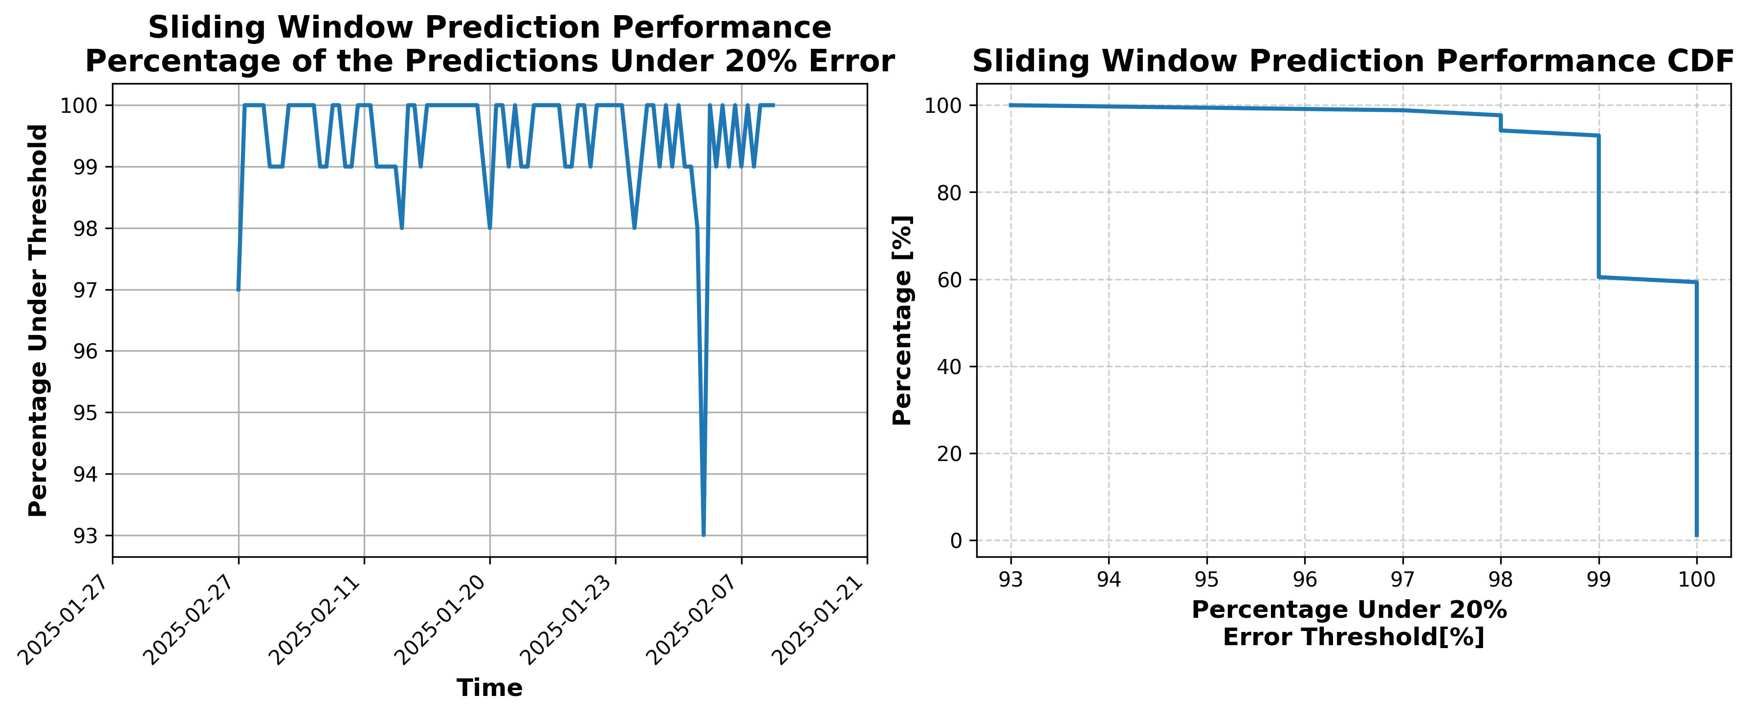

### Results for Latest_Test_2025-03-09.csv

Lines used: 10110 out of 19118 (52%)

Data sorted by: CHS Pickup Date

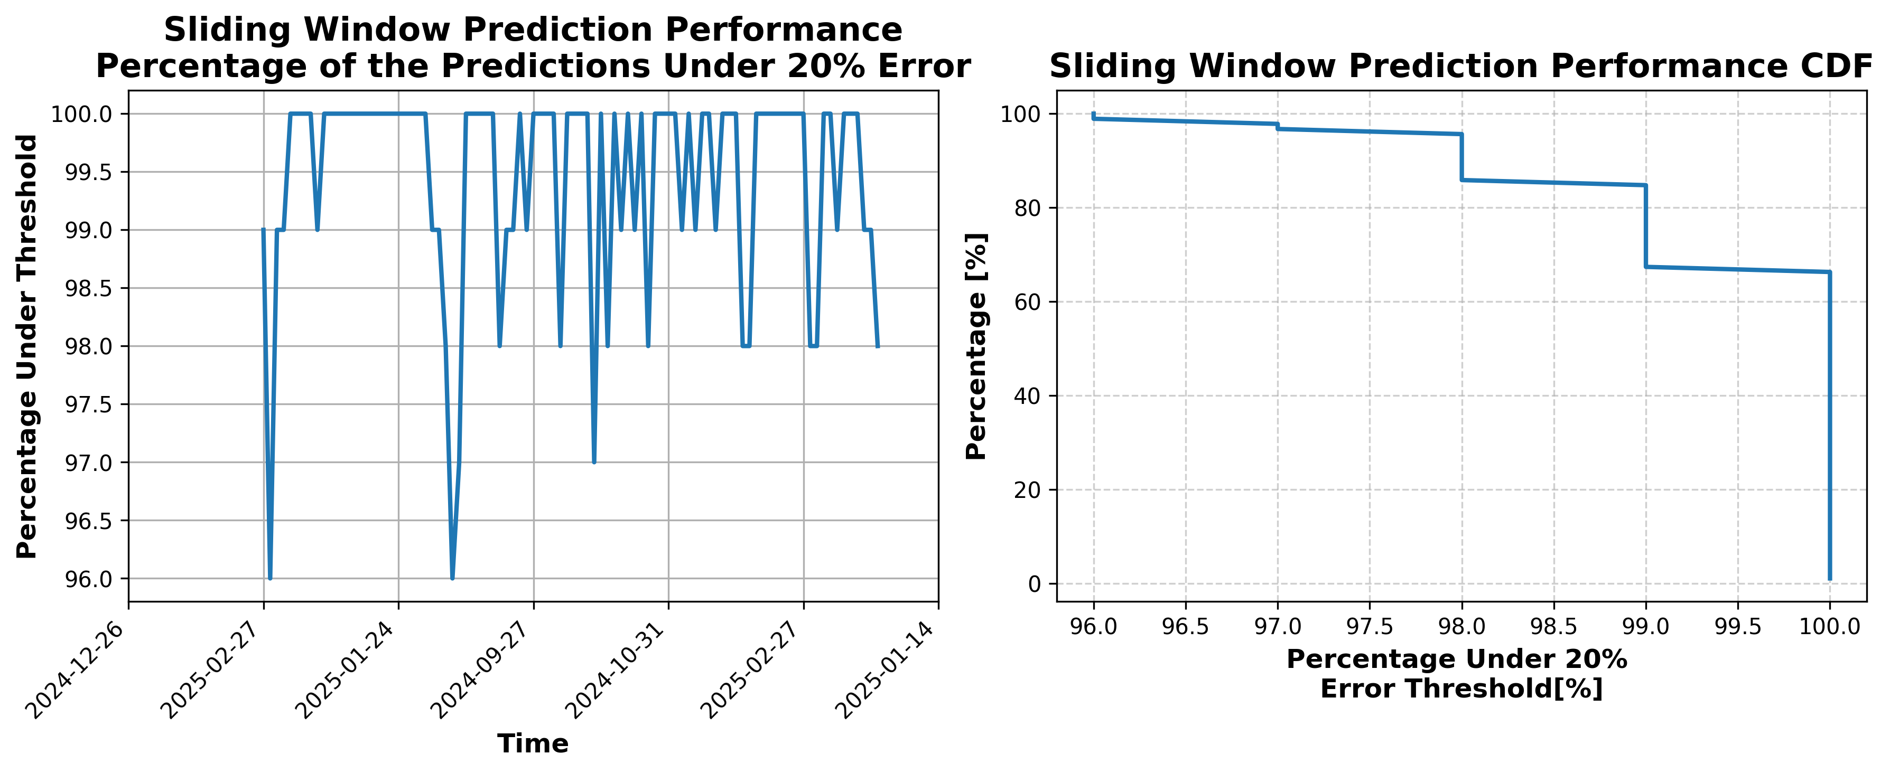

### Results for Latest_Test_2025-03-21.csv

Lines used: 9486 out of 16760 (56%)

Data sorted by: CHS Pickup Date

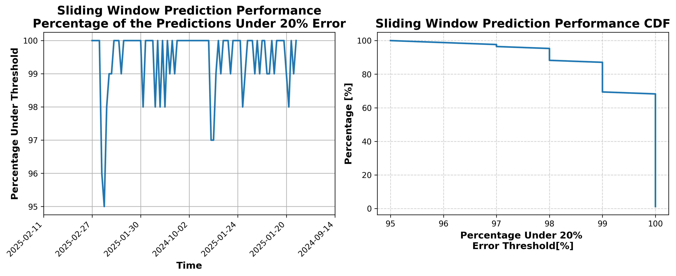

### Results for Latest_Test_2025-04-28.csv

Lines used: 8842 out of 15847 (55%)

Data sorted by: CHS Pickup Date

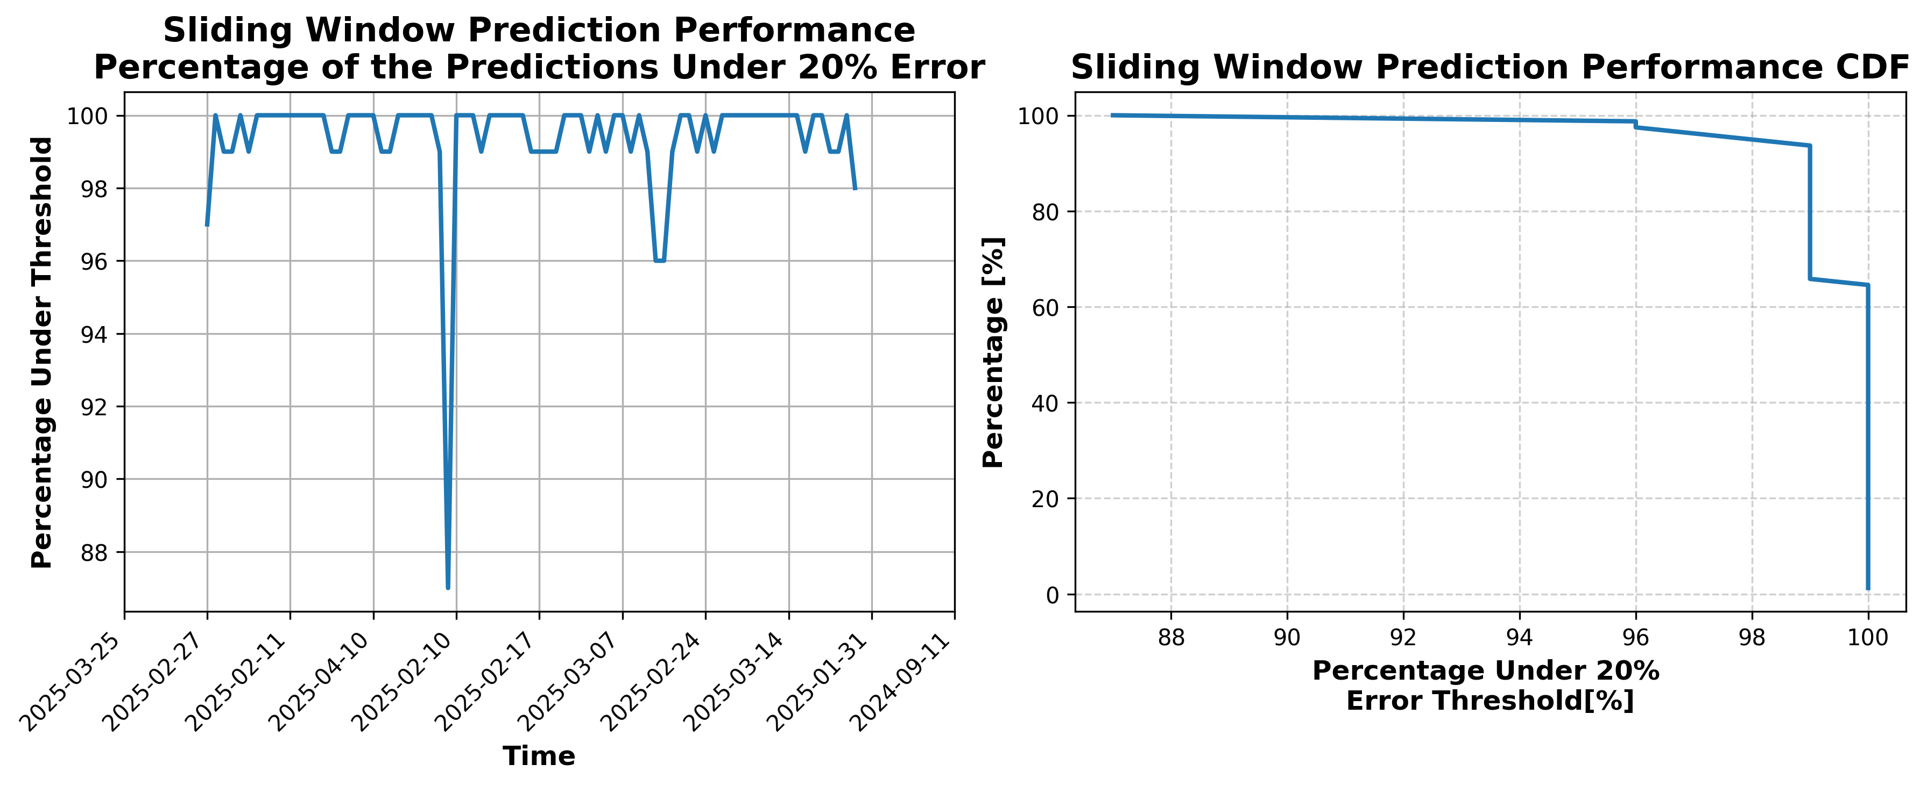

### Results for Latest_Test_2025-04-04.csv

Lines used: 9944 out of 16848 (59%)

Data sorted by: CHS Pickup Date

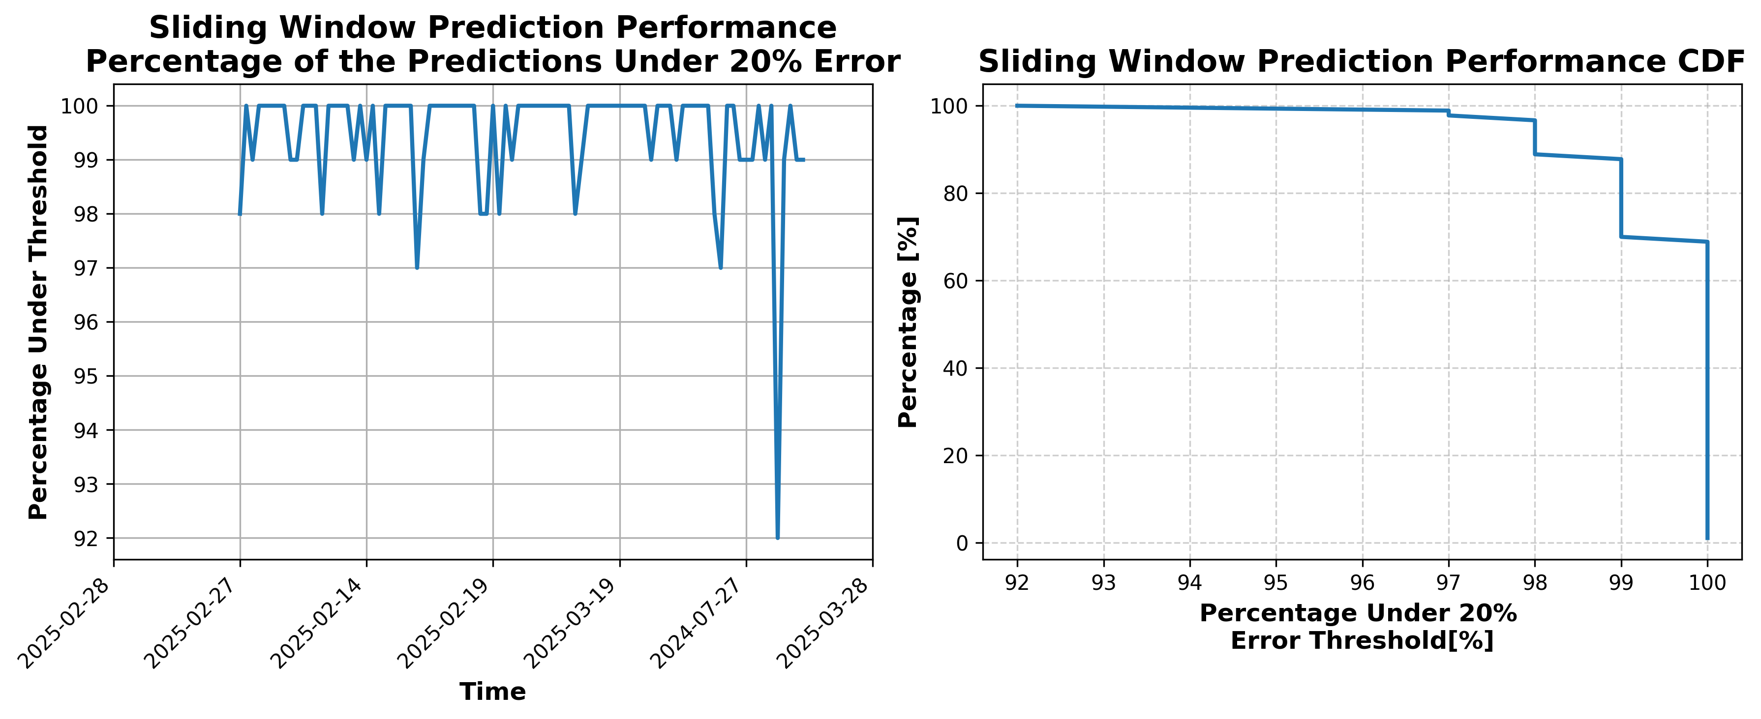

### Results for Latest_Test_2025-04-10.csv

Lines used: 9819 out of 16774 (58%)

Data sorted by: CHS Pickup Date

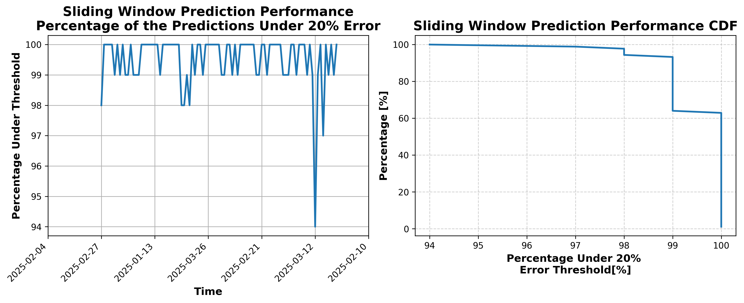

### Results for Latest_Test_2025-03-19.csv

Lines used: 9332 out of 16783 (55%)

Data sorted by: CHS Pickup Date

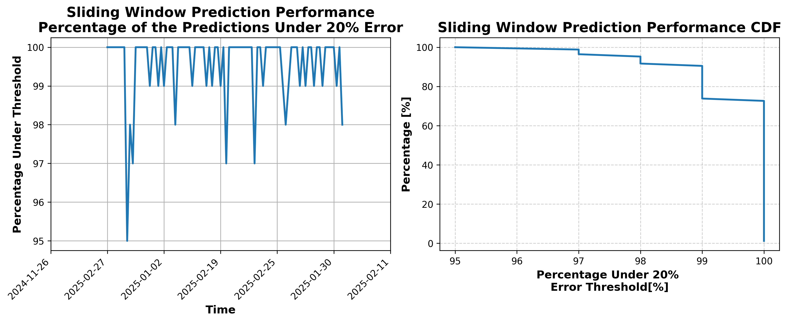

### Results for Latest_Test_2025-03-31.csv

Lines used: 9518 out of 16552 (57%)

Data sorted by: CHS Pickup Date

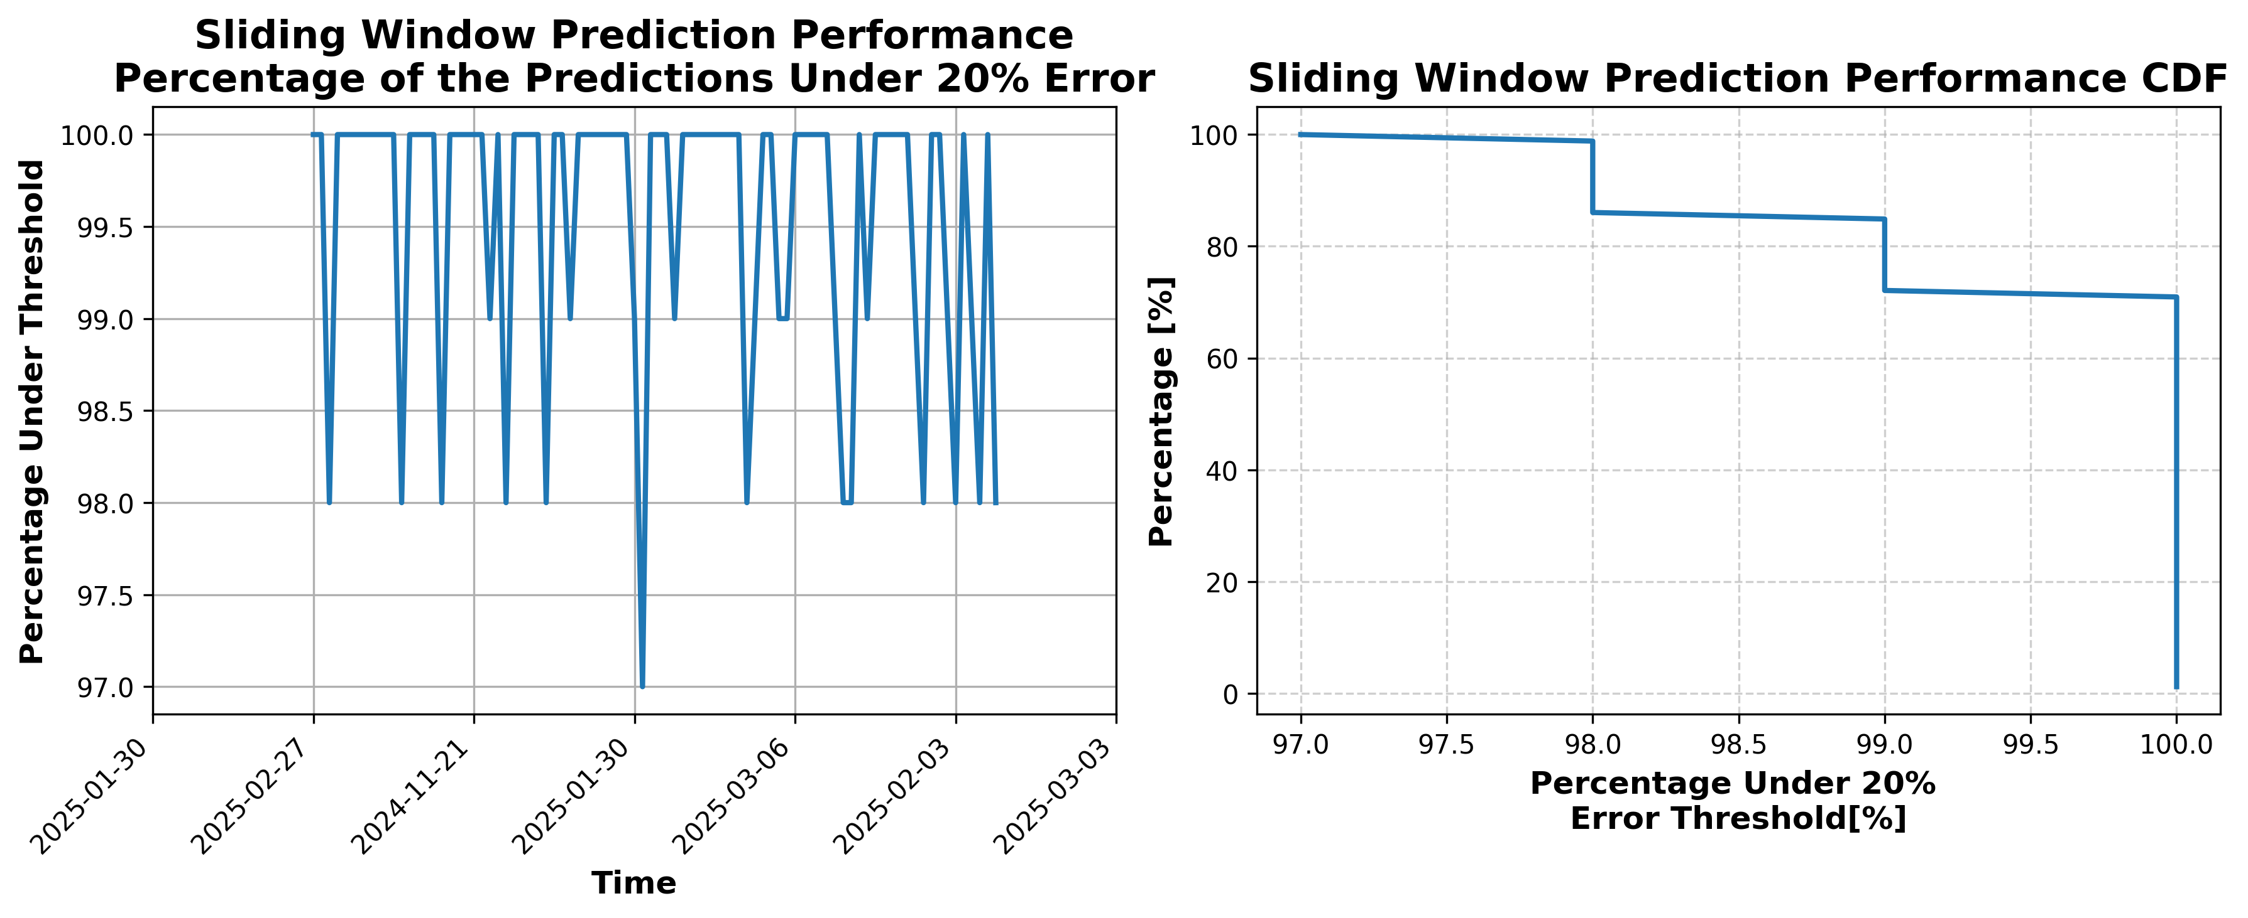

### Results for Latest_Test_2025-03-25.csv

Lines used: 9627 out of 16910 (56%)

Data sorted by: CHS Pickup Date

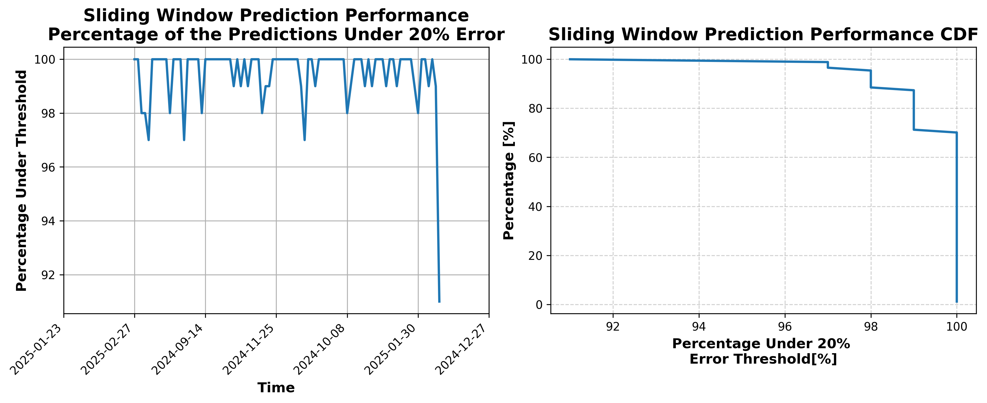

### Results for Latest_Test_2025-06-01.csv

Lines used: 9430 out of 14274 (66%)

Data sorted by: CHS Pickup Date

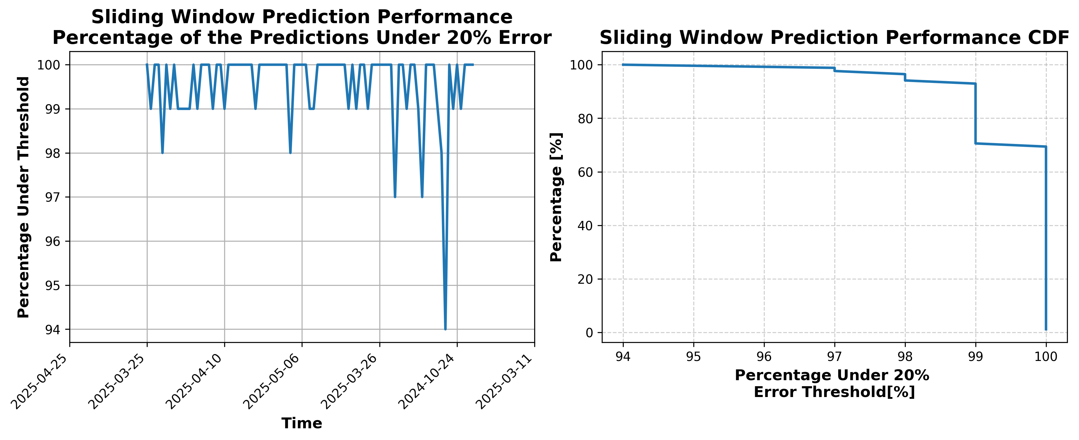

### Results for Latest_Test_2025-06-15.csv

Lines used: 9150 out of 13920 (65%)

Data sorted by: CHS Pickup Date

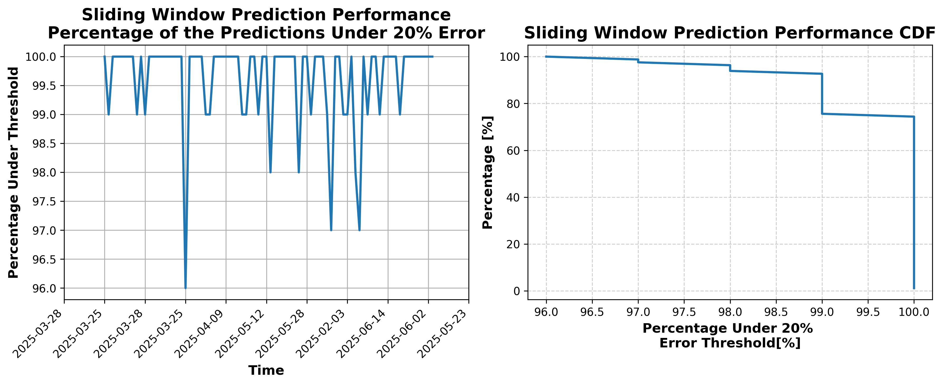

### Results for Latest_Test_2025-08-10.csv

Lines used: 8546 out of 14362 (59%)

Data sorted by: CHS Pickup Date

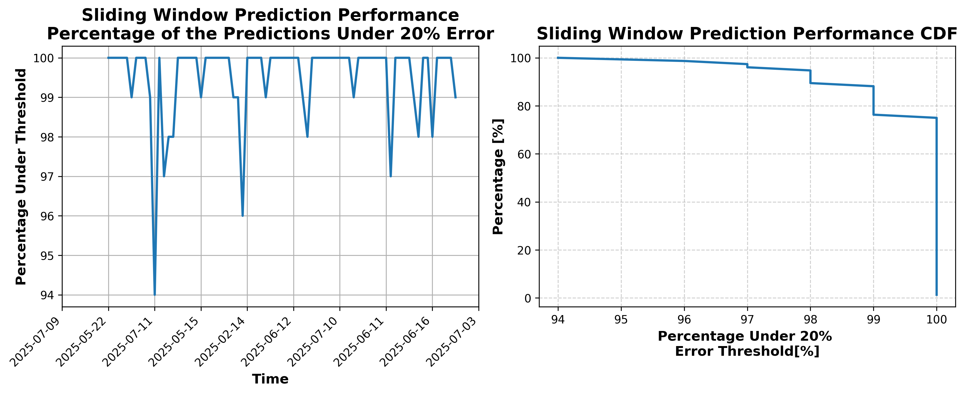

### Results for Latest_Test_2025-06-29.csv

Lines used: 9294 out of 13905 (66%)

Data sorted by: CHS Pickup Date

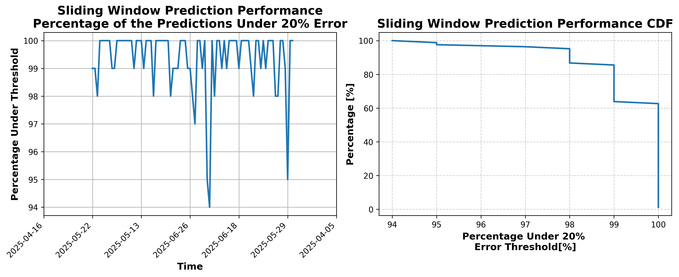

### Results for Latest_Test_2025-08-04.csv

Lines used: 8269 out of 14117 (58%)

Data sorted by: CHS Pickup Date

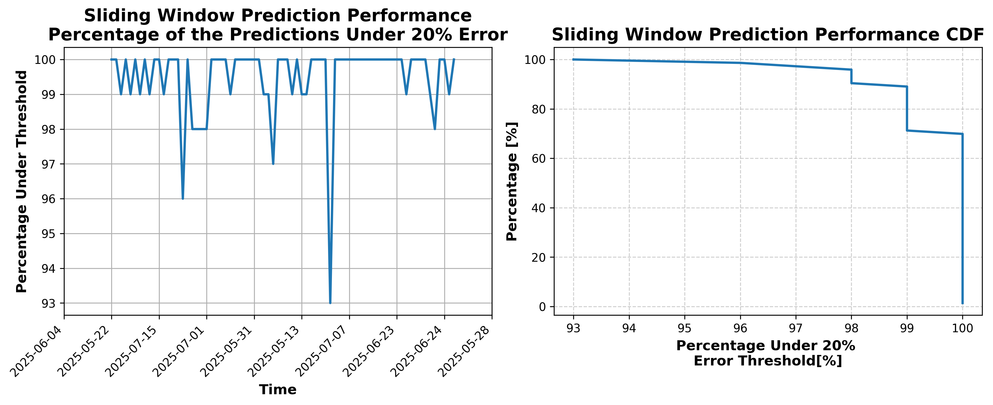

### Results for Latest_Test_2025-08-05.csv

Lines used: 8346 out of 14219 (58%)

Data sorted by: CHS Pickup Date

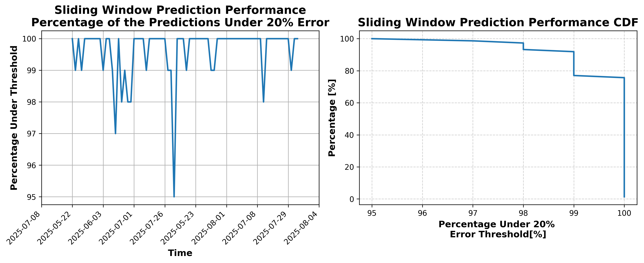

### Results for Latest_Test_2025-06-28.csv

Lines used: 9405 out of 14032 (67%)

Data sorted by: CHS Pickup Date

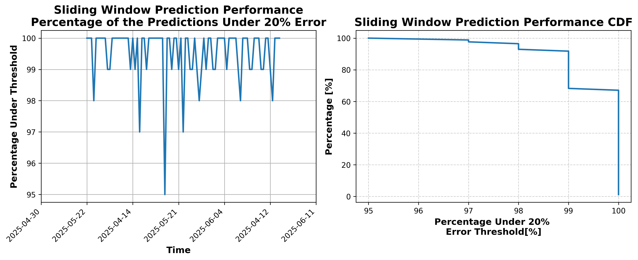

### Results for Latest_Test_2025-08-11.csv

Lines used: 8446 out of 14314 (59%)

Data sorted by: CHS Pickup Date

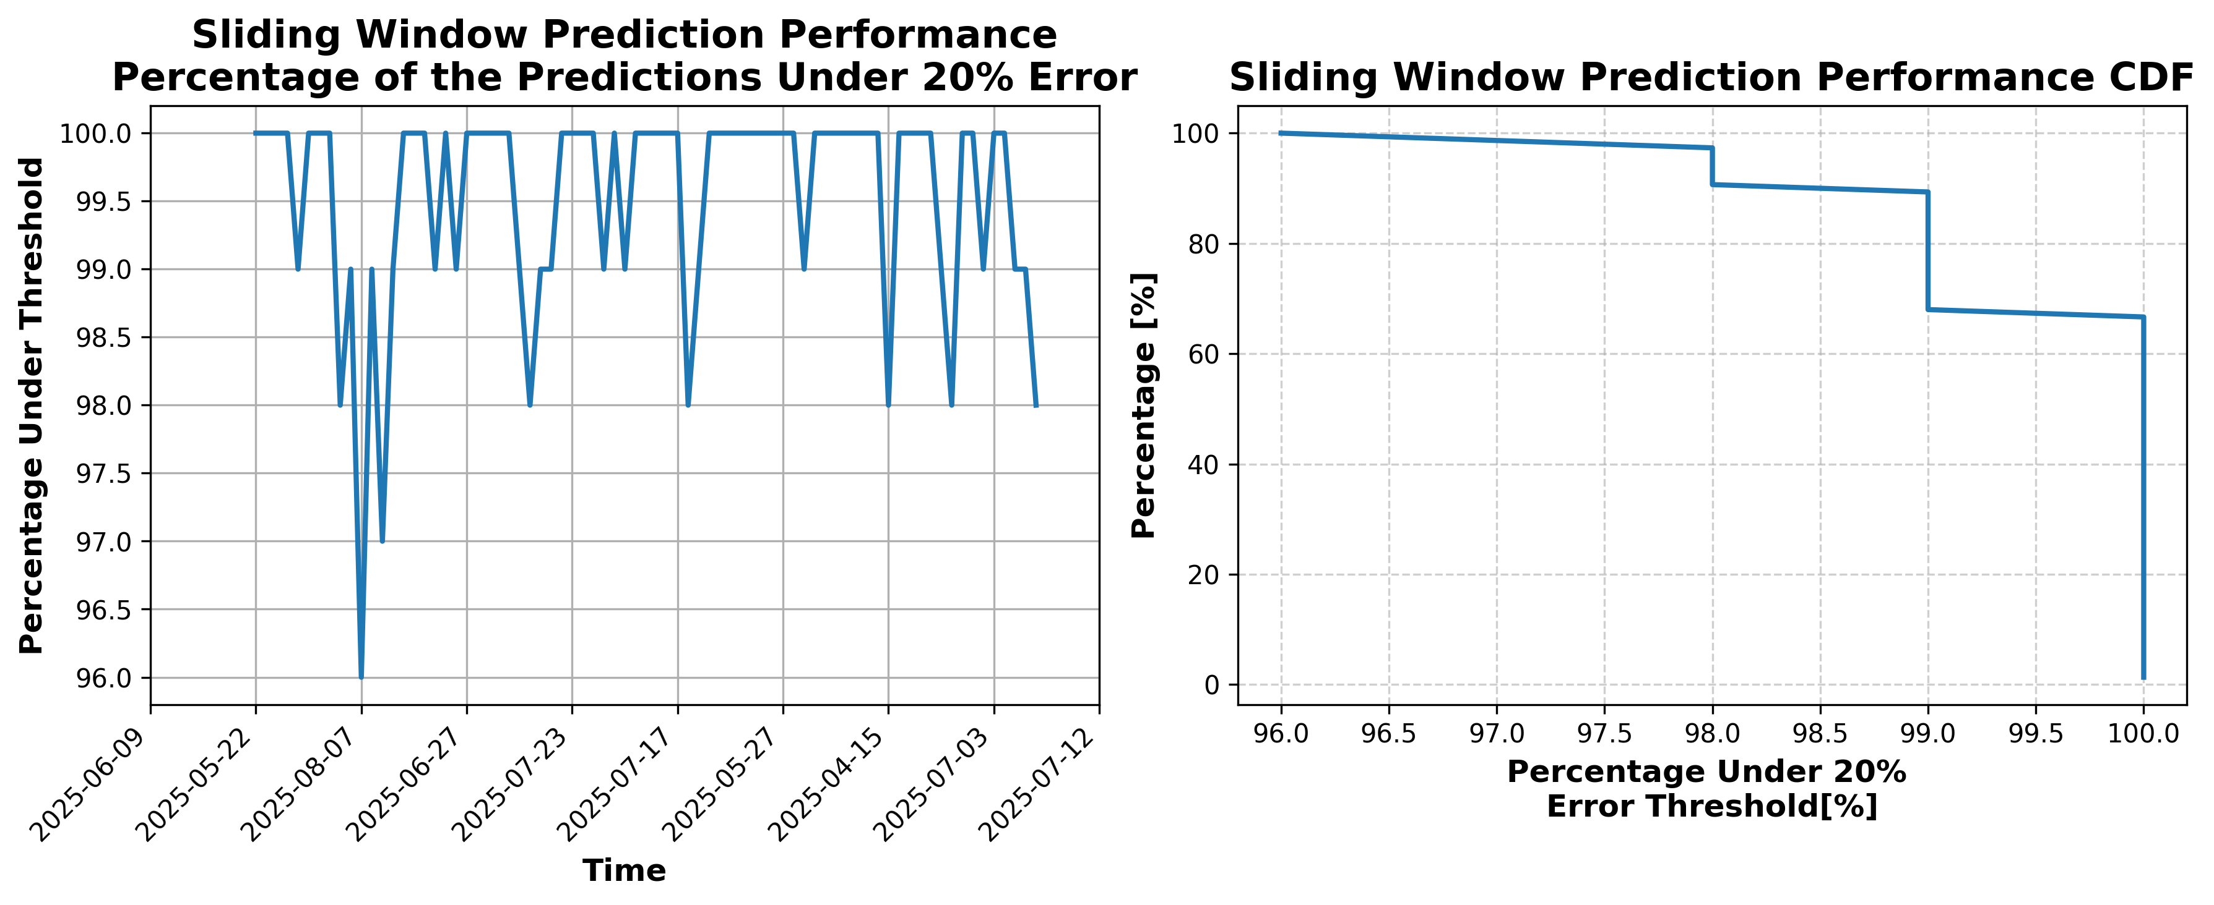

### Results for Latest_Test_2025-06-14.csv

Lines used: 9424 out of 14193 (66%)

Data sorted by: CHS Pickup Date

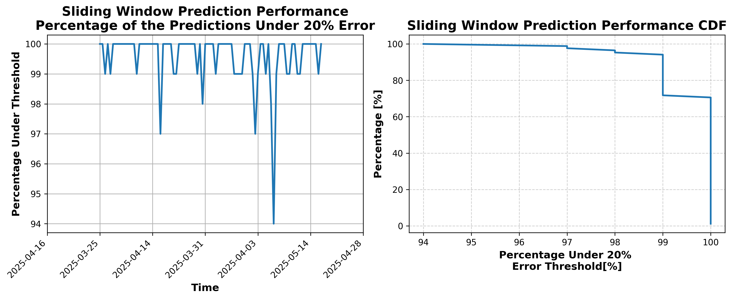

### Results for Latest_Test_2025-03-24.csv

Lines used: 9369 out of 16675 (56%)

Data sorted by: CHS Pickup Date

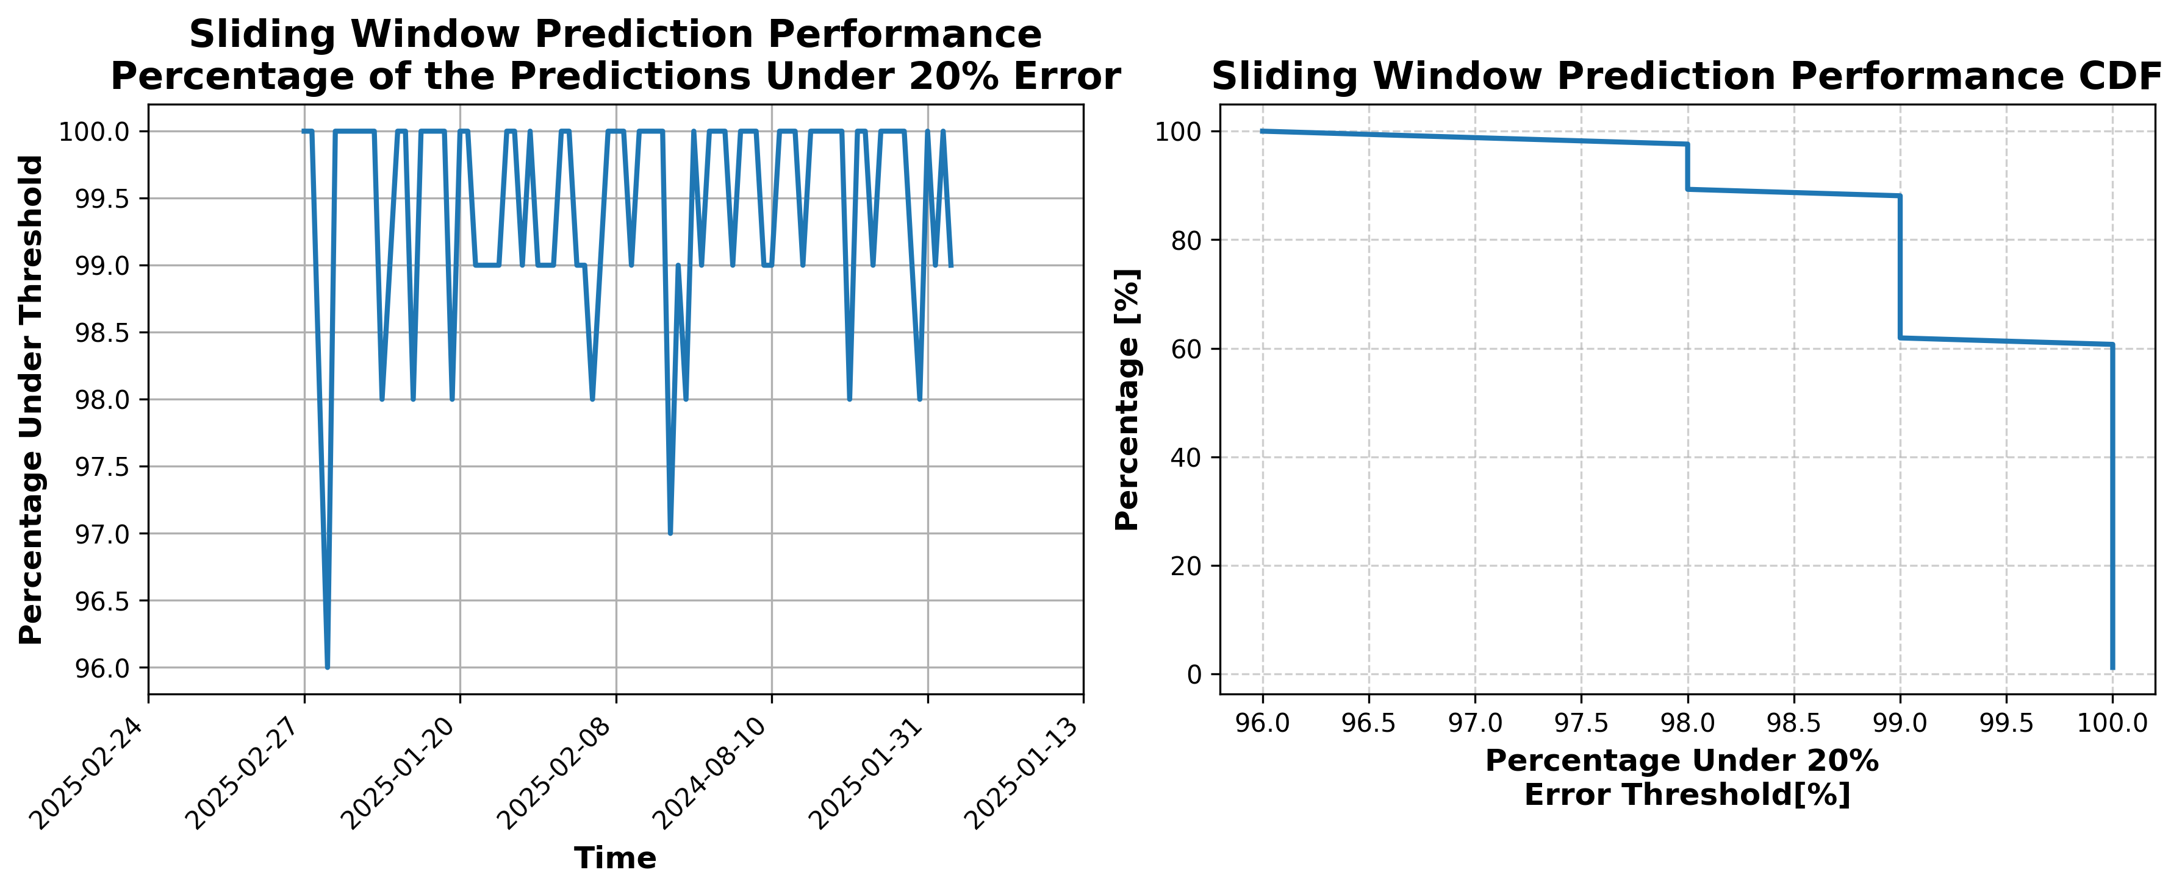

### Results for Latest_Test_2025-03-30.csv

Lines used: 9525 out of 16635 (57%)

Data sorted by: CHS Pickup Date

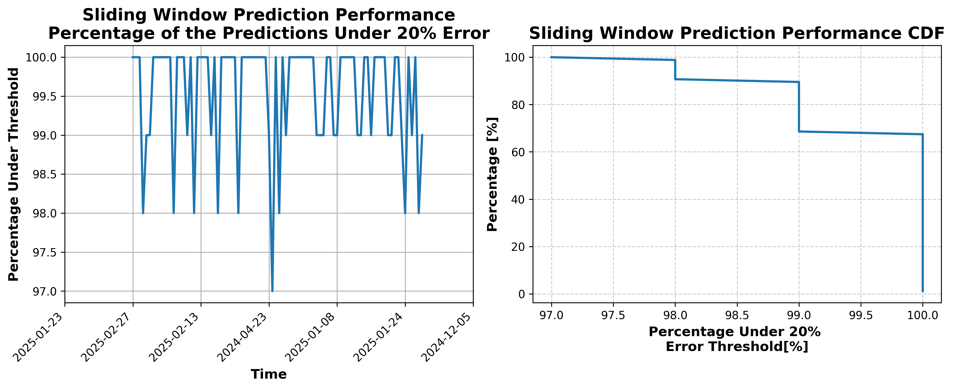

### Results for Latest_Test_2025-04-11.csv

Lines used: 10015 out of 16948 (59%)

Data sorted by: CHS Pickup Date

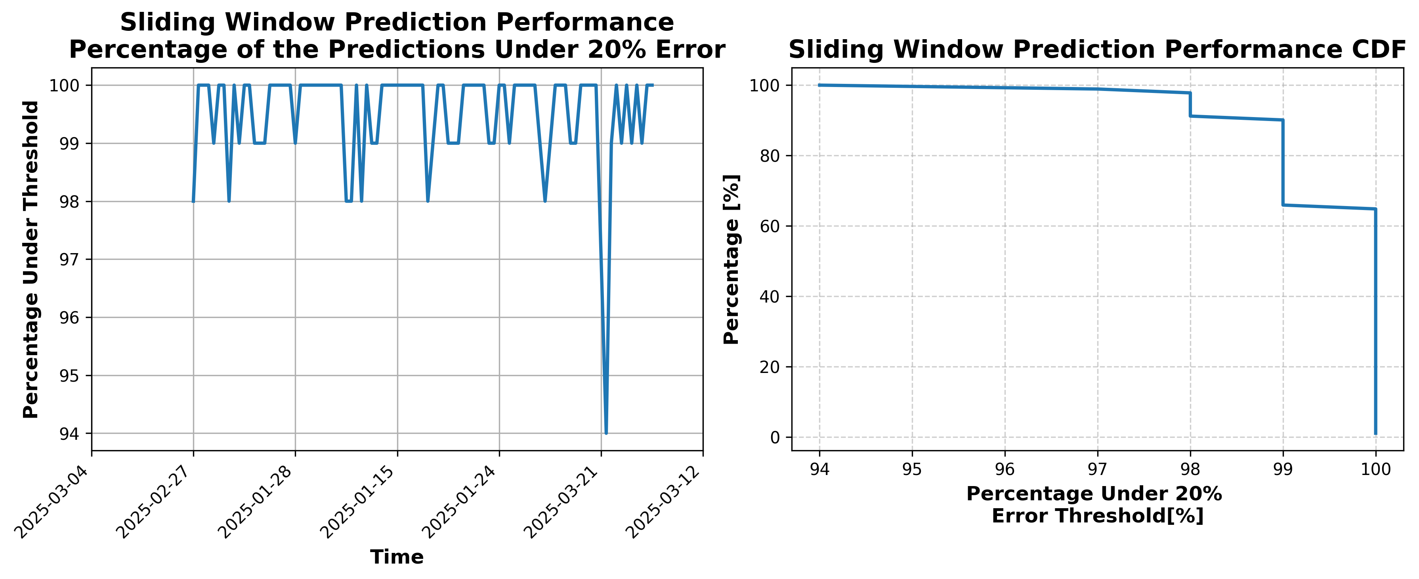

### Results for Latest_Test_2025-03-18.csv

Lines used: 9125 out of 16702 (54%)

Data sorted by: CHS Pickup Date

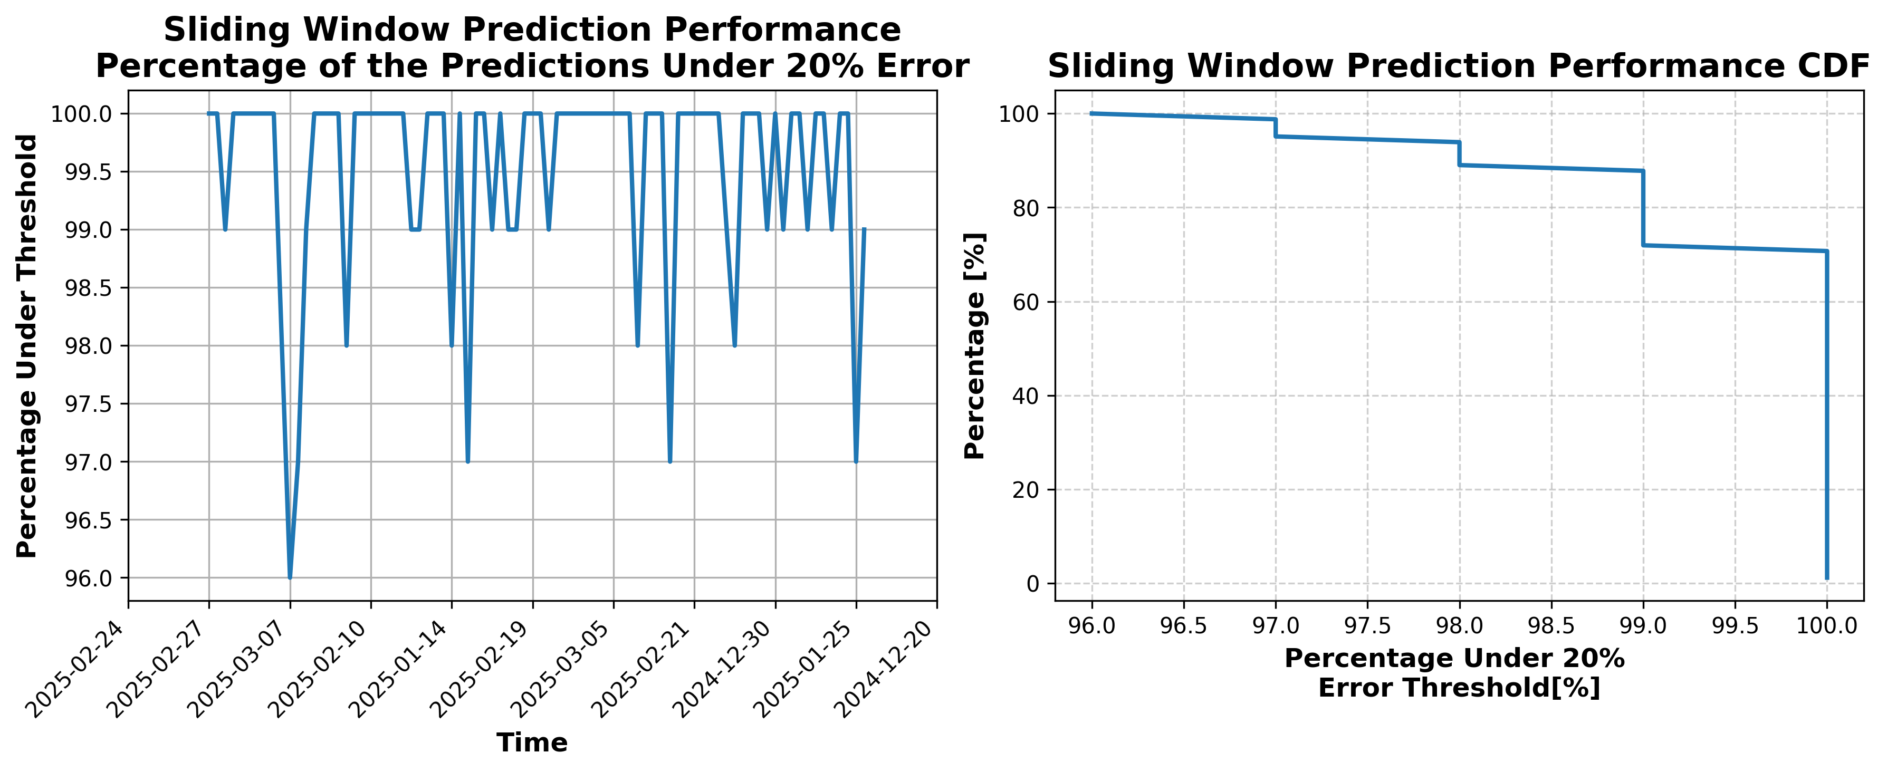

### Results for Latest_Test_2025-04-05.csv

Lines used: 10053 out of 16958 (59%)

Data sorted by: CHS Pickup Date

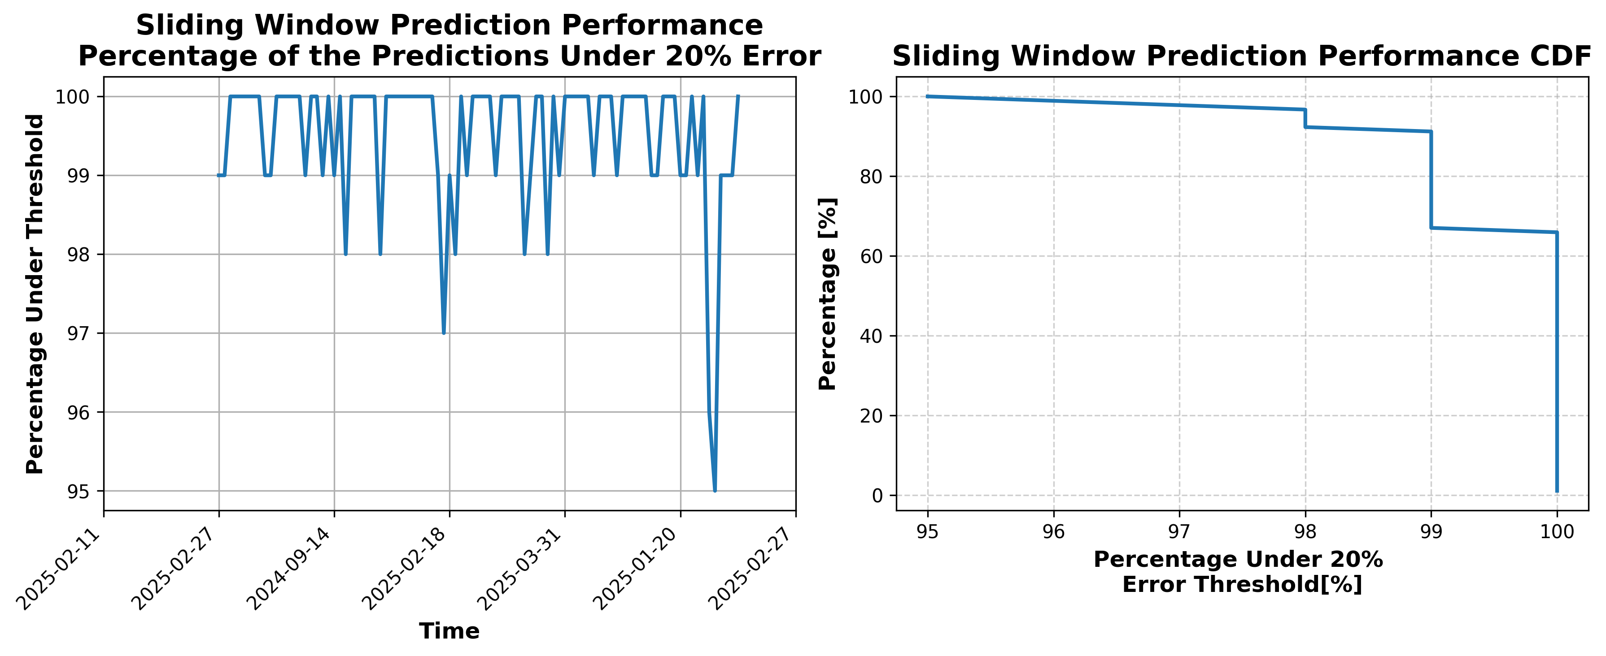

### Results for Latest_Test_2025-04-13.csv

Lines used: 9903 out of 16772 (59%)

Data sorted by: CHS Pickup Date

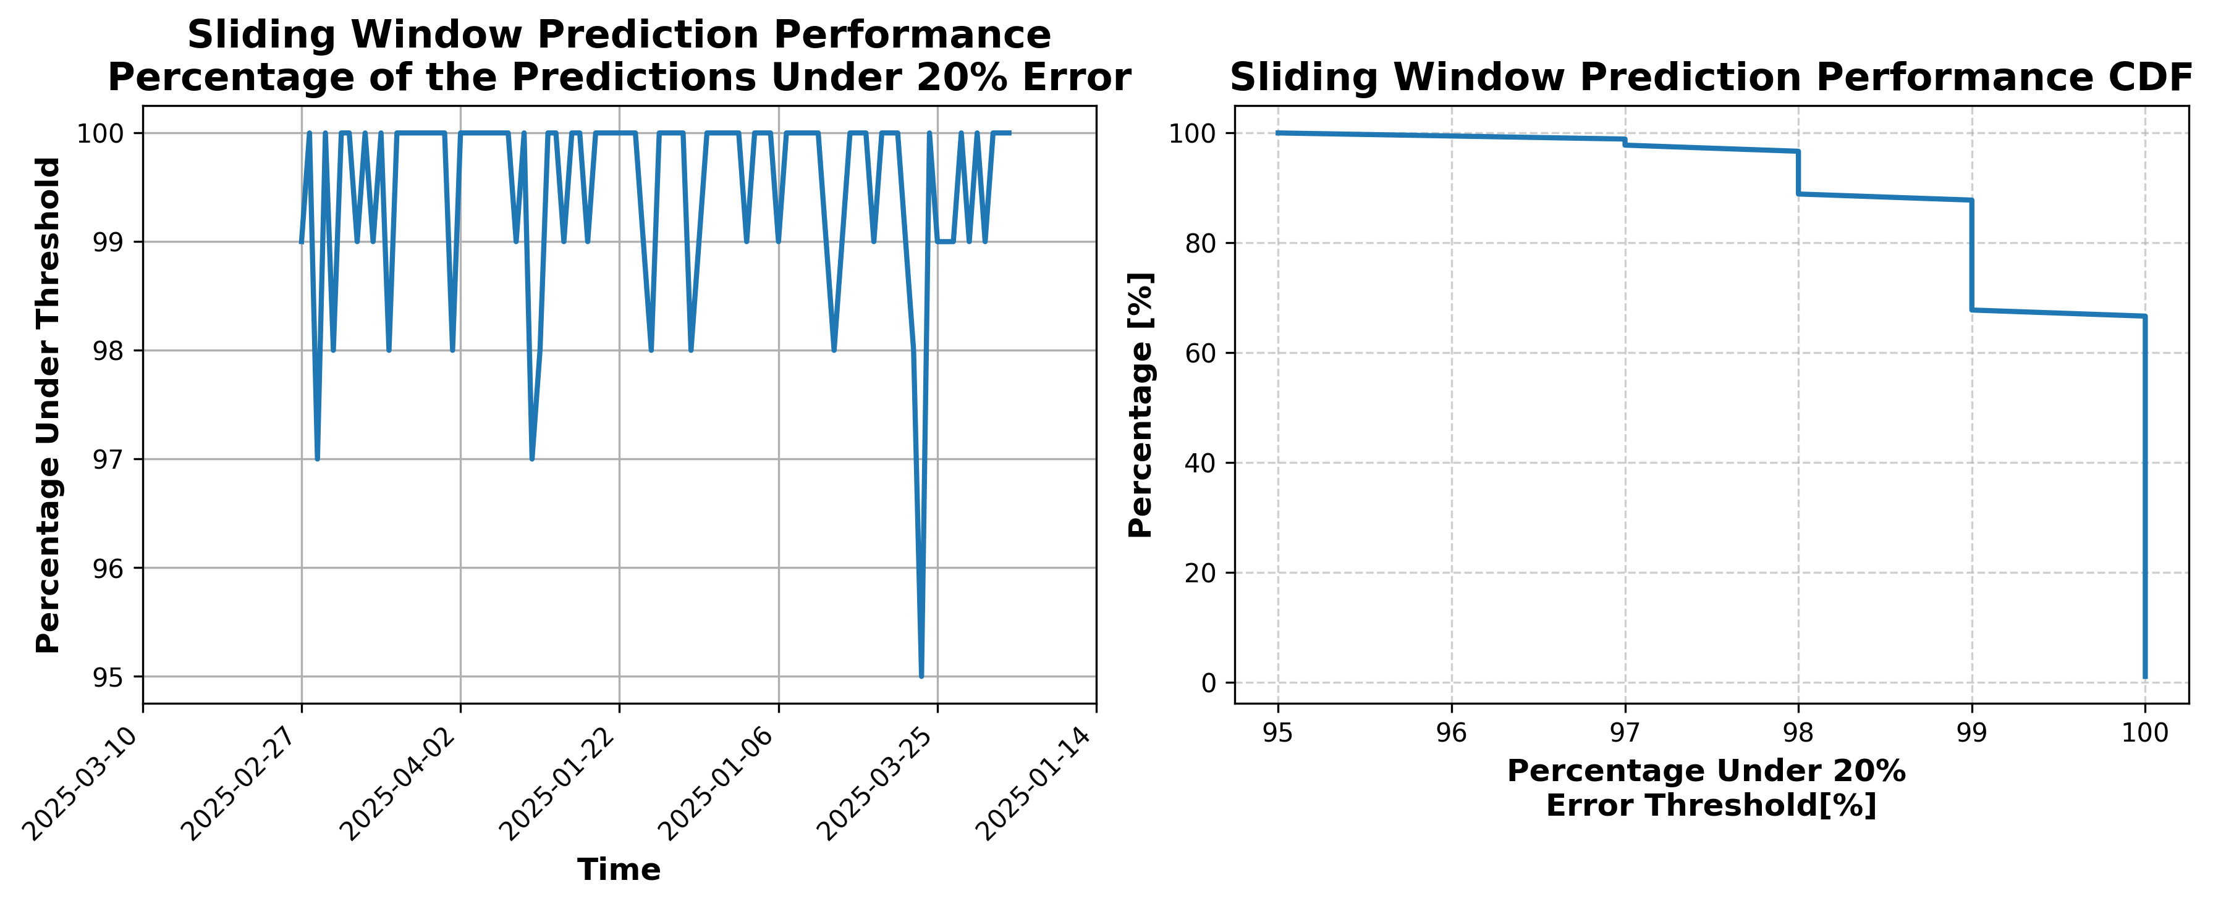

### Results for Latest_Test_2025-04-07.csv

Lines used: 9735 out of 16590 (58%)

Data sorted by: CHS Pickup Date

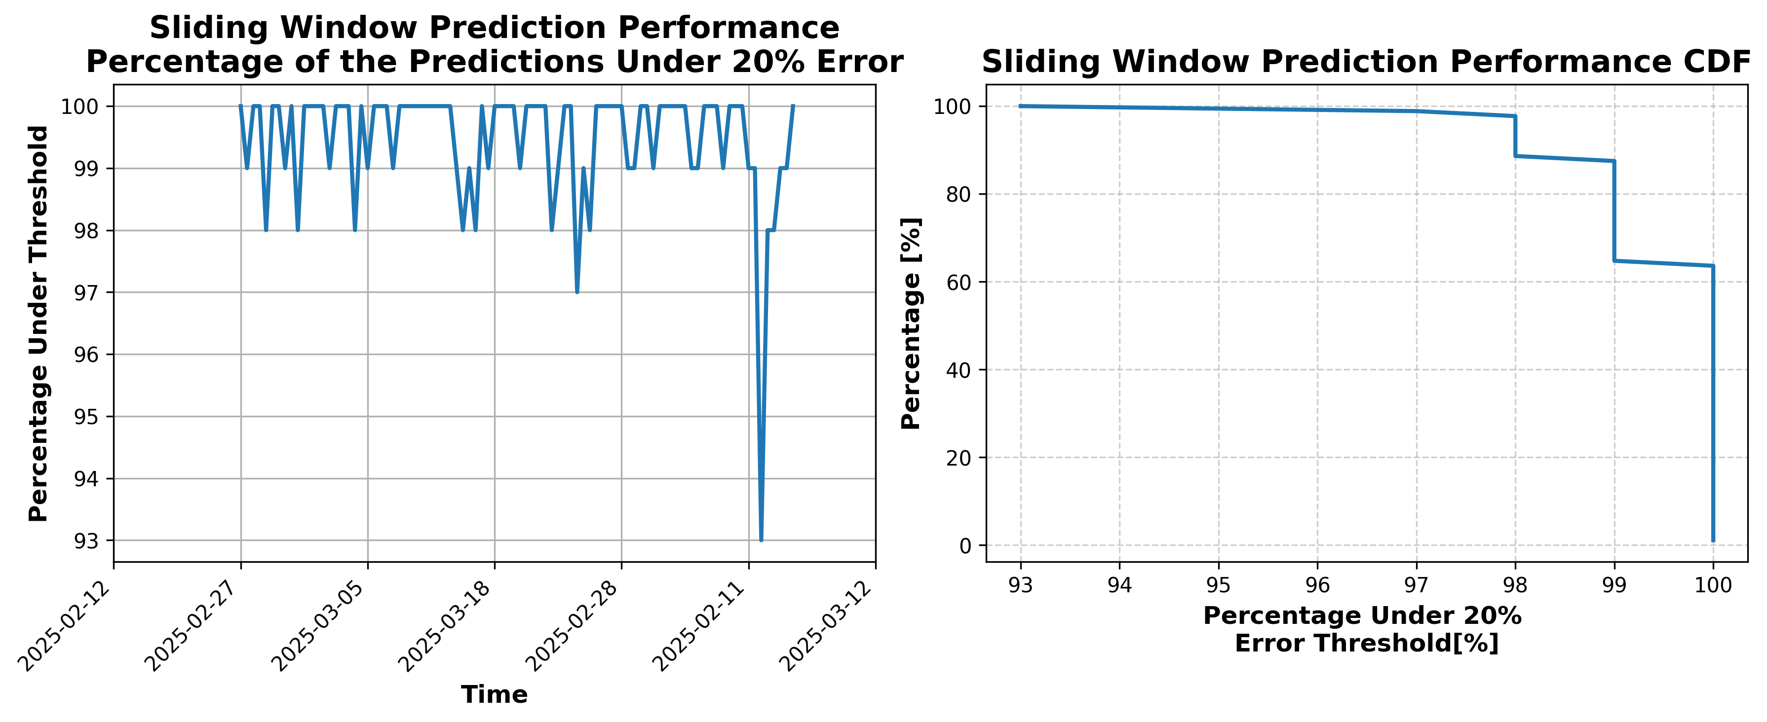

### Results for Latest_Test_2025-03-26.csv

Lines used: 9666 out of 16828 (57%)

Data sorted by: CHS Pickup Date

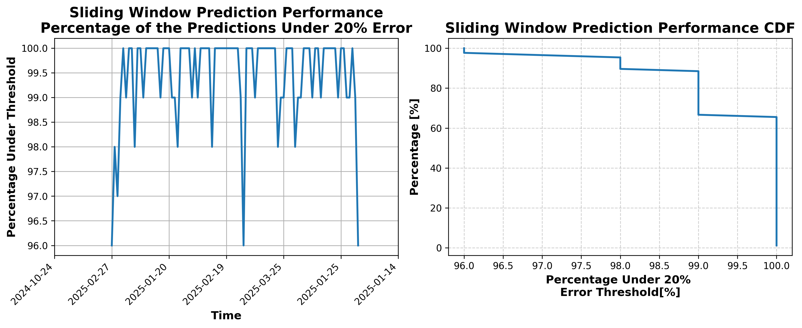

### Results for Latest_Test_2025-06-16.csv

Lines used: 9005 out of 13756 (65%)

Data sorted by: CHS Pickup Date

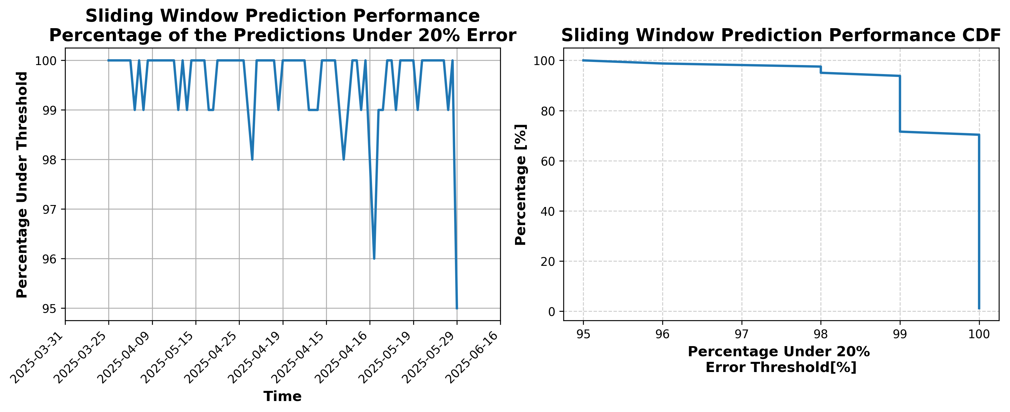

### Results for Latest_Test_2025-06-02.csv

Lines used: 9315 out of 14148 (65%)

Data sorted by: CHS Pickup Date

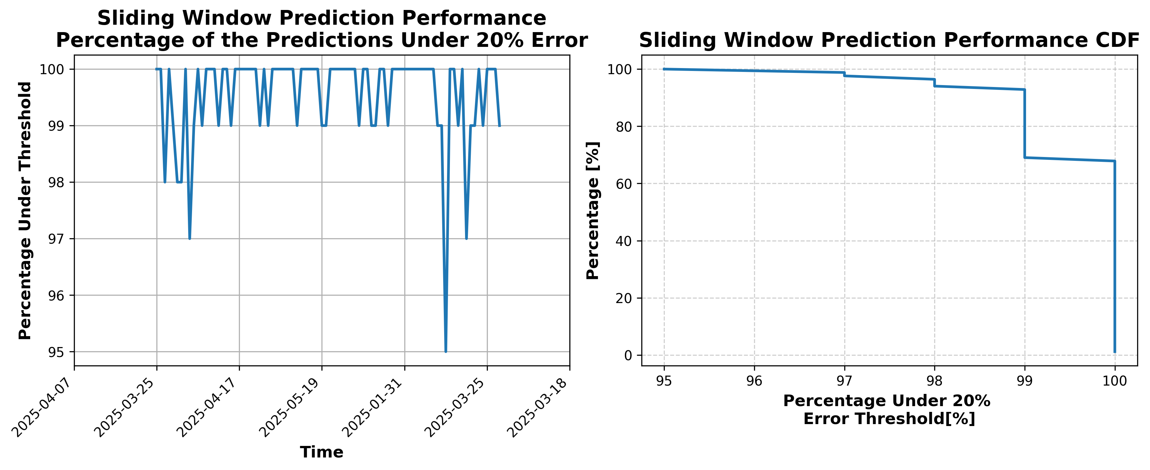

### Results for Latest_Test_2025-08-07.csv

Lines used: 8568 out of 14306 (59%)

Data sorted by: CHS Pickup Date

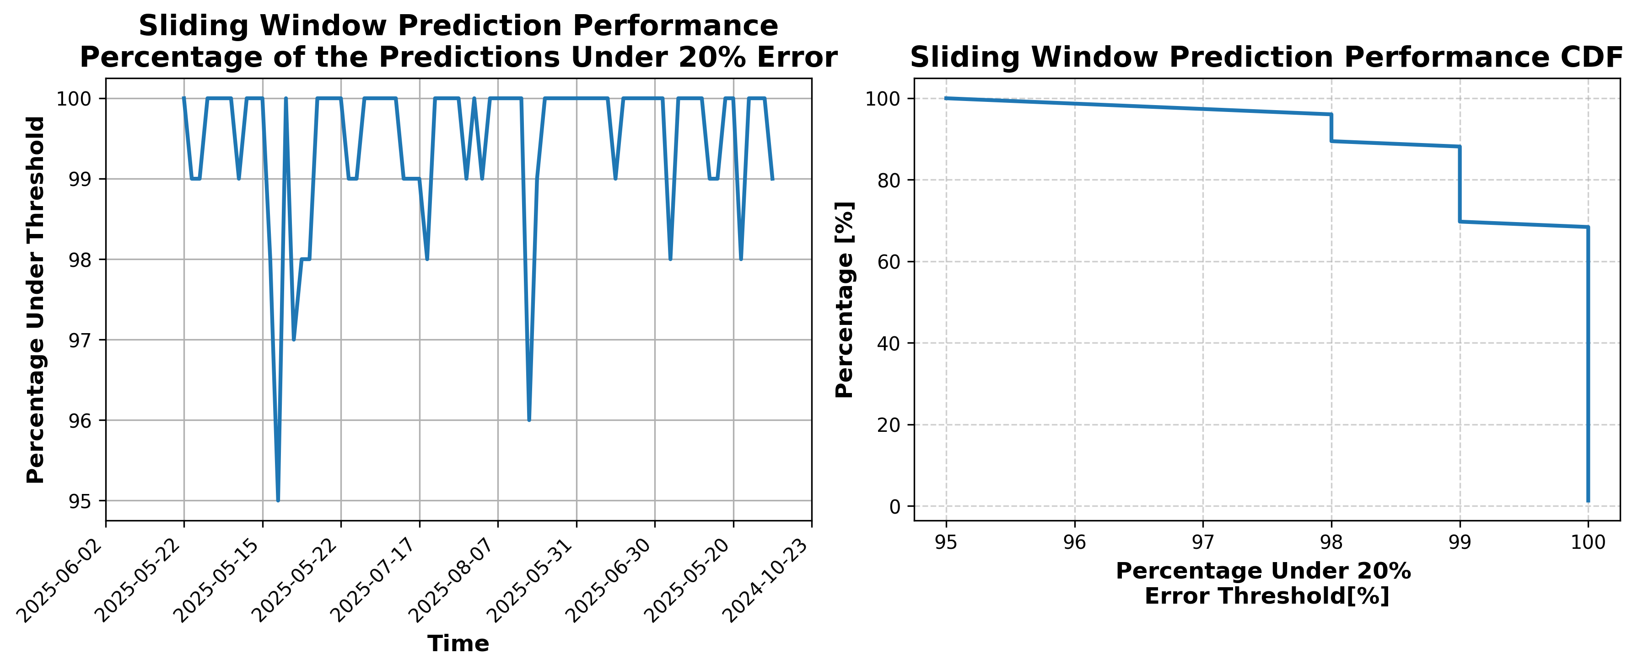

### Results for Latest_Test_2025-08-13.csv

Lines used: 8653 out of 14493 (59%)

Data sorted by: CHS Pickup Date

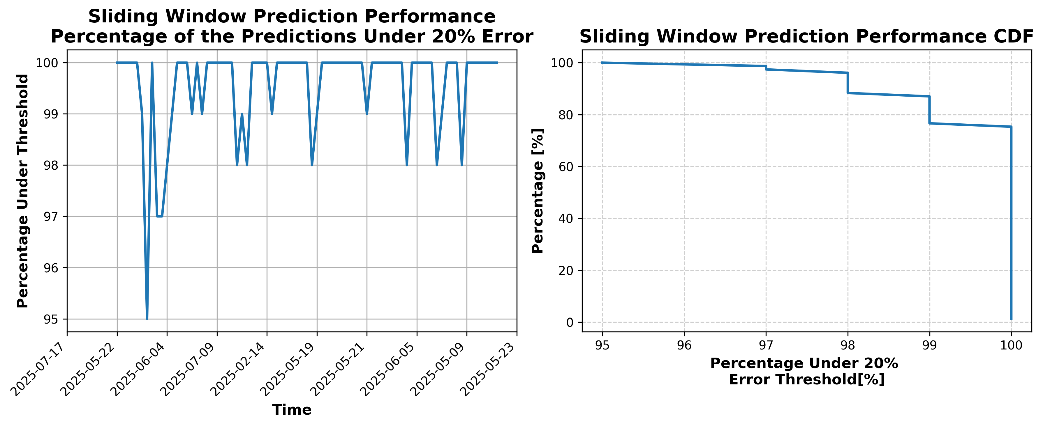

### Results for Latest_Test_2025-08-12.csv

Lines used: 8495 out of 14417 (58%)

Data sorted by: CHS Pickup Date

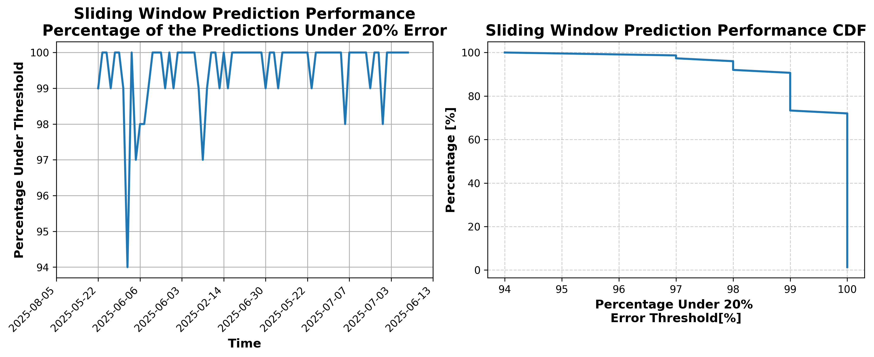

### Results for Latest_Test_2025-08-06.csv

Lines used: 8483 out of 14248 (59%)

Data sorted by: CHS Pickup Date

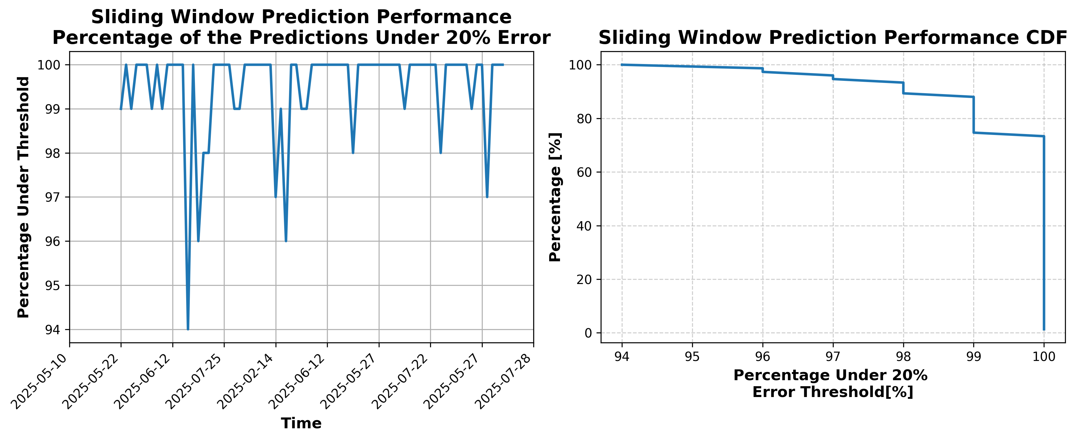

### Results for Latest_Test_2025-06-03.csv

Lines used: 9324 out of 14064 (66%)

Data sorted by: CHS Pickup Date

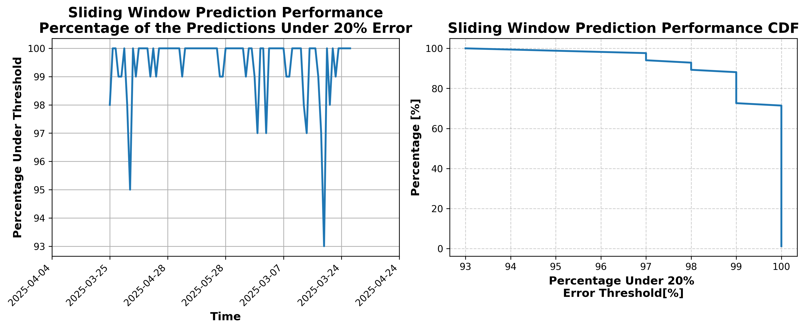

### Results for Latest_Test_2025-06-17.csv

Lines used: 9111 out of 13779 (66%)

Data sorted by: CHS Pickup Date

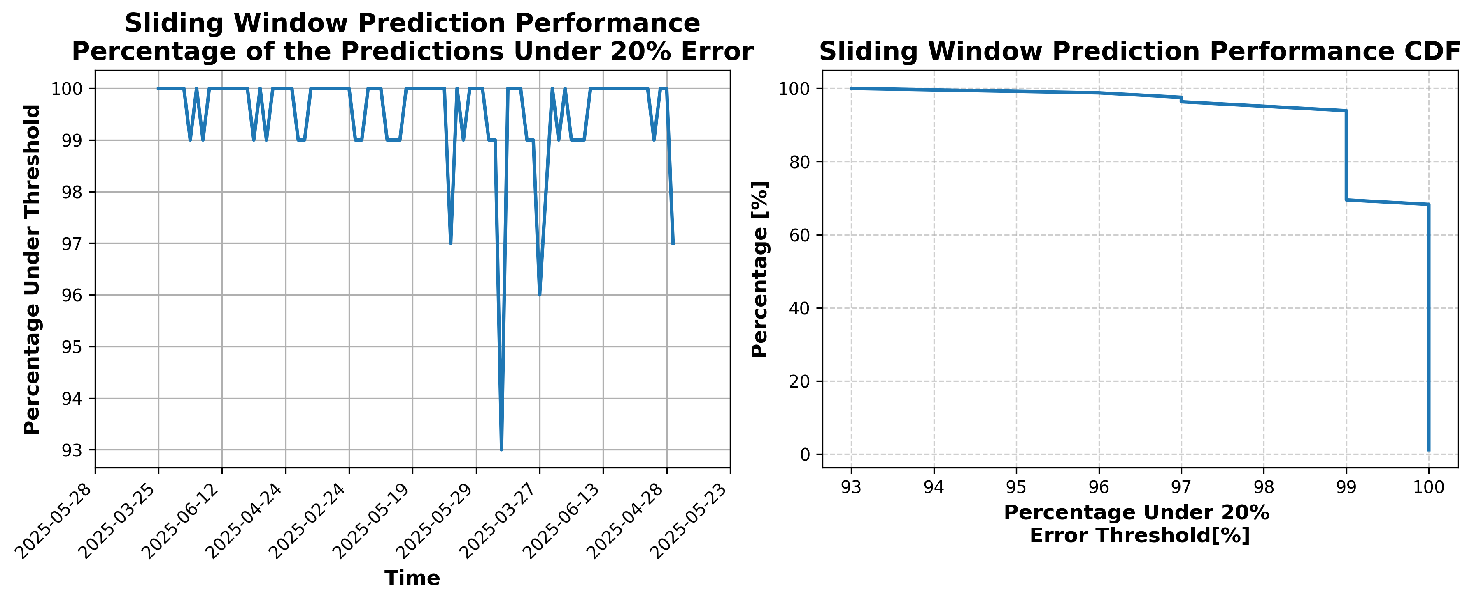

### Results for Latest_Test_2025-03-27.csv

Lines used: 9577 out of 16747 (57%)

Data sorted by: CHS Pickup Date

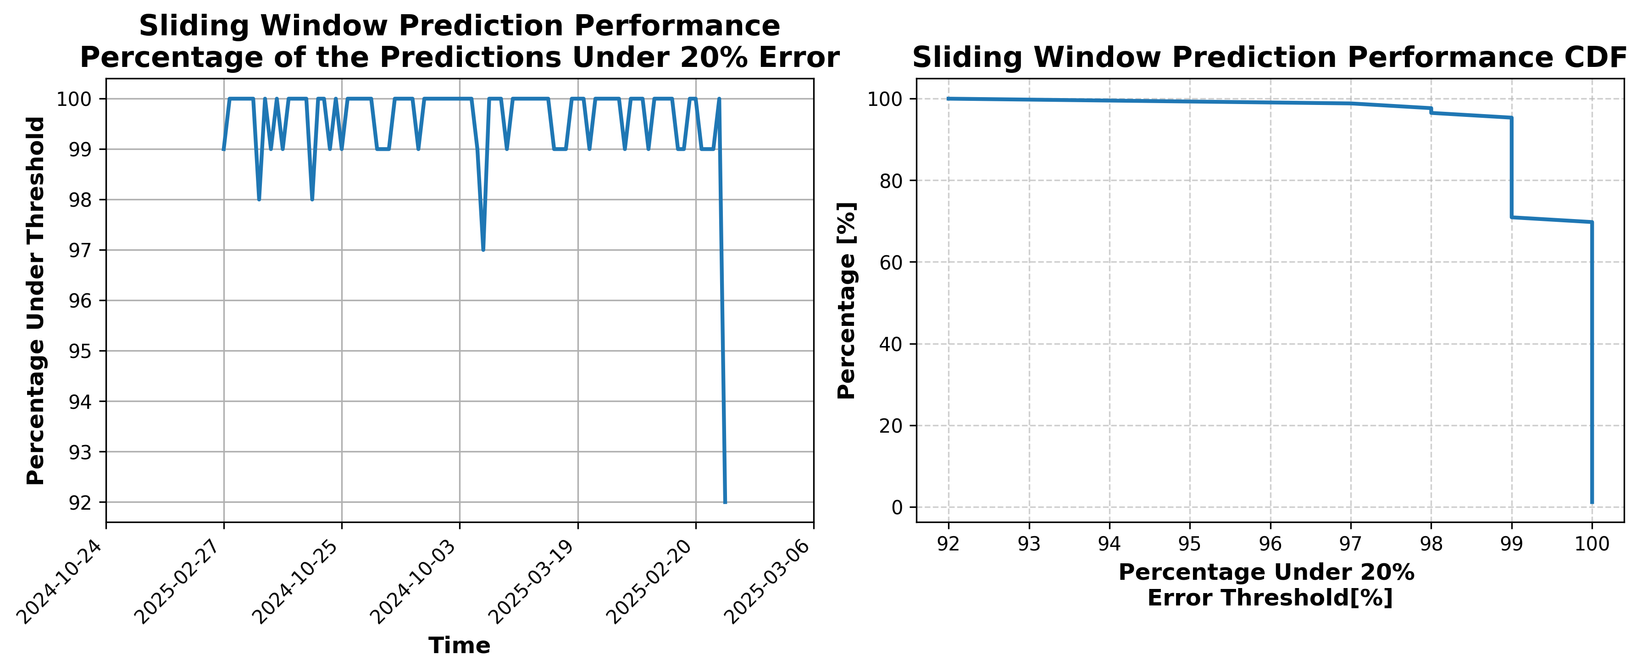

### Results for Latest_Test_2025-04-06.csv

Lines used: 9865 out of 16706 (59%)

Data sorted by: CHS Pickup Date

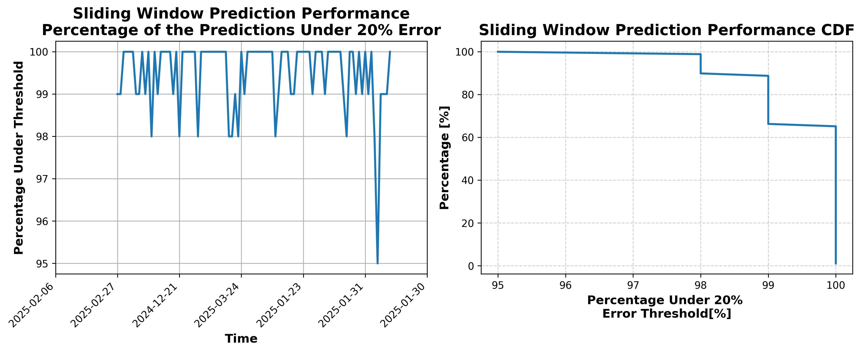

### Results for Latest_Test_2025-04-12.csv

Lines used: 10150 out of 17050 (59%)

Data sorted by: CHS Pickup Date

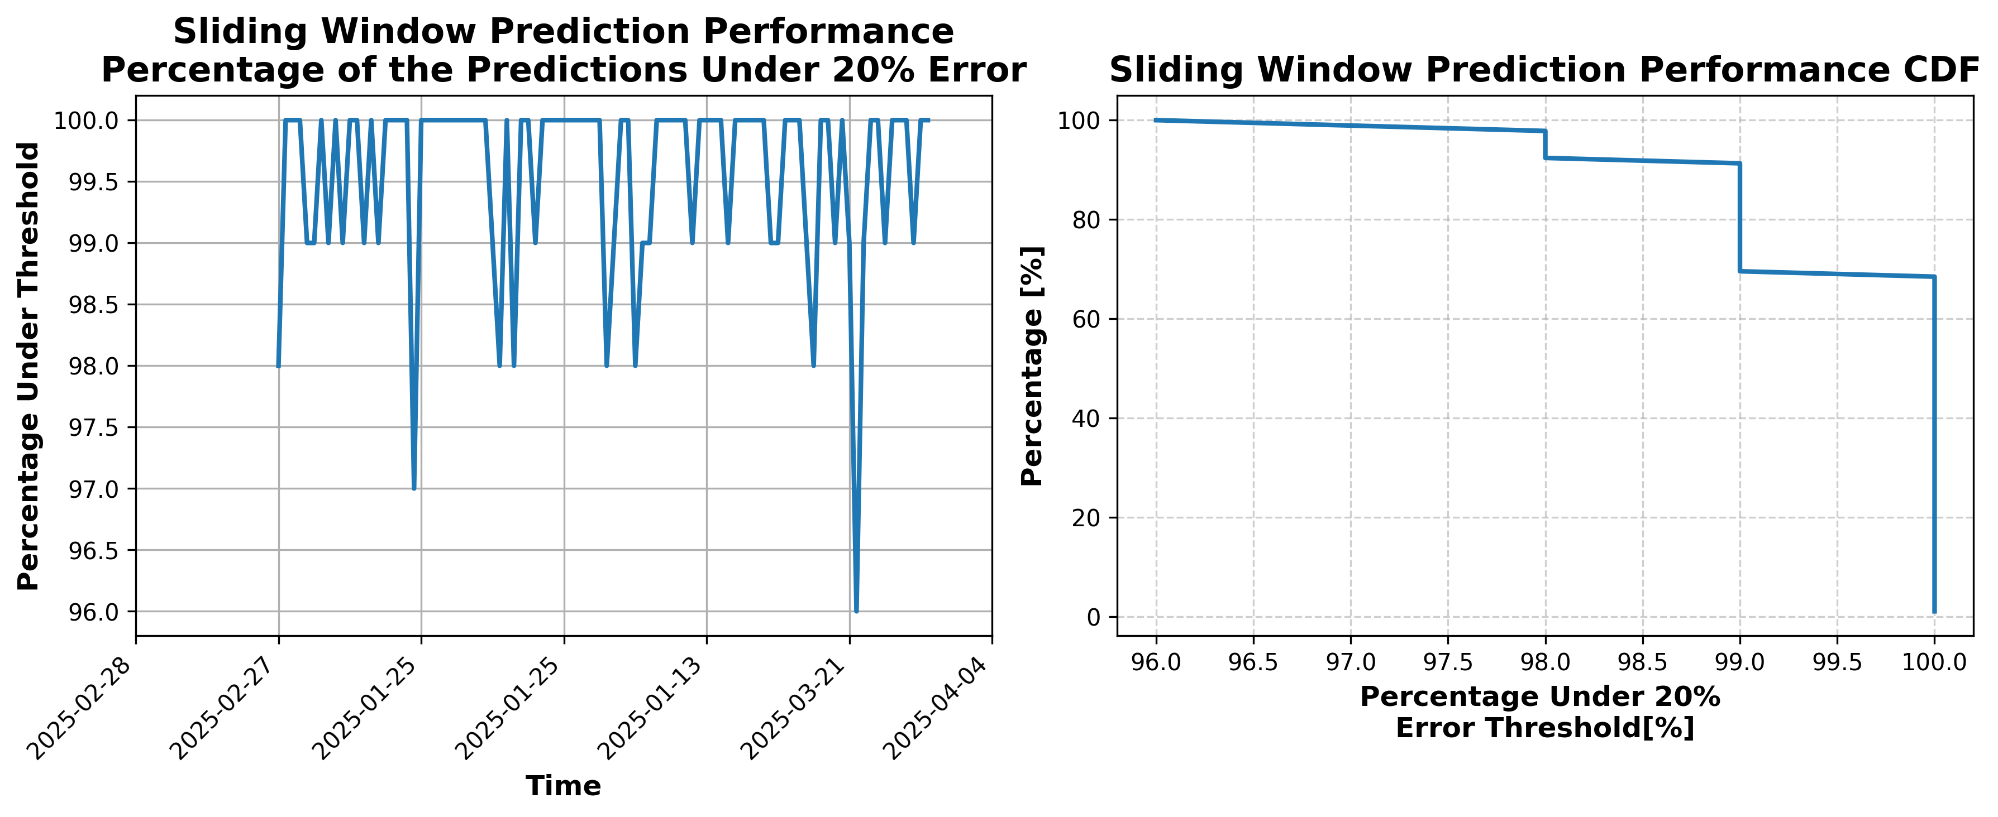

### Results for Latest_Test_2025-09-09.csv

Lines used: 8199 out of 14195 (57%)

Data sorted by: CHS Pickup Date

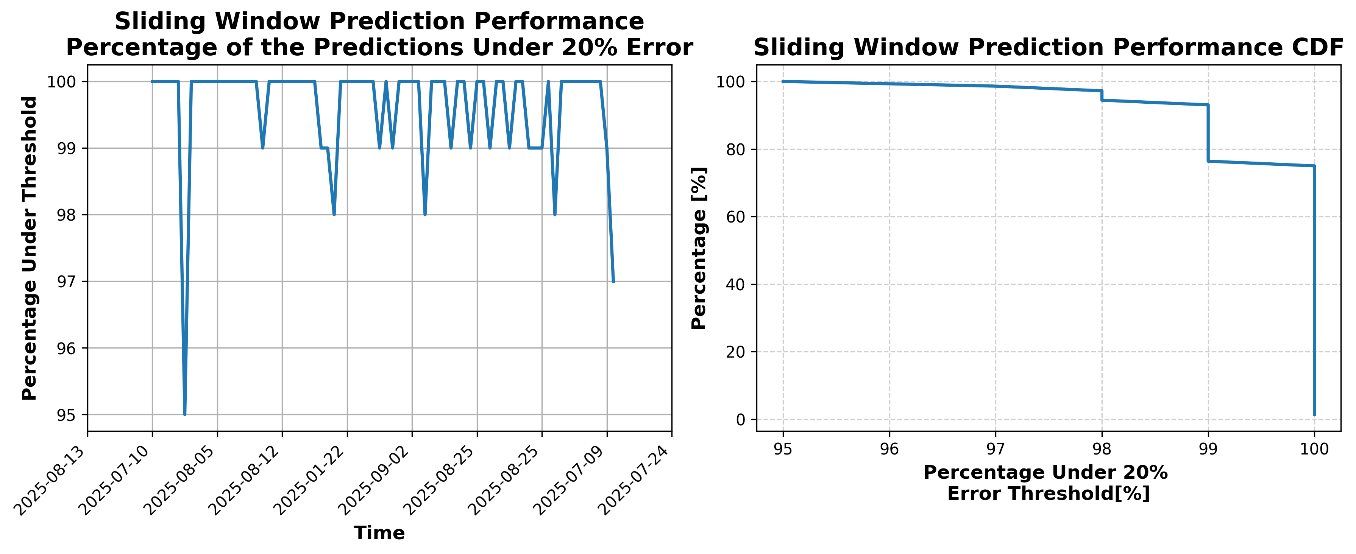

### Results for Latest_Test_2025-07-24.csv

Lines used: 8238 out of 13875 (59%)

Data sorted by: CHS Pickup Date

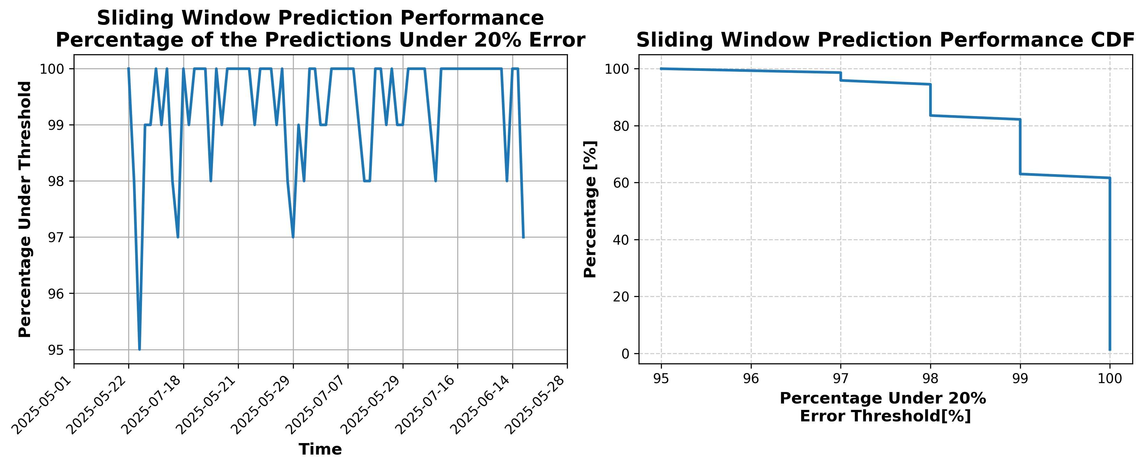

### Results for Latest_Test_2025-07-30.csv

Lines used: 8233 out of 13961 (58%)

Data sorted by: CHS Pickup Date

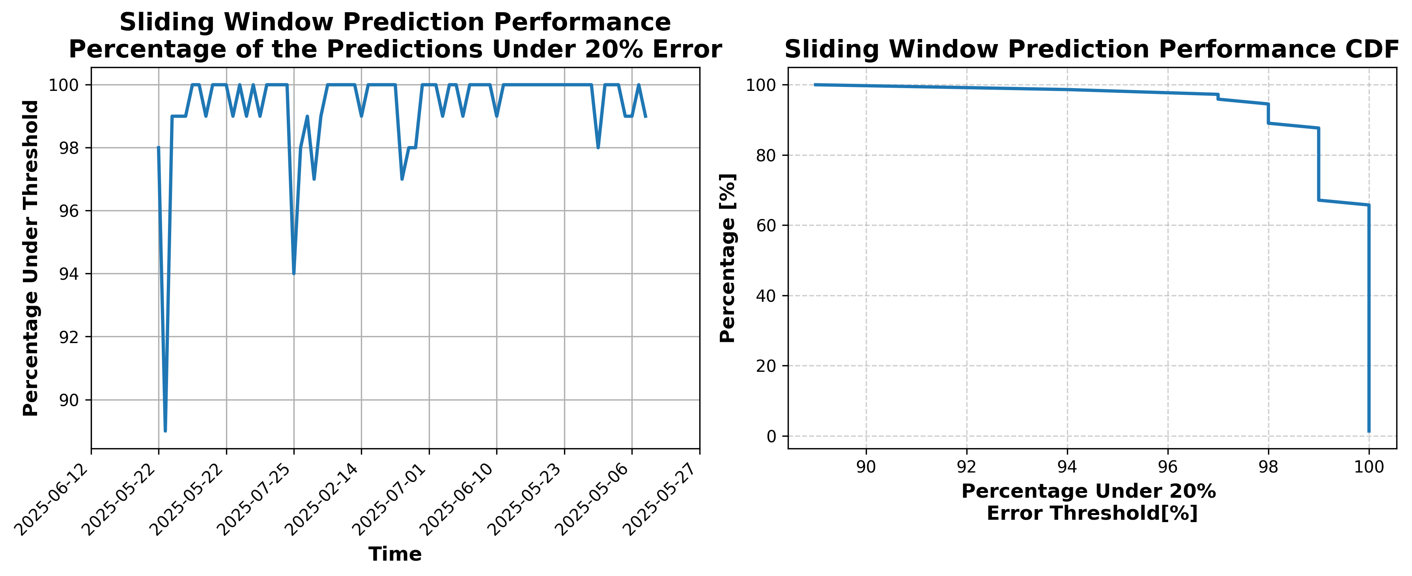

### Results for Latest_Test_2025-07-18.csv

Lines used: 8406 out of 13969 (60%)

Data sorted by: CHS Pickup Date

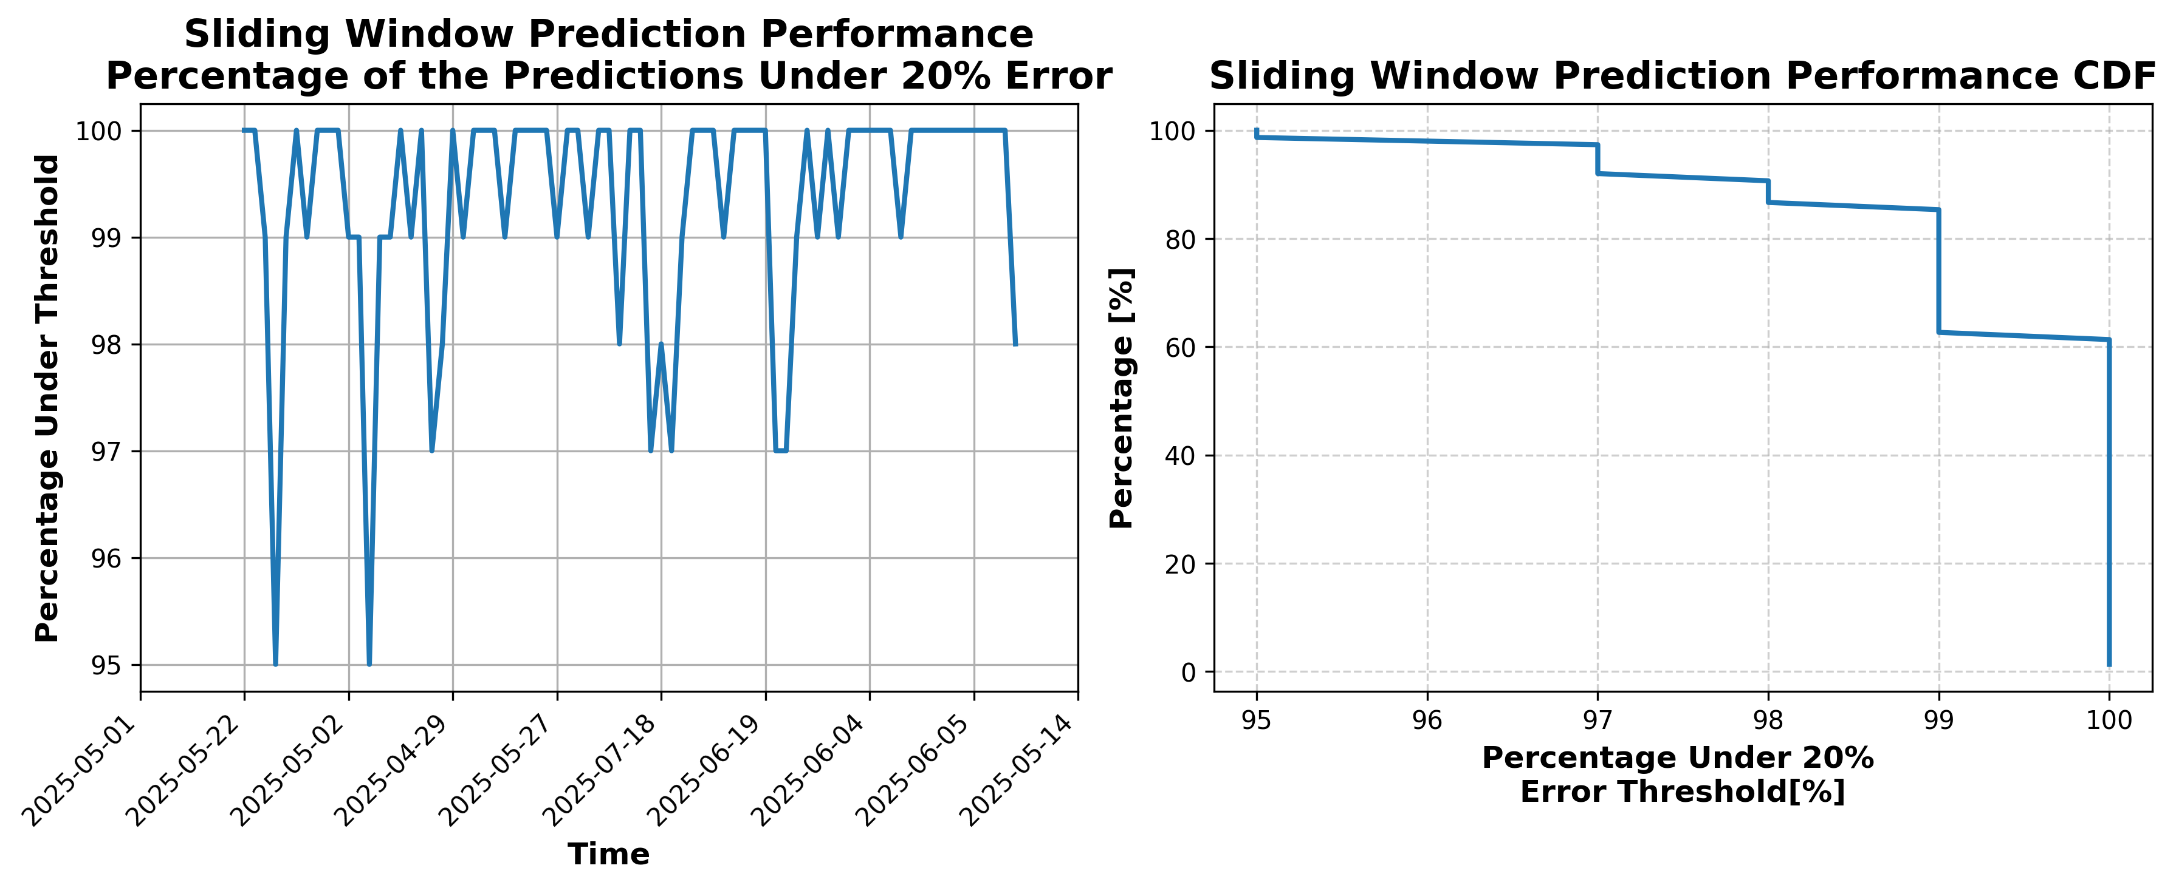

### Results for Latest_Test_2025-09-21.csv

Lines used: 8280 out of 14054 (58%)

Data sorted by: CHS Pickup Date

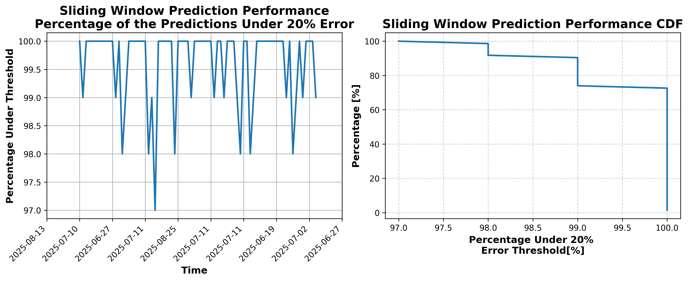

### Results for Latest_Test_2025-10-28.csv

Lines used: 7182 out of 13952 (51%)

Data sorted by: CHS Pickup Date

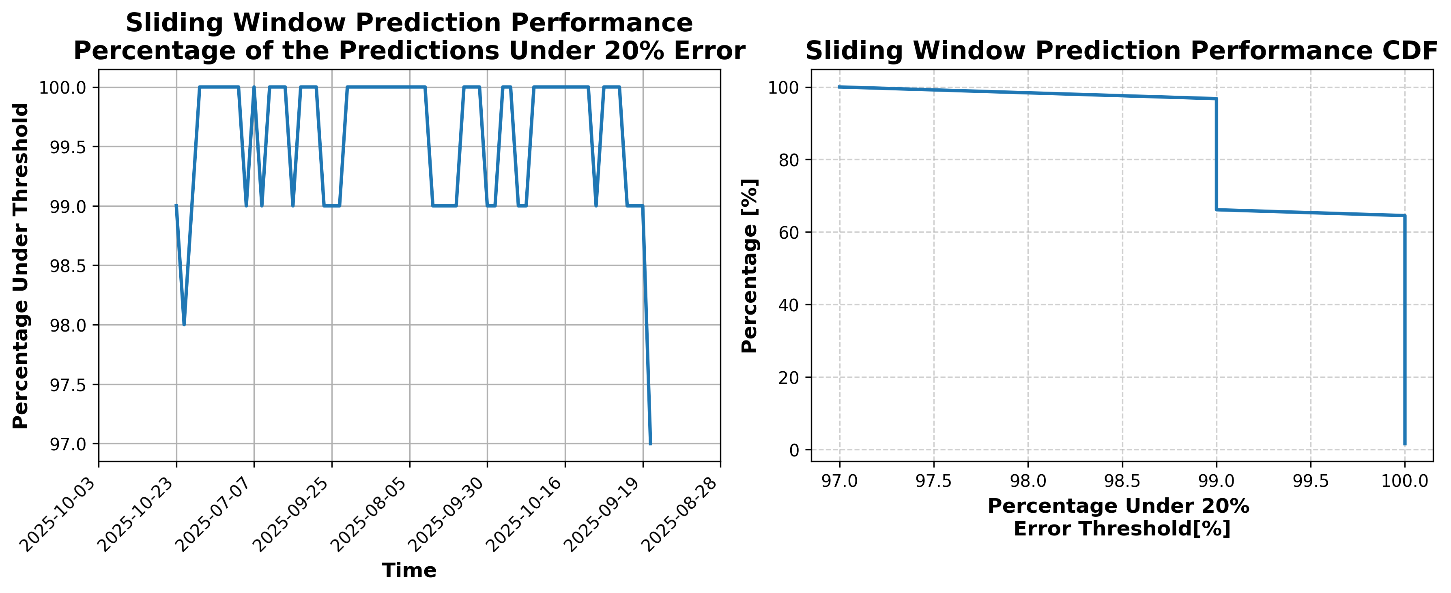

### Results for Latest_Test_2025-10-14.csv

Lines used: 7659 out of 13543 (56%)

Data sorted by: CHS Pickup Date

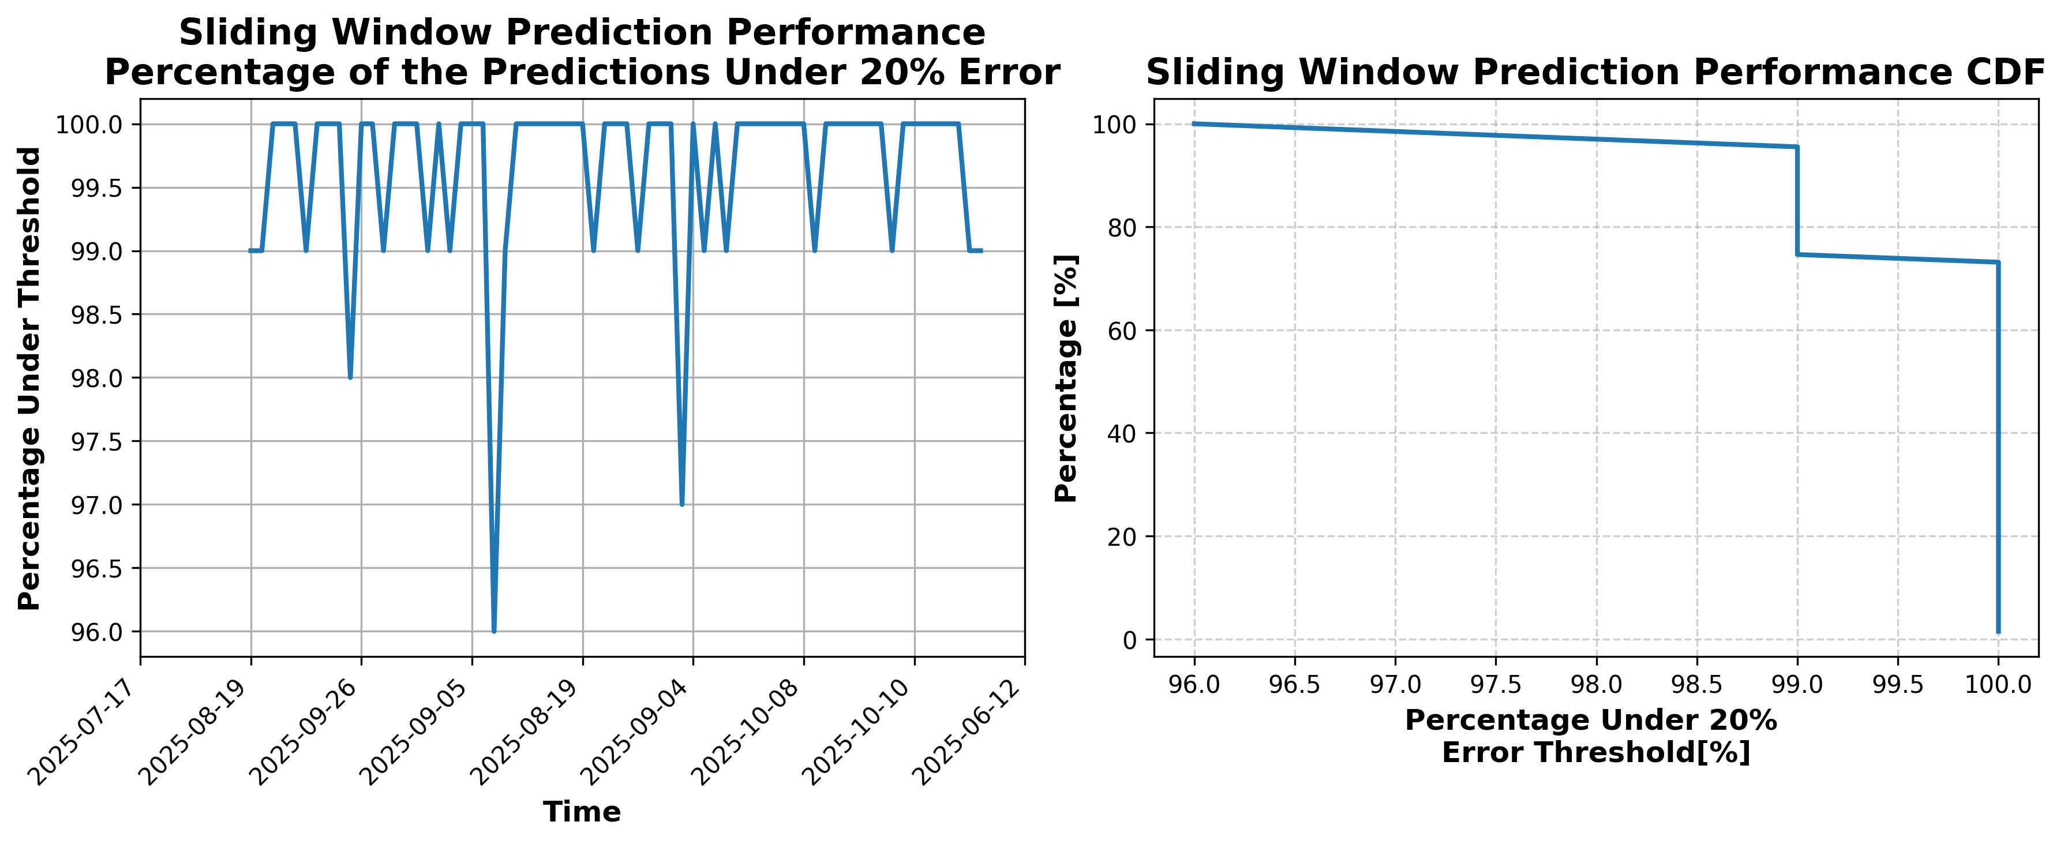

### Results for Latest_Test_2025-05-21.csv

Lines used: 9369 out of 14577 (64%)

Data sorted by: CHS Pickup Date

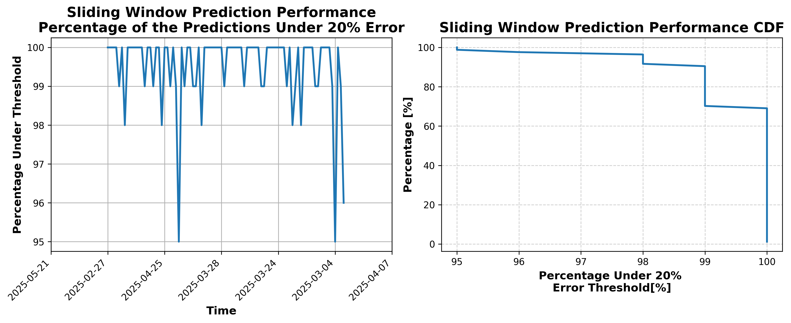

### Results for Latest_Test_2025-05-09.csv

Lines used: 9070 out of 15270 (59%)

Data sorted by: CHS Pickup Date

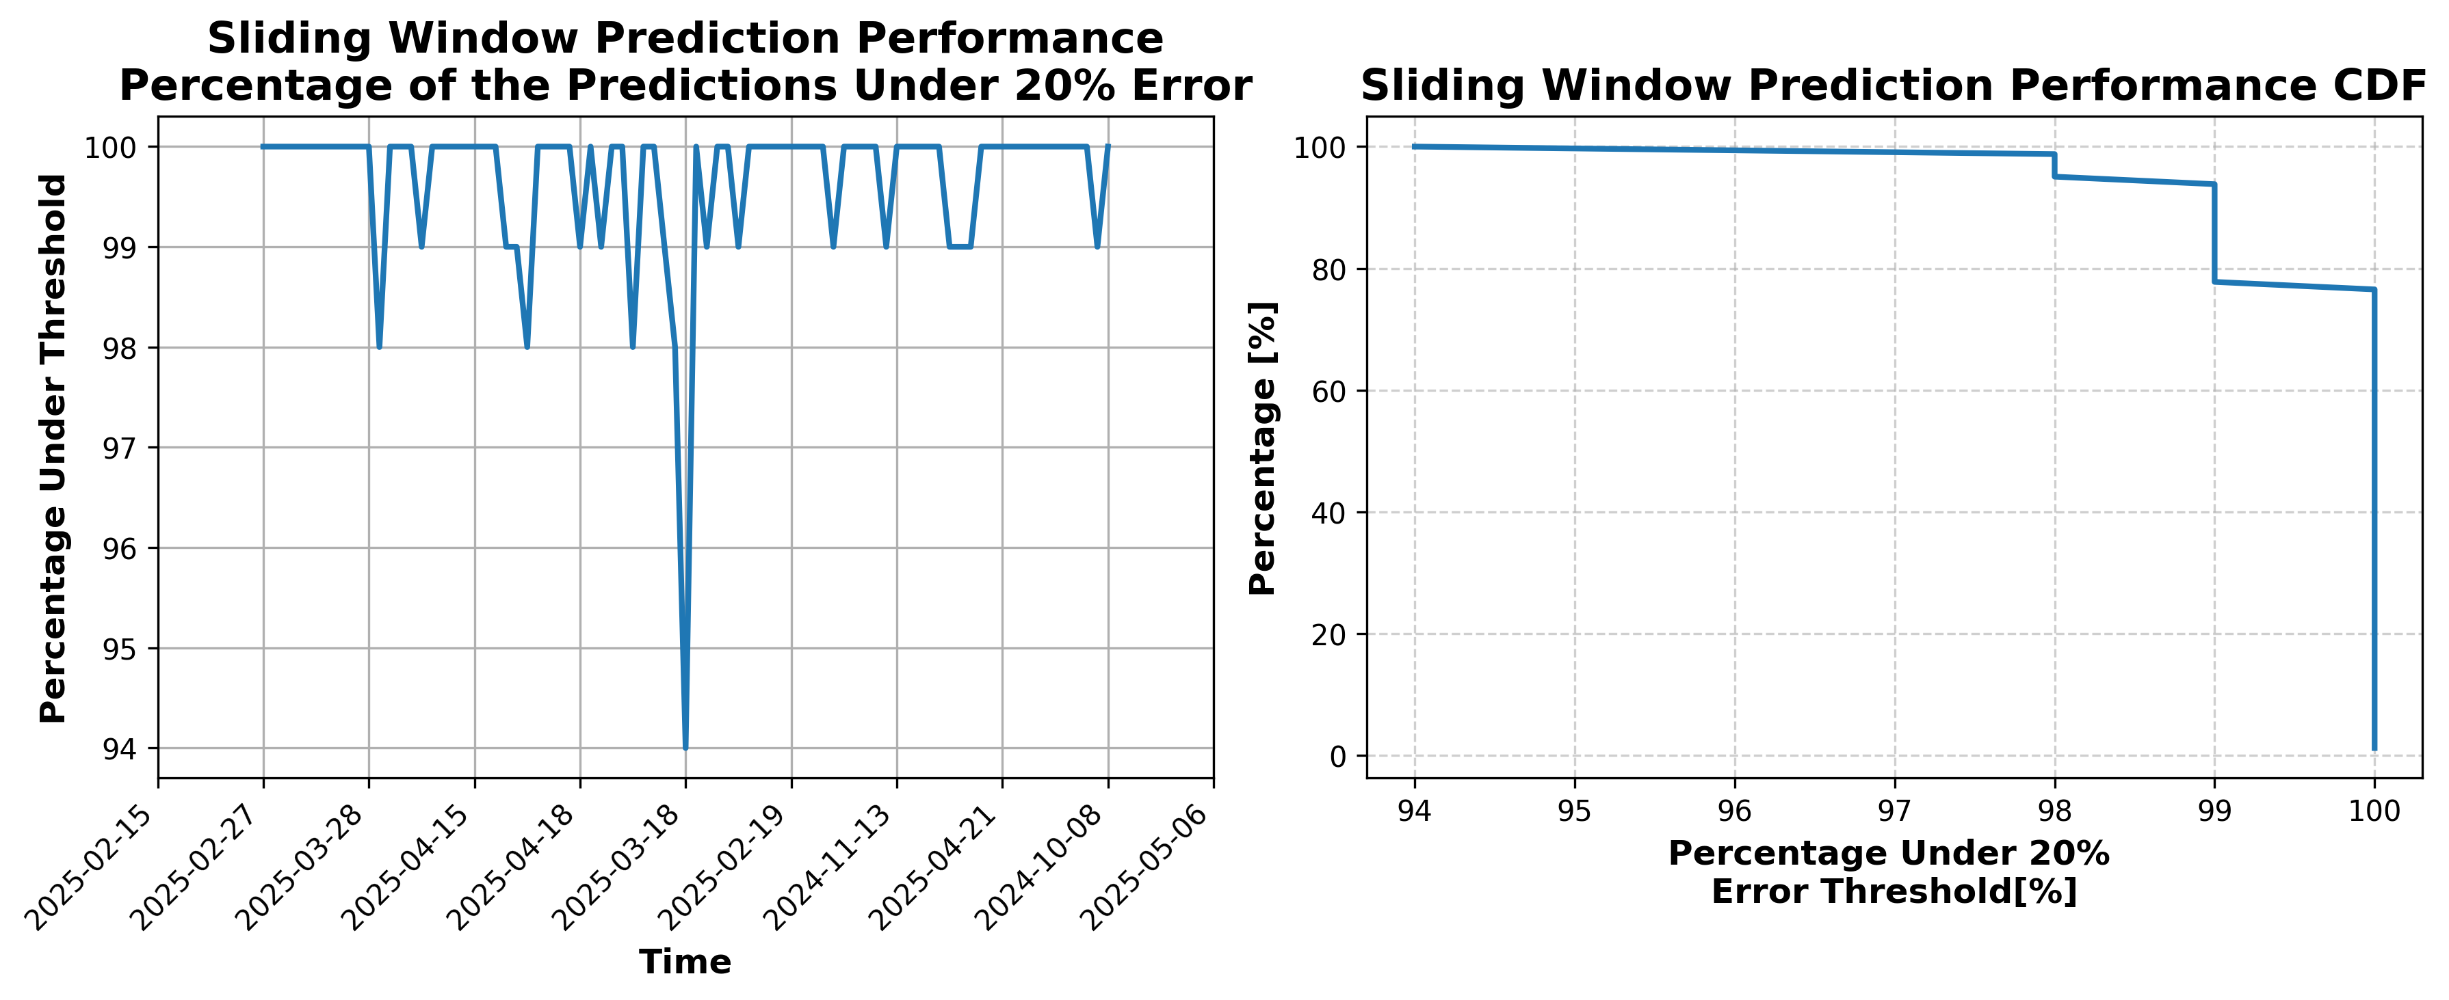

### Results for Latest_Test_2025-05-08.csv

Lines used: 8864 out of 15115 (58%)

Data sorted by: CHS Pickup Date

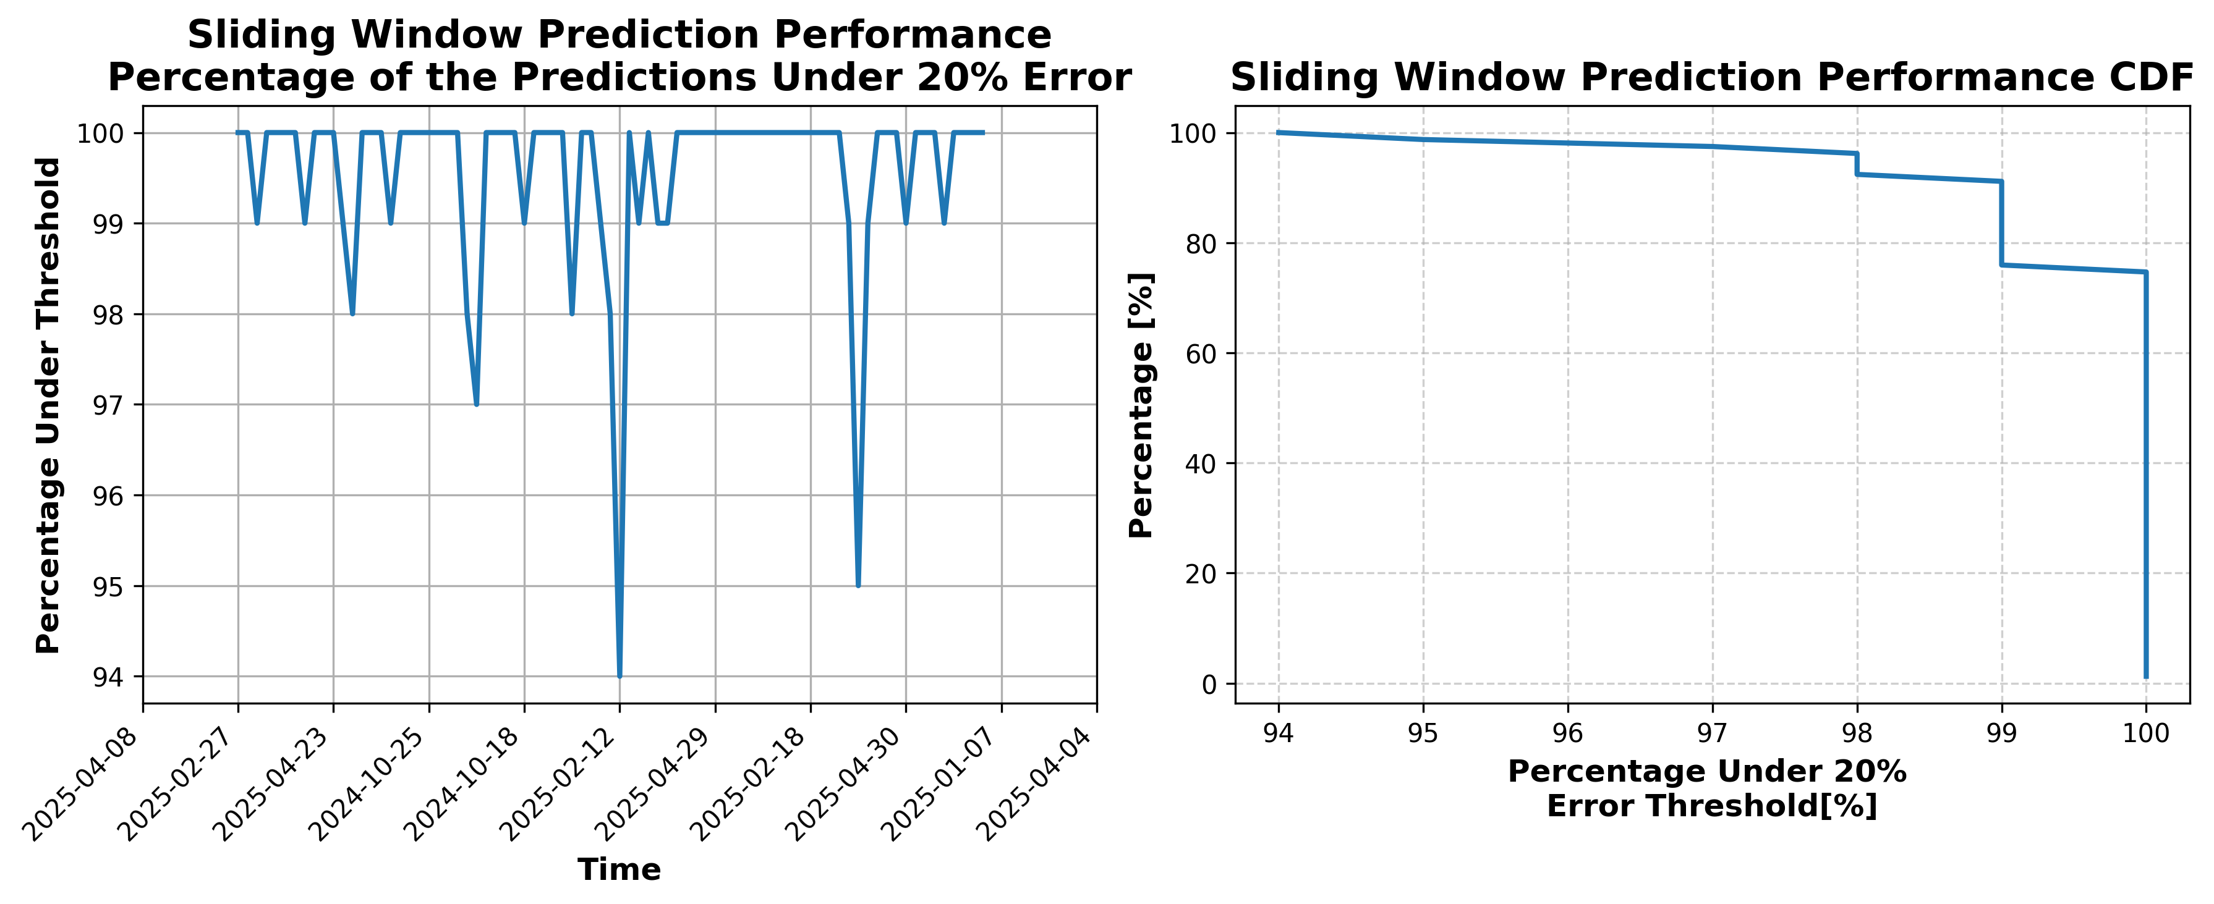

### Results for Latest_Test_2025-05-20.csv

Lines used: 9275 out of 14487 (64%)

Data sorted by: CHS Pickup Date

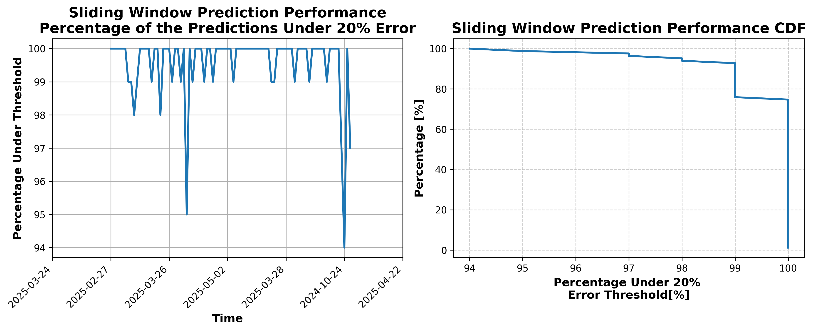

### Results for Latest_Test_02112025.csv

### Results for Latest_Test_2025-10-15.csv

Lines used: 7735 out of 13501 (57%)

Data sorted by: CHS Pickup Date

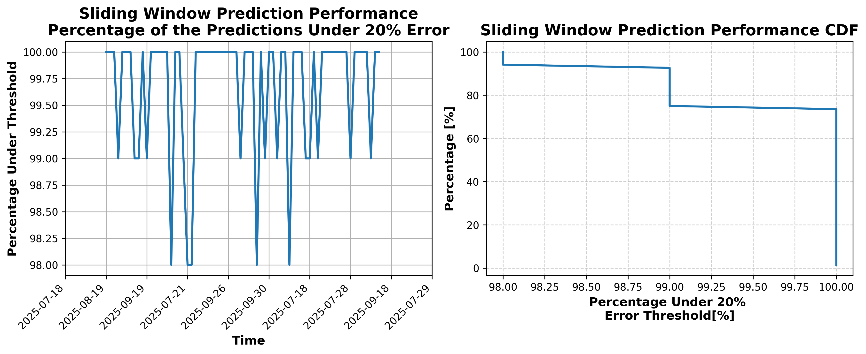

### Results for Latest_Test_2025-10-01.csv

Lines used: 7579 out of 13879 (54%)

Data sorted by: CHS Pickup Date

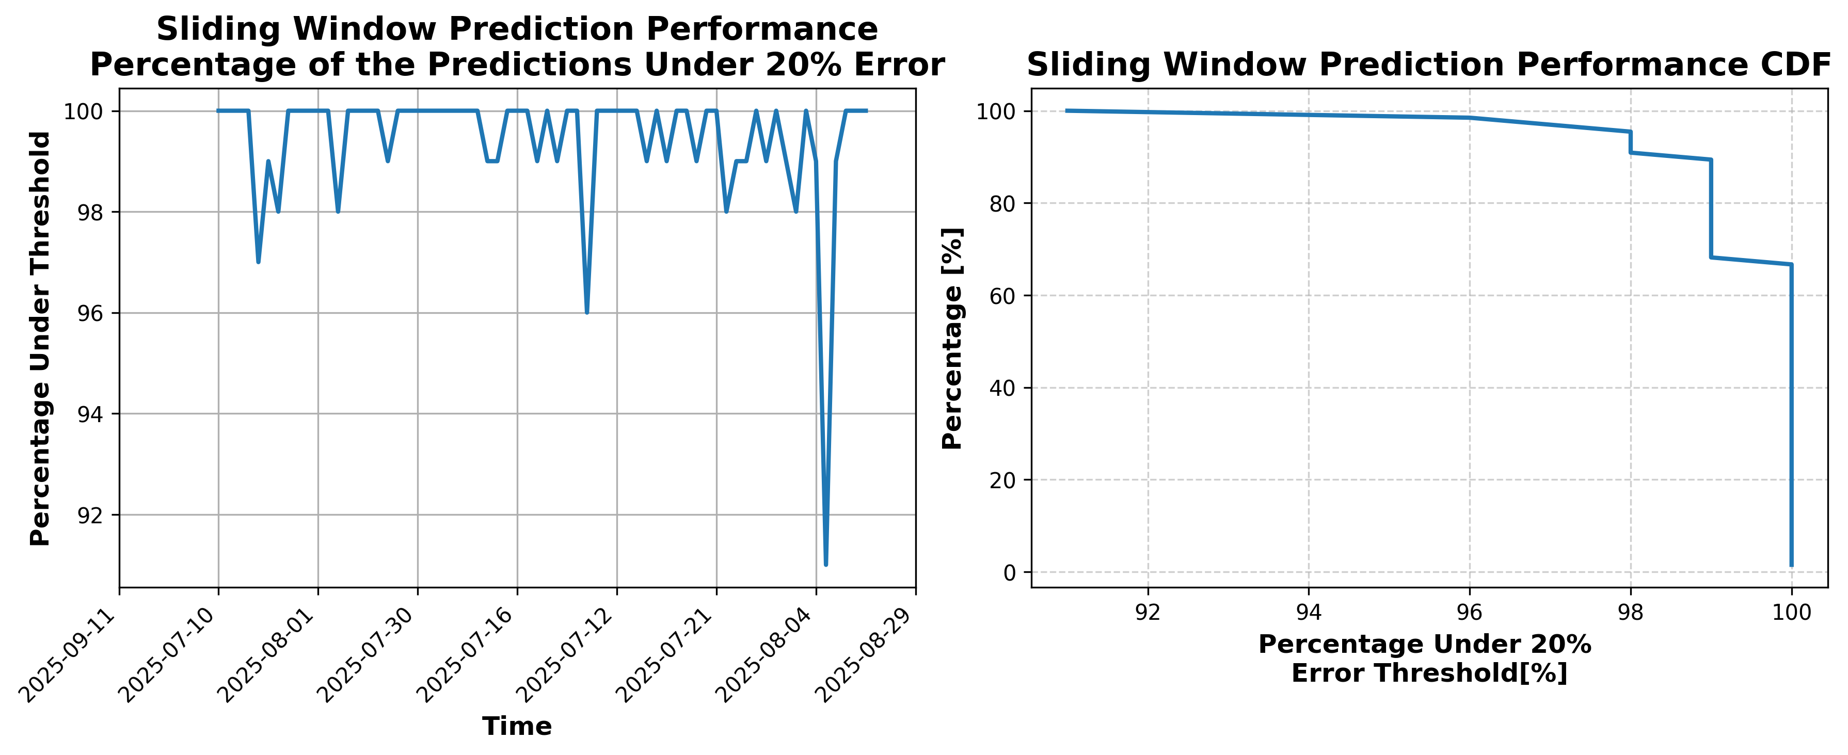

### Results for Latest_Test_2025-10-29.csv

Lines used: 7145 out of 14163 (50%)

Data sorted by: CHS Pickup Date

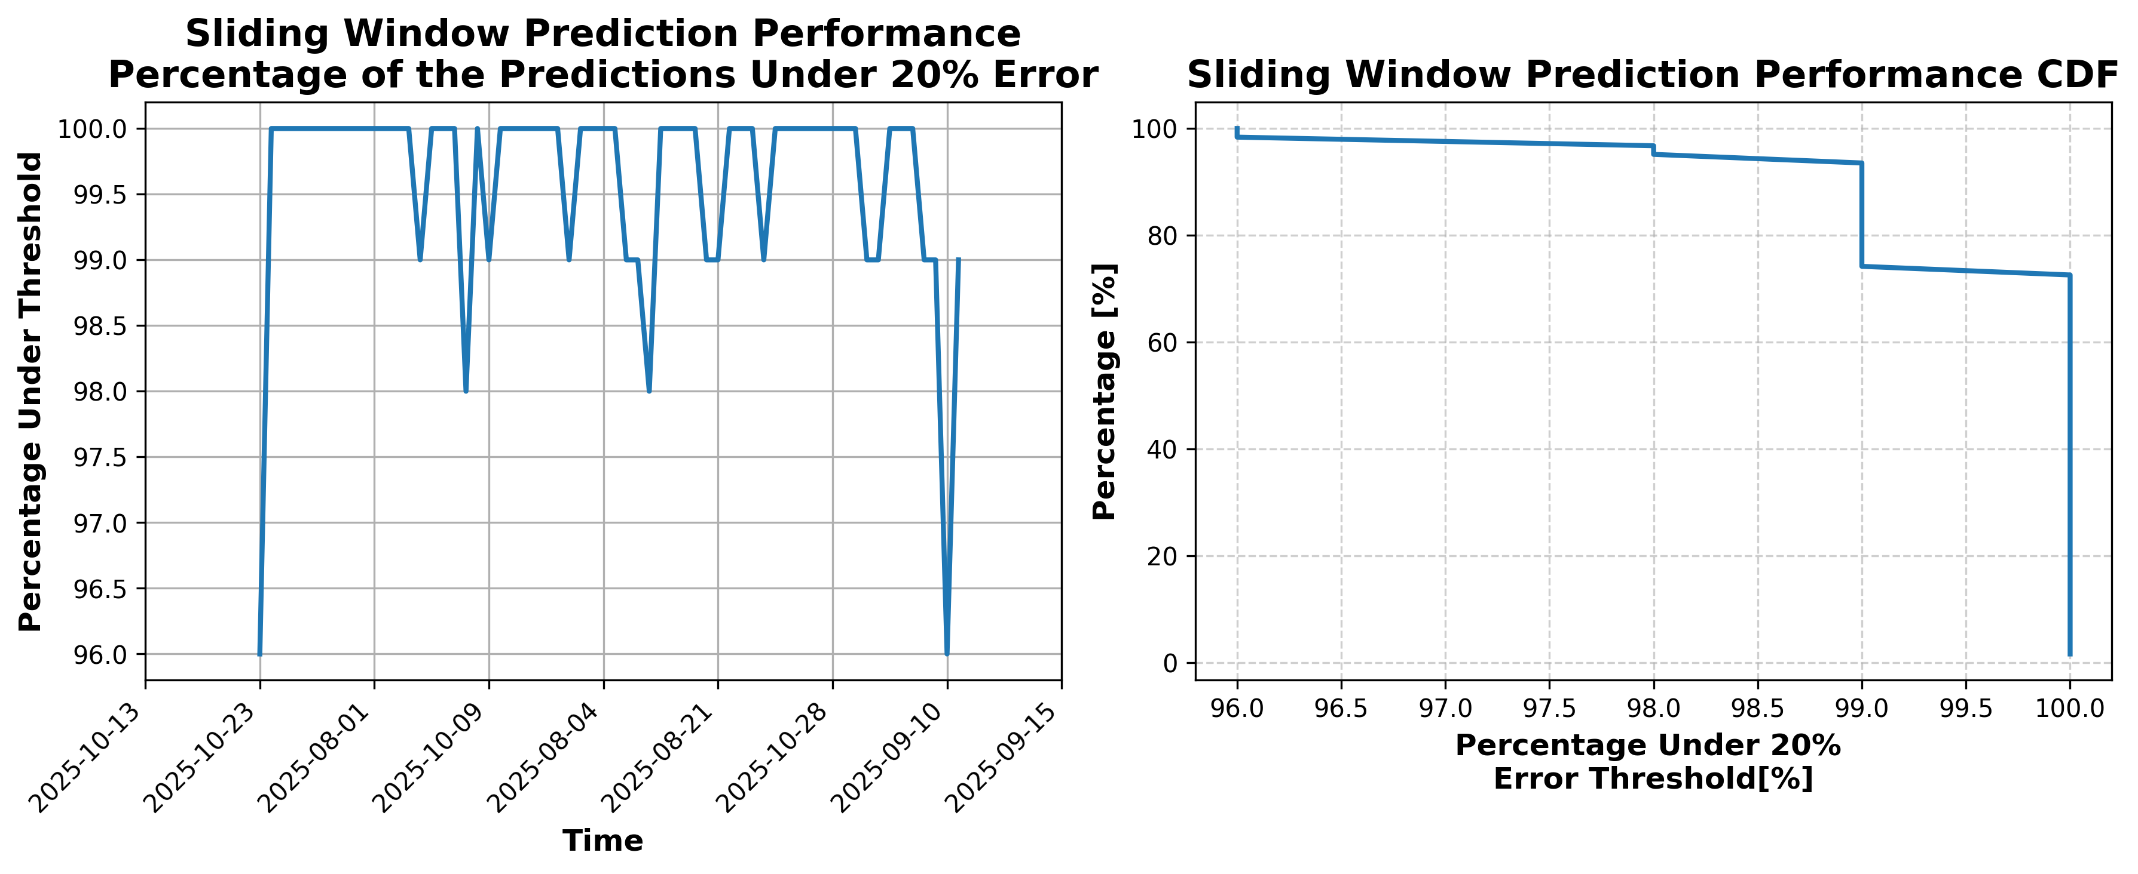

### Results for Latest_Test_2025-09-20.csv

Lines used: 8500 out of 14329 (59%)

Data sorted by: CHS Pickup Date

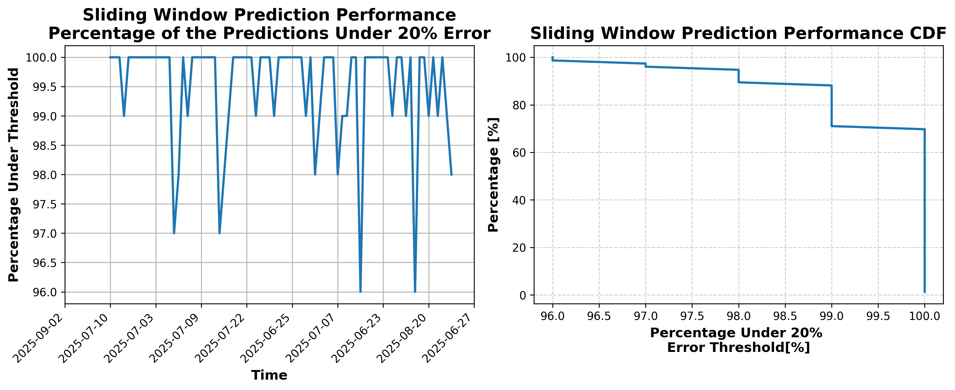

### Results for Latest_Test_2025-07-19.csv

Lines used: 8483 out of 14107 (60%)

Data sorted by: CHS Pickup Date

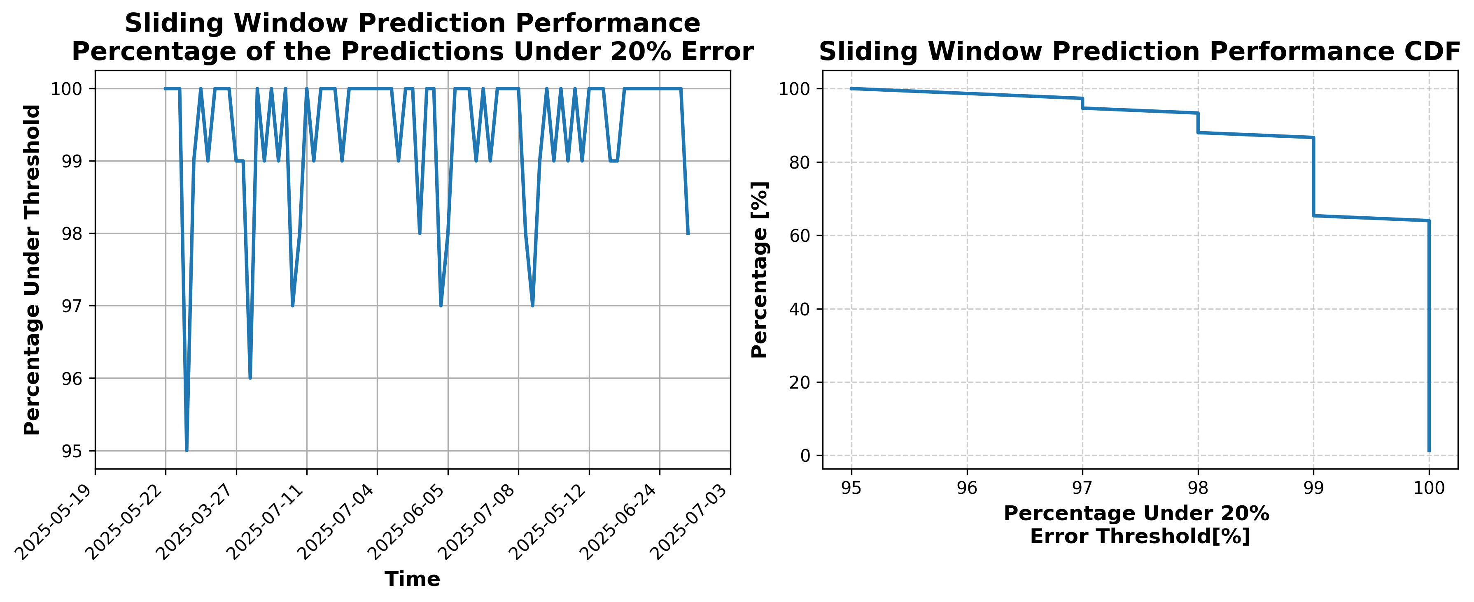

### Results for Latest_Test_2025-07-31.csv

Lines used: 8209 out of 13948 (58%)

Data sorted by: CHS Pickup Date

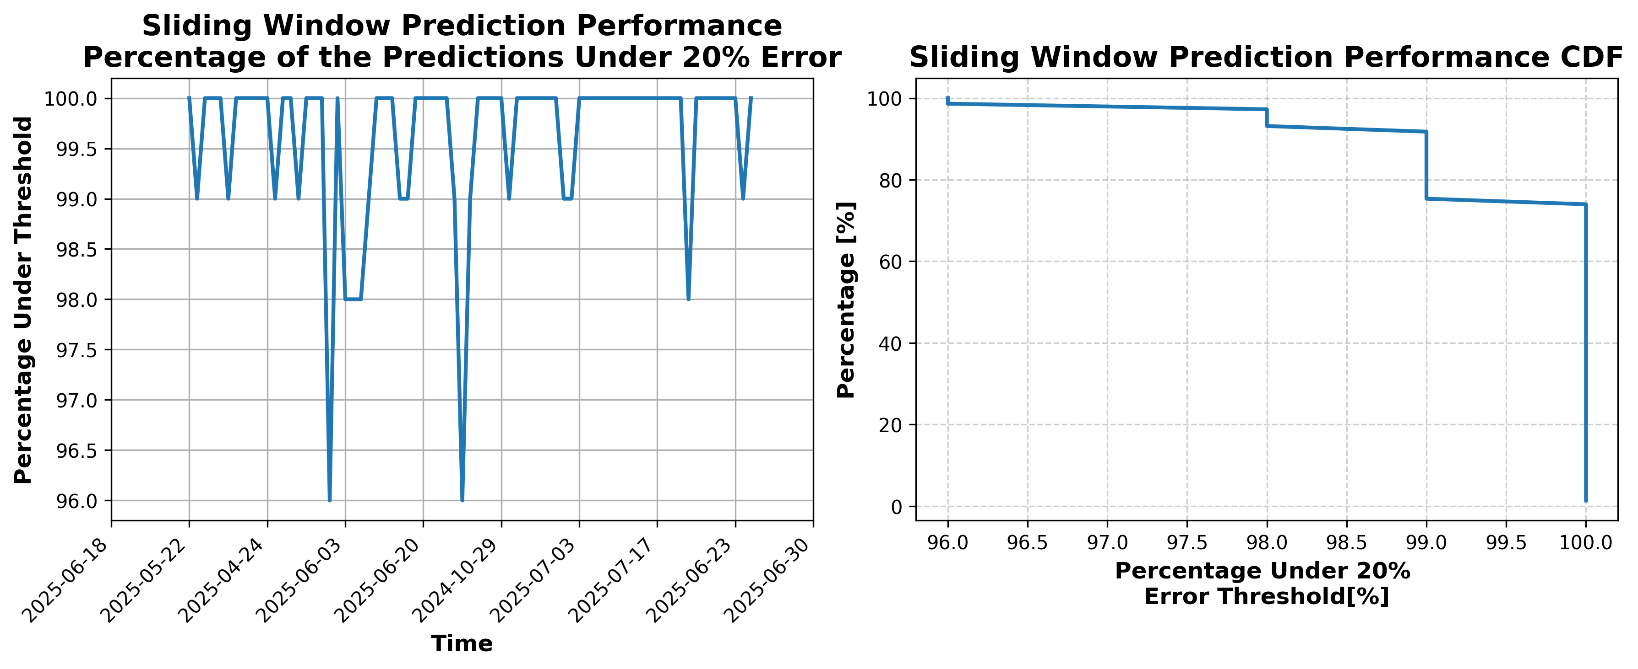

### Results for Latest_Test_2025-07-25.csv

Lines used: 8398 out of 14079 (59%)

Data sorted by: CHS Pickup Date

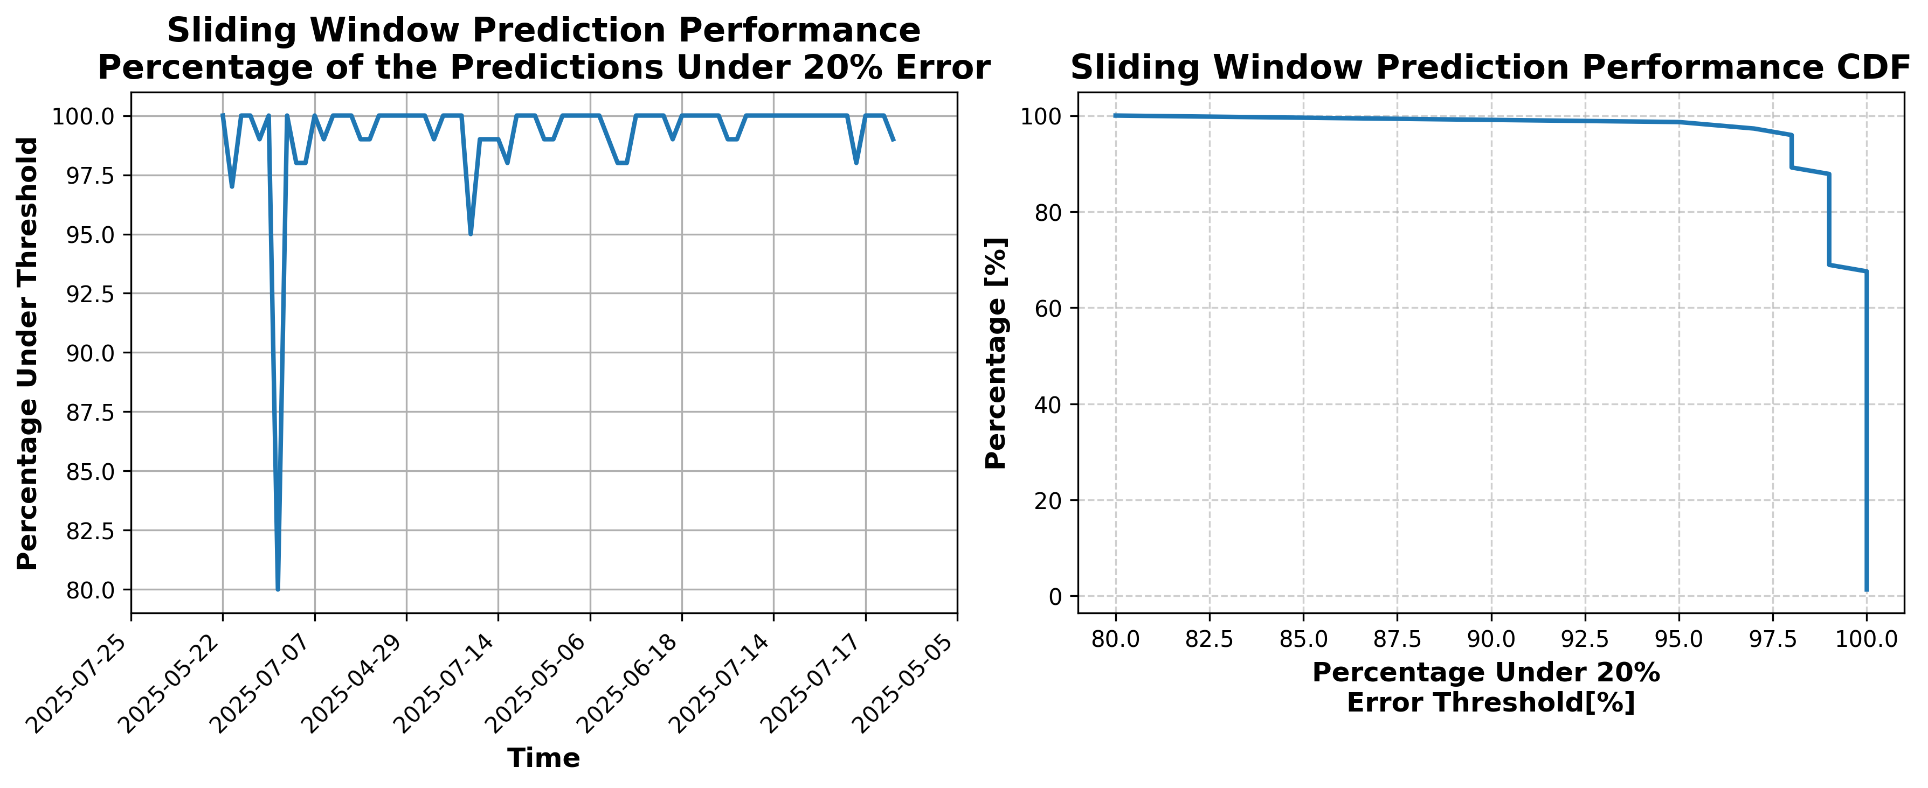

### Results for Latest_Test_2025-09-08.csv

Lines used: 8330 out of 14339 (58%)

Data sorted by: CHS Pickup Date

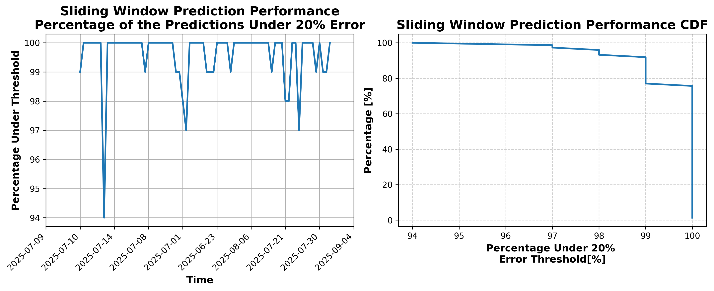

### Results for Latest_Test_2025-07-27.csv

Lines used: 8364 out of 14016 (59%)

Data sorted by: CHS Pickup Date

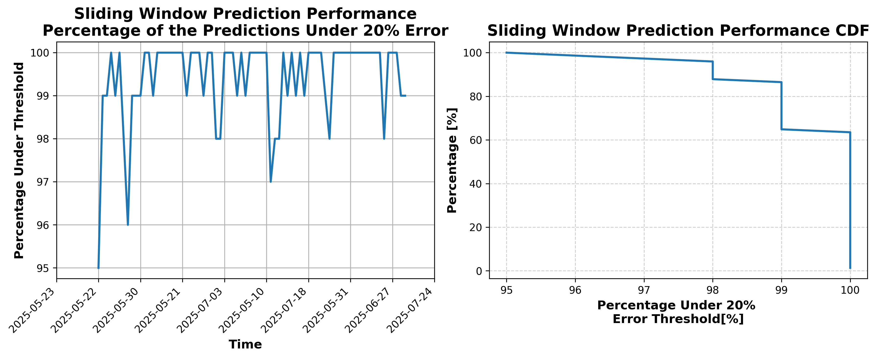

### Results for Latest_Test_2025-09-22.csv

Lines used: 8195 out of 14148 (57%)

Data sorted by: CHS Pickup Date

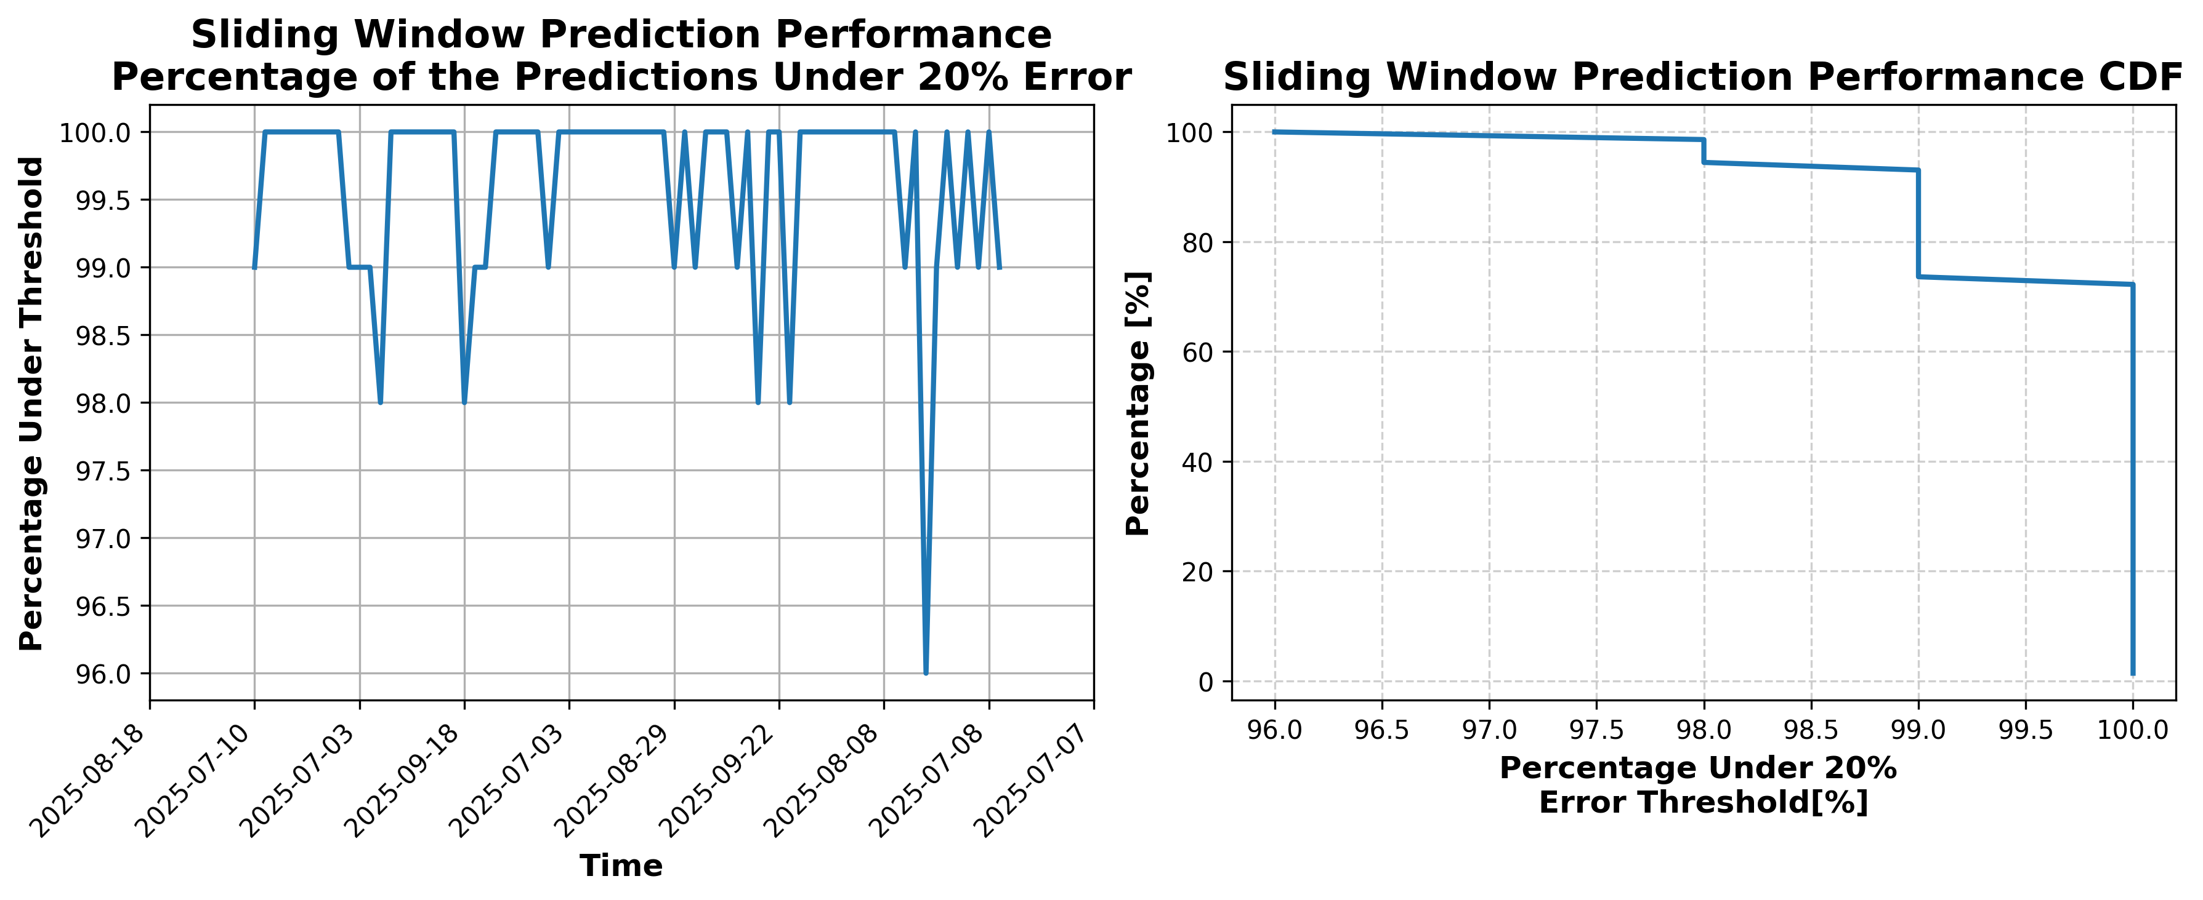

### Results for Latest_Test_2025-10-17.csv

Lines used: 7788 out of 13942 (55%)

Data sorted by: CHS Pickup Date

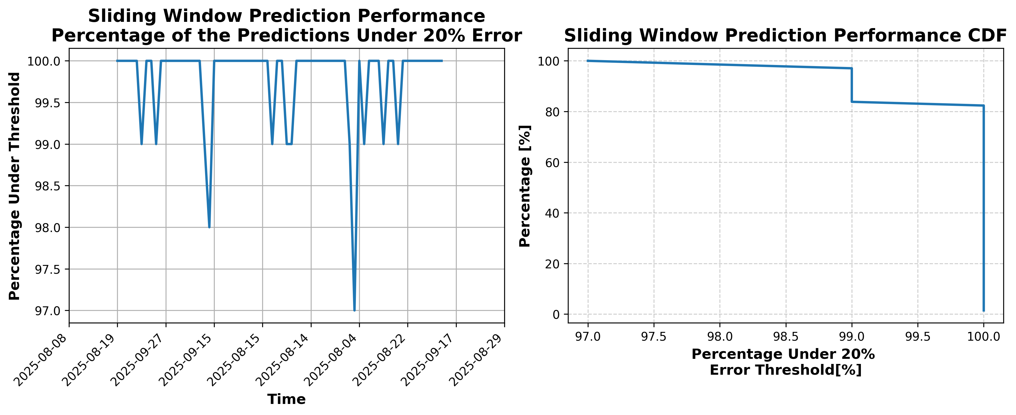

### Results for Latest_Test_2025-10-03.csv

Lines used: 7691 out of 14192 (54%)

Data sorted by: CHS Pickup Date

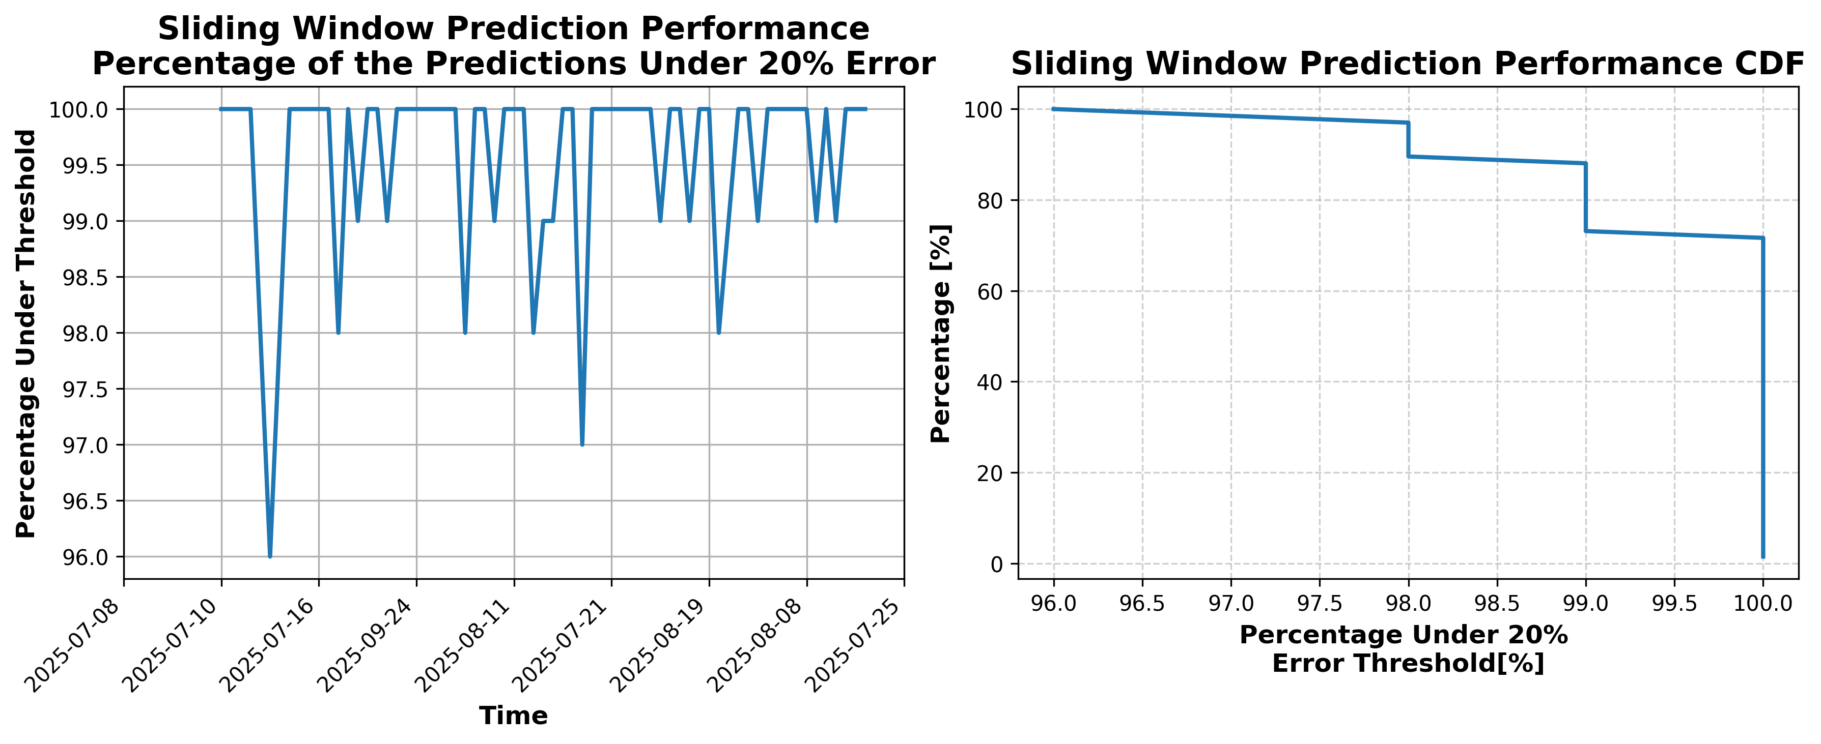

### Results for Latest_Test_2025-05-22.csv

Lines used: 9419 out of 14653 (64%)

Data sorted by: CHS Pickup Date

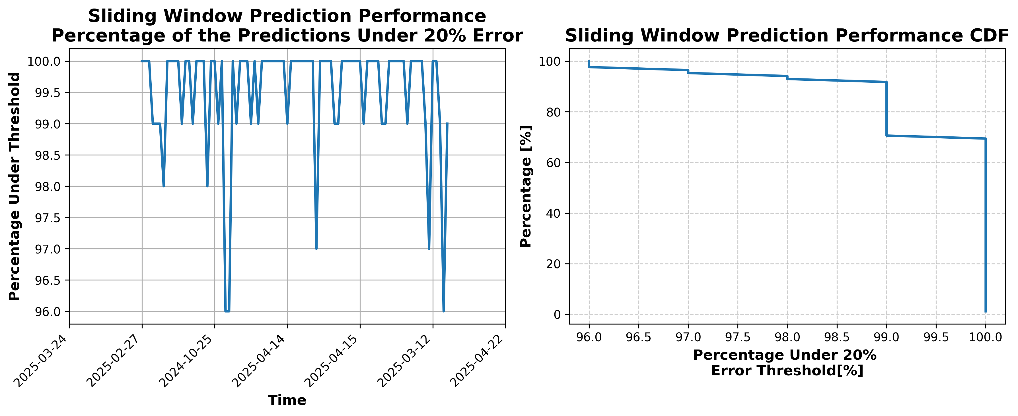

### Results for Latest_Test_2025-02-16.csv

### Results for Latest_Test_2025-05-23.csv

Lines used: 9571 out of 14970 (63%)

Data sorted by: CHS Pickup Date

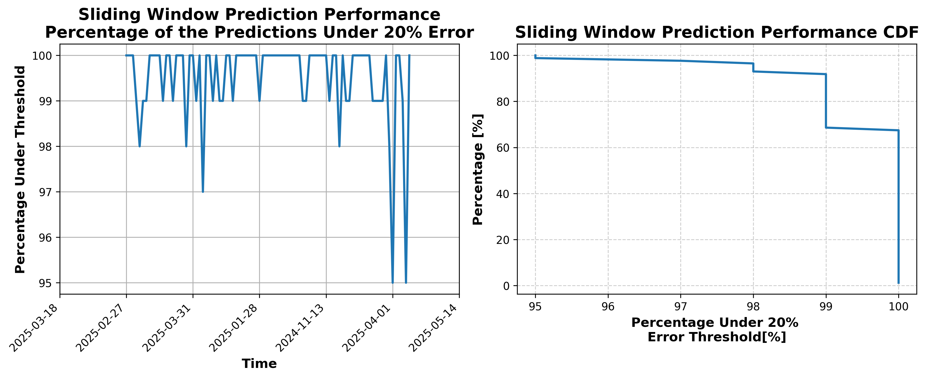

### Results for Latest_Test_2025-10-02.csv

Lines used: 7657 out of 14104 (54%)

Data sorted by: CHS Pickup Date

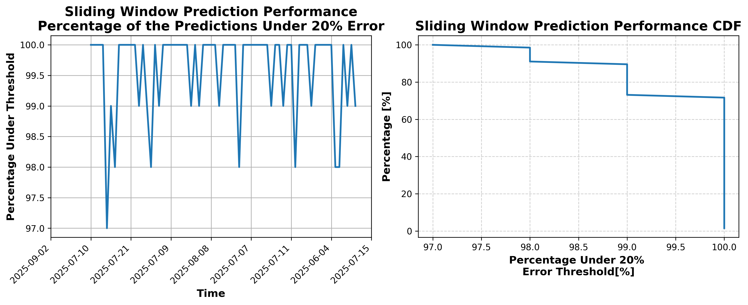

### Results for Latest_Test_2025-10-16.csv

Lines used: 7757 out of 13719 (56%)

Data sorted by: CHS Pickup Date

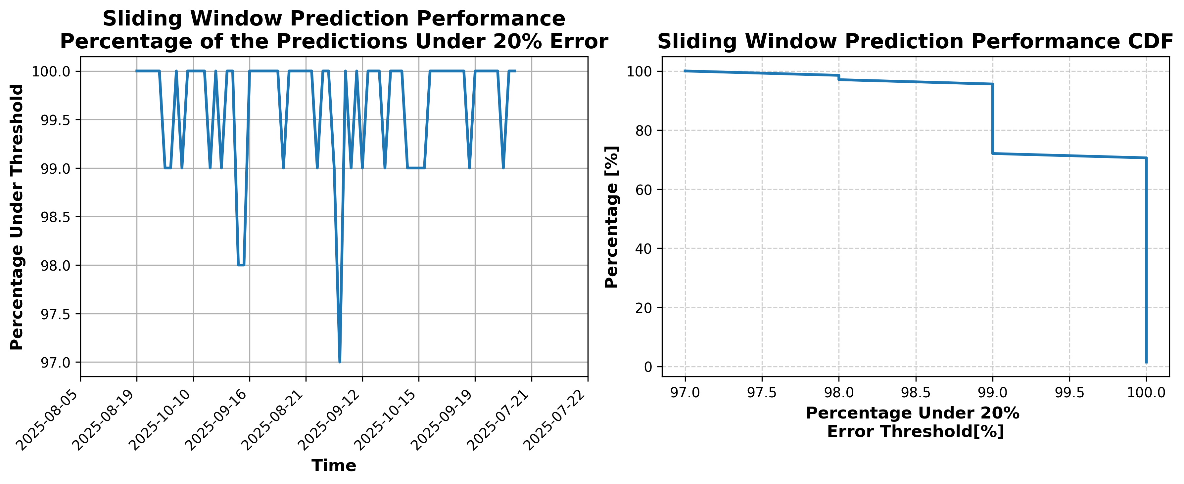

### Results for Latest_Test_2025-09-23.csv

Lines used: 8233 out of 14202 (57%)

Data sorted by: CHS Pickup Date

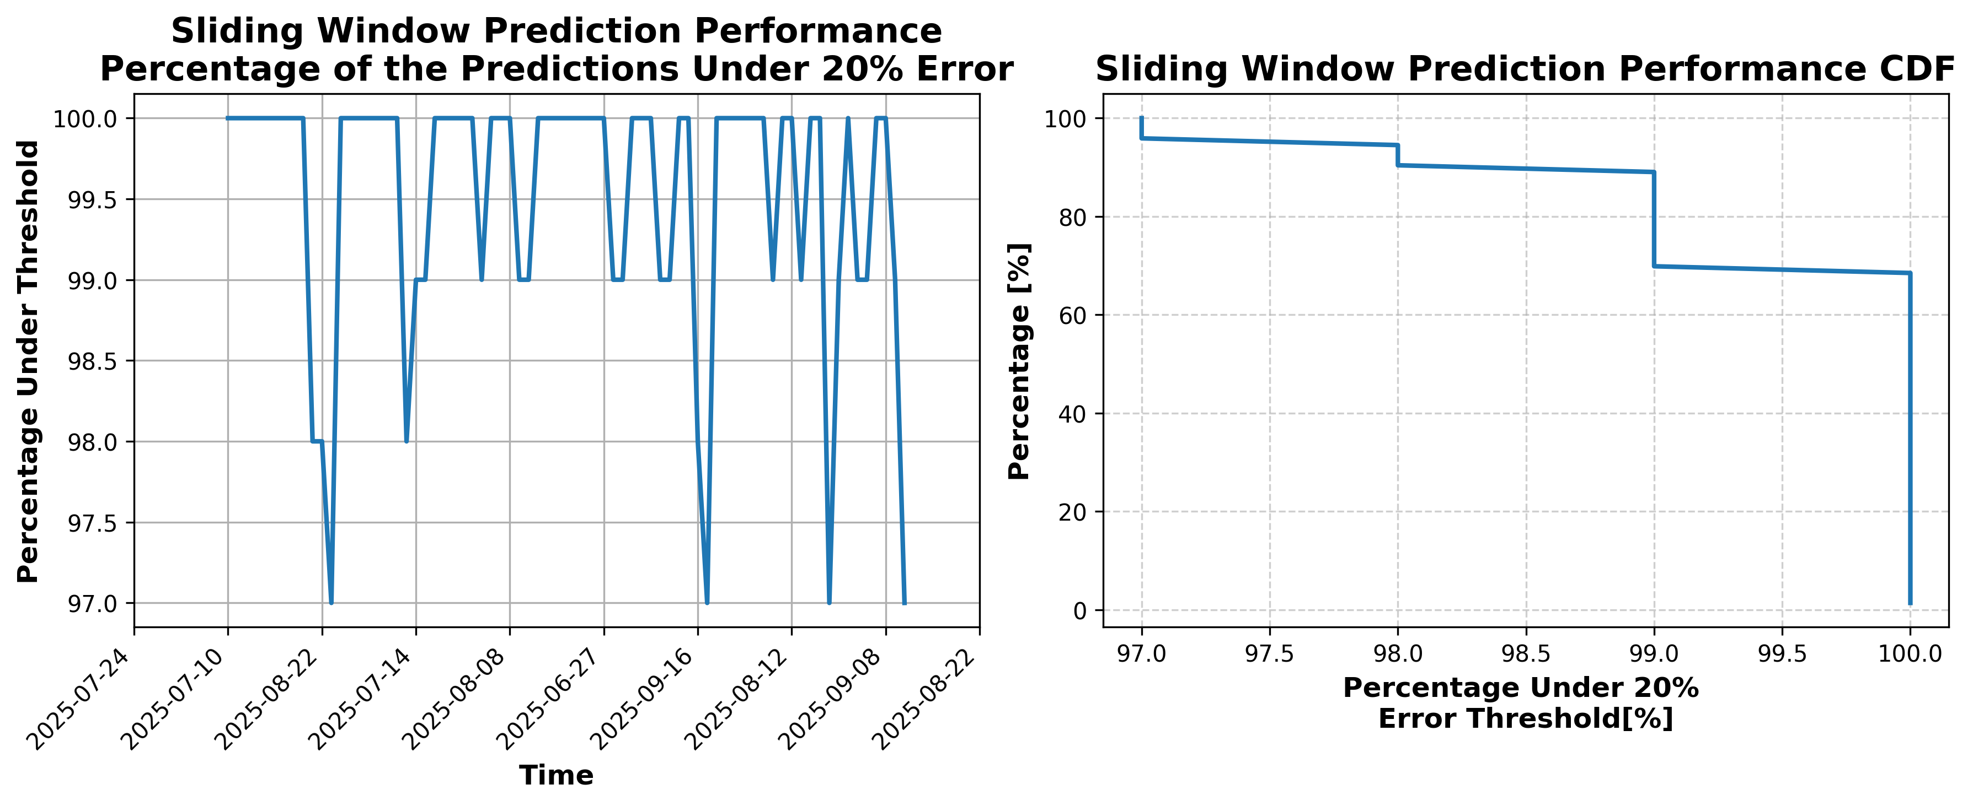

### Results for Latest_Test_2025-07-26.csv

Lines used: 8512 out of 14207 (59%)

Data sorted by: CHS Pickup Date

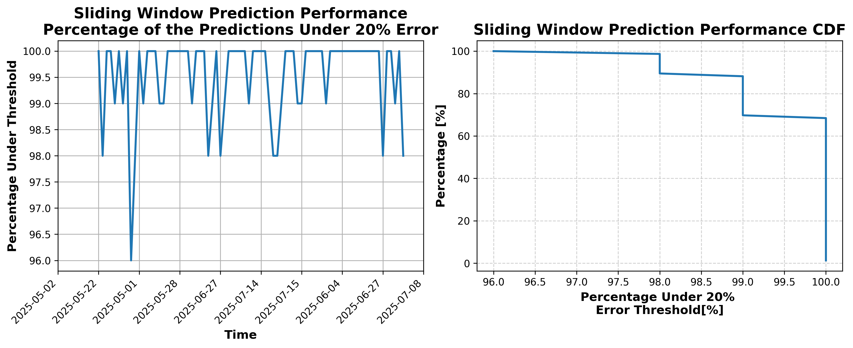

### Results for Latest_Test_2025-09-27.csv

Lines used: 8233 out of 14471 (56%)

Data sorted by: CHS Pickup Date

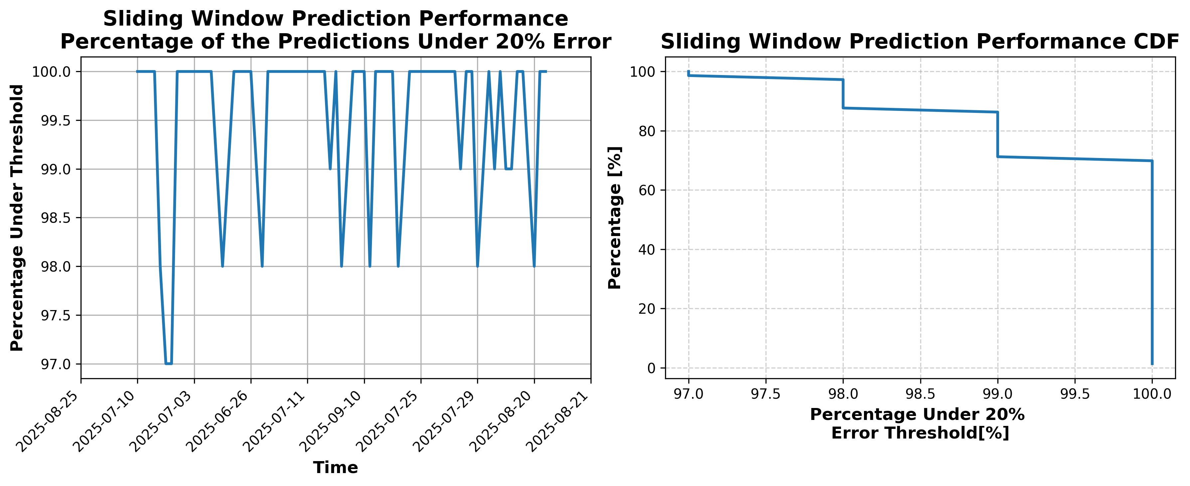

### Results for Latest_Test_2025-07-22.csv

Lines used: 8212 out of 13973 (58%)

Data sorted by: CHS Pickup Date

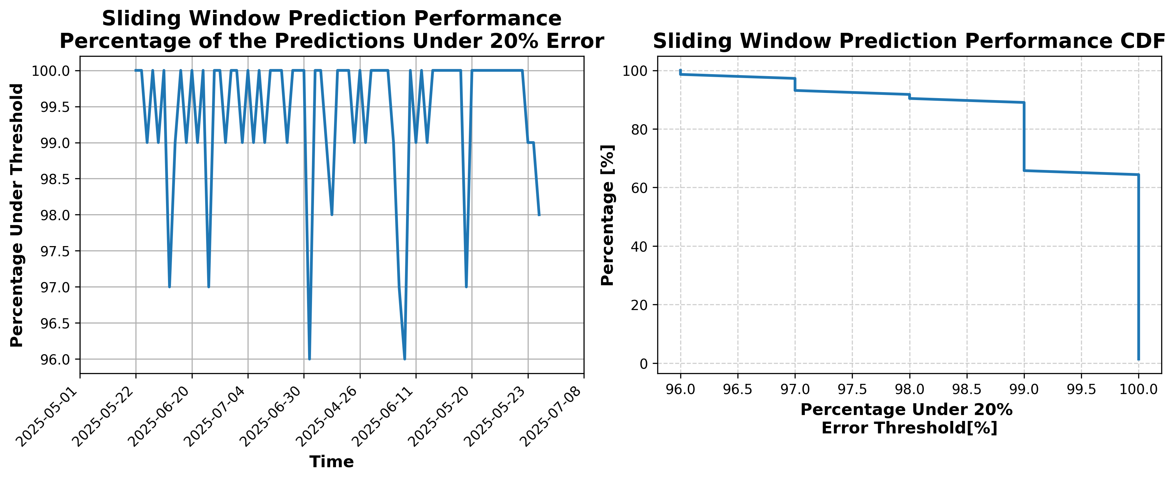

### Results for Latest_Test_2025-10-12.csv

Lines used: 7620 out of 13639 (55%)

Data sorted by: CHS Pickup Date

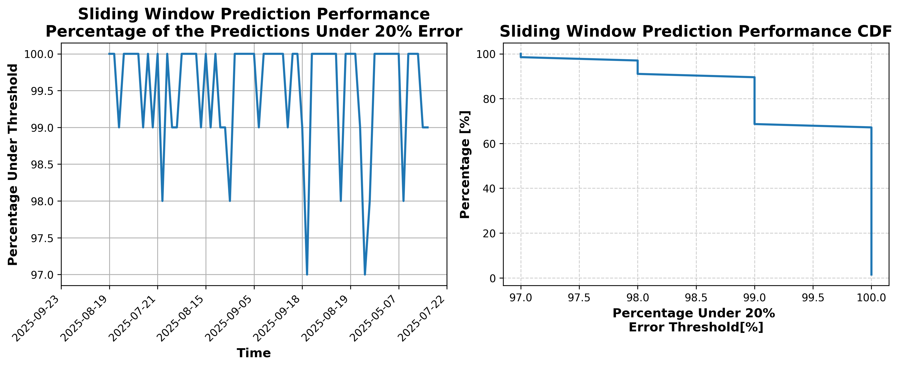

### Results for Latest_Test_2025-10-06.csv

Lines used: 7271 out of 13778 (52%)

Data sorted by: CHS Pickup Date

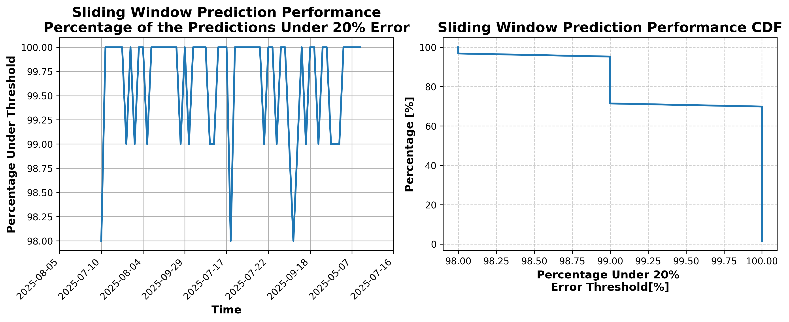

### Results for Latest_Test_2025-05-27.csv

Lines used: 9321 out of 14562 (64%)

Data sorted by: CHS Pickup Date

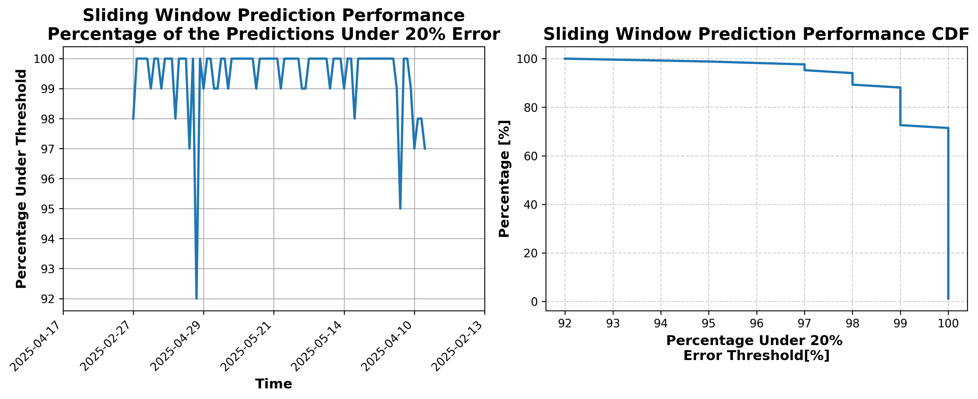

### Results for Latest_Test_2025-05-26.csv

Lines used: 9370 out of 14639 (64%)

Data sorted by: CHS Pickup Date

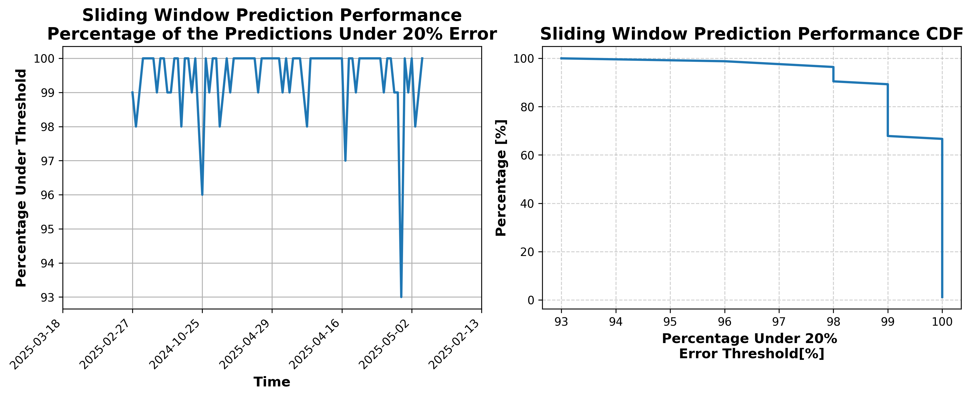

### Results for Latest_Test_2025-10-07.csv

Lines used: 7223 out of 13601 (53%)

Data sorted by: CHS Pickup Date

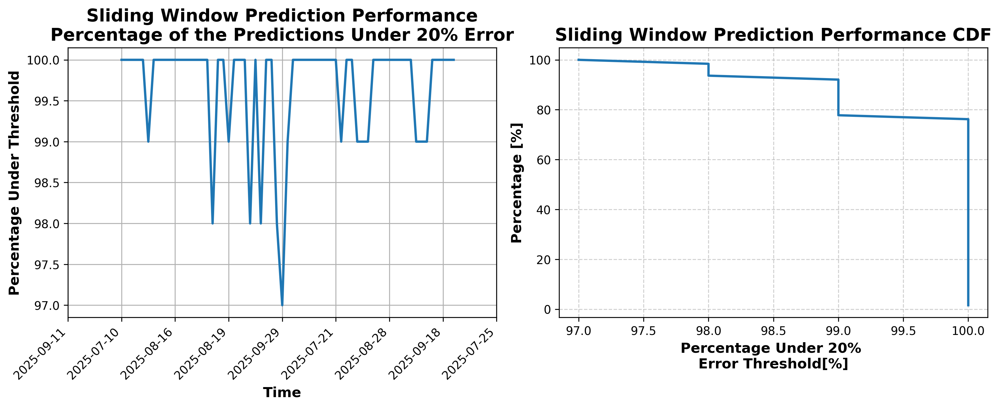

### Results for Latest_Test_2025-10-13.csv

Lines used: 7525 out of 13516 (55%)

Data sorted by: CHS Pickup Date

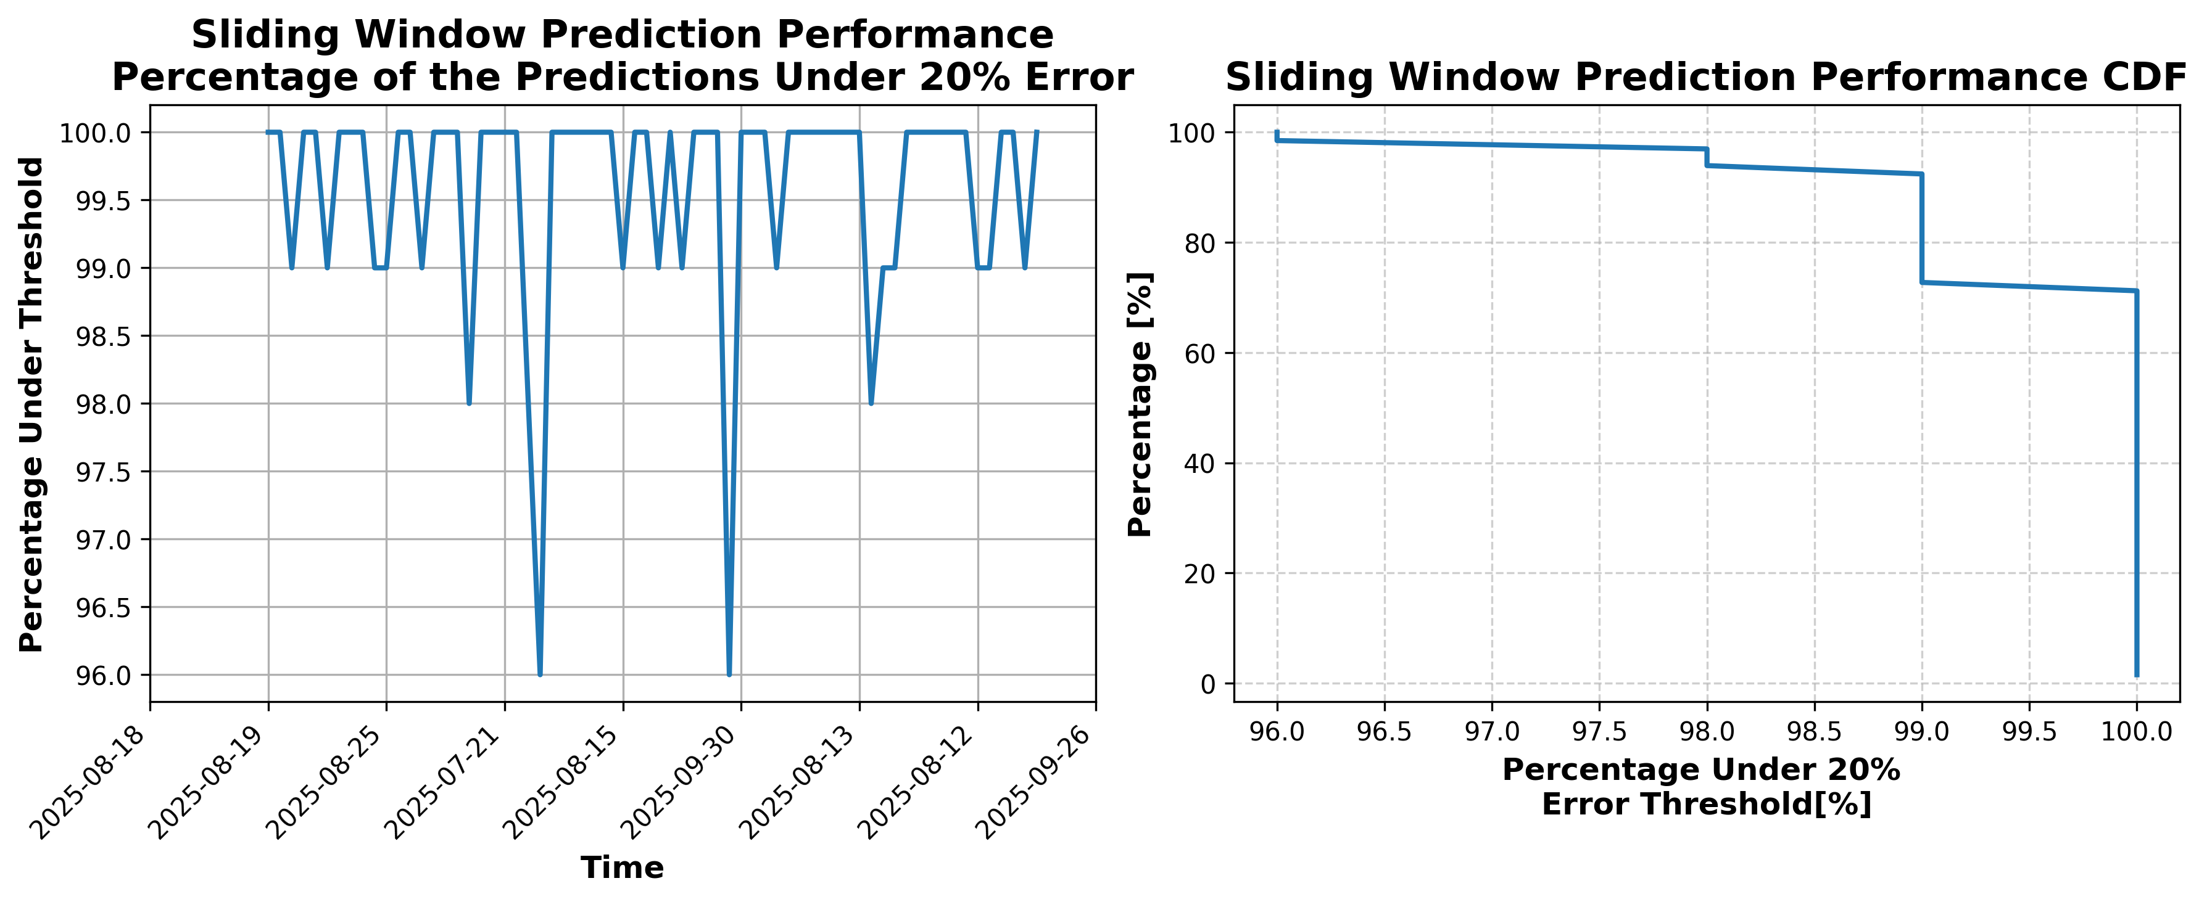

### Results for Latest_Test_2025-07-23.csv

Lines used: 8247 out of 13979 (58%)

Data sorted by: CHS Pickup Date

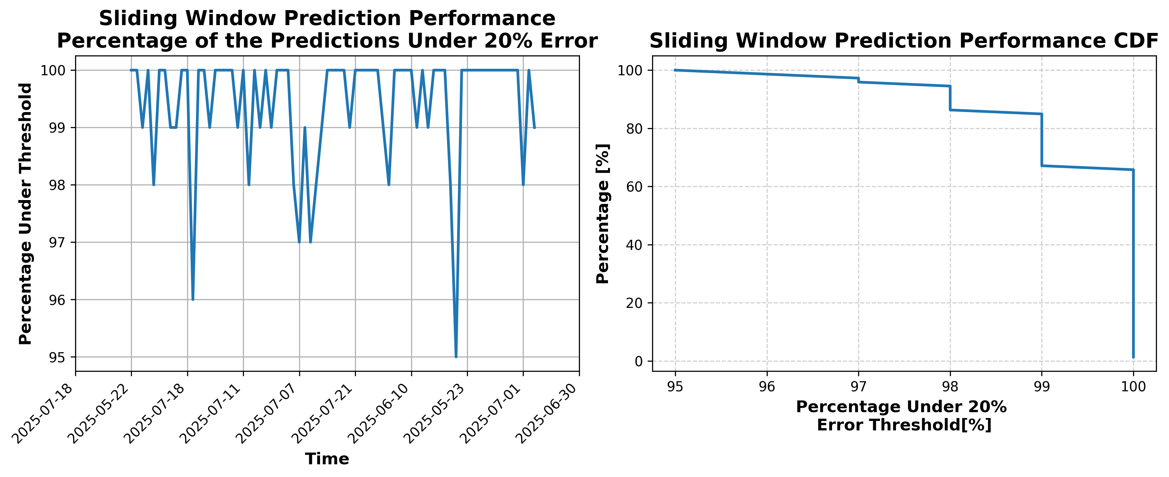

### Results for Latest_Test_2025-09-26.csv

Lines used: 8162 out of 14227 (57%)

Data sorted by: CHS Pickup Date

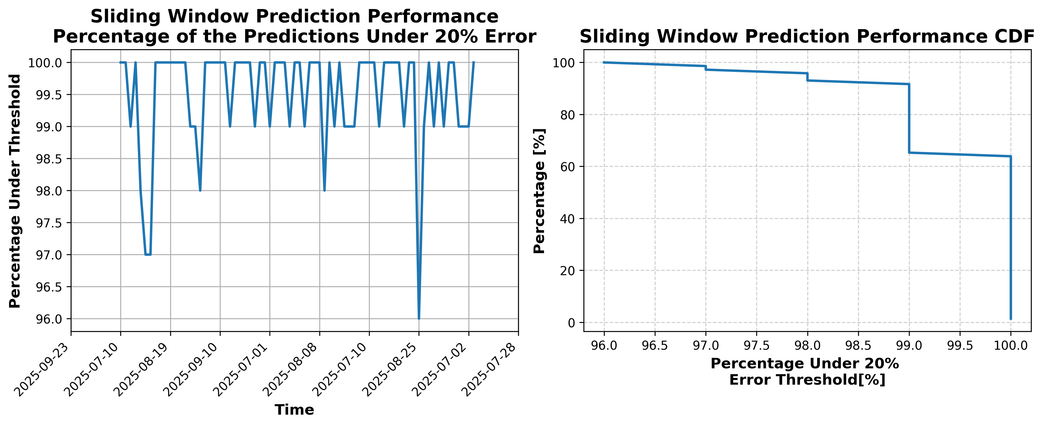

### Results for Latest_Test_2025-09-30.csv

Lines used: 7770 out of 14101 (55%)

Data sorted by: CHS Pickup Date

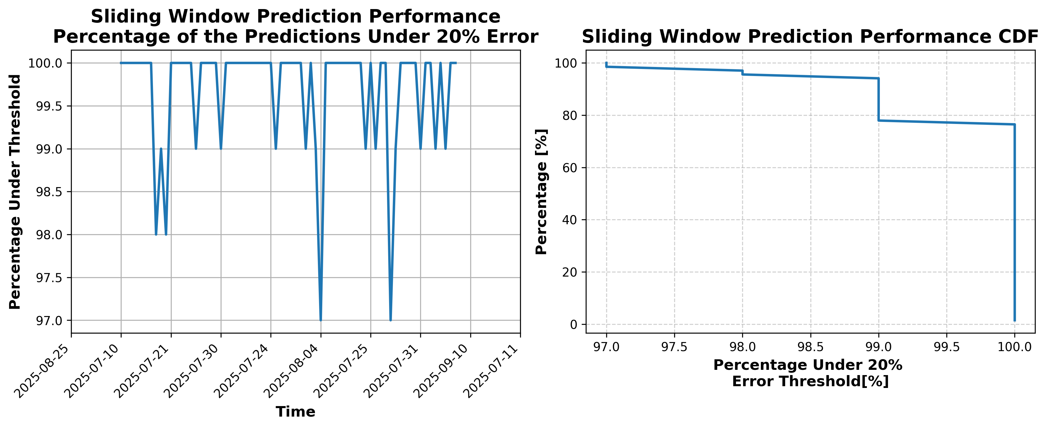

### Results for Latest_Test_2025-09-24.csv

Lines used: 8241 out of 14272 (57%)

Data sorted by: CHS Pickup Date

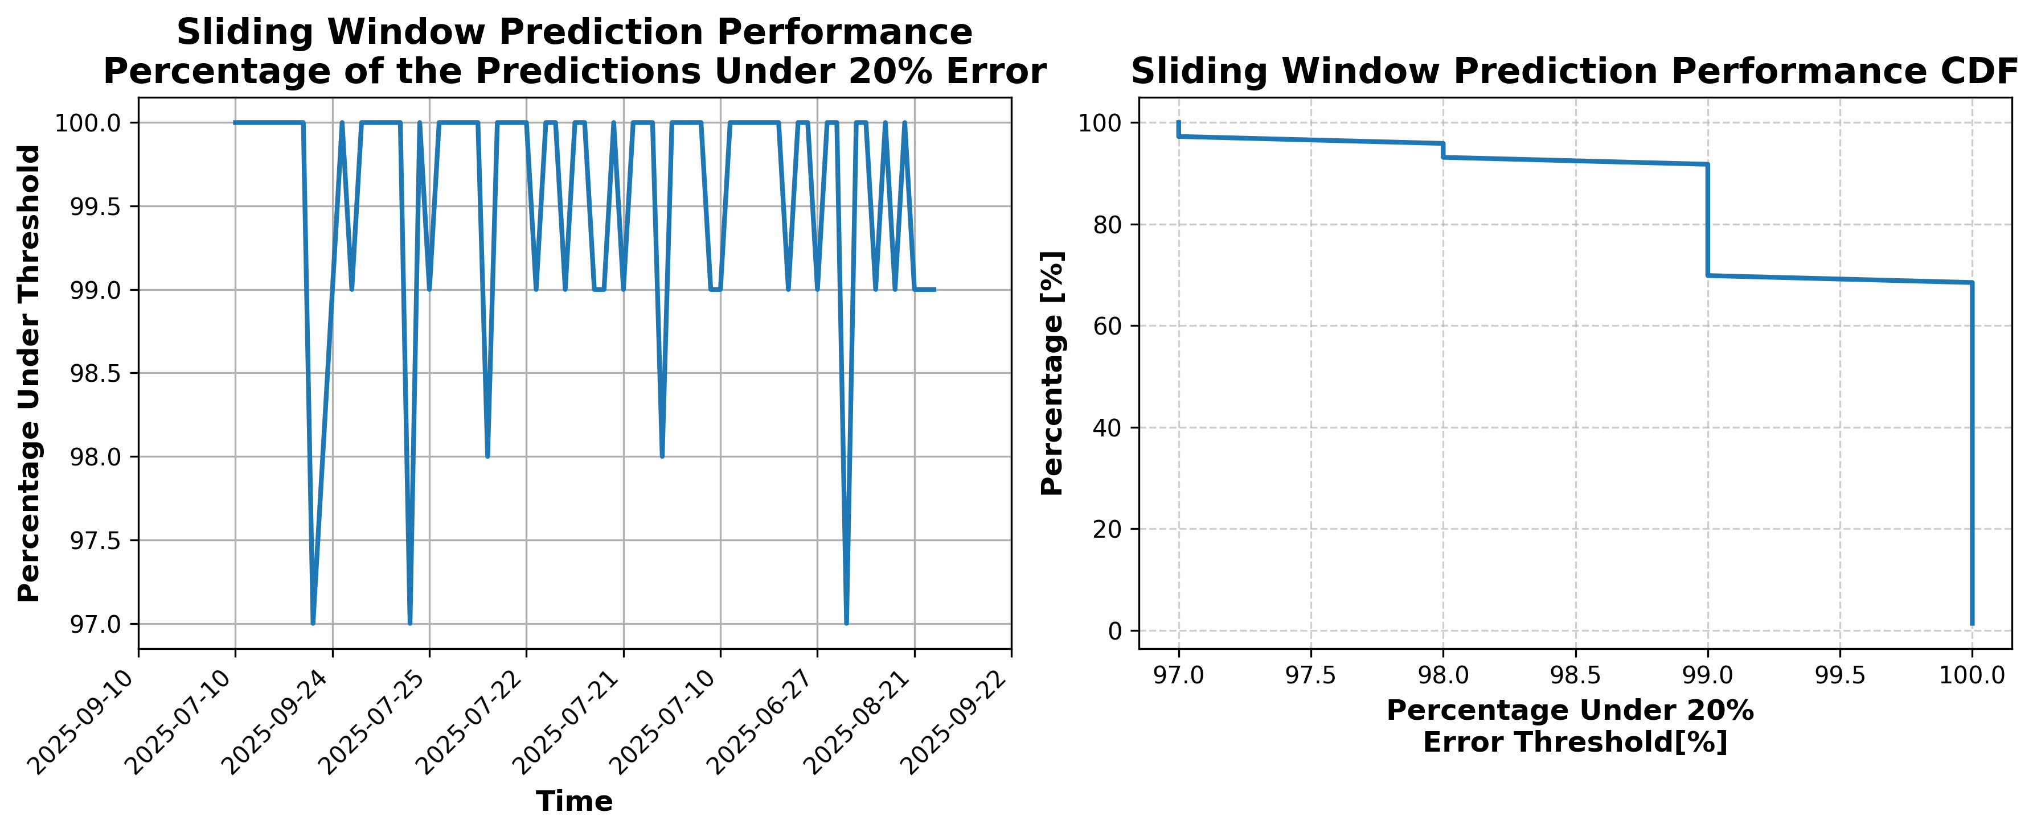

### Results for Latest_Test_2025-07-09.csv

Lines used: 8967 out of 14124 (63%)

Data sorted by: CHS Pickup Date

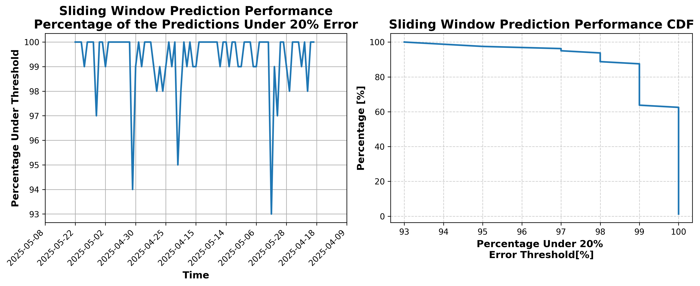

### Results for Latest_Test_2025-07-21.csv

Lines used: 8236 out of 13910 (59%)

Data sorted by: CHS Pickup Date

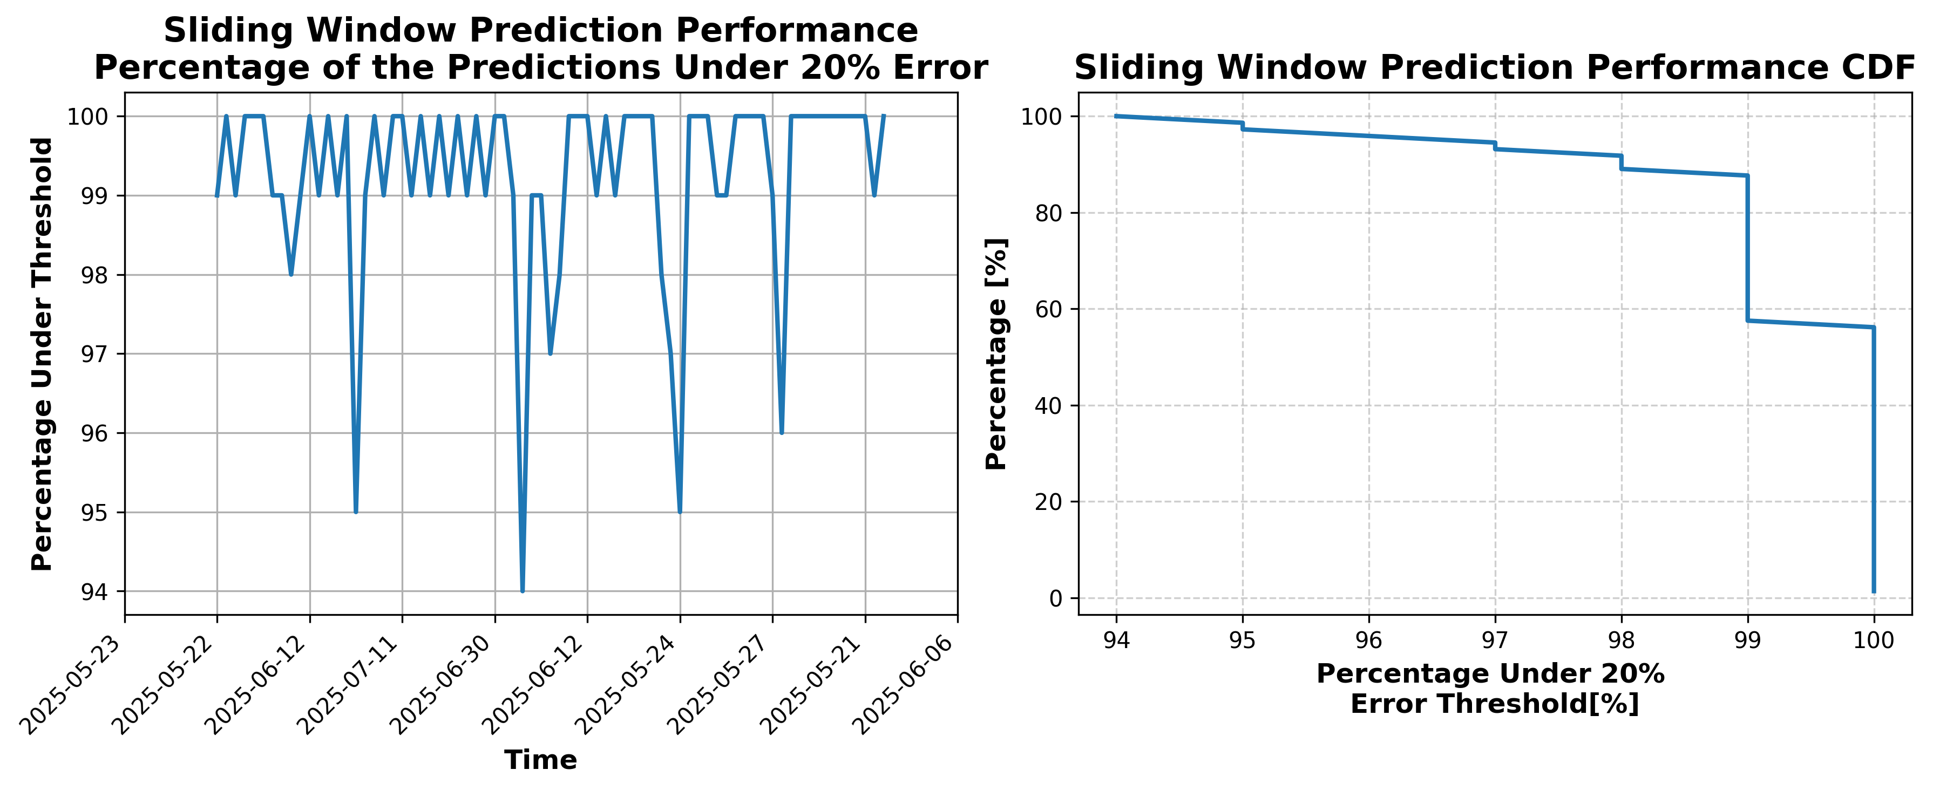

### Results for Latest_Test_2025-09-18.csv

Lines used: 8326 out of 14026 (59%)

Data sorted by: CHS Pickup Date

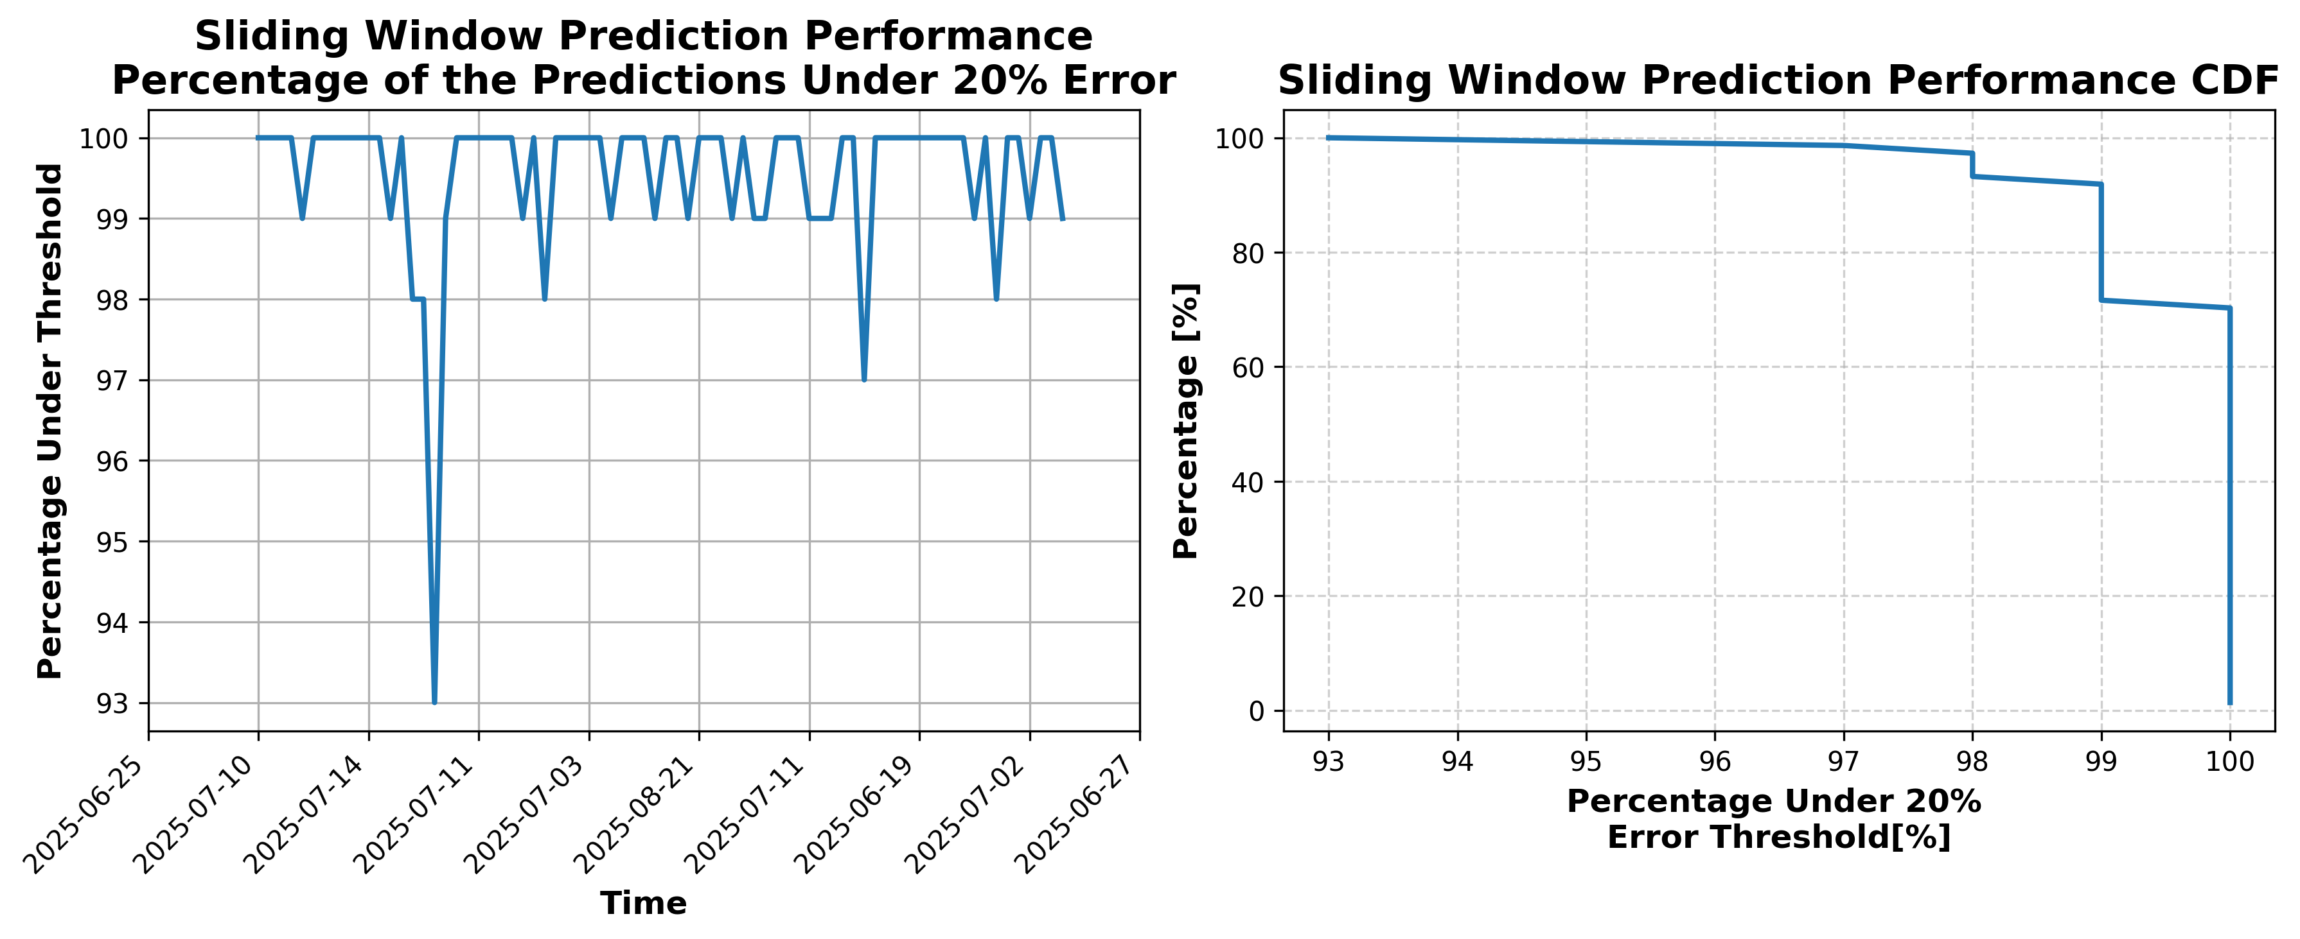

### Results for Latest_Test_2025-10-05.csv

Lines used: 7449 out of 14061 (52%)

Data sorted by: CHS Pickup Date

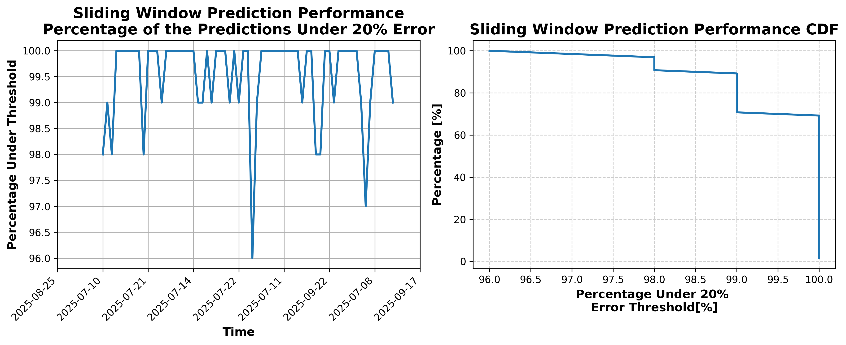

### Results for Latest_Test_2025-10-11.csv

Lines used: 7882 out of 13954 (56%)

Data sorted by: CHS Pickup Date

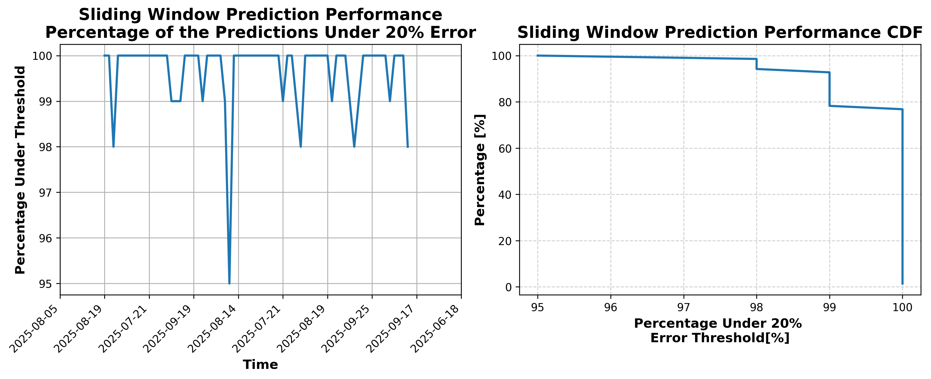

### Results for Latest_Test_2025-05-18.csv

Lines used: 9205 out of 14649 (62%)

Data sorted by: CHS Pickup Date

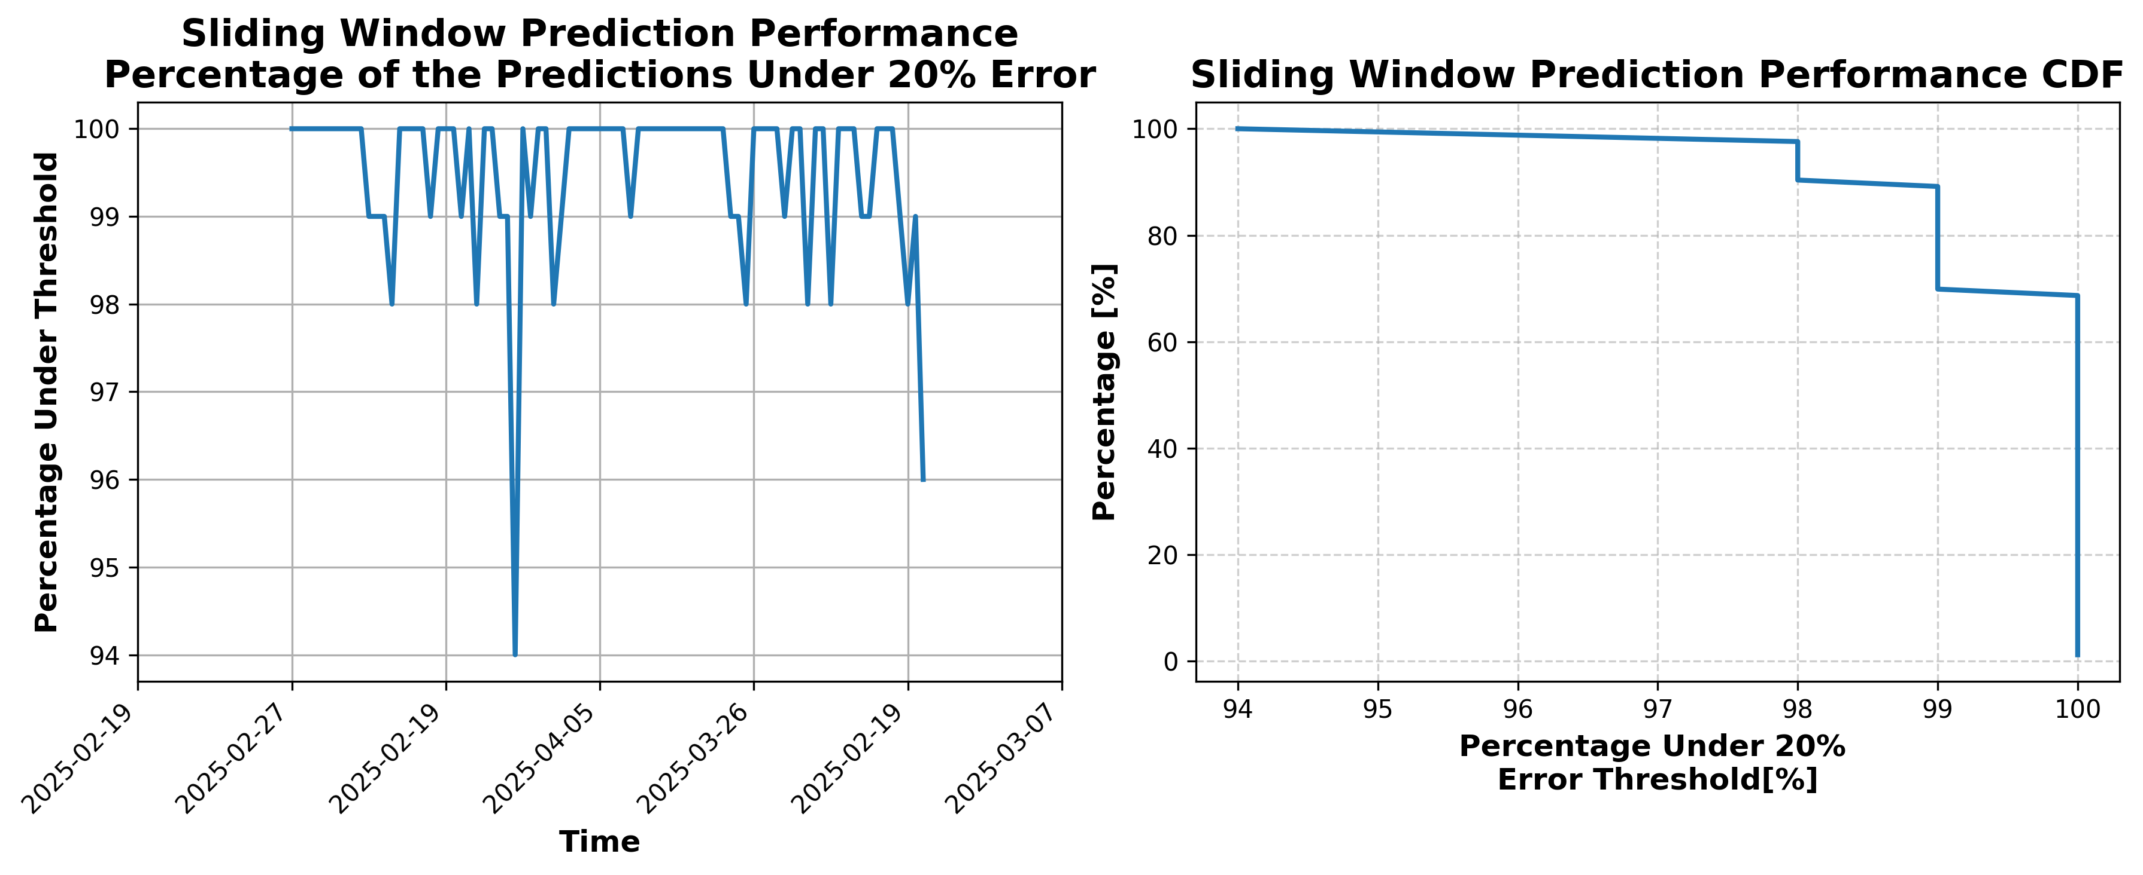

### Results for Latest_Test_2025-05-24.csv

Lines used: 9716 out of 15071 (64%)

Data sorted by: CHS Pickup Date

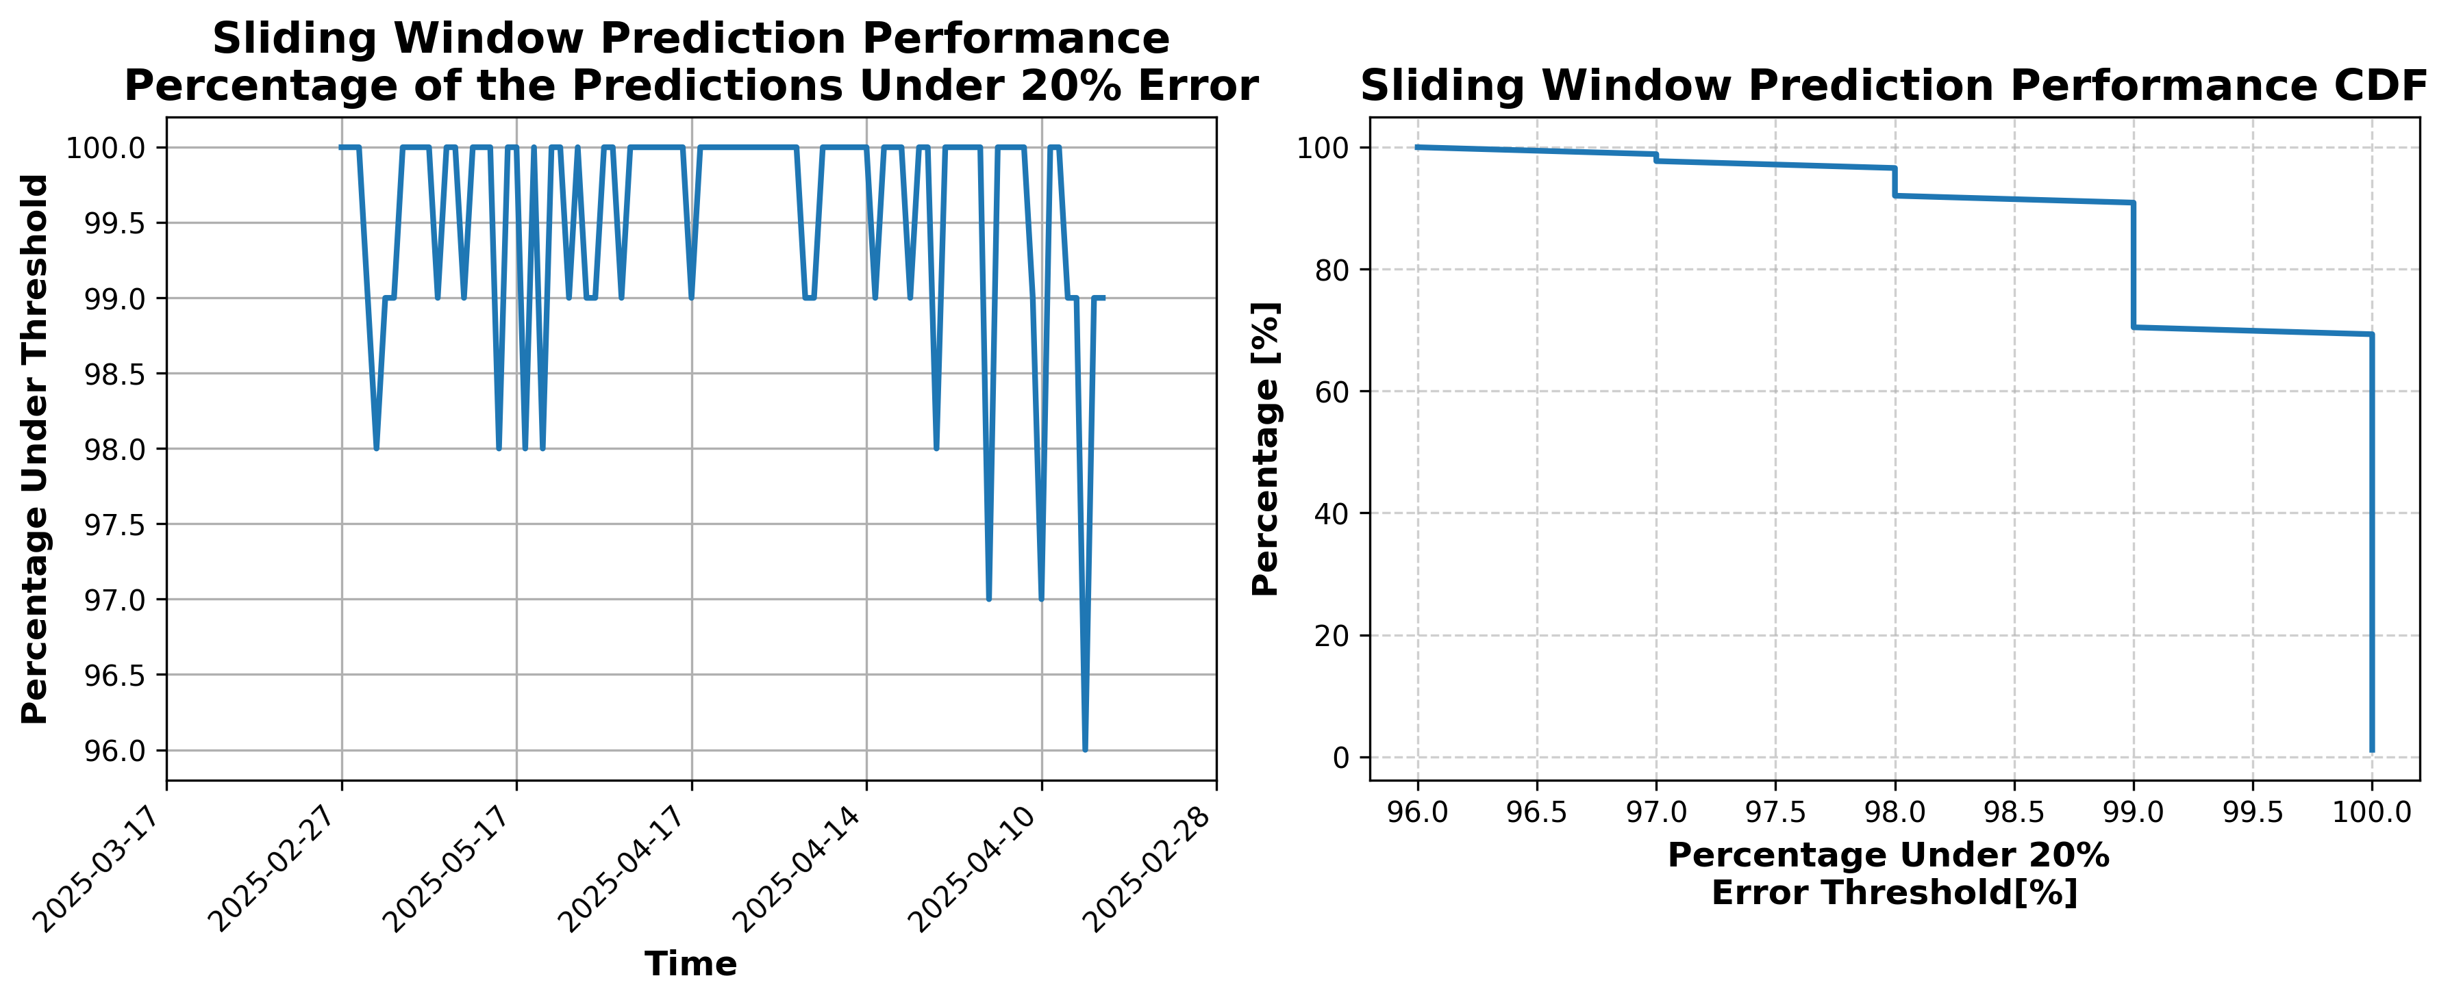

### Results for Latest_Test_2025-05-30.csv

Lines used: 9527 out of 14406 (66%)

Data sorted by: CHS Pickup Date

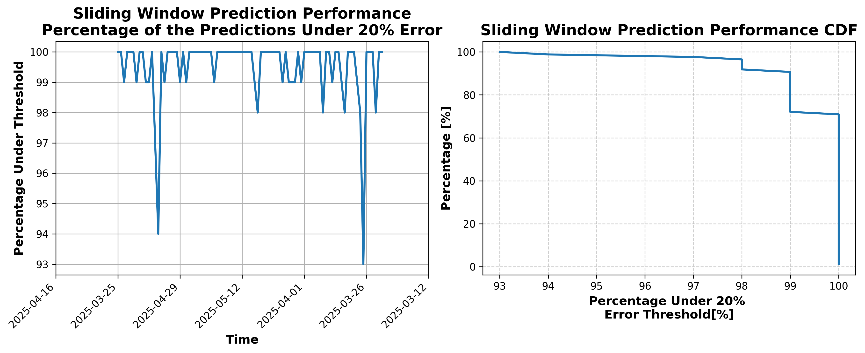

### Results for Latest_Test_2025-05-31.csv

Lines used: 9653 out of 14558 (66%)

Data sorted by: CHS Pickup Date

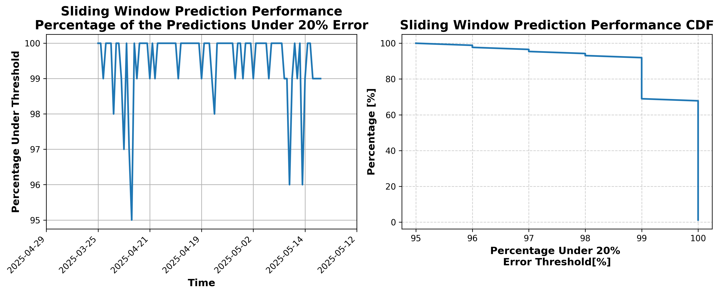

### Results for Latest_Test_2025-05-25.csv

Lines used: 9577 out of 14882 (64%)

Data sorted by: CHS Pickup Date

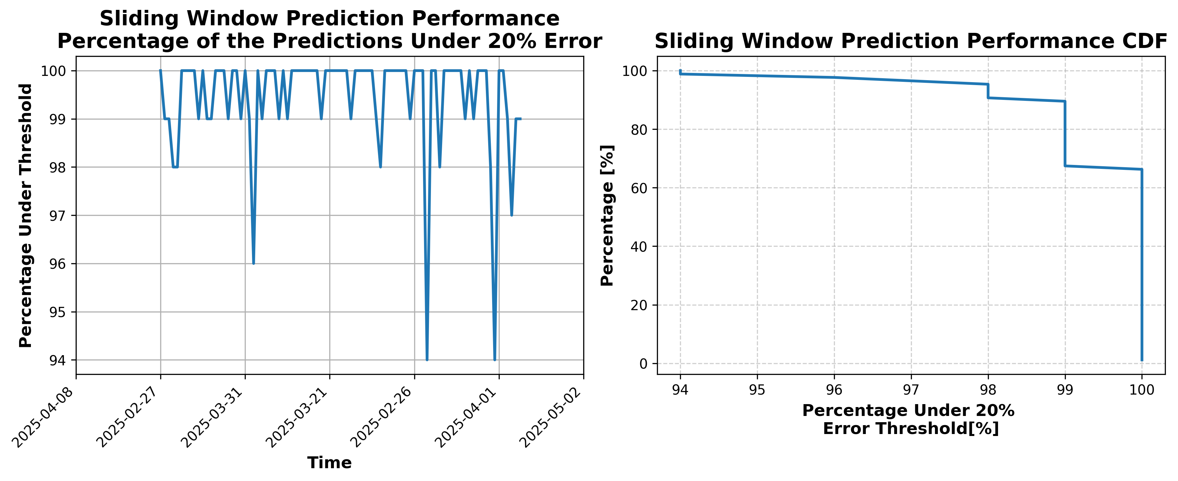

### Results for Latest_Test_2025-05-19.csv

Lines used: 9080 out of 14540 (62%)

Data sorted by: CHS Pickup Date

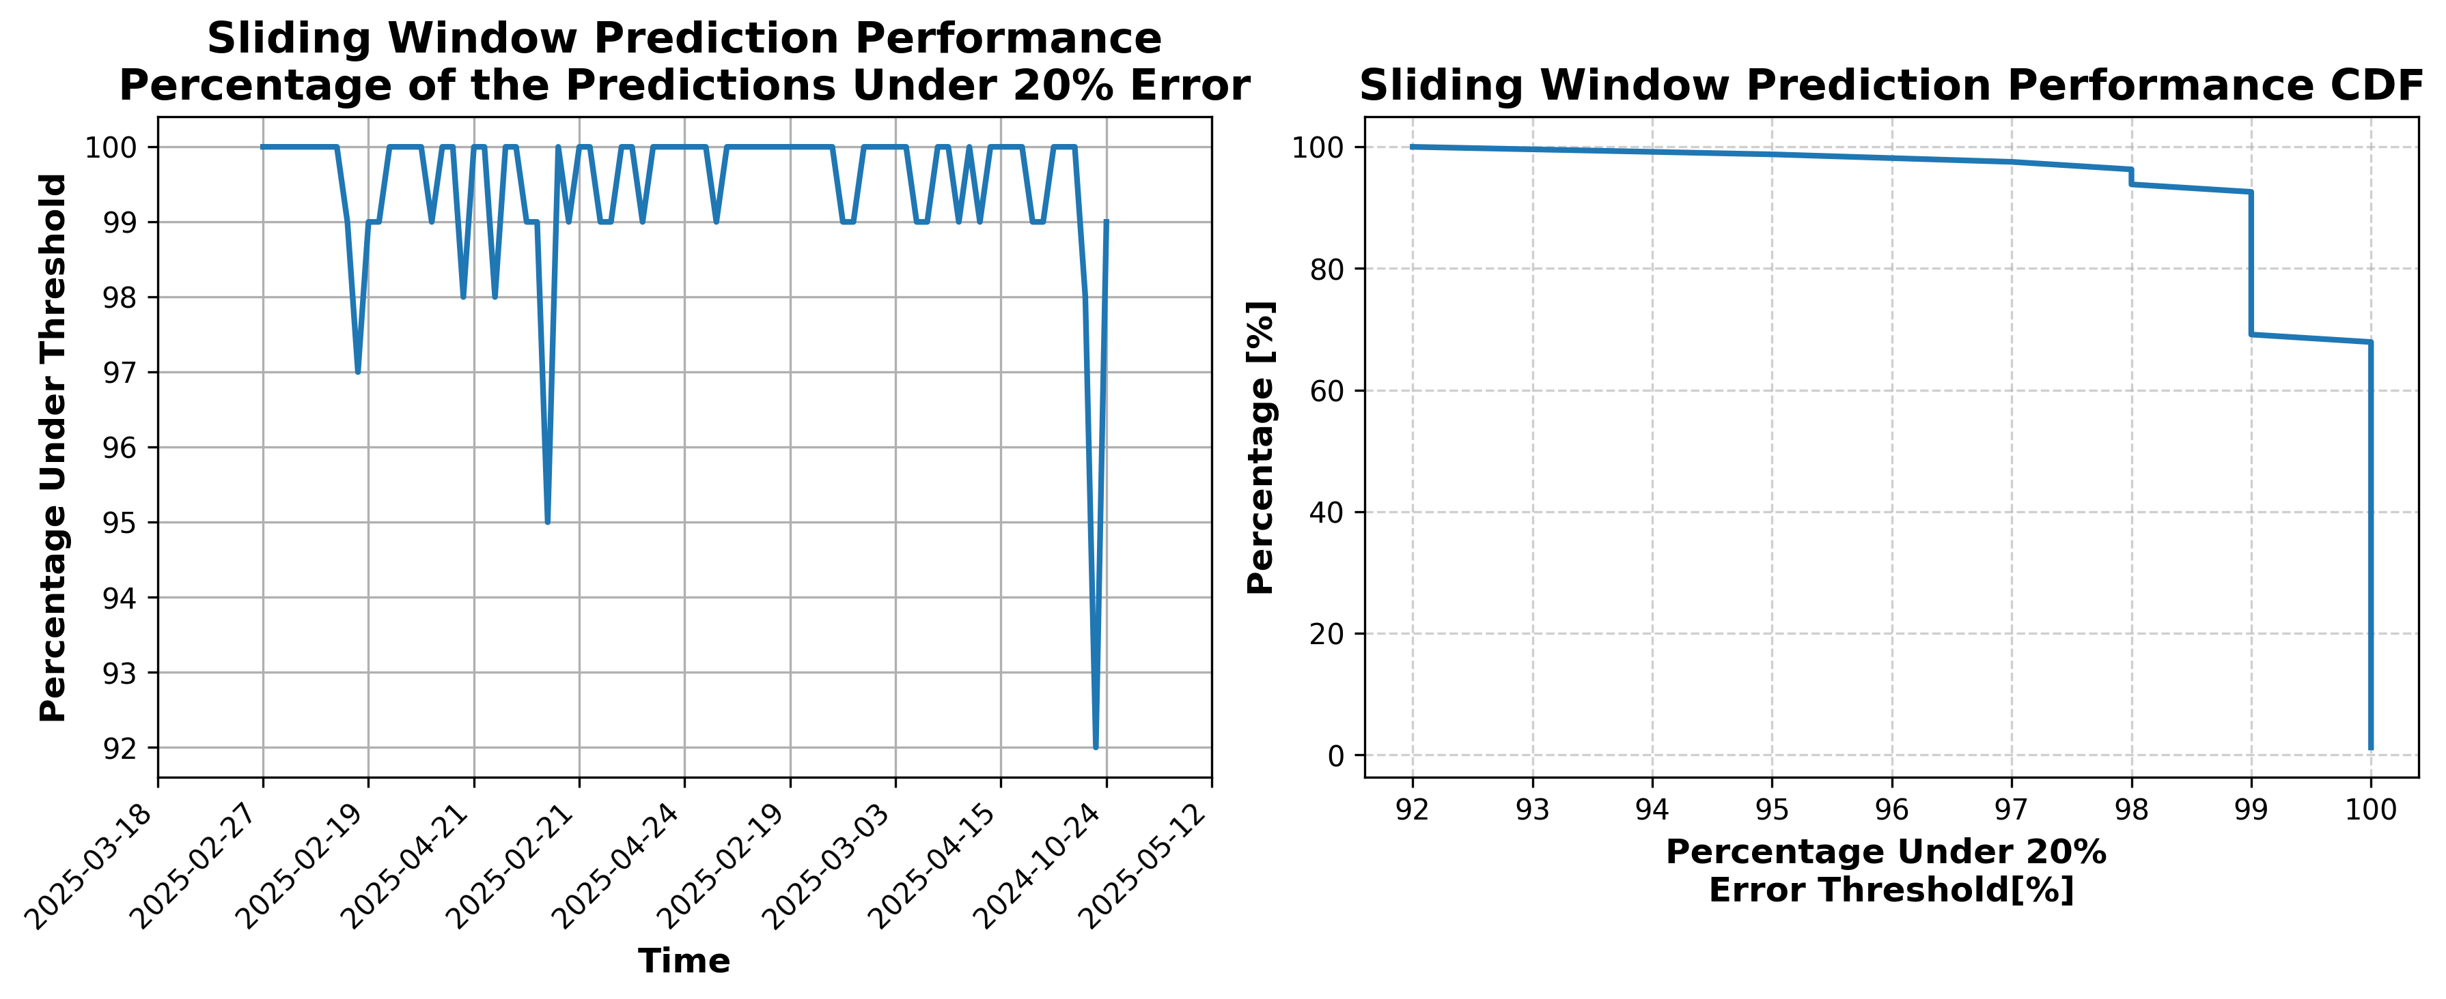

### Results for Latest_Test_2025-10-10.csv

Lines used: 7690 out of 13781 (55%)

Data sorted by: CHS Pickup Date

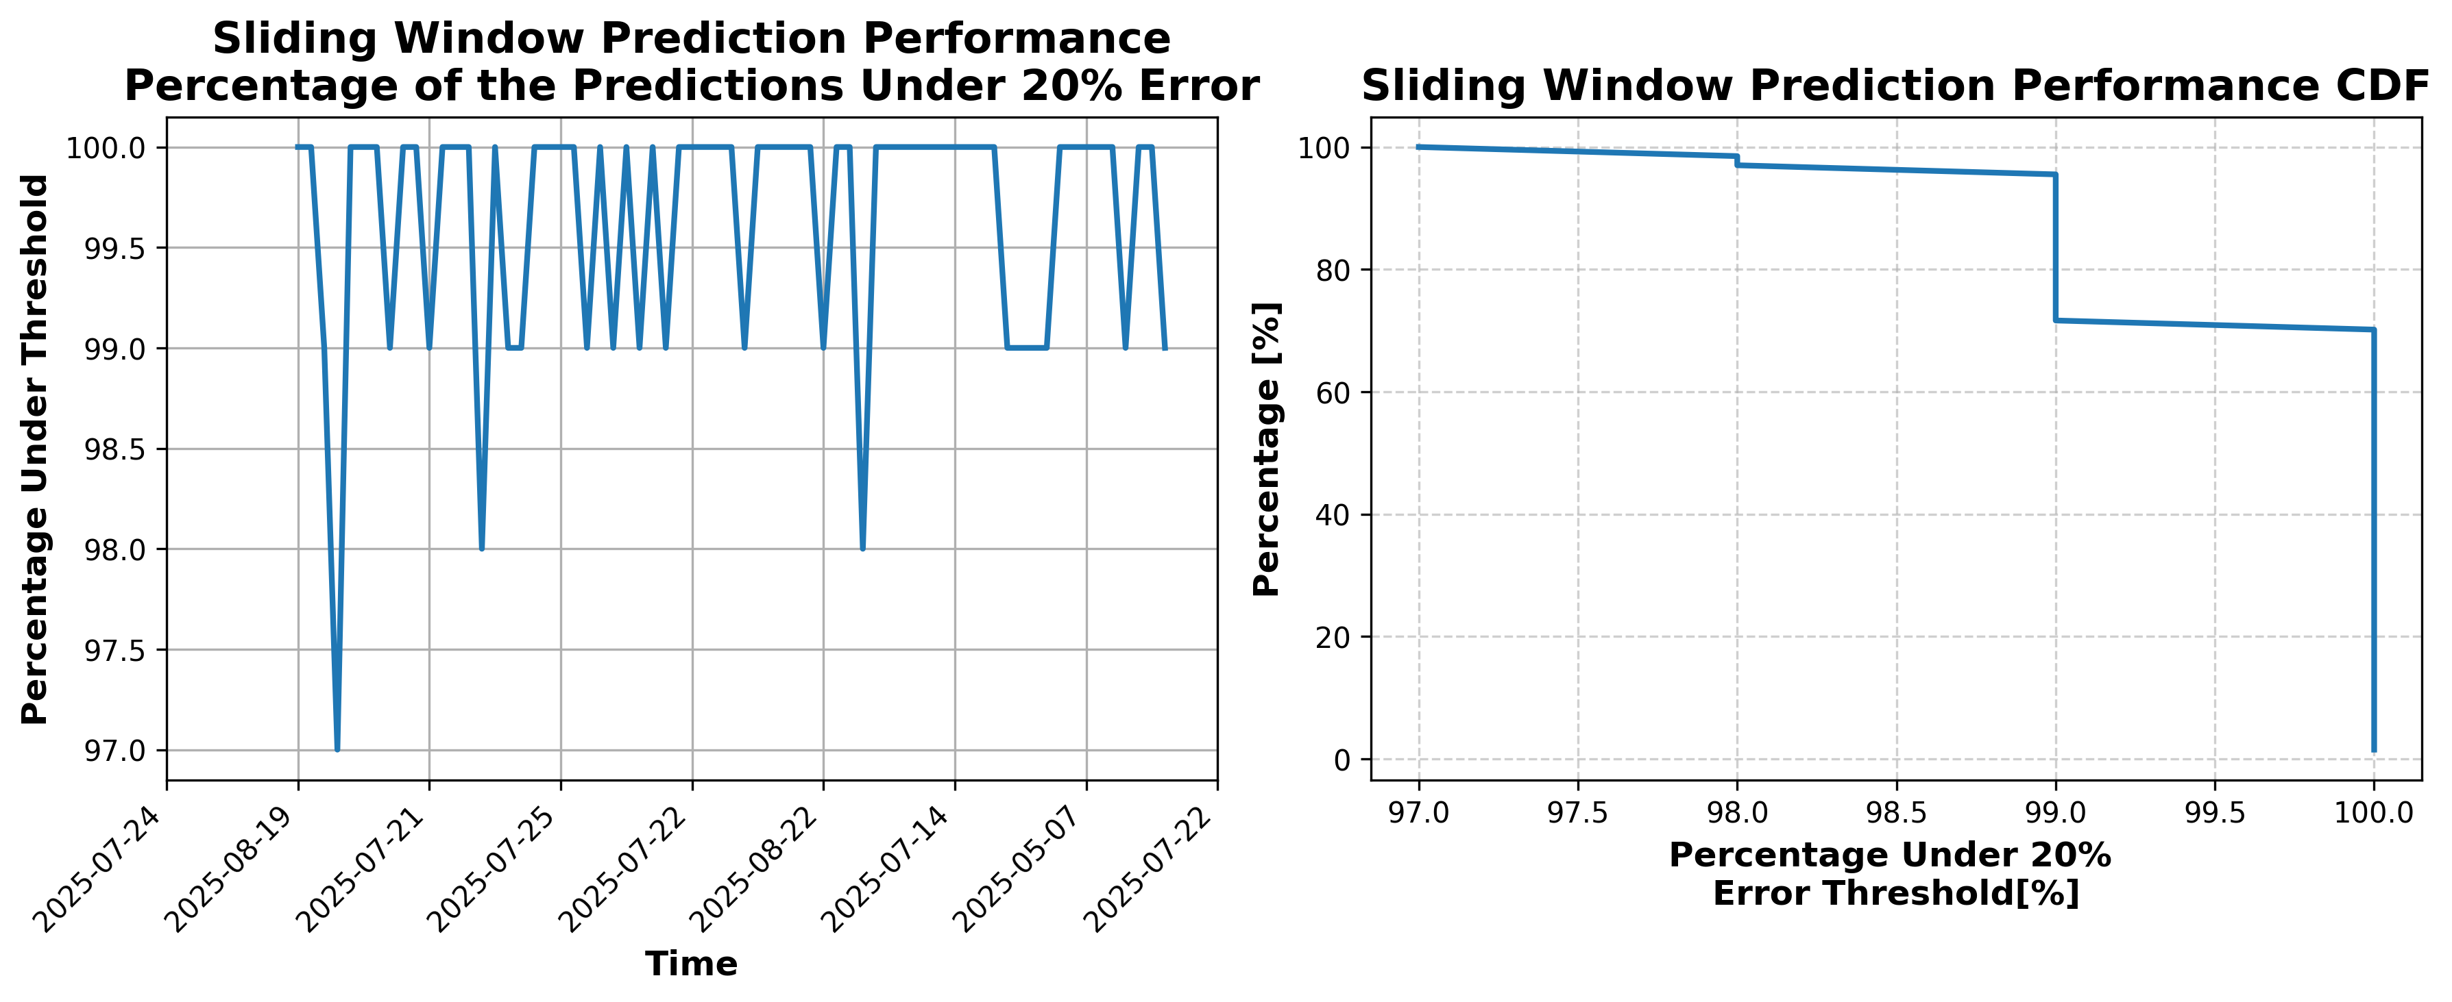

### Results for Latest_Test_2025-10-04.csv

Lines used: 7809 out of 14372 (54%)

Data sorted by: CHS Pickup Date

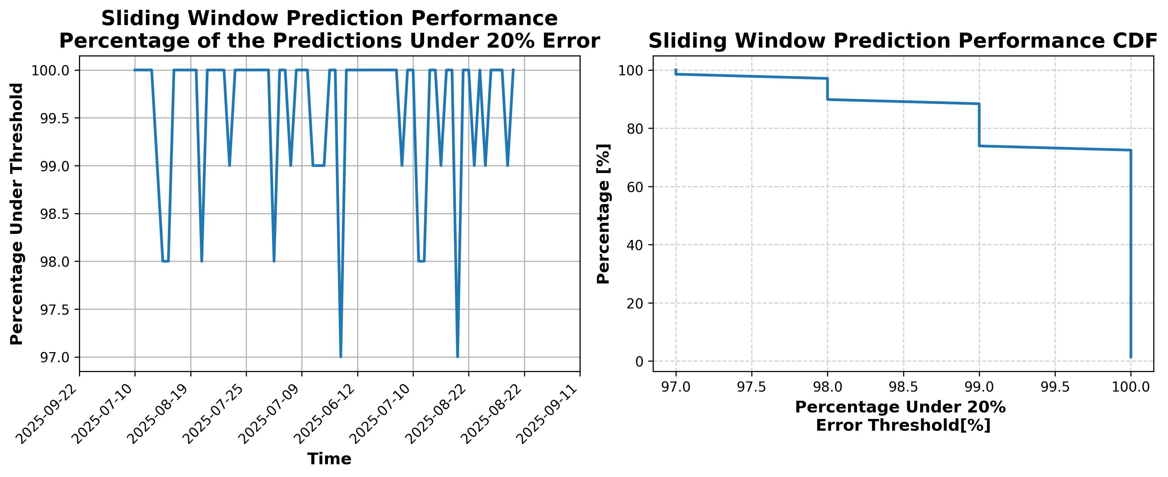

### Results for Latest_Test_2025-09-19.csv

Lines used: 8429 out of 14227 (59%)

Data sorted by: CHS Pickup Date

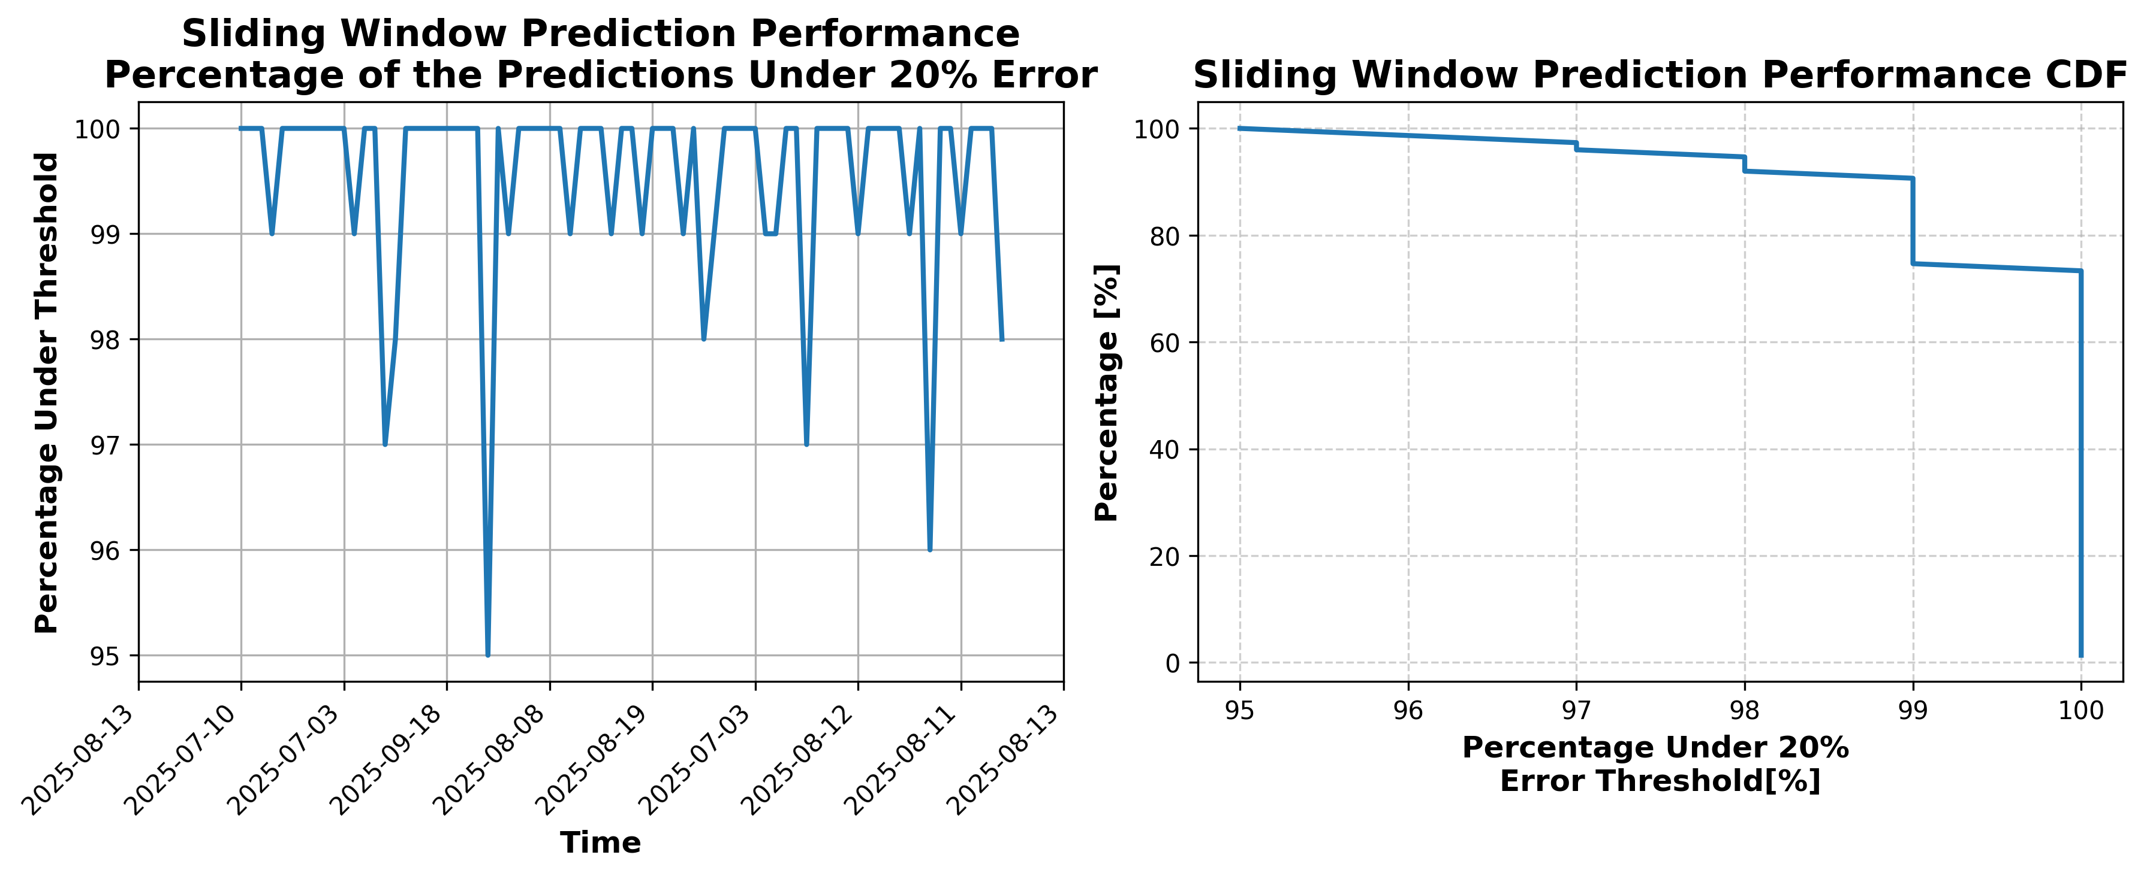

### Results for Latest_Test_2025-07-20.csv

Lines used: 8313 out of 13900 (59%)

Data sorted by: CHS Pickup Date

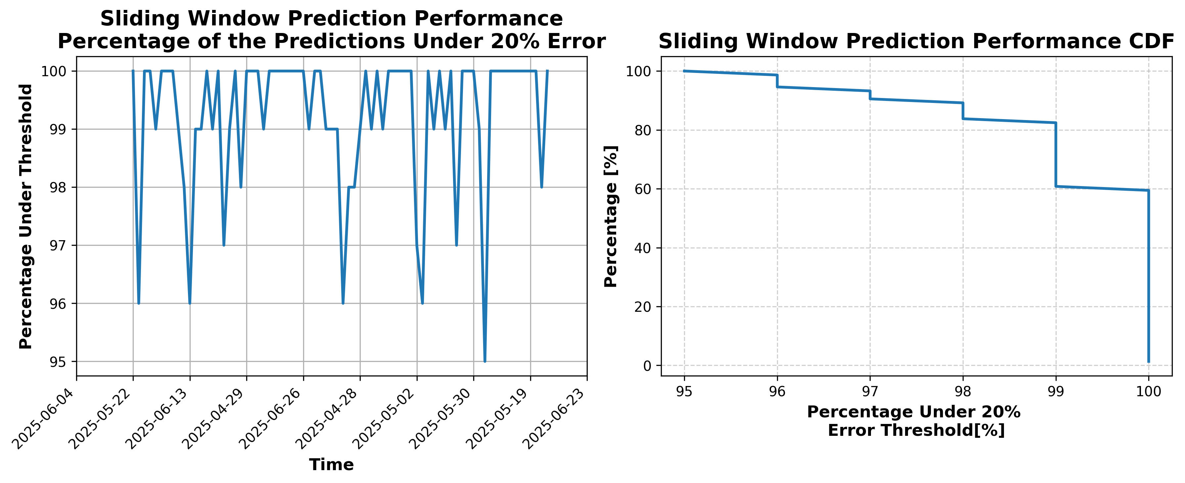

### Results for Latest_Test_2025-07-08.csv

Lines used: 8983 out of 14111 (63%)

Data sorted by: CHS Pickup Date

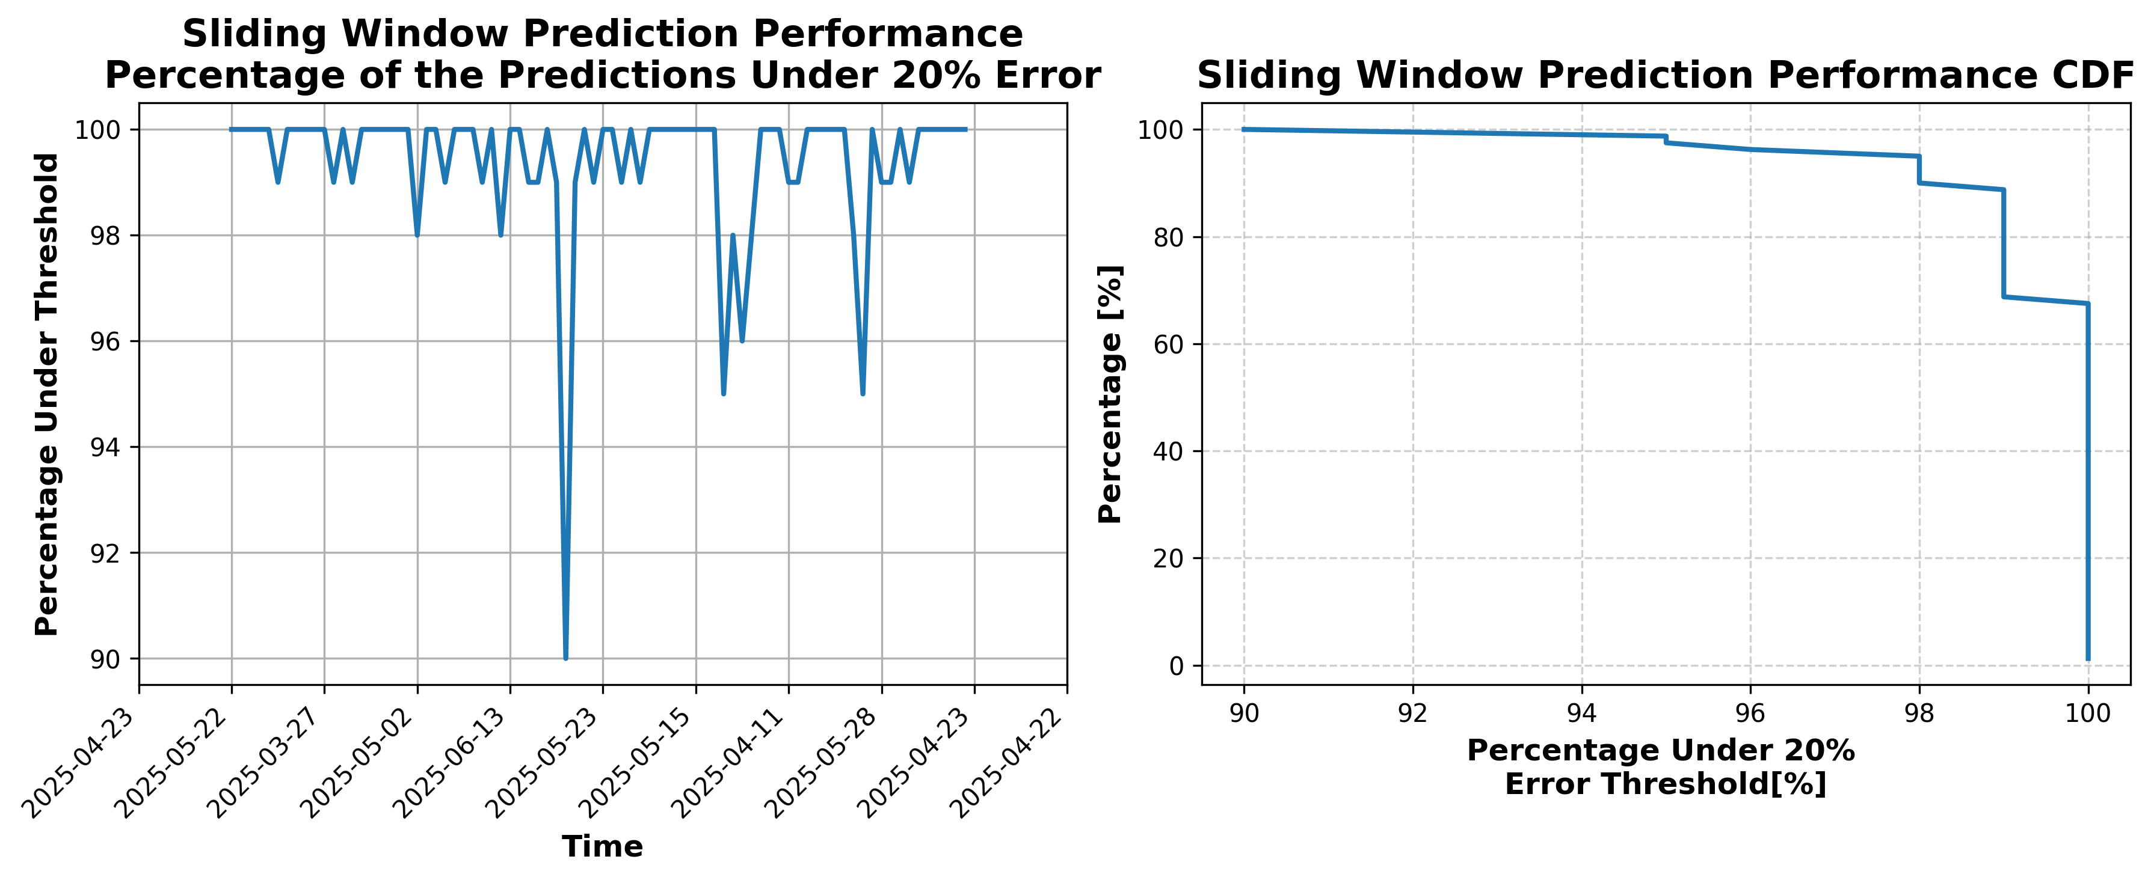

### Results for Latest_Test_2025-09-25.csv

Lines used: 8018 out of 14068 (56%)

Data sorted by: CHS Pickup Date

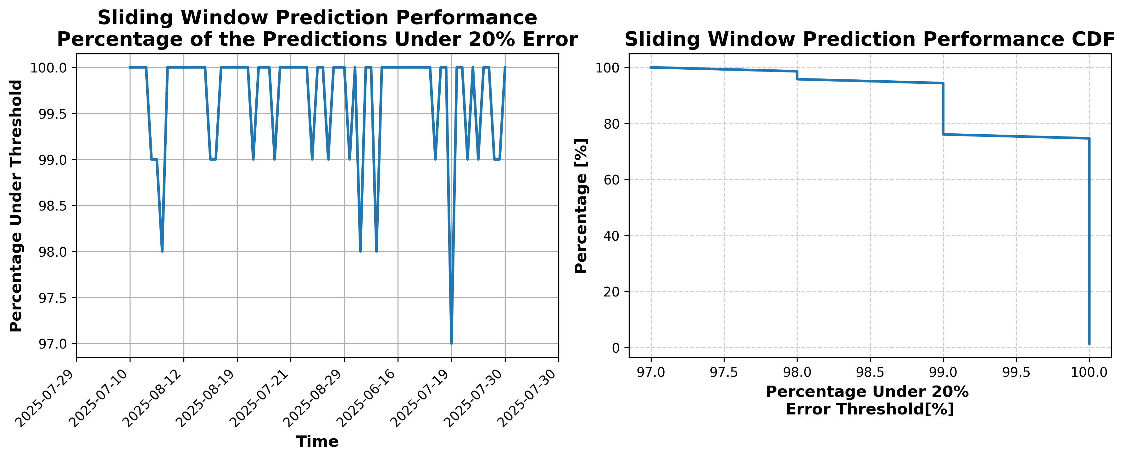

## Results Summary

This section contains a results summary table for all files. The summary metric is the percentage of the prediction results that were below the selected error threshold (20%) averaged over all windows in file analysis

|  |  |
| --- | --- |
| **Data Filename** | **% Below 20%** |
| Latest_Test_2025-09-28.csv | 99.64% |
| Latest_Test_2025-07-05.csv | 99.4% |
| Latest_Test_2025-07-11.csv | 99.33% |
| Latest_Test_2025-09-14.csv | 99.67% |
| Latest_Test_2025-10-09.csv | 99.7% |
| Latest_Test_2025-10-21.csv | 99.59% |
| Latest_Test_2025-05-14.csv | 99.59% |
| Latest_Test_2025-05-28.csv | 99.54% |
| Latest_Test_2025-05-29.csv | 99.38% |
| Latest_Test_2025-05-15.csv | 99.53% |
| Latest_Test_2025-05-01.csv | 99.61% |
| Latest_Test_2025-10-20.csv | 99.62% |
| Latest_Test_2025-10-08.csv | 99.75% |
| Latest_Test_2025-09-01.csv | 99.7% |
| Latest_Test_2025-09-15.csv | 99.57% |
| Latest_Test_2025-07-10.csv | 99.34% |
| Latest_Test_2025-07-04.csv | 99.4% |
| Latest_Test_2025-09-29.csv | 99.55% |
| Latest_Test_2025-07-12.csv | 99.29% |
| Latest_Test_2025-07-06.csv | 99.21% |
| Latest_Test_2025-09-03.csv | 99.62% |
| Latest_Test_2025-09-17.csv | 99.53% |
| Latest_Test_2025-10-22.csv | 99.72% |
| Latest_Test_2025-05-17.csv | 99.64% |
| Latest_Test_2025-05-03.csv | 99.59% |
| Latest_Test_2025-02-23.csv | 98.75% |
| Latest_Test_2025-05-02.csv | 99.59% |
| Latest_Test_2025-05-16.csv | 99.6% |
| Latest_Test_2025-10-23.csv | 99.52% |
| Latest_Test_2025-09-16.csv | 99.58% |
| Latest_Test_2025-09-02.csv | 99.59% |
| Latest_Test_2025-07-07.csv | 99.43% |
| Latest_Test_2025-07-13.csv | 99.39% |
| Latest_Test_2025-10-02_OTO.csv | 99.21% |
| Latest_Test_2025-09-06.csv | 99.61% |
| Latest_Test_2025-09-12.csv | 99.55% |
| Latest_Test_2025-07-17.csv | 99.36% |
| Latest_Test_2025-07-03.csv | 99.33% |
| Latest_Test_2025-10-27.csv | 99.63% |
| Latest_Test_2025-05-12.csv | 99.55% |
| Latest_Test_2025-05-06.csv | 99.58% |
| Latest_Test_2025-05-07.csv | 99.54% |
| Latest_Test_2025-05-13.csv | 99.5% |
| Latest_Test_2025-10-26.csv | 99.68% |
| Latest_Test_2025-07-02.csv | 99.33% |
| Latest_Test_2025-07-16.csv | 99.43% |
| Latest_Test_2025-09-13.csv | 99.54% |
| Latest_Test_2025-09-07.csv | 99.59% |
| Latest_Test_2025-09-11.csv | 99.42% |
| Latest_Test_2025-09-05.csv | 99.55% |
| Latest_Test_2025-07-28.csv | 99.47% |
| Latest_Test_2025-07-14.csv | 99.49% |
| Latest_Test_2025-10-24.csv | 99.65% |
| Latest_Test_2025-10-30.csv | 99.62% |
| Latest_Test_2025-10-18.csv | 99.71% |
| Latest_Test_2025-05-05.csv | 99.57% |
| Latest_Test_2025-05-11.csv | 99.62% |
| Latest_Test_2025-05-10.csv | 99.62% |
| Latest_Test_2025-05-04.csv | 99.59% |
| Latest_Test_2025-02-25.csv | 99.58% |
| Latest_Test_2025-10-19.csv | 99.52% |
| Latest_Test_2025-10-31.csv | 99.68% |
| Latest_Test_2025-10-25.csv | 99.55% |
| Latest_Test_2025-07-15.csv | 99.28% |
| Latest_Test_2025-07-01.csv | 99.27% |
| Latest_Test_2025-07-29.csv | 99.4% |
| Latest_Test_2025-09-04.csv | 99.56% |
| Latest_Test_2025-09-10.csv | 99.53% |
| Latest_Test_2025-03-02.csv | 99.63% |
| Latest_Test_2025-03-16.csv | 99.54% |
| Latest_Test_2025-04-23.csv | 99.51% |
| Latest_Test_2025-08-23.csv | 99.48% |
| Latest_Test_2025-06-26.csv | 99.4% |
| Latest_Test_2025-11-02.csv | 99.56% |
| Latest_Test_2025-06-27.csv | 99.42% |
| Latest_Test_2025-08-22.csv | 99.6% |
| Latest_Test_2025-04-22.csv | 99.58% |
| Latest_Test_2025-03-17.csv | 99.5% |
| Latest_Test_2025-03-03.csv | 99.6% |
| Latest_Test_2025-03-15.csv | 99.4% |
| Latest_Test_2025-04-08.csv | 99.57% |
| Latest_Test_2025-04-20.csv | 99.49% |
| Latest_Test_2025-03-29.csv | 99.42% |
| Latest_Test_2025-06-19.csv | 99.56% |
| Latest_Test_2025-08-20.csv | 99.67% |
| Latest_Test_2025-06-25.csv | 99.36% |
| Latest_Test_2025-08-08.csv | 99.56% |
| Latest_Test_2025-11-01.csv | 99.67% |
| Latest_Test_2025-06-30.csv | 99.37% |
| Latest_Test_2025-08-09.csv | 99.55% |
| Latest_Test_2025-06-24.csv | 99.55% |
| Latest_Test_2025-08-21.csv | 99.58% |
| Latest_Test_2025-06-18.csv | 99.6% |
| Latest_Test_2025-04-21.csv | 99.45% |
| Latest_Test_2025-03-28.csv | 99.54% |
| Latest_Test_2025-04-09.csv | 99.24% |
| Latest_Test_2025-03-14.csv | 99.44% |
| Latest_Test_2025-04-25.csv | 99.55% |
| Latest_Test_2025-03-10.csv | 99.47% |
| Latest_Test_2025-04-19.csv | 99.55% |
| Latest_Test_2025-03-04.csv | 99.5% |
| Latest_Test_2025-06-20.csv | 99.55% |
| Latest_Test_2025-08-19.csv | 99.62% |
| Latest_Test_2025-08-31.csv | 99.68% |
| Latest_Test_2025-06-08.csv | 99.45% |
| Latest_Test_2025-08-25.csv | 99.6% |
| Latest_Test_2025-08-24.csv | 99.48% |
| Latest_Test_2025-06-09.csv | 99.51% |
| Latest_Test_2025-08-30.csv | 99.58% |
| Latest_Test_2025-08-18.csv | 99.58% |
| Latest_Test_2025-06-21.csv | 99.49% |
| Latest_Test_2025-03-05.csv | 99.62% |
| Latest_Test_2025-03-11.csv | 99.57% |
| Latest_Test_2025-04-18.csv | 99.51% |
| Latest_Test_2025-04-30.csv | 99.63% |
| Latest_Test_2025-04-24.csv | 99.57% |
| Latest_Test_2025-04-26.csv | 99.51% |
| Latest_Test_2025-03-07.csv | 99.52% |
| Latest_Test_2025-03-13.csv | 99.52% |
| Latest_Test_2025-06-23.csv | 99.47% |
| Latest_Test_2025-08-26.csv | 99.5% |
| Latest_Test_2025-08-27.csv | 99.6% |
| Latest_Test_2025-06-22.csv | 99.62% |
| Latest_Test_2025-03-12.csv | 99.55% |
| Latest_Test_2025-03-06.csv | 99.51% |
| Latest_Test_2025-04-27.csv | 99.57% |
| Latest_Test_2025-03-23.csv | 99.5% |
| Latest_Test_2025-04-16.csv | 99.44% |
| Latest_Test_2025-04-02.csv | 99.36% |
| Latest_Test_2025-08-02.csv | 99.39% |
| Latest_Test_2025-08-16.csv | 99.58% |
| Latest_Test_2025-06-13.csv | 99.62% |
| Latest_Test_2025-06-07.csv | 99.45% |
| Latest_Test_2025-06-06.csv | 99.51% |
| Latest_Test_2025-06-12.csv | 99.66% |
| Latest_Test_2025-08-17.csv | 99.57% |
| Latest_Test_2025-08-03.csv | 99.43% |
| Latest_Test_2025-04-03.csv | 99.54% |
| Latest_Test_2025-04-17.csv | 99.45% |
| Latest_Test_2025-03-22.csv | 99.49% |
| Latest_Test_2025-03-20.csv | 99.44% |
| Latest_Test_2025-04-29.csv | 99.53% |
| Latest_Test_2025-04-01.csv | 99.45% |
| Latest_Test_2025-03-08.csv | 99.56% |
| Latest_Test_2025-04-15.csv | 99.52% |
| Latest_Test_2025-08-15.csv | 99.52% |
| Latest_Test_2025-08-01.csv | 99.54% |
| Latest_Test_2025-06-04.csv | 99.51% |
| Latest_Test_2025-08-29.csv | 99.51% |
| Latest_Test_2025-06-10.csv | 99.49% |
| Latest_Test_2025-06-11.csv | 99.69% |
| Latest_Test_2025-08-28.csv | 99.43% |
| Latest_Test_2025-06-05.csv | 99.5% |
| Latest_Test_2025-08-14.csv | 99.58% |
| Latest_Test_2025-04-14.csv | 99.45% |
| Latest_Test_2025-03-09.csv | 99.45% |
| Latest_Test_2025-03-21.csv | 99.47% |
| Latest_Test_2025-04-28.csv | 99.38% |
| Latest_Test_2025-04-04.csv | 99.48% |
| Latest_Test_2025-04-10.csv | 99.51% |
| Latest_Test_2025-03-19.csv | 99.56% |
| Latest_Test_2025-03-31.csv | 99.55% |
| Latest_Test_2025-03-25.csv | 99.46% |
| Latest_Test_2025-06-01.csv | 99.55% |
| Latest_Test_2025-06-15.csv | 99.62% |
| Latest_Test_2025-08-10.csv | 99.53% |
| Latest_Test_2025-06-29.csv | 99.35% |
| Latest_Test_2025-08-04.csv | 99.48% |
| Latest_Test_2025-08-05.csv | 99.62% |
| Latest_Test_2025-06-28.csv | 99.53% |
| Latest_Test_2025-08-11.csv | 99.52% |
| Latest_Test_2025-06-14.csv | 99.58% |
| Latest_Test_2025-03-24.csv | 99.45% |
| Latest_Test_2025-03-30.csv | 99.56% |
| Latest_Test_2025-04-11.csv | 99.49% |
| Latest_Test_2025-03-18.csv | 99.51% |
| Latest_Test_2025-04-05.csv | 99.51% |
| Latest_Test_2025-04-13.csv | 99.49% |
| Latest_Test_2025-04-07.csv | 99.44% |
| Latest_Test_2025-03-26.csv | 99.46% |
| Latest_Test_2025-06-16.csv | 99.58% |
| Latest_Test_2025-06-02.csv | 99.55% |
| Latest_Test_2025-08-07.csv | 99.49% |
| Latest_Test_2025-08-13.csv | 99.56% |
| Latest_Test_2025-08-12.csv | 99.55% |
| Latest_Test_2025-08-06.csv | 99.48% |
| Latest_Test_2025-06-03.csv | 99.45% |
| Latest_Test_2025-06-17.csv | 99.51% |
| Latest_Test_2025-03-27.csv | 99.57% |
| Latest_Test_2025-04-06.csv | 99.51% |
| Latest_Test_2025-04-12.csv | 99.57% |
| Latest_Test_2025-09-09.csv | 99.62% |
| Latest_Test_2025-07-24.csv | 99.36% |
| Latest_Test_2025-07-30.csv | 99.33% |
| Latest_Test_2025-07-18.csv | 99.32% |
| Latest_Test_2025-09-21.csv | 99.62% |
| Latest_Test_2025-10-28.csv | 99.6% |
| Latest_Test_2025-10-14.csv | 99.64% |
| Latest_Test_2025-05-21.csv | 99.5% |
| Latest_Test_2025-05-09.csv | 99.65% |
| Latest_Test_2025-05-08.csv | 99.56% |
| Latest_Test_2025-05-20.csv | 99.57% |
| Latest_Test_2025-10-15.csv | 99.66% |
| Latest_Test_2025-10-01.csv | 99.41% |
| Latest_Test_2025-10-29.csv | 99.6% |
| Latest_Test_2025-09-20.csv | 99.5% |
| Latest_Test_2025-07-19.csv | 99.4% |
| Latest_Test_2025-07-31.csv | 99.6% |
| Latest_Test_2025-07-25.csv | 99.26% |
| Latest_Test_2025-09-08.csv | 99.59% |
| Latest_Test_2025-07-27.csv | 99.42% |
| Latest_Test_2025-09-22.csv | 99.62% |
| Latest_Test_2025-10-17.csv | 99.78% |
| Latest_Test_2025-10-03.csv | 99.55% |
| Latest_Test_2025-05-22.csv | 99.52% |
| Latest_Test_2025-05-23.csv | 99.51% |
| Latest_Test_2025-10-02.csv | 99.6% |
| Latest_Test_2025-10-16.csv | 99.65% |
| Latest_Test_2025-09-23.csv | 99.52% |
| Latest_Test_2025-07-26.csv | 99.54% |
| Latest_Test_2025-09-27.csv | 99.53% |
| Latest_Test_2025-07-22.csv | 99.42% |
| Latest_Test_2025-10-12.csv | 99.54% |
| Latest_Test_2025-10-06.csv | 99.65% |
| Latest_Test_2025-05-27.csv | 99.45% |
| Latest_Test_2025-05-26.csv | 99.46% |
| Latest_Test_2025-10-07.csv | 99.67% |
| Latest_Test_2025-10-13.csv | 99.58% |
| Latest_Test_2025-07-23.csv | 99.41% |
| Latest_Test_2025-09-26.csv | 99.5% |
| Latest_Test_2025-09-30.csv | 99.68% |
| Latest_Test_2025-09-24.csv | 99.56% |
| Latest_Test_2025-07-09.csv | 99.32% |
| Latest_Test_2025-07-21.csv | 99.25% |
| Latest_Test_2025-09-18.csv | 99.54% |
| Latest_Test_2025-10-05.csv | 99.54% |
| Latest_Test_2025-10-11.csv | 99.65% |
| Latest_Test_2025-05-18.csv | 99.51% |
| Latest_Test_2025-05-24.csv | 99.56% |
| Latest_Test_2025-05-30.csv | 99.5% |
| Latest_Test_2025-05-31.csv | 99.49% |
| Latest_Test_2025-05-25.csv | 99.43% |
| Latest_Test_2025-05-19.csv | 99.48% |
| Latest_Test_2025-10-10.csv | 99.64% |
| Latest_Test_2025-10-04.csv | 99.58% |
| Latest_Test_2025-09-19.csv | 99.55% |
| Latest_Test_2025-07-20.csv | 99.23% |
| Latest_Test_2025-07-08.csv | 99.36% |
| Latest_Test_2025-09-25.csv | 99.68% |